MapReduce job实验
用MapReduce运行个简单的WordCount job

1. vi /home/aaa.txt
cat /home/aaa.txt
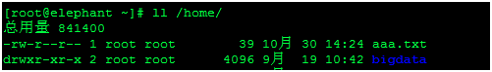


2. sudo -u hdfs hadoop fs -mkdir /user/hdfs/input (在hdfs上创建input目录,用于存放需要统计的文件)
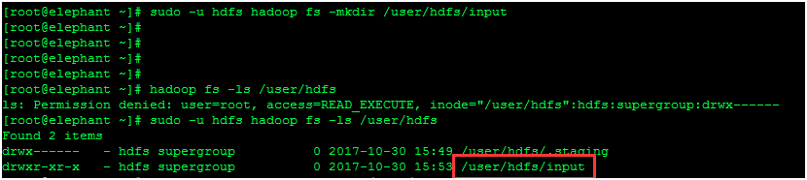

3. sudo -u hdfs hadoop fs -put /home/aaa.txt /user/hdfs/input（把home下的aaa文件上传到hdfs的input目录）
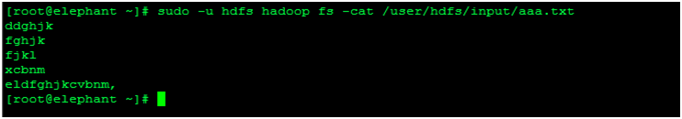

4. sudo -u hdfs hadoop jar /home/hadoop-mapreduce-examples.jar wordcount input counts 运行jar包
（hadoop-mapreduce-examples.jar包可以到hadoop官网下载，是一个单词统计包，感兴趣的小伙伴也可以自己写Python scala java脚本实现不同的功能，wordcount为作业名称，input为存放统计文件的目录，counts为mapreduce输入目录）

17/10/30 16:07:10 INFO client.RMProxy: Connecting to ResourceManager at elephant/192.168.10.128:8032
17/10/30 16:07:11 INFO input.FileInputFormat: Total input paths to process : 1
17/10/30 16:07:12 INFO mapreduce.JobSubmitter: number of splits:1
17/10/30 16:07:12 INFO mapreduce.JobSubmitter: Submitting tokens for job: job_1509333705246_0002
17/10/30 16:07:14 INFO impl.YarnClientImpl: Submitted application application_1509333705246_0002
17/10/30 16:07:14 INFO mapreduce.Job: The url to track the job: http://elephant:8088/proxy/application_1509333705246_0002/
17/10/30 16:07:14 INFO mapreduce.Job: Running job: job_1509333705246_0002
17/10/30 16:09:05 INFO mapreduce.Job: Job job_1509333705246_0002 running in uber mode : false
17/10/30 16:09:05 INFO mapreduce.Job: map 0% reduce 0%

17/10/30 16:13:57 INFO mapreduce.Job: map 100% reduce 0%
17/10/30 16:15:33 INFO mapreduce.Job: map 100% reduce 22%
17/10/30 16:15:47 INFO mapreduce.Job: map 100% reduce 33%
17/10/30 16:15:59 INFO mapreduce.Job: map 100% reduce 67%
17/10/30 16:17:13 INFO mapreduce.Job: map 100% reduce 100%
17/10/30 16:17:17 INFO mapreduce.Job: Job job_1509333705246_0002 completed successfully（作业已经成功跑完）
17/10/30 16:17:22 INFO mapreduce.Job: Counters: 49
File System Counters
FILE: Number of bytes read=124
FILE: Number of bytes written=588775
FILE: Number of read operations=0
FILE: Number of large read operations=0
FILE: Number of write operations=0
HDFS: Number of bytes read=147
HDFS: Number of bytes written=49
HDFS: Number of read operations=12
HDFS: Number of large read operations=0
HDFS: Number of write operations=6
Job Counters
Launched map tasks=1
Launched reduce tasks=3
Data-local map tasks=1
Total time spent by all maps in occupied slots (ms)=274644
Total time spent by all reduces in occupied slots (ms)=243951
Total time spent by all map tasks (ms)=274644
Total time spent by all reduce tasks (ms)=243951
Total vcore-milliseconds taken by all map tasks=274644
Total vcore-milliseconds taken by all reduce tasks=243951
Total megabyte-milliseconds taken by all map tasks=281235456
Total megabyte-milliseconds taken by all reduce tasks=249805824
Map-Reduce Framework
Map input records=5
Map output records=5
Map output bytes=59
Map output materialized bytes=112
Input split bytes=108
Combine input records=5
Combine output records=5
Reduce input groups=5
Reduce shuffle bytes=112
Reduce input records=5
Reduce output records=5
Spilled Records=10
Shuffled Maps =3
Failed Shuffles=0
Merged Map outputs=3
GC time elapsed (ms)=13313
CPU time spent (ms)=15470
Physical memory (bytes) snapshot=982937600
Virtual memory (bytes) snapshot=6274256896
Total committed heap usage (bytes)=765460480
Shuffle Errors
BAD_ID=0
CONNECTION=0
IO_ERROR=0
WRONG_LENGTH=0
WRONG_MAP=0
WRONG_REDUCE=0
File Input Format Counters
Bytes Read=39
File Output Format Counters
Bytes Written=49
17/10/30 16:17:22 INFO mapred.ClientServiceDelegate: Application state is completed. FinalApplicationStatus=SUCCEEDED. Redirecting to job history server

5. sudo -u hdfs hadoop fs -ls /user/hdfs/counts（counts目录为上面跑mapreduce定义的输出目录，注意红框里面的1就是mapreduce统计出来的每行记录）
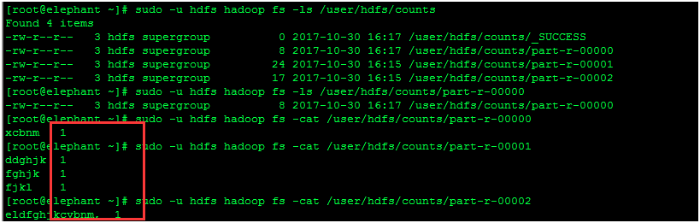

6.http://elephant:8088（通过ResourceManager Web UI 查看具体job）
