函数分类
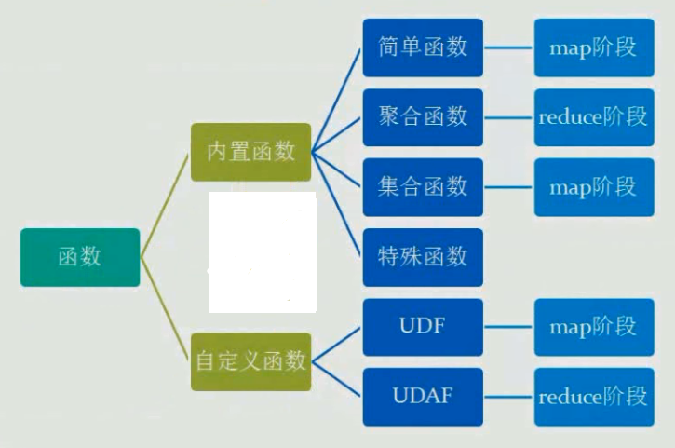

HIVE CLI命令
显示当前会话有多少函数可用
SHOW FUNCTIONS;
显示函数的描述信息
DESC FUNCTION concat;
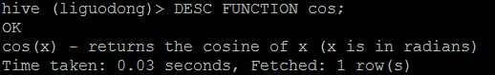
显示函数的扩展描述信息
DESC FUNCTION EXTENDED concat;

简单函数
函数的计算粒度为单条记录。
关系运算
数学运算
逻辑运算
数值计算
类型转换
日期函数
条件函数
字符串函数
统计函数

聚合函数
函数处理的数据粒度为多条记录。
sum()—求和
count()—求数据量
avg()—求平均直
distinct—求不同值数
min—求最小值
max—求最人值

集合函数
复合类型构建
复杂类型访问
复杂类型长度

特殊函数

窗口函数
应用场景
用于分区排序
动态Group By
Top N
累计计算
层次查询
Windowing functions
lead
lag
FIRST_VALUE
LAST_VALUE

分析函数
Analytics functions
RANK
ROW_NUMBER
DENSE_RANK
CUME_DIST
PERCENT_RANK
NTILE

混合函数
java_method(class,method [,arg1 [,arg2])reflect(class,method [,arg1 [,arg2..]])hash(a1 [,a2...])

UDTF
lateralView: LATERAL VIEW udtf(expression) tableAlias AS columnAlias (‘,‘ columnAlias)* fromClause: FROM baseTable (lateralView)*
ateral view用于和split, explode等UDTF一起使用，它能够将一行数据拆成多行数据，在此基础上可以对拆分后的数据进行聚合。lateral view首先为原始表的每行调用UDTF，UTDF会把一行拆分成一或者多行，lateral view再把结果组合，产生一个支持别名表的虚拟表。

常用函数Demo：
create table employee(
id string,
money double,
type string)row format delimited
fields terminated by ‘\t‘
lines terminated by ‘\n‘
stored as textfile;load data local inpath ‘/liguodong/hive/data‘ into table employee;select * from employee;
优先级依次为NOT AND ORselect id,money from employee where (id=‘1001‘ or id=‘1002‘) and money=‘100‘;
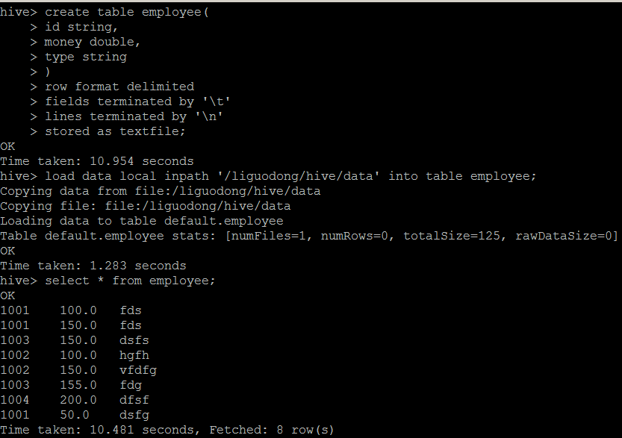
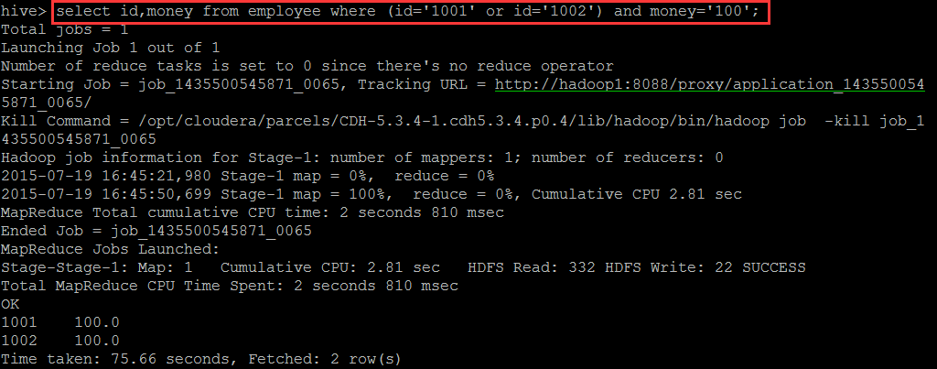
cast类型转换
select cast(1.5 as int);
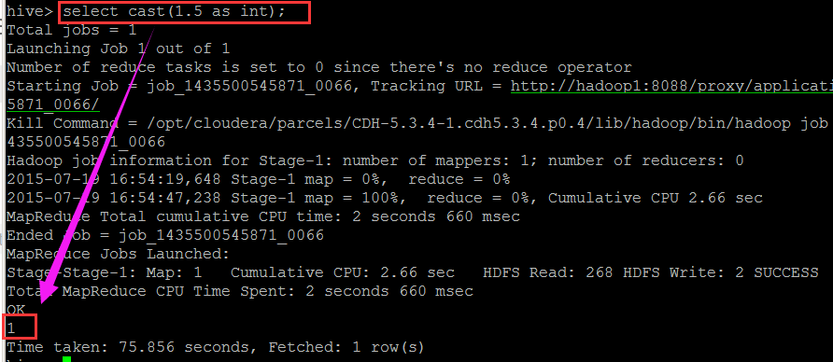
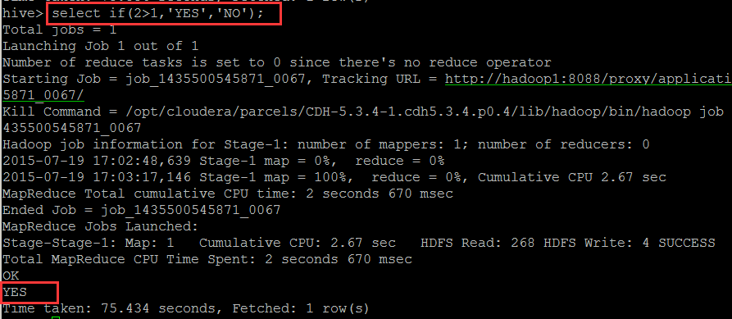
if判断
if(con,‘‘,‘‘);

hive (default)> select if(2>1,‘YES‘,‘NO‘);
YES
case when con then ‘‘ when con then ‘‘ else ‘‘ end (‘‘里面类型要一样)
select case when id=‘1001‘ then ‘v1001‘ when id=‘1002‘ then ‘v1002‘ else ‘v1003‘ end from employee;
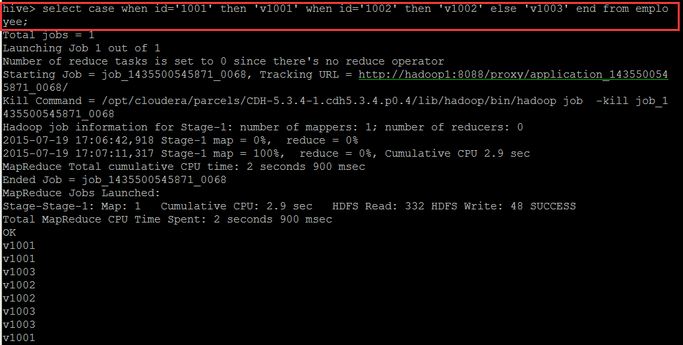
get_json_object
get_json_object(json 解析函数，用来处理json，必须是json格式)select get_json_object(‘{"name":"jack","age":"20"}‘,‘$.name‘);
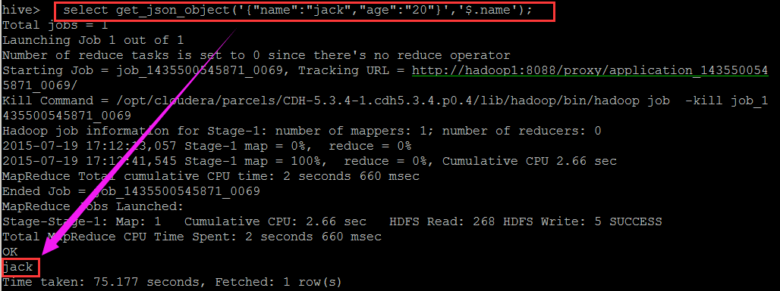
URL解析函数
parse_url(string urlString, string partToExtract [, string keyToExtract])
select parse_url(‘http://facebook.com/path1/p.php?k1=v1&k2=v2#Ref1‘, ‘HOST‘) from
employee limit 1;
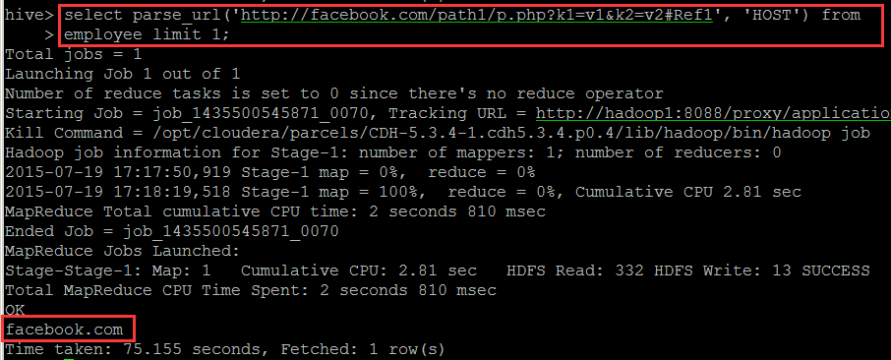
字符串连接函数： concat
语法: concat(string A, string B…)
返回值: string
说明：返回输入字符串连接后的结果，支持任意个输入字符串
举例：
hive> select concat(‘abc‘,‘def’,‘gh‘) from lxw_dual;
abcdefgh
带分隔符字符串连接函数： concat_ws
语法: concat_ws(string SEP, string A, string B…)
返回值: string
说明：返回输入字符串连接后的结果， SEP 表示各个字符串间的分隔符
concat_ws(string SEP, array<string>)
举例：
hive> select concat_ws(‘,‘,‘abc‘,‘def‘,‘gh‘) from lxw_dual;
abc,def,gh
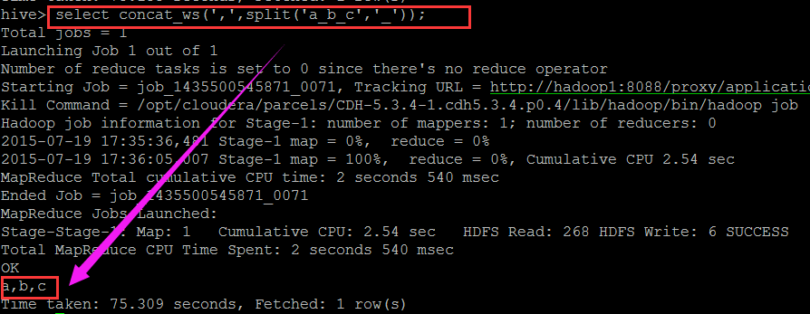
列出该字段所有不重复的值，相当于去重
collect_set(id) //返回的是数组
列出该字段所有的值，列出来不去重
collect_list(id) //返回的是数组
select collect_set(id) from taborder;
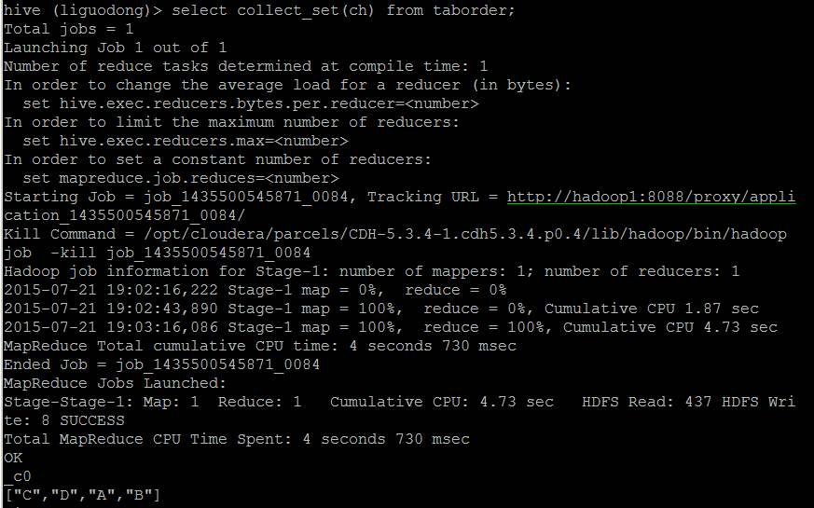
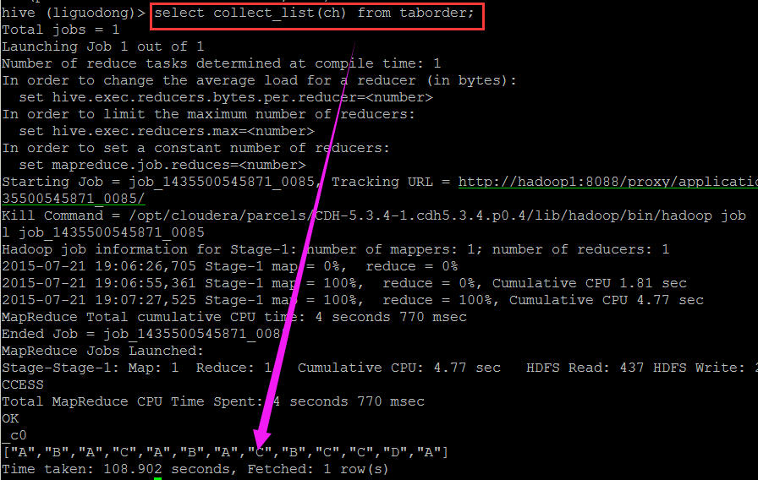
求和
sum(money)
统计列数
count(*)
select sum(num),count(*) from taborder;
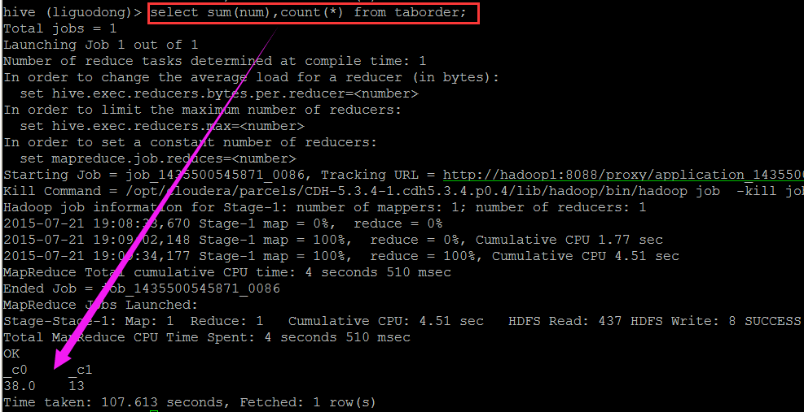
窗口函数
first_value(第一行值)

first_value(money) over (partition by id order by money)
select ch,num,first_value(num) over (partition by ch order by num) from taborder;
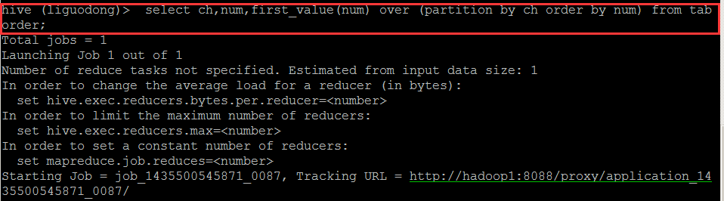
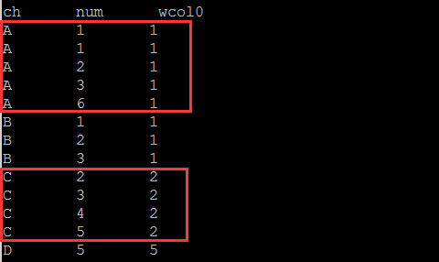
rows between 1 preceding and 1 following (当前行以及当前行的前一行与后一行)

hive (liguodong)> select ch,num,first_value(num) over (partition by ch order by num ROWS BETWEEN 2 PRECEDING AND CURRENT ROW) from taborder;
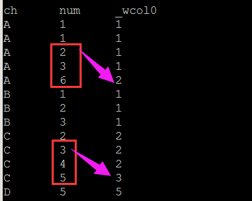
last_value 最后一行值
hive (liguodong)> select ch,num,last_value(num) over (partition by ch) from taborder;
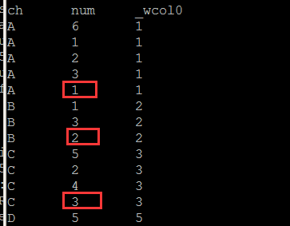
lead
去当前行后面的第二行的值
lead(money,2) over (order by money)

lag
去当前行前面的第二行的值
lag(money,2) over (order by money)
```

```
select ch, num, lead(num,2) over (order by num) from taborder;
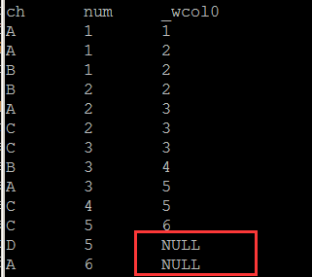
select ch, num, lag(num,2) over (order by num) from taborder;
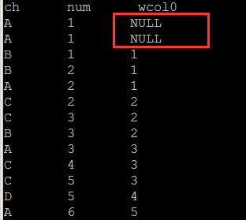
rank排名
rank() over(partition by id order by money)
select ch, num, rank() over(partition by ch order by num) as rank from taborder;
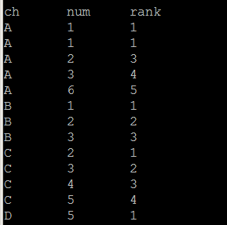
select ch, num, dense_rank() over(partition by ch order by num) as dense_rank from taborder;
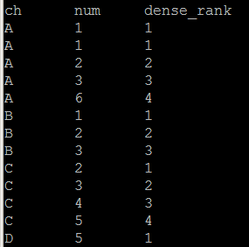
cume_dist
cume_dist (相同值的最大行号/行数)
cume_dist() over (partition by id order by money)

percent_rank (相同值的最小行号-1)/(行数-1)
第一个总是从0开始
percent_rank() over (partition by id order by money)

select ch,num,cume_dist() over (partition by ch order by num) as cume_dist,
percent_rank() over (partition by ch order by num) as percent_rank
from taborder;
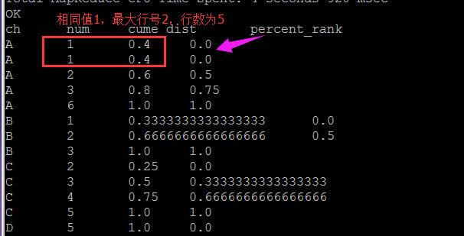
ntile分片
ntile(2) over (order by money desc) 分两份

select ch,num,ntile(2) over (order by num desc) from taborder;
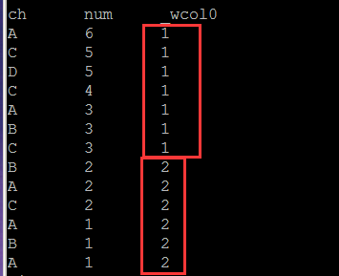
混合函数
select id,java_method("java.lang,Math","sqrt",cast(id as double)) as sqrt from hiveTest;
UDTF
select id,adid
from employee
lateral view explode(split(type,‘B‘)) tt as adid;
explode 把一列转成多行

hive (liguodong)> select id,adid
> from hiveDemo
> lateral view explode(split(str,‘,‘)) tt as adid;
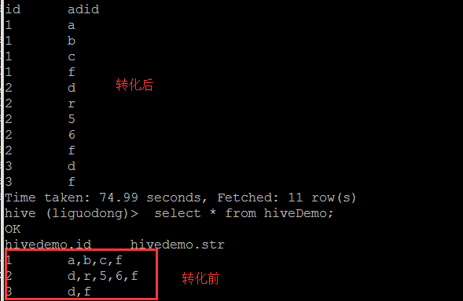
正则表达式
使用正则表达式的函数
regexp_replace(string subject A,string B,string C)
regexp_extract(string subject,string pattern,int index)
hive> select regexp_replace(‘foobar‘, ‘oo|ar‘, ‘‘) from lxw_dual;
fb

hive> select regexp_replace(‘979|7.10.80|8684‘, ‘.*\\|(.*)‘,1) from hiveDemo limit 1;
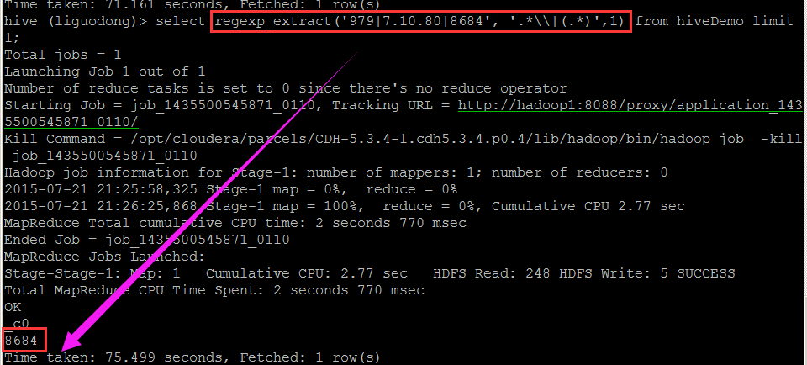
hive> select regexp_replace(‘979|7.10.80|8684‘, ‘(.*?)\\|(.*)‘,1) from hiveDemo limit 1;
