Percona-XtraDB-Cluster互为见证发生脑裂情况的测试

测试目的
测试Percona-XtraDB-Cluster互为见证架构可靠性。

测试环境
1.PXC集群：
PXC-node1:192.168.4.40
PXC-node2:192.168.4.41
2.见证服务器:
garbd-node1:192.168.4.40
garbd-node2:192.168.4.41
3.Percona软件版本：
Percona-XtraDB-Cluster版本：Percona-XtraDB-Cluster-57.x86_64
Percona-XtraDB-Garbd版本：Percona-XtraDB-Cluster-garbd-57.x86_64

测试步骤
pxc搭建过程不再赘述，如有需要请参考Percona XtraDB Cluster安装部署手册，路径：DBA团队—>How-to 文档。
1.1 node1:my.cnf配置如下：
Expand source
[mysqld_safe]
pid-file =/data/mysqldata/mysql.pid
[mysqld]
# GENERAL
#basedir = /usr/local/mysql
datadir = /data/mysqldata
tmpdir = /tmp
socket = /data/mysqldata/mysql.sock
pid_file = /data/mysqldata/mysql.pid
user = mysql
port = 3306
character-set-server = utf8
bind-address = 0.0.0.0
server-id = 3232236584
skip-name-resolve = 1
# INNODB
# This changes how |InnoDB| autoincrement locks are managed and is a requirement for Galera
default_storage_engine = InnoDB
innodb_buffer_pool_size = 50G
innodb_autoinc_lock_mode = 2
innodb_buffer_pool_instances = 8
innodb_thread_concurrency = 16
innodb_log_buffer_size = 32M
innodb_log_file_size = 1024M
innodb_online_alter_log_max_size = 512M
innodb_open_files = 1024
innodb_purge_threads = 2
innodb_data_home_dir = /data/mysqldata
innodb_data_file_path = ibdata1:256M:autoextend
innodb_read_io_threads = 8
innodb_write_io_threads = 8
innodb_file_per_table = 1
innodb_flush_method = O_DIRECT
innodb_flush_log_at_trx_commit = 2
innodb_max_dirty_pages_pct = 90
innodb_file_format = Barracuda
innodb_file_format_max = Barracuda
innodb_buffer_pool_dump_at_shutdown = ON
innodb_buffer_pool_load_at_startup = ON
innodb_undo_log_truncate = ON
innodb_undo_tablespaces = 4
innodb_strict_mode = OFF
# MyISAM
key_buffer_size = 32M
# LOGS
#general_log = 1
#general_log_file = /data/logs/mysql/mysql_general.log
log_timestamps = system
log_warnings = 2
log_error = /data/logs/mysql/mysql_error.log
slow_query_log = ON
slow_query_log_file = /data/logs/mysql/mysql_slow.log
log_queries_not_using_indexes = 0
long_query_time = 1
expire_logs_days = 15
log-bin = mysql-bin.log
innodb_print_all_deadlocks = 1
relay-log = relay-log
relay-log-index = relay-log
# BINLOG
# In order for Galera to work correctly binlog format should be ROW
binlog_format = ROW
binlog_cache_size = 16M
max_binlog_size = 512M
# OTHER
tmp_table_size = 32M
max_heap_table_size = 128M
query_cache_type = 0
query_cache_size = 0M
max_connections = 1024
thread_cache_size = 200
open_files_limit = 65535
optimizer-switch = "mrr=on,mrr_cost_based=off,batched_key_access=on" #开启mmr功能
auto_increment_offset = 1
join_buffer_size = 5M
sort_buffer_size = 5M
sql_mode = STRICT_TRANS_TABLES,NO_ENGINE_SUBSTITUTION
performance_schema = ON
default_password_lifetime = 0
# WSREP
wsrep_auto_increment_control = OFF
# Path to Galera library
wsrep_provider = /usr/lib64/libgalera_smm.so
# Cluster connection URL
wsrep_cluster_address = gcomm://192.168.34.40:4567,192.168.34.41:5567
# Node #1 address
wsrep_node_address = 192.168.34.40 # 本机IP地址
# SST method
wsrep_sst_method = xtrabackup-v2
# Cluster name
wsrep_cluster_name = Yooli_TEST_Cluster
# Authentication for SST method
wsrep_sst_auth = "sstuser:sstuser"
wsrep_max_ws_rows = 0
wsrep_max_ws_size = 2147483647
wsrep_slave_threads = 16
wsrep_provider_options = "base_port=4567;gcache.size=50G; gcache.page_size=512M; gcs.fc_limit = 256;gcs.fc_master_slave = yes"
pxc_strict_mode = PERMISSIVE
#Replication
log_slave_updates = 1
gtid-mode = on
enforce_gtid_consistency = true
binlog_checksum = CRC32
slave_allow_batching = 1
master_verify_checksum = 1
slave_sql_verify_checksum = 1
master_info_repository = TABLE
relay_log_info_repository = TABLE
slave_parallel_type = LOGICAL_CLOCK
slave_parallel_workers = 16
relay_log_recovery = ON
[client]
socket = /data/mysqldata/mysql.sock
port = 3306
[mysql]
default-character-set = utf8
prompt ="\\u@\\h : \\d \\R:\\m:\\s>"
no-auto-rehash

1.2 node1 garb配置文件如下(garb配置文件中ip与my.cnf不在同一个网段，彼此不能通信)：
# Copyright (C) 2012 Coedership Oy
# # # This config file is to be sourced by garb service script.
# # # A space-separated list of node addresses (address[:port]) in the cluster
GALERA_NODES="192.168.4.41:5567 192.168.4.40:4567"
# # # Galera cluster name, should be the same as on the rest of the nodes.
GALERA_GROUP="Yooli_TEST_Cluster"
# # # Log file for garbd. Optional, by default logs to syslog
LOG_FILE="/tmp/garbd.log"
2.1 node2:my.cnf配置如下：
Expand source
[mysqld_safe]
pid-file =/data/mysqldata/mysql.pid
[mysqld]
# GENERAL
#basedir = /usr/local/mysql
datadir = /data/mysqldata
tmpdir = /tmp
socket = /data/mysqldata/mysql.sock
pid_file = /data/mysqldata/mysql.pid
user = mysql
port = 3306
character-set-server = utf8
bind-address = 0.0.0.0
server-id = 3232236585
skip-name-resolve = 1
# INNODB
# This changes how |InnoDB| autoincrement locks are managed and is a requirement for Galera
default_storage_engine = InnoDB
innodb_buffer_pool_size = 50G
innodb_autoinc_lock_mode = 2
innodb_buffer_pool_instances = 8
innodb_thread_concurrency = 16
innodb_log_buffer_size = 32M
innodb_log_file_size = 1024M
innodb_online_alter_log_max_size = 512M
innodb_open_files = 1024
innodb_purge_threads = 2
innodb_data_home_dir = /data/mysqldata
innodb_data_file_path = ibdata1:256M:autoextend
innodb_read_io_threads = 8
innodb_write_io_threads = 8
innodb_file_per_table = 1
innodb_flush_method = O_DIRECT
innodb_flush_log_at_trx_commit = 2
innodb_max_dirty_pages_pct = 90
innodb_file_format = Barracuda
innodb_file_format_max = Barracuda
innodb_buffer_pool_dump_at_shutdown = ON
innodb_buffer_pool_load_at_startup = ON
innodb_undo_log_truncate = ON
innodb_undo_tablespaces = 4
innodb_strict_mode = OFF
# MyISAM
key_buffer_size = 32M
# LOGS
#general_log = 1
#general_log_file = /data/logs/mysql/mysql_general.log
log_timestamps = system
log_warnings = 2
log_error = /data/logs/mysql/mysql_error.log
slow_query_log = ON
slow_query_log_file = /data/logs/mysql/mysql_slow.log
log_queries_not_using_indexes = 0
long_query_time = 1
expire_logs_days = 15
log-bin = mysql-bin.log
innodb_print_all_deadlocks = 1
relay-log = relay-log
relay-log-index = relay-log
# BINLOG
# In order for Galera to work correctly binlog format should be ROW
binlog_format = ROW
binlog_cache_size = 16M
max_binlog_size = 512M
# OTHER
tmp_table_size = 32M
max_heap_table_size = 128M
query_cache_type = 0
query_cache_size = 0M
max_connections = 1024
thread_cache_size = 200
open_files_limit = 65535
optimizer-switch = "mrr=on,mrr_cost_based=off,batched_key_access=on" #开启mmr功能
auto_increment_offset = 1
join_buffer_size = 5M
sort_buffer_size = 5M
sql_mode = STRICT_TRANS_TABLES,NO_ENGINE_SUBSTITUTION
performance_schema = ON
default_password_lifetime = 0
# WSREP
wsrep_auto_increment_control = OFF
# Path to Galera library
wsrep_provider = /usr/lib64/libgalera_smm.so
# Cluster connection URL
wsrep_cluster_address = gcomm://192.168.34.41:5567,192.168.34.40:4567
# Node #1 address
wsrep_node_address = 192.168.34.41 # 本机IP地址
# SST method
wsrep_sst_method = xtrabackup-v2
# Cluster name
wsrep_cluster_name = Yooli_TEST_Cluster
# Authentication for SST method
wsrep_sst_auth = "sstuser:sstuser"
wsrep_max_ws_rows = 0
wsrep_max_ws_size = 2147483647
wsrep_slave_threads = 16
wsrep_provider_options = "base_port=5567;gcache.size=50G; gcache.page_size=512M; gcs.fc_limit = 256;gcs.fc_master_slave = yes"
pxc_strict_mode = PERMISSIVE
#Replication
log_slave_updates = 1
gtid-mode = on
enforce_gtid_consistency = true
binlog_checksum = CRC32
slave_allow_batching = 1
master_verify_checksum = 1
slave_sql_verify_checksum = 1
master_info_repository = TABLE
relay_log_info_repository = TABLE
slave_parallel_type = LOGICAL_CLOCK
slave_parallel_workers = 16
relay_log_recovery = ON
[client]
socket = /data/mysqldata/mysql.sock
port = 3306
[mysql]
default-character-set = utf8
prompt ="\\u@\\h : \\d \\R:\\m:\\s>"
no-auto-rehash

2.2 node2 garb配置文件如下(garb配置文件中ip与my.cnf不在同一个网段，彼此不能通信)：
# Copyright (C) 2012 Coedership Oy
# # # # This config file is to be sourced by garb service script.
# # # # A space-separated list of node addresses (address[:port]) in the cluster
GALERA_NODES="192.168.4.41:4567 192.168.4.40:5567"
# # # # Galera cluster name, should be the same as on the rest of the nodes.
GALERA_GROUP="Yooli_TEST_Cluster"
# # # # Log file for garbd. Optional, by default logs to syslog
LOG_FILE="/tmp/garbd.log"
3.node1，node2节点启动mysql、garb服务，在node1上show status like 'wsrep%';状态如下：
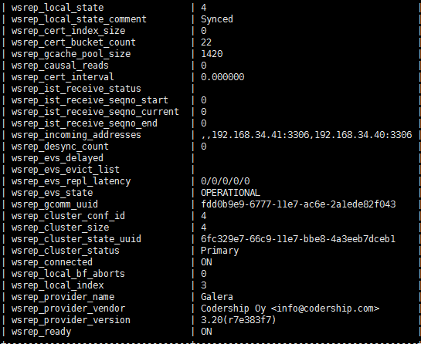
4.在node2上同时kill -9 mysql，garb进程
5.node2 kill -9 进程之后，node1上mysql_error.log内容摘要如下（注意观察后6行）：
Expand source
2017-07-13T15:18:03.387139+08:00 0 [Note] WSREP: (fdd0b9e9, 'tcp://0.0.0.0:4567') turning message relay requesting on, nonlive peers: tcp://192.168.34.41:4567 tcp://192.168.4.41:4567
2017-07-13T15:18:04.517477+08:00 0 [Note] WSREP: (fdd0b9e9, 'tcp://0.0.0.0:4567') reconnecting to 220df60c (tcp://192.168.34.41:4567), attempt 0
2017-07-13T15:18:04.517712+08:00 0 [Note] WSREP: (fdd0b9e9, 'tcp://0.0.0.0:4567') reconnecting to 82cd007a (tcp://192.168.34.41:5567), attempt 0
2017-07-13T15:18:04.517926+08:00 0 [Note] WSREP: (fdd0b9e9, 'tcp://0.0.0.0:4567') reconnecting to 220df60c (tcp://192.168.4.41:4567), attempt 0
2017-07-13T15:18:08.520194+08:00 0 [Note] WSREP: evs::proto(fdd0b9e9, OPERATIONAL, view_id(REG,080650e4,41)) suspecting node: 220df60c
2017-07-13T15:18:08.520272+08:00 0 [Note] WSREP: evs::proto(fdd0b9e9, OPERATIONAL, view_id(REG,080650e4,41)) suspected node without join message, declaring inactive
2017-07-13T15:18:08.520336+08:00 0 [Note] WSREP: evs::proto(fdd0b9e9, OPERATIONAL, view_id(REG,080650e4,41)) suspecting node: 82cd007a
2017-07-13T15:18:08.520374+08:00 0 [Note] WSREP: evs::proto(fdd0b9e9, OPERATIONAL, view_id(REG,080650e4,41)) suspected node without join message, declaring inactive
2017-07-13T15:18:09.521537+08:00 0 [Note] WSREP: Current view of cluster as seen by this node
view (view_id(NON_PRIM,080650e4,41)
memb {
080650e4,0
fdd0b9e9,0
}
joined {
}
left {
}
partitioned {
220df60c,0
82cd007a,0
}
)
2017-07-13T15:18:09.521714+08:00 0 [Note] WSREP: declaring 080650e4 at tcp://192.168.34.40:5567 stable
2017-07-13T15:18:09.521717+08:00 0 [Note] WSREP: New COMPONENT: primary = no, bootstrap = no, my_idx = 1, memb_num = 2
2017-07-13T15:18:09.521823+08:00 0 [Note] WSREP: Flow-control interval: [256, 256]
2017-07-13T15:18:09.521846+08:00 0 [Note] WSREP: Received NON-PRIMARY.
2017-07-13T15:18:09.521860+08:00 0 [Note] WSREP: Shifting SYNCED -> OPEN (TO: 10)
2017-07-13T15:18:09.522020+08:00 1 [Note] WSREP: New cluster view: global state: 6fc329e7-66c9-11e7-bbe8-4a3eeb7dceb1:10, view# -1: non-Primary, number of nodes: 2, my index: 1, protocol version 3
2017-07-13T15:18:09.522117+08:00 1 [Note] WSREP: wsrep_notify_cmd is not defined, skipping notification.
2017-07-13T15:18:09.522143+08:00 0 [Note] WSREP: Current view of cluster as seen by this node
view (view_id(NON_PRIM,080650e4,42)
memb {
080650e4,0
fdd0b9e9,0
}
joined {
}
left {
}
partitioned {
220df60c,0
82cd007a,0
}
)
2017-07-13T15:18:09.522303+08:00 0 [Note] WSREP: New COMPONENT: primary = no, bootstrap = no, my_idx = 1, memb_num = 2
2017-07-13T15:18:09.522353+08:00 0 [Note] WSREP: Flow-control interval: [256, 256]
2017-07-13T15:18:09.522382+08:00 0 [Note] WSREP: Received NON-PRIMARY.
2017-07-13T15:18:09.522439+08:00 1 [Note] WSREP: New cluster view: global state: 6fc329e7-66c9-11e7-bbe8-4a3eeb7dceb1:10, view# -1: non-Primary, number of nodes: 2, my index: 1, protocol version 3
2017-07-13T15:18:09.522473+08:00 1 [Note] WSREP: wsrep_notify_cmd is not defined, skipping notification.
2017-07-13T15:18:48.025178+08:00 0 [Note] WSREP: (fdd0b9e9, 'tcp://0.0.0.0:4567') reconnecting to 220df60c (tcp://192.168.34.41:4567), attempt 30
6.node1上发现keepalived已停止工作，show status like 'wsrep%';状态如下：
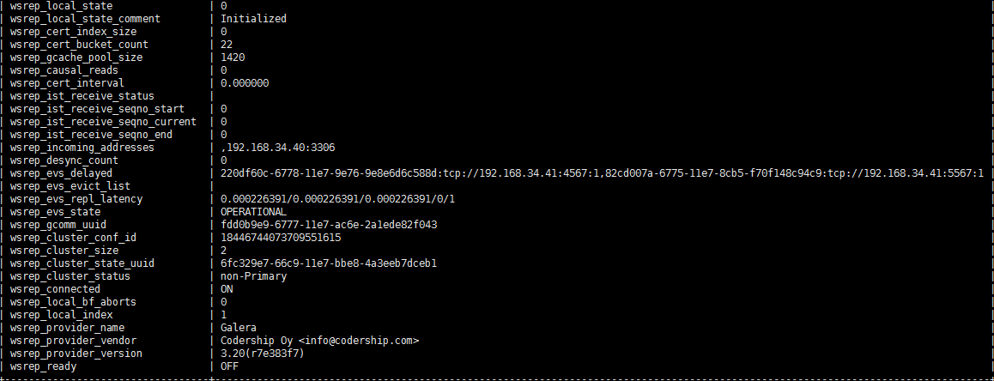
通过show status like 'wsrep%';发现:
wsrep_cluster_size:2
wsrep_cluster_status:non-Primary
wsrep_ready:off
从这三个状态来看node1数据库不可用，已发生脑裂，原因是集群的成员本来是4个，node2上mysql和garb服务都意外挂掉，集群成员还剩2个，小于等于总数量的50%，所以发生脑裂。
7.恢复步骤：
7.1 node1停掉mysql，并将grastate.dat中safe_to_bootstrap改为1，然后执行service mysql bootstrap-pxc启动mysql；重启见证：service garb restart；启动keepalived：service keepalived start。
7.2 node2参考节点崩溃避免SST方法启动mysql（详情路径：DBA团队-->故障排除文章），启动见证：service garb start;启动keepalived：service keepalived start。
8.修改node1，node2 garb配置文件
8.1将node1 garb配置文件ip修改成跟my.cnf同一网段：
# Copyright (C) 2012 Coedership Oy
# # # This config file is to be sourced by garb service script.
# # # A space-separated list of node addresses (address[:port]) in the cluster
GALERA_NODES="192.168.34.41:5567 192.168.34.40:4567"
# # # Galera cluster name, should be the same as on the rest of the nodes.
GALERA_GROUP="Yooli_TEST_Cluster"
# # # Log file for garbd. Optional, by default logs to syslog
LOG_FILE="/tmp/garbd.log"
8.2将node2 garb配置文件ip修改成跟my.cnf同一网段：
# Copyright (C) 2012 Coedership Oy
# # # # This config file is to be sourced by garb service script.
# # # # A space-separated list of node addresses (address[:port]) in the cluster
GALERA_NODES="192.168.34.41:4567 192.168.34.40:5567"
# # # # Galera cluster name, should be the same as on the rest of the nodes.
GALERA_GROUP="Yooli_TEST_Cluster"
# # # # Log file for garbd. Optional, by default logs to syslog
LOG_FILE="/tmp/garbd.log"
重启node1，node2见证服务，然后在node2上再次同时kill -9 mysql,garb进程，结果发现node1还是会发生脑裂。

测试结论
1.互为见证架构只能保证在mysql服务不可用时，整个集群健康可用；如遇服务器宕机，仍会发生脑裂造成集群不可用。
2.garb配置文件跟my.cnf配置文件中IP不在同一网段不会对服务器因宕机发生的集群不可用造成影响，仅当在bond0被流量打满的情况下，会造成集群不可用。

