TokuDB 安装
背景：
TokuDB 是一个高性能、支持事务处理的 MySQL 和 MariaDB 的存储引擎。TokuDB 的主要特点是高压缩比，高 INSERT 性能，支持大多数在线修改索引、添加字段，特别适合像 Zabbix 数据库这种高 INSERT，少 UPDATE 的应用场景。但是TokuDB需要单独安装。所以撰写这个文档，希望对大家有所帮助（此文档针对的是Percona Server）
安装步骤：

安装yum源

yum install http://www.percona.com/redir/downloads/percona-release/percona-release-0.0-1.x86_64.rpm

安装Percona Server（如已安装则忽略）

安装过程忽略……

- 安装jemalloc
检查jemalloc是否已经安装：rpm -qa | grep jemalloc
yum install jemalloc
tokuDB内存分配需要jemalloc支持（一般安装percona mysql以后自己就有，如果没有则需要额外安装）
- 检查系统参数：
cat /sys/kernel/mm/transparent_hugepage/enabled
[always] madvise never
如果结果不符，则需要执行以下命令：
echo never > /sys/kernel/mm/transparent_hugepage/enabled
echo never > /sys/kernel/mm/transparent_hugepage/defrag
- 安装 tokudb
yum -y install Percona-Server-tokudb-56
ps_tokudb_admin --enable -uroot -pPassword （执行命令前，请重启mysql）
Checking if Percona server is running with jemalloc enabled...
>> Percona server is running with jemalloc enabled.

Checking transparent huge pages status on the system...
>> Transparent huge pages are enabled (should be disabled).

Checking if thp-setting=never option is already set in config file...
>> Option thp-setting=never is not set in the config file.
>> (needed only if THP is not disabled permanently on the system)

Checking TokuDB plugin status...
>> TokuDB plugin is not installed.

Disabling transparent huge pages for the current session...
>> Successfuly disabled transparent huge pages for this session.

Adding thp-setting=never option into /etc/my.cnf
>> Successfuly added thp-setting=never option into /etc/my.cnf

Installing TokuDB engine...
>> Successfuly installed TokuDB plugin.

验证

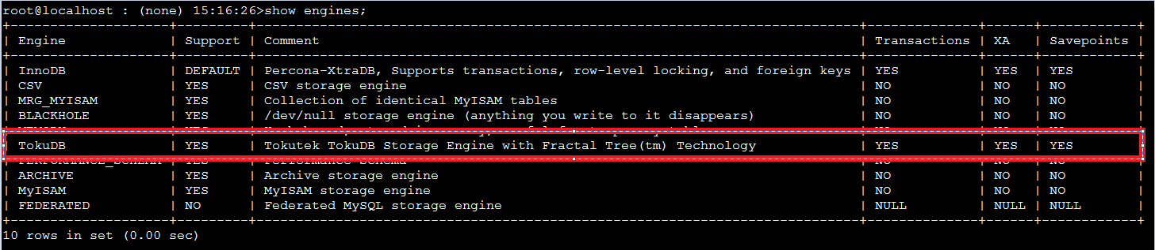

如果 运行的Percona Server版本为 5.6.22-71.0 则需要手动安装

INSTALL PLUGIN tokudb SONAME 'ha_tokudb.so';INSTALL PLUGIN tokudb_file_map SONAME 'ha_tokudb.so';INSTALL PLUGIN tokudb_fractal_tree_info SONAME 'ha_tokudb.so';INSTALL PLUGIN tokudb_fractal_tree_block_map SONAME 'ha_tokudb.so';INSTALL PLUGIN tokudb_trx SONAME 'ha_tokudb.so';INSTALL PLUGIN tokudb_locks SONAME 'ha_tokudb.so';INSTALL PLUGIN tokudb_lock_waits SONAME 'ha_tokudb.so';

mysql> SHOW PLUGINS;...| TokuDB | ACTIVE | STORAGE ENGINE | ha_tokudb.so | GPL || TokuDB_file_map | ACTIVE | INFORMATION SCHEMA | ha_tokudb.so | GPL || TokuDB_fractal_tree_info | ACTIVE | INFORMATION SCHEMA | ha_tokudb.so | GPL || TokuDB_fractal_tree_block_map | ACTIVE | INFORMATION SCHEMA | ha_tokudb.so | GPL || TokuDB_trx | ACTIVE | INFORMATION SCHEMA | ha_tokudb.so | GPL || TokuDB_locks | ACTIVE | INFORMATION SCHEMA | ha_tokudb.so | GPL || TokuDB_lock_waits | ACTIVE | INFORMATION SCHEMA | ha_tokudb.so | GPL |

