

Release Date:

Revision: 1.0

Preliminary (Released) Information
Document Number:

Power On Procedure Application Note

MTK平台开机流程应用指南
MediaTek
Legal Disclaimer

BY OPENING OR USING THIS FILE, BUYER HEREBY UNEQUIVOCALLY ACKNOWLEDGES AND AGREES THAT THE SOFTWARE/FIRMWARE AND ITS DOCUMENTATIONS (“MEDIATEK SOFTWARE”) RECEIVED FROM MEDIATEK AND/OR ITS REPRESENTATIVES ARE PROVIDED TO BUYER ON AN “AS-IS” BASIS ONLY. MEDIATEK EXPRESSLY DISCLAIMS ANY AND ALL WARRANTIES, EXPRESS OR IMPLIED, INCLUDING BUT NOT LIMITED TO THE IMPLIED WARRANTIES OF MERCHANTABILITY, FITNESS FOR A PARTICULAR PURPOSE OR NONINFRINGEMENT. NEITHER DOES MEDIATEK PROVIDE ANY WARRANTY WHATSOEVER WITH RESPECT TO THE SOFTWARE OF ANY THIRD PARTY WHICH MAY BE USED BY, INCORPORATED IN, OR SUPPLIED WITH THE MEDIATEK SOFTWARE, AND BUYER AGREES TO LOOK ONLY TO SUCH THIRD PARTY FOR ANY WARRANTY CLAIM RELATING THERETO. MEDIATEK SHALL ALSO NOT BE RESPONSIBLE FOR ANY MEDIATEK SOFTWARE RELEASES MADE TO BUYER’S SPECIFICATION OR TO CONFORM TO A PARTICULAR STANDARD OR OPEN FORUM.

BUYER'S SOLE AND EXCLUSIVE REMEDY AND MEDIATEK'S ENTIRE AND CUMULATIVE LIABILITY WITH RESPECT TO THE MEDIATEK SOFTWARE RELEASED HEREUNDER WILL BE, AT MEDIATEK'S OPTION, TO REVISE OR REPLACE THE MEDIATEK SOFTWARE AT ISSUE, OR REFUND ANY SOFTWARE LICENSE FEES OR SERVICE CHARGE PAID BY BUYER TO MEDIATEK FOR SUCH MEDIATEK SOFTWARE AT ISSUE.

THE TRANSACTION CONTEMPLATED HEREUNDER SHALL BE CONSTRUED IN ACCORDANCE WITH THE LAWS OF THE STATE OF CALIFORNIA, USA, EXCLUDING ITS CONFLICT OF LAWS PRINCIPLES.

Revision History

Revision | Date (mm/dd/yyyy) | Author | Comments
1.0 | 03/31/2006 | 李素娜 | Draft version
Table of Contents
Legal Disclaimer 2
Revision History 3
Table of Contents 4
1. 开机方式及硬件实现方法 5
1.1 正常开关机 5
1.2 充电开机 6
1.3 闹钟开机 7
1.4 开机debug流程图如下： 8
2. 常见问题分析与解答 9

1. 开机方式及硬件实现方法

正常开关机
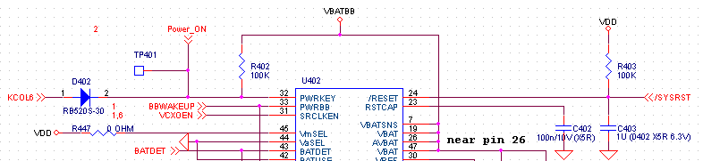

手机开机硬件电路图

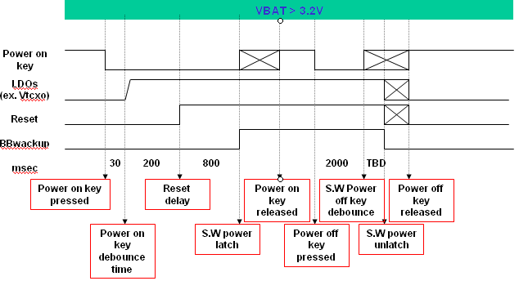
正常开机过程

开机过程：按下power key 后，二极管导通，PWRKEY检测到低电平,驱动PMIC打开LDOs，之后PMIC使BB复位，随之BB起来进入软件开机程序，完成开机，按power key关机时，首先执行软件关机程序，随后复位及LDOs也被关闭，完成关机。

充电开机
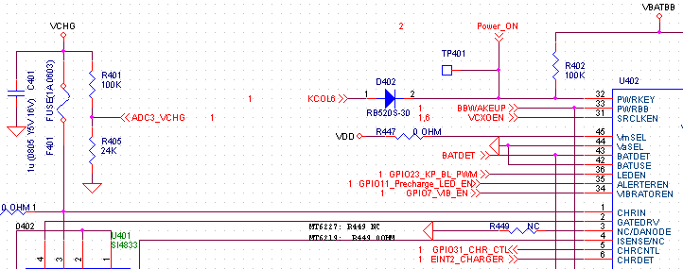
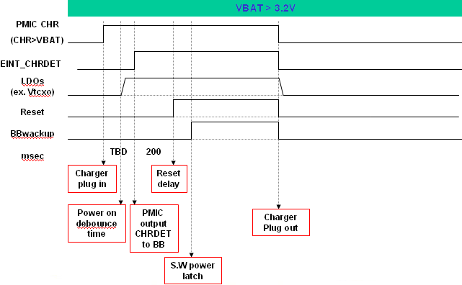
开机过程：当插充电器给手机充电时，CHRIN检测到高电平，驱动PMIC打开LDOs，如果此时电池的电压>3.2V,PMIC产生EINT 中断(高电平)，（如果此时电池的电压<3.2v，先小电流充电使电池电压>3.2v） PMIC使BB复位，BB起来执行软件开机程序，完成充电开机。

闹钟开机
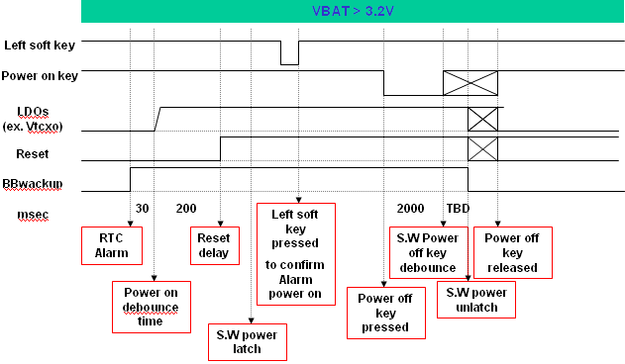
闹钟开机过程

开机过程：闹钟醒来时，BBwakeup先起来由低电平变高电平,然后PMIC的所有LDO后起来，过200ms后PMIC使BB复位，执行软件开机程序，当按下左键停止闹钟，完成开机。其关机过程同正常关机一样。

开机debug流程图如下：
按powerkey
正常
检查最基本的信号包括,LDO, Reset, Clock, BB wake,以及贴片问题
正确
检查EMI配置，如WST, RLT和PRLT以及page size.
检查Nand flash问题,如是否支持NAND,以及NAND ID Code是否在nand_mtd.c所支持的列表内
检查make file，如nor flash type设置及是否支持charger与use共用中断等问题
根据nor flash和sram的时序要求适当的调整WST, RLT和PRLT这三个参数
LDO电压不对，查看MT6305BN的PIN3，MT6205/17/26/27需加上拉电阻至VBAT
6219/28需拉至地
Clk不正常，查看26MHz，13KHz焊接及其负载电容值
有nand_support时，必须要有nand flash系统才能启动
检查Audio_bias-R上的容值是否为51K 1%
还要检查手机是否支持某个功能而在MAKE FILE 中是否定义此功能

2. 常见问题分析与解答
- 按powerkey手机不能开机
检查硬件电路发现
  - 漏掉Audio_bias-R的51KR
  - 32Khz焊接不良
- 手机不能正常开机(MT6226)
  - 量测信号发现VCORE=1.2V,(MT6226 VCORE=1.8V),发现MT6305BN的PIN3悬浮，未上拉至地
  - 更换MCP,而相关软件设定为相应修改
- Download完毕不能开机，电流一直在50mA到20mA左右摆动
  - EMI配置的问题，可以根据nor flash和sram的时序要求适当的调整WST, RLT和PRLT这三个三个参数，另外还要注意page size设置是否正确；
- 从S71PL127JB0BAW9U切换到QB之后不能开机
  - 这两颗MCP的SRAM Die是不同的，所以就会有SRAM部分的timing, page size是不一样
    - S71PL127JB0BAW9U使用Toshiba SRAM, 16B page size, Toe is 25ns, Twp is 50ns;
    - S71PL127JB0BAWQB使用Samsung utRAM, 16B page size, Toe < 35ns, Twp > 55ns;
  - 从上面可以看到QB系列的SRAM读写时间都比较慢，需要适当调整RLT和WST两个参数才能正常开机；对QB的正确配置应该是：
/* 4MB SRAM: Spansion PL127JB0BAWQB0 */
{EMI_CS1, EMI_BURST_MODE, EMI_4_WAIT_STATE, EMI_4_WAIT_STATE,
EMI_16B_PER_PAGE, EMI_1_WAIT_STATE, EMI_16BIT_DEVICE, EMI_RBLN_ENABLE,
EMI_SETUP_TIME_1, EMI_SETUP_TIME_1, EMI_HOLD_TIME_0}
  - 另外还需要特别注意page size设置是否正确；

