**Exploring Möbius Strip – A Fusion of Mathematics and Programming**

1. **Introduction**

The Möbius strip, a one-sided non-orientable surface, presents fascinating properties in the realms of topology, geometry, and practical applications. This project will explore the mathematical intricacies of the Möbius strip and implement a computational simulation to visualize its behavior and investigate its real-world implications. Through a blend of theoretical exploration and interactive programming, this project aims to provide a deeper understanding of the Möbius strip’s unique properties and showcase its relevance to fields such as material science, physics, and art.

1. **Objectives**

The main objectives of this project are:

* **Mathematical Exploration:** Investigate the topological and geometrical properties of the Möbius strip using parametric equations, topology, and algebraic concepts such as Euler characteristics and homology.
* **Interactive Visualization:** Develop an interactive 3D visualization of the Möbius strip using Python, allowing users to manipulate and explore its properties in real-time.
* **Applications:** Study and simulate the real-world applications of the Möbius strip in areas such as conveyor belts, electrical circuits, and art installations.

1. **Research Questions**

The project will address the following key questions:

* What are the fundamental topological and geometrical properties of the Möbius strip, and how do they distinguish it from other surfaces?
* How can the Möbius strip be represented mathematically using parametric equations, and what insights can be gained from its visualization?
* What real-world applications leverage the unique properties of the Möbius strip, and how can these applications be simulated?

1. **Project Scope**

This project will consist of three phases:

1. **Mathematical Foundation:** A theoretical exploration of the Möbius strip, focusing on its topology and geometry.
2. **Programming and Visualization:** An implementation of the Möbius strip in Python, with a focus on 3D interactive visualization.
3. **Real-world Applications and Simulations:** A study of the Möbius strip's applications and practical relevance in various fields.
4. **Methodology**

The project will use the following methods:

* **Mathematical Analysis:** Study topological concepts such as non-orientable surfaces, Euler characteristics, and homology, alongside parametric questions for equations for geometric visualization.
* **Programming:** Python, with libraries such as matplotlib, numpy, and plotly, will be used to build 3D visualizations and simulate real-world applications.
* **Application Research:** Explore real-world use cases through research and simulation, integrating the theoretical and computational findings.

1. **Expected Results**

The project aims to deliver:

* A comprehensive mathematical analysis of the Möbius strip’s properties.
* An interactive 3D model that allows users to visualize and manipulate the Möbius strip in real time.
* Simulations of practical systems that use the Möbius strip, demonstrating its relevance to various fields.

1. **Timeline**

* **Phase 1 (Weeks 1-2):** Research and formalize the mathematical concepts, derive parametric equations, and write a theoretical report.
* **Phase 2 (Weeks 3-4):** Develop a Python-based 3D visualization of the Möbius strip, focusing on interactivity and user experience.
* **Phase 3 (Weeks 5-6):** Explore real-world applications and implement simulations based on the Möbius strip’s properties.
* **Final Weeks (Weeks 7-8):** Compile a formal report, refine the code, and prepare a presentation for the project.

1. **Resources Required**

* Python programming environment (with matplotlib, numpy, and plotly libraries).
* Academic resources on topology and algebraic geometry.
* Access to research papers and case studies on the practical applications of the Möbius strip.

1. **Topological and Geometrical Concepts for the Möbius Strip**
2. **Topology: Understanding Surfaces and Boundaries**

Topology is the study of properties that are preserved under continuous deformations, such as stretching or bending, without tearing or cutting. The Möbius strip is a classic example of a **non-orientable surface** in topology.

* **Surface:** A surface is a 2D object that exists in 3D space. Examples include spheres, toruses, and cylinders. What distinguishes the Möbius strip from other surfaces is that it has only **one side** and **one boundary**.
* **Boundary:** The Möbius strip has one boundary, even though it seems to have two sides. This is a topological peculiarity – if you start drawing a line down the middle of the Möbius strip, you will eventually return to the starting point on the other side without crossing an edge.
* **Non-orientability:** Unlike a regular strip (which has two distinct sides), the Möbius strip is **non-orientable** – this means that there is no consistent “inside” or “outside”. You can travel along the surface and end up on the “other side” without ever leaving the surface.

1. **Euler Characteristic**

The **Euler characteristic (ꭓ)** is an important invariant in topology that helps classify surfaces. It is given by the formula:

$$ꭓ=V-E+F$$

where  **V** is the number of vertices, **E** is the number of edges, and **F** is the number of faces in a polygonal decomposition of the surface.

For most familiar surfaces:

* The Euler characteristic of a sphere is 2.
* The Euler characteristic of a torus is 0.

For the Möbius strip, the Euler characteristic is **0**, which is interesting because it implies that the Möbius strip behaves somewhat like a cylinder in certain respects, even though it is a non-orientable surface.

1. **Homology**

In algebraic topology, **homology** is a method for computing the “holes” in a space. The Möbius strip has a non-trivial first homology group, which indicates the presence of a “twist” or non-orientability. This will come in handy when we further explore the algebraic structure of the Möbius strip.

1. **Parametric Equations of the Möbius Strip**

Now that we’ve covered the basic topology, we’ll move on to the mathematical representation of the Möbius strip. To model the Möbius strip in 3D space, we use parametric equations.

1. **Deriving the Parametric Equations**

The Möbius strip can be described using a **parametric equation** that represents its position in 3D space. The strip is defined by two parameters: $u$ and $v$, where:

* $u∈\left[0,2π\right]$ represents the angular position around the loop.
* $v∈\left[-1,1\right]$ represents the position across the width of the strip.

The parametric equations for the Möbius strip are:

$$x\left(u,v\right)=\left(1+\frac{v}{2}\cos\left(\frac{u}{2}\right)\right)\cos\left(u\right)$$

$$y\left(u,v\right)=\left(1+\frac{v}{2}\cos\left(\frac{u}{2}\right)\right)\sin\left(u\right)$$

$$z\left(u,v\right)=\frac{v}{2}\sin\left(\frac{u}{2}\right)$$

1. **Explanation of the Parametric Equations**

* The $u$**-term** controls the strip’s path around the central circle, defining the position on the loop.
* The $v$**-term** controls the position across the width of the strip. The twist in the Möbius strip is captured by the presence of the $\cos\left(\frac{u}{2}\right)$ and $\sin\left(\frac{u}{2}\right)$ terms, which cause the strip to loop back on itself with a half-twist.

This half-twist is what gives the Möbius strip its non-orientable property – if you travel along the surface, you eventually return to your starting point on the “other side”.

1. **Visualizing the Parametric Equations**

We can now use these equations to create a 3D visualization. To do that, we’ll use Python’s **matplotlib** and **numpy** libraries to plot the Möbius strip.

1. **Visualization with Python**
2. **Setting Up the Python Environment**

Let’s start by installing the required libraries:

pip install matplotlib numpy

1. **Python Code for Visualizing the Möbius Strip**

Here is a basic code snippet to visualize the Möbius strip using the parametric equations we derived:

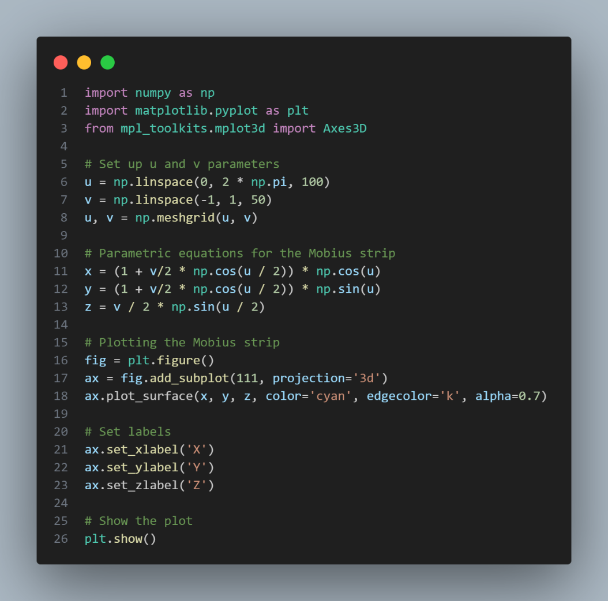

**Explanation:**

* The **u** and **v** parameters are used to generate a meshgrid, which allows us to compute the 3D coordinates for each point on the Möbius strip.
* The **plot_surface** function is used to render the 3D surface.

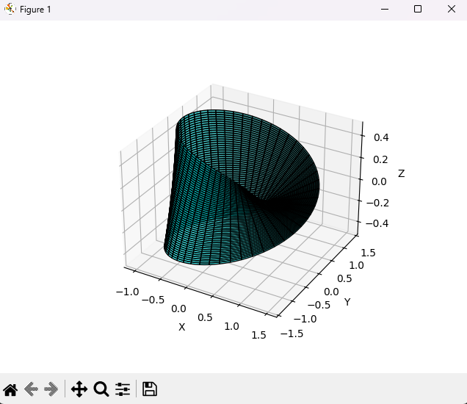

1. **Adding Interactivity to the Visualization**

To make the Möbius strip visualization more interactive, I’ll use **Plotly**, a Python library for creating interactive plots. This will allow us to zoom, rotate, and explore the Möbius strip in real-time.  
  
**a) Installing Plotly**

First, install the **plotly** library:

pip install plotly

**b) Creating an Interactive Möbius strip with Plotly**

Here’s how you can use Plotly to make the Möbius strip interactive:

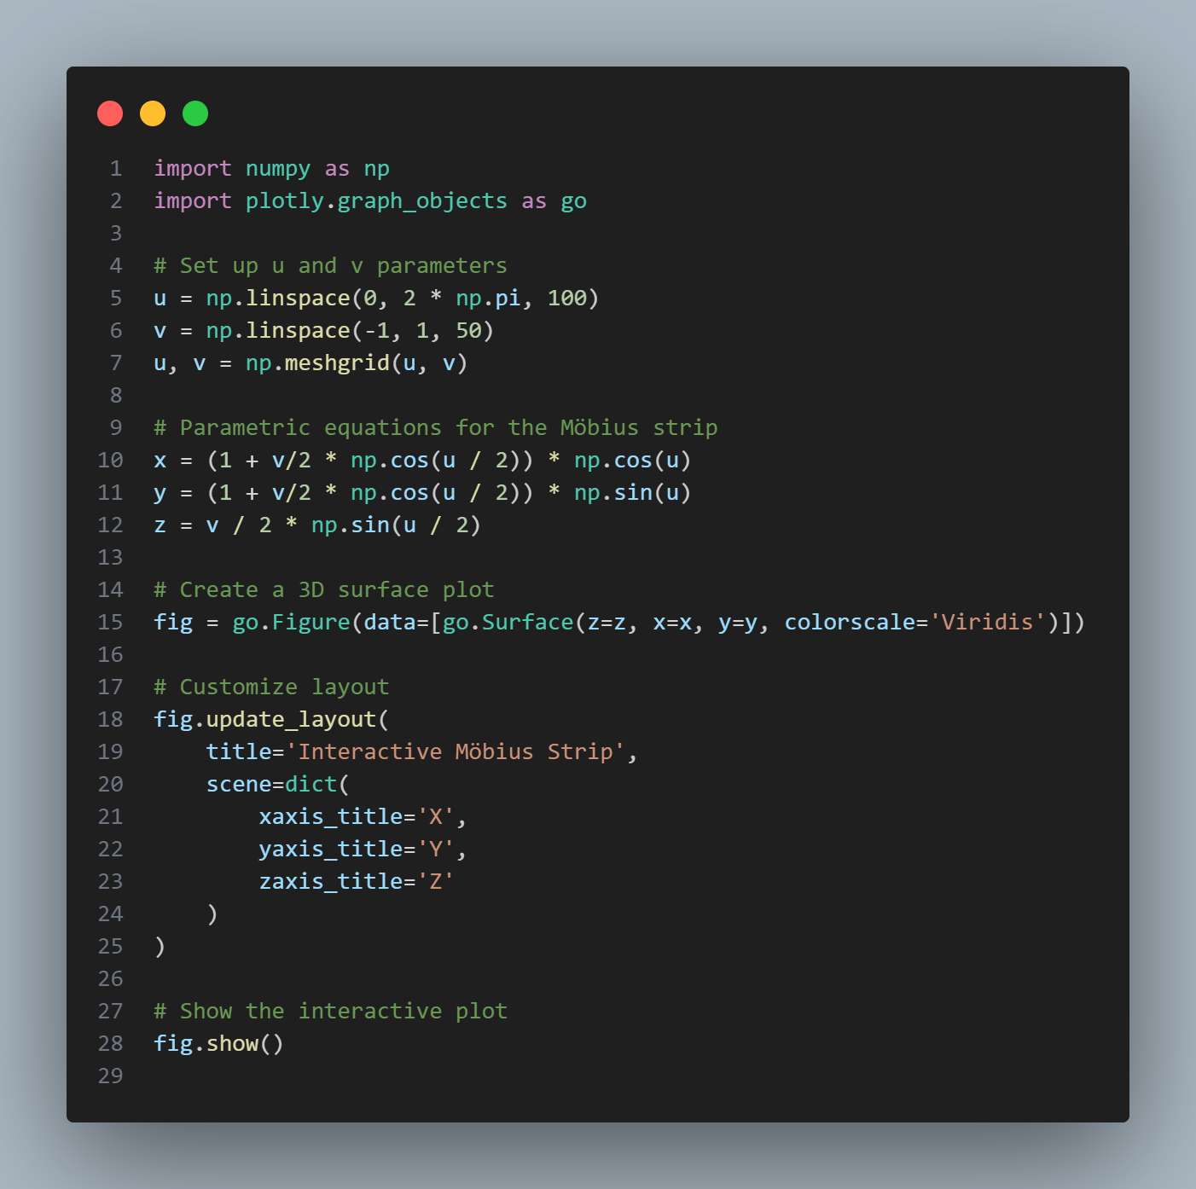

**Explanation:**

* This code uses **plotly.graph_objects** to create an interactive 3D surface plot.
* The **colorscale=’Viridis’** option adds a color gradient to the strip for better visualization.
* The result will be an interactive Möbius strip where you can rotate, zoom, and explore the surface in your browser.

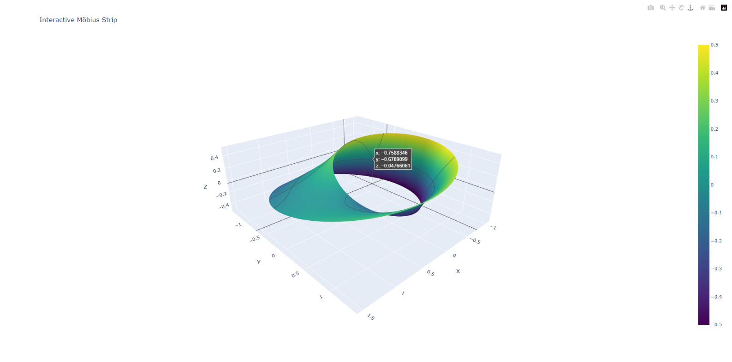

1. **Exploring Topological Properties Further**

Now that we have a solid visual representation, let’s dive into some more advanced mathematical concepts related to the Möbius strip. This will strengthen the theoretical side of the project.

1. **Homology and Topological Invariants**

We’ll start with homology. Homology helps classify spaces by identifying “holes” of different dimensions:

* **0-dimensional holes** correspond to connected components (like points or isolated shapes).
* **1-dimensional holes** correspond to loops or holes though which you can pass a string.
* **2-dimensional holes** correspond to voids in the surface, like the inside of a sphere.

The Möbius strip has a **non-trivial 1st homology group** because it has a “twist” and is non-orientable, which creates an interesting topological structure.

1. **Euler Characteristic**

As we discussed earlier, the Euler characteristic **ꭓ**  for the Möbius strip is 0. This can be shown by triangulating the surface and applying the formula:

$$ꭓ=V-E+F$$

Let’s try a simple example of computing the Euler characteristic for a triangulated surface (not specifically for a Möbius strip but for any surface):

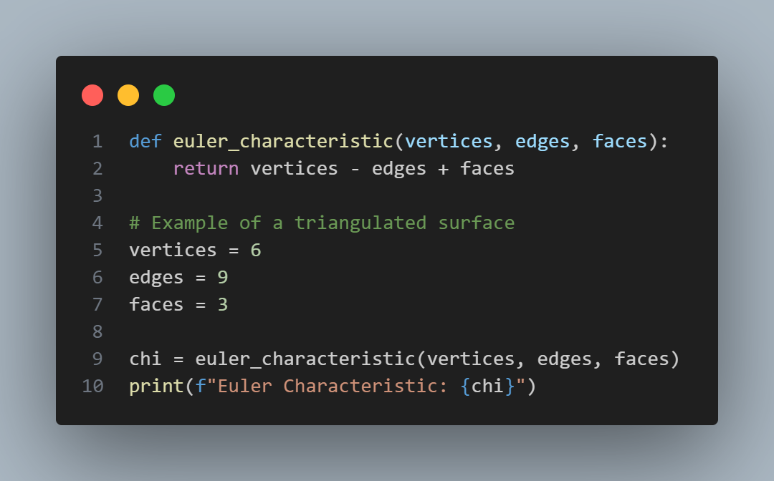

1. **Advanced Topology: Fundamental Group and Covering Spaces**

**Fundamental Group:**

* The Möbius strip’s fundamental group is non-trivial due to its single twist. Consider a path that starts at a point on the strip and moves around it. After one loop, the path ends on the opposite side, creating a non-orientable surface. This feature means that any path returning to its starting point has to account for a “flip” or twist.
* Mathematically, the fundamental group of the Möbius strip is isomorphic to $Z_{2}$, meaning it has two elements: the identity (no twist) and one representing the path with a single twist. This group’s structure can distinguish between paths based on the presence of a twist, with paths that return to their starting point having an odd or even number of twists.

**Covering Spaces:**

* Covering spaces provide an alternative way to visualize the Möbius strip’s twist. If you think of the Möbius strip as a “half-twisted” loop, you can “untwist” it by creating a double cover, which takes each point on the Möbius strip to two points on a cylindrical covering space.
* You can visualize this with a cylinder that “double covers” the Möbius strip by mapping each point on the Möbius strip twice to a cylinder without a twist. This approach not only makes the Möbius strip orientable but also highlights the relationship between the Möbius strip and more conventional surfaces like cylinders.

1. **Real-World Applications in Depth**

**Conveyor Belts:**

* In conveyor systems, a Möbius strip configuration maximizes efficiency by ensuring the entire surface wears down uniformly. This is advantageous because conventional belts have two sides that wear unevenly. By adding a half-twist (as in a Möbius strip), the belt utilizes both sides of its surface, effectively doubling its lifespan.
* This configuration is particularly useful in large-scale material transport applications, where replacement or repair of conveyor belts is costly. You could explore case studies of industries like mining or agriculture, where Möbius strip conveyor belts are commonly implemented.

**Quantum Mechanics and Möbius Strips:**

* In quantum mechanics, a Möbius strip represents a non-trivial topology that can affect the state of particles. For example, particles constrained to move along a Möbius strip’s surface will have wave functions that display non-orientable characteristics. A particle’s state might “flip” when it travels around the strip, creating interference patterns unique to non-orientable surfaces.
* Möbius strips also appear in materials science, such as in the creation of thin-film Möbius structures, which can affect electrical or magnetic properties. Some molecules, particularly in organic chemistry (Möbius aromatic compounds), demonstrate similar non-orientable properties that influence their stability and reactivity.

1. **Mathematical Derivations and Extensions**

**Gaussian Curvature of the Möbius Strip:**

* The Gaussian curvature of a surface describes how it bends at each point. For a Möbius strip, the Gaussian curvature varies: at points closer to the center (the “waist”), the curvature is low, while towards the edges, it becomes higher due to the twist.
* Calculating the Gaussian curvature involves deriving the second derivatives of the parametric equations. In your project’s context, it could be insightful to approximate the curvature across several points to observe this variation.

**Intersection with Knot Theory:**

* The Möbius strip and knot theory are connected because a Möbius strip can be represented as a "knot" in three-dimensional space. This is typically done by embedding it in a way that intersects itself, creating a kind of Möbius knot. This type of structure appears in molecular chemistry, where certain molecules adopt knotted Möbius-like configurations, known as Möbius aromatics.
* You could introduce the concept of a trefoil knot as a familiar knot type that, when embedded with certain twists, resembles the Möbius strip. This connection to knot theory might also be visually represented, showing how Möbius structures transition into knotted forms in 3D space.

1. **CONCLUSION**

The Möbius strip, a deceptively simple yet deeply complex surface, exemplifies the fascinating interplay between mathematics and real-world applications. Through this project, we explored its topological uniqueness, mathematical representation, and practical relevance across multiple fields. Beginning with its non-orientable properties and culminating in the derivation of its parametric equations, our study underscores how a single twist transforms a standard loop into a surface with only one side and boundary, challenging traditional notions of geometry and orientation.

The mathematical concepts of the fundamental group, covering spaces, and Euler characteristic reveal that the Möbius strip is not only a geometric anomaly but also a valuable tool in understanding complex surfaces and spaces. These topological properties underpin its role in various real-world applications, from enhancing the durability of conveyor belts to influencing molecular structures in chemistry. Additionally, quantum mechanics and advanced material science leverage the Möbius strip’s unique geometry to create new opportunities for innovation.

Furthermore, through programming and visualization, we gained an interactive perspective on the Möbius strip, observing its behavior and twist in three-dimensional space. Such visualizations not only aid in theoretical exploration but also serve as powerful educational tools, bridging abstract mathematical concepts with tangible experiences. The Möbius strip’s intersections with knot theory and Gaussian curvature further emphasize its versatility, providing avenues for future research in both theoretical and applied mathematics.

In conclusion, the Möbius strip is more than a mathematical curiosity—it is a profound symbol of how geometry and topology intersect with the physical world. This project highlights that even the most elementary surfaces can unlock deep insights, fostering a better understanding of non-orientable structures, symmetry, and the role of geometry in the sciences. The Möbius strip invites us to reconsider our assumptions about dimensionality, challenging us to look beyond the ordinary to appreciate the extraordinary patterns that exist in both mathematics and nature.