1. **Outcome of Applying Machine Learning**
2. **A brief of overview of AI:**

Artificial intelligence is powering more and more of the devices we interact with every day. It is also playing a growing scheme in how societies under grinding resources-energy, food, and water.

AI is not a discrete technology, but rather a powerful method with widely applicable data science tools, which include machine learning, pattern recognition, and natural language processing. These tools can squeeze far more useful information out of data, and more quickly than humans could reasonably do on their own.

1. **Supply and Demand:**

Homes and businesses account for nearly 40 percent of U.S. energy consumption, which is why so much effort has been made to boost the efficiencies of buildings. Google’s subsidiary DeepMind, based in London, applies AI to control fans and cooling system for its data centers, reducing the amount of energy needed to manage the indoor temperature.

Commercial buildings, such as offices, hotels, or factories, can also be major energy hogs. A six-year-old Silicon Valley startup called Verdigris integrates its sensor into heating and cooling system, manufacturing equipment, and washing machines and uses machine learning to remotely identify faulty, inefficient equipment.

At the macro level of the power grid, a great deal of energy is wasted because of mismatched supply and demand. Energy providers and utilities have offered various schemes designed to help bring those factors into balance, such as the of the demand-response program, in which consumer opt in to reduce consumption during heat waves or other periods when prices spike and utilities fire up more power plants.

To refine the process by which utilities predict demand, a startup called Drift is turning to data science. The Seattle-based company uses machine learning to analyze a host of unconventional and data network data- such as internet search activity, the condition of energy infrastructure, and even business hours- to improve demand forecasts.

Drift then buy powers from producers like hydroelectric plants or from large energy consumers, such as businesses that agree to reduce consumption during low-demand periods. The company sells that power at a rate that follows it compete with energy incumbents.

1. **Optimizing Supply:**

When it comes to producing energy, AI is being used to squeeze efficiencies out of solar plants, as well as wind farms and even oil wells. General Electric makes many of the parts our energy infrastructure, from massive wind turbine to gas-powered turbines used in more conventional power plants. The company has spent years developing software, called Predix, that can interpret sensor data from that equipment and uses artificial intelligence to make its machines both operate more efficiently

Wind Power is booming in the recent century. Every few seconds, almost every one of the hundreds of turbines records the windspeed and its own power output. By applying machine learning, the wind power forecasts of unprecedented accuracy that are making it possible for many utilities company to use far more renewable energy, at lower cost, than utilities than ever.

Before the forecasts were developed, Xcel Energy only output 10 percent of renewable energy. But thanks in large part to the improved forecasts, it has produced more wind power than any other U.S. utility and supports a mandate for utilities to get 30 percent of their energy from renewable sources.

In fact, by applying machine learning, Xcel was confident enough in wind power to shut down many of the idling backup plants. For example, on nice days with steady wind flow, Xcel might shut down all the backup plants. The company now can use the wind farms themselves to ensure that power supply matches demand. Interestingly, the output of wind turbine can be changed almost instantly by angling the blades, so they capture wind. Computers tell wind farms how much power to produce, and automated controls coordinate hundreds of turbines, changing output minute by minute if needed.

1. **Data Analysis:**

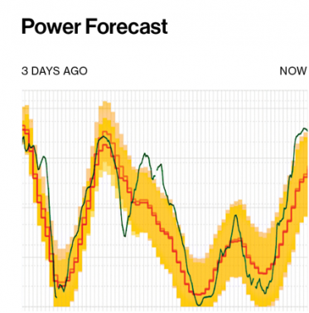

Here is the graph from Xcel Company. Actual power output is overlaid on a three-day wind power forecast (red line). The larger the yellow shaded are, the more uncertain the forecast.

1. **Future Prediction:**
2. **Gas Prices Reduction:**

The energy sector has probably undergone more rapid change in the last ten years the in the previous fifty. In a matter of a decade, gas production in the US increased by more than factor of ten, taking US gas imports to their lowest level since the early 80s.

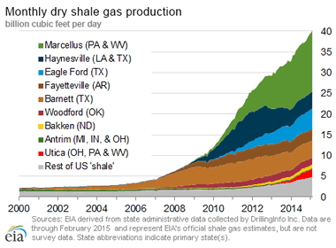

1. **A global carbon price will be established:**

By the mid-2020s, the Canadian-Californian schemes had begun negotiations for inclusion, making a way for a global carbon price by 2030. This means that there is one price, applicable all over the world, for the right to emit a ton of CO2 into the atmosphere-providing a simple and powerful incentive to make the switch to clean energy.

**Work Cited:**

* [1] Bullis, Kevin. “Smart Wind and Solar Power.” Page 1-15. November 12 2016.Web. < <https://www.technologyreview.com/s/526541/smart-wind-and-solar-power/>>
* [2]Todd, Jaquith. “How Future Energy Will Change Our Lives.” January 9, 2017. Web. <https://futurism.com/predicting-2017-how-future-energy-will-change-our-lives/>
* [3]Statoil, Boye. “Why The World Isn’t Ready For Renewable Energy”. Jan 21, 2015. Web. <https://www.forbes.com/sites/statoil/2015/01/21/why-the-world-isnt-ready-for-renewable-energy-and-how-we-can-be/#37abe438687e>
* [4]O’Connor, Mary. “How Artificial Intelligence Is Making Energy Smarter and Cleaner”. July 18 2016. Web. <https://medium.com/s/ai-for-good/how-artificial-intelligence-is-making-energy-smarter-and-cleaner-75688867f25e>
* [5]Burston, Jane. “Predictions For Energy In 2030”. Nov 10 2016. Web. <https://www.weforum.org/agenda/2016/11/5-predictions-for-energy-in-2030/>