工业化的兴起导致了对能源的大量需求，化石能源的枯竭以及环境污染促进了新能源的崛起[2,3]。然而，大多数可再生能源，如太阳能和风能，本质上是间歇性的，依靠自然现象来发电，能源存储便成为新的需求 [4-10]。可充电锂离子电池作为一种储能技术，由于拥有更高的能量密度，更小的体积、更长的寿命、更大的容量等优点，作为储能的最佳选择，已经得到了广泛应用[11,12]。但同时锂电池的老化也带来了包括电动汽车的续航减少、动力不足、电池爆炸等问题，如图1所示。如果能在电池老化之前对电池寿命进行预测的话，在避免上述问题的同时还可以为电池生产、使用和优化带来新的机遇[15]。例如，制造商可以加快电池单元开发周期，对电池进行分级，快速验证新的工艺等。同样，终端用户可以估计他们的电池寿命[16-18]。此外，电池预测能够使在电池完全老化之前进行二次回收。总之，对电池当前和未来状态的准确预测将为电池的制造、使用和优化带来巨大的机会【19、20、21】。

目前的电池寿命估计所采用的模型主要可以分为以下三种，等效电路模型(ecm)[22-23]、电化学模型[24-26]或数据驱动模型[27-32]。电化学模型和等效电路模型的准确性和鲁棒性有限，因此这两种模型并不是一个很好的可行解决方案。相反，数据驱动的方法有着不需要了解电池内部的复杂化学反应，没有复杂的建立电路的过程等优势被研究者广泛应用。随着近几年的研究展开，发现了电池数据集中带有噪声是不可避免的，这主要源于充放电过程中的环境干扰，如温度变化、湿度波动的影响。此外实验条件并不能完全模拟现实，因此，越来越多的研究开始关注带有噪声的电池寿命预测。

线性参数估计问题出现在信号处理等广泛的科学学科中[33-34]。如[35]和[36]所示，在所有感兴趣的变量都具有参数线性关系且所有测量值都受到噪声污染的情况下，总最小二乘法是参数估计的最佳选择。

但实际情况中电池厂商提供的电池信息数据集来源不同，故由于温度、人为干扰以及传感器等造成的误差大不相同，此时便不能简单的假设数据集的噪声服从同一个分布。此时直接使用TLS/OLS并不能很好的建立电池寿命预测模型，故本文在建立线性模型计算电池的寿命时进行改进，对带有不同噪声分布的电池样本进行加权之后，使用TLS/OLS进行预测，经循环迭代能够准确的计算出噪声分布的标准差的同时建立适应不同噪声分布的预测模型对电池寿命进行预测，预测结果显示我们的方法比传统的TLS/OLS方法更好。

本文使用三个基于商用锂离子电池的公共数据集，三个数据集分别称为“数据集1”、“数据集2”和“数据集3”，分别由41个、43个和40个样本组成，虽然这些数据集总共提取了20个特征，但我们进一步根据领域专业知识手动选择3个重要特征的子集，具体含义table1）

实验将三个数据集按照9:1划分之后合并作为训练集和测试集，每次实验随机打乱样本顺序，每次运行均独立随机生成训练和测试数据集。为每种方法报告1000个RMSE值的中位数，以便误差度量不会因随机波动而产生强烈偏差。

实验结果如图3所示，我们设置了四种不同的噪声比例模式，图a,b,c,d是噪声水平增大的实验结果：（1）随着噪声增大，TLS和OLS效果明显变差，而改进的算法受噪声水平的影响不明显，具有较强的稳定性。（2）结合EM思想改进的算法（TLS_EM、OLS_EM）比传统算法（TLS、OLS）效果更佳,说明了改进的算法更能适应带有噪声的电池数据集。（3）TLS_EM效果优于OLS_EM，（TLS效果也优于OLS），在所有测量值都收到噪声污染的情况下，TLS比LS有更大的优势。

图e,f,g,h是训练集比例增大的实验结果：（1）随着训练集占比增大，四种方法效果更好，有了更多的训练数据，模型预测能力提升。（2）不论训练集比例大小，改进的算法优于传统算法，说明了融入EM思想的算法有效性 。（3） 在绝大部分情况下（训练集占比大于25%）TLS_EM效果优于OLS_EM，说明了TLS_EM比OLS_EM适用性更强。

图4展示了算法经过循环迭代噪声收敛过程：算法通过TLS/OLS拟合样本数据得到模型系数 $w$ 和 $b$，根据模型系数 $w$ 和 $b$ 对样本数据进行预测得到新一轮的电池寿命预测值，将预测值和真实值对比得到新一轮的误差，由此求出标准差对样本数据加权后通过TLS/OLS求出下一轮的模型系数 $w$ 和 $b$，进行循环迭代，收敛得到真实模型系数。

本文在建立线性模型计算电池的寿命时进行改进，对带有不同噪声分布的电池样本进行加权之后，使用TLS/OLS进行预测，经循环迭代能够在准确的计算出噪声分布的标准差的同时建立适应不同噪声分布的预测模型，进而对电池寿命进行预测。预测结果显示我们的方法有着更好的效果。

The rise of industrialization led to a large demand for energy, and the depletion of fossil energy and environmental pollution promoted the rise of new energy [2,3]. However, most renewable energy sources, such as solar and wind, are intermittent in nature and rely on natural phenomena to generate electricity, and energy storage becomes a new demand [4-10]. As an energy storage technology, rechargeable lithium-ion battery has been widely used as the best choice for energy storage due to its advantages of higher energy density, smaller volume, longer life and larger capacity [11,12]. However, at the same time, the aging of lithium batteries also brings problems including the reduction of battery life of electric vehicles, insufficient power, and battery explosion, as shown in Figure 1. If the battery life can be predicted before the battery is aged, it can also bring new opportunities for battery production, use and optimization while avoiding the above problems[15]. For example, manufacturers can speed up cell development cycles, grade batteries, and quickly validate new processes. Similarly, end users can estimate their battery life [16-18]. In addition, battery prediction enables secondary recycling before the battery is fully aged. In conclusion, accurate prediction of the current and future state of batteries will open up huge opportunities for the manufacture, use and optimization of batteries[19,21].

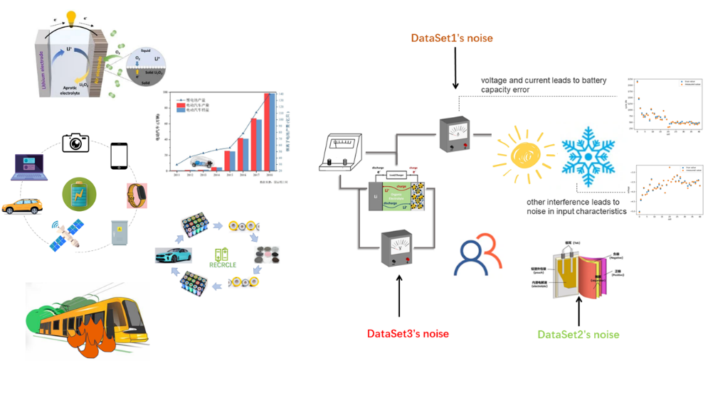

Figure1: Lithium battery applications and hidden dangers

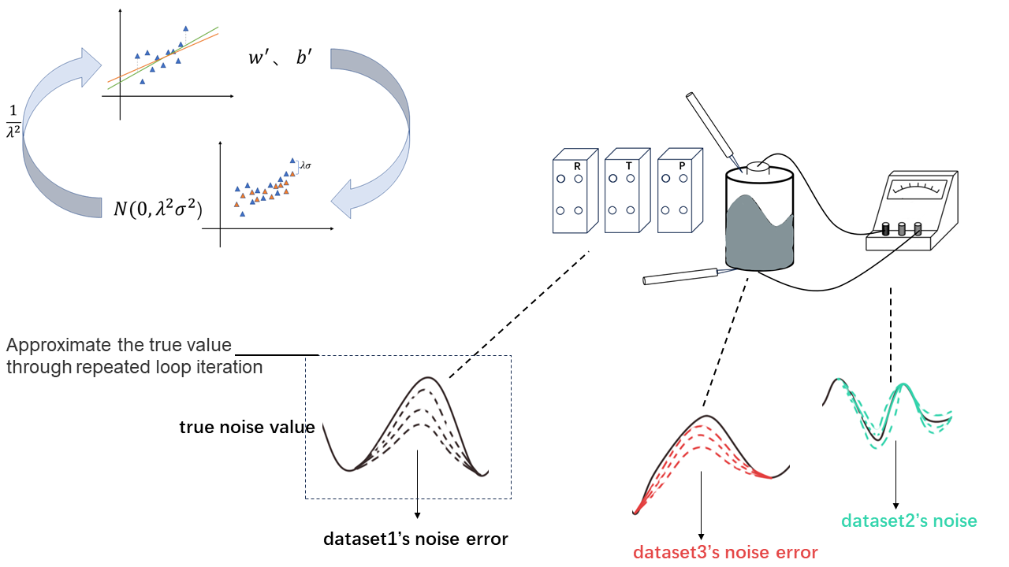

Figure 2: Improved TLS/OLS algorithm

The current models used for battery life estimation can be mainly divided into the following three types: equivalent circuit model (ecm)[22-23], electrochemical model [24-26] or data-driven model [27-32]. The accuracy and robustness of the electrochemical model and the equivalent circuit model are limited, so these two models are not a good viable solution. In contrast, the data-driven approach has the advantage of not needing to understand the complex chemical reactions inside the battery, and there is no complicated process of building the circuit, which is widely used by researchers. With the development of the research in recent years, it is found that the noise in the battery data set is inevitable, which is mainly due to the environmental interference during the charging and discharging process, such as temperature change and humidity fluctuation. In addition, experimental conditions do not fully simulate reality, so more and more research has begun to focus on the prediction of battery life with noise.

Linear parameter estimation problems arise in a wide range of scientific disciplines such as signal processing [33-34]. As shown in [35] and [36], total least squares is the best choice for parameter estimation when all variables of interest have parametric linear relationships and all measurements are noise polluted.

However, in the actual situation, the battery information data set provided by the battery manufacturer comes from different sources, so the errors caused by temperature, human interference and sensors are very different, so it is not simple to assume that the noise of the data set follows the same distribution. At this time, TLS/OLS cannot be used directly to establish a good battery life prediction model, so this paper makes improvements when establishing a linear model to calculate the battery life. After weighted battery samples with different noise distributions, TLS/OLS is used for prediction. The standard deviation of noise distribution can be accurately calculated by cyclic iteration, and the prediction model adapted to different noise distribution can be established to predict the battery life. The prediction results show that our method is better than the traditional TLS/OLS method.

When dataset samples obey noise of different distributions, $y_{i}=X_{i}w+ϵ_{i}$, we can know that our goal is to minimize the error when the samples obey different noises：

$\min{\sum_{i}{{\left(y_{i}-X_{i}w\right)}^{2}}}$,

To solve this problem, we give each sample a different weight:

$\min{\sum_{i}{α_{i}{\left(y_{i}-X_{i}w\right)}^{2}}}$,

Assuming that the noise obeys a Gaussian distribution with zero mean and different variances: $ϵ_{i}\sim N\left(0, λ_{i}^{2}σ^{2}\right)$, then $y_{i}$ obeys a Gaussian distribution $y_{i}\sim N\left(X_{i}w, λ^{2}σ^{2}\right)$. The likelihood function is:

$l\left(w\right)=\prod_{i}{p\left(y_{i}|w\right)}=\prod_{i}{\frac{1}{\sqrt{2π}λ_{i}σ}\exp\left[-\frac{{\left(y_{i}-X_{i}w\right)}^{2}}{2{λ_{i}^{2}σ}^{2}}\right]}$,

Maximizing the likelihood function is equivalent to minimizing the objective function $\sum_{i}{\frac{1}{λ_{i}^{2}}{\left(y_{i}-X_{i}w\right)}^{2}}$, and we can get $α_{i}=\frac{1}{λ_{i}^{2}}$ by comparison.

EM algorithm can solve the problem with hidden variables well. In this paper, we assume that the standard deviation of noise obeys the distribution as hidden variables, and improve the traditional OLS/TLS algorithm. The specific steps are as follows:

1. Initialize model coefficients w,b

2. Predict the battery life according to the model coefficient, and calculate the error between the predicted value and the real value to update the noise standard deviation of the three data sets.

1 , ()

3. The samples are weighted according to the formula, and a new round of model coefficients are obtained by using TLS/OLS.

4. Repeat steps 2 and 3 until convergence.

In this paper, three public datasets based on commercial lithium-ion batteries, called "Dataset 1", "Dataset 2" and "Dataset 3", are composed of 41, 43 and 40 samples, respectively. Although these datasets extract a total of 20 features, we further manually select subsets of 3 important features based on domain expertise. In table1. The experiment divides the three data sets according to 9:1 and combines them as a training set and a test set. Each experiment randomly disrupts the sample order, and each run generates training and test data sets independently and randomly. A median of 1,000 RMSE values is reported for each method so that the error measure is not strongly biased by random fluctuations.

The experimental results are shown in FIG. 3, in which we set four different noise ratio modes. FIG. a, b, c, and d show the experimental results with the increase of noise level: 1) With the increase of noise, the effects of TLS and OLS become significantly worse, while the improved algorithm is not significantly affected by noise level and has strong stability. 2) The improved algorithms TLS_EM and OLS_EM combined with EM idea have better effects than the traditional algorithms TLS and OLS, indicating that the improved algorithm is more suitable for the battery data set with noise. 3) The effect of TLS_EM is better than that of OLS_EM, and the effect of TLS is also better than that of OLS). In the case that all the measured values receive noise pollution, TLS has greater advantages than LS. Figure e, f, g, and h show the experimental results of increasing the proportion of training set: 1) With the increase of the proportion of training set, the effect of the four methods is better, with more training data, the model prediction ability is improved. 2) Regardless of the proportion of training set, the improved algorithm is superior to the traditional algorithm, indicating the effectiveness of the algorithm integrated with EM thought. 3) In most cases, the proportion of training set is greater than 25%) TLS_EM has better effect than OLS_EM, indicating that TLS_EM is more applicable than OLS_EM.

Figure 4 shows the iterative noise convergence process of the algorithm: The algorithm uses TLS/OLS to fit the sample data to get model coefficients w and b, and predicts the sample data according to the model coefficients w and b to get a new round of predicted battery life value, compares the predicted value with the real value to get a new round of error, and then calculates the standard deviation to weight the sample data, and then calculates the next round of model coefficients w and b through TLS/OLS. The real model coefficients are obtained by circular iteration and convergence.

In this paper, the linear model was established to calculate the battery life. After the battery samples with different noise distributions were weighted, TLS/OLS was used for prediction. After cyclic iteration, the standard deviation of noise distribution could be accurately calculated while the prediction model adapted to different noise distributions could be established to predict the battery life. The results show that our method has better results