The industrialization revolution led to a large demand for energy, and the depletion of fossil energy and environmental pollution promoted the rise of new energy [1-3]. However, most renewable energy sources, such as solar and wind, are intermittent in nature and rely on natural phenomena to generate electricity, at which point energy storage becomes a new demand [4-10]. Due to their high density, high capacity, and long lifespan, lithium-ion batteries have become the primary energy storage device for portable electronic devices, electric vehicles (EVs), and many other applications[11,12]. However, in the use of lithium batteries, it cannot be ignored that the decline in battery performance will cause problems such as reduced battery life, insufficient power, and battery explosion, as shown in Figure1. If the battery life can be predicted before the battery aging, the above problems can be avoided, and the battery development cycle can be accelerated, new processes can be validated, and the battery can be rerecycled [13-15], which will bring major opportunities for the manufacturing, use and optimization of the battery [16-18].

At present, the models used for battery life estimation can be mainly divided into equivalent circuit model (ecm)[19-20], electrochemical model [21-23] and data-driven model [24-29]. The accuracy and robustness of the electrochemical model and the equivalent circuit model are limited, so these two models are not a good viable solution. In contrast, data-driven models do not need to understand the complex chemical reactions inside the battery, there is no complex process to build the circuit and other advantages are widely used by researchers. At the same time, with the development of research in recent years, it is found that the noise in the battery data set is inevitable, which is mainly due to the environmental interference during the charging and discharging process, such as temperature change and humidity fluctuation. In addition, experimental conditions do not fully simulate reality, so more and more research has begun to focus on the prediction of battery life with noise.

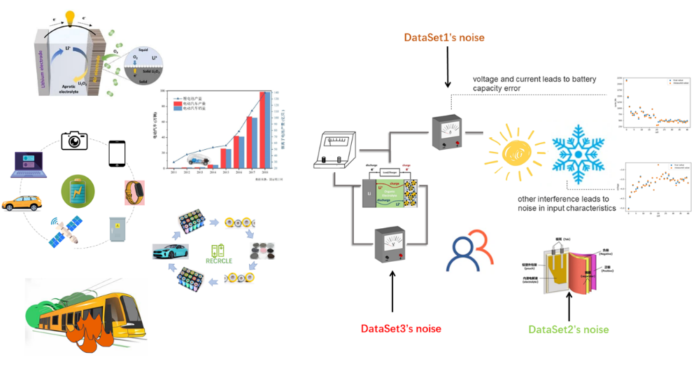

Figure1: Lithium battery applications and hidden dangers

Linear parameter estimation problems arise in a wide range of scientific disciplines such as signal processing [30-31]. As shown in [32] and [33], total least squares is the best choice for parameter estimation when all variables of interest have parametric linear relationships and all measurements are noise polluted.

However, in the actual situation, the battery information data sets provided by battery manufacturers come from different sources, so the errors caused by temperature, human interference and sensors are very different. At this time, it is impossible to simply assume that the noise of the data sets obey the same distribution, and the direct use of TLS/OLS cannot establish a good battery life prediction model. Therefore, this paper made improvements in the establishment of a linear model to calculate battery life. After weighted battery samples with different noise distributions, TLS/OLS was used for prediction. The standard deviation of noise distribution could be accurately calculated through cyclic iteration, and a prediction model adapted to different noise distributions was established to predict battery life. The prediction results show that our method is better than the traditional TLS/OLS method.

[1] Renewable energy technologies in Pakistan: Prospects and challenges

[2] Mirza UK, Ahmad N, Majeed T, Harijan K. Wind energy development in Pakistan. Renewable and Sustainable Energy Reviews 2007;11(9): 2179–90.

[3] Tiwari, GN, Ghosal, MK. Renewable Energy Resources: Basic Principles and Applications. Alpha Science Int’l Ltd., 2005. ISBN 1-84265-125-0

[4] B. Obama, Science 2017, DOI: 10.1126/science.aam6284.

[5]Porous Carbon Composites for Next Generation Rechargeable Lithium Batteries

[6] P. Poizot, S. Laruelle, S. Grugeon, L. Dupont, J. M. Tarascon, Nature 2000, 407, 496.

[7] B. Dunn, H. Kamath, J. M. Tarascon, Science 2011, 334, 928.

Recent progress of magnetic field application in lithium-based batteries

[8] Raza MQ, Khosravi A. A review on artificial intelligence based load demand forecasting techniques for smart grid and buildings. Renew Sustain Energy Rev 2015;50:1352e72.

[9] Xu J, Zhang R. CoMP meets smart grid: a new communication and energy cooperation paradigm. IEEE Trans Veh Technol 2013;64(6):2476e88.

[10]An energy matching method for battery electric vehicle and hydrogen fuel cell vehicle based on source energy consumption rate

[11] Wang G, Xu Z, Wen F, et al Traffic-constrained multiobjective planning of electric-vehicle charging stations.IEEE Trans Power Deliv 2013;28(4):2363e72.

[12] Hu J, Zheng L, Jia M, et al Optimization and model validation of operation control strategies for a novel dual-motor coupling-propulsion pure electric vehicle. Energies 2018;11.

[13]. Peterson, S. B., Apt, J. & Whitacre, J. F. Lithium-ion battery cell degradation resulting from realistic vehicle and vehicle-to-grid utilization. J. Power Sources 195, 2385–2392 (2010).

[14]. Ramadesigan, V. et al Modeling and simulation of lithium-ion batteries from a systems engineering perspective. J. Electrochem. Soc. 159, R31–R45 (2012).

[15]. Waag, W., Fleischer, C. & Sauer, D. U. Critical review of the methods for monitoring of lithium-ion batteries in electric and hybrid vehicles. J. Power Sources 258, 321–339 (2014)

[16].Identifying degradation patterns of lithium ion batteries from impedance spectroscopy using machine learning

[17] Severson, K. A. et al Data-driven prediction of battery cycle life before capacity degradation. Nat. Energy 4, 383–391 (2019).

[18]. Nuhic, A., Terzimehic, T., Soczka-Guth, T., Buchholz, M. & Dietmayer K. Health diagnosis and remaining useful life prognostics of lithium-ion batteries using datadriven methods. J. Power Sources 239, 680–688 (2013).

[19] Tianheng Feng, Lin Yang, Xiaowei Zhao, Huidong Zhang, and Jiaxi Qiang. Online identification of lithium-ion battery parameters based on an improved equivalent-circuit model and its implementation on battery state-of-power prediction. Journal of Power Sources, 281:192–203, 2015.

[20] D Andre, M Meiler, K Steiner, H Walz, T Soczka-Guth, and DU Sauer. Characterization of high-power lithium-ion batteries by electrochemical impedance spectroscopy. ii: Modelling. Journal of Power Sources, 196(12):5349–5356, 2011.

[21] Matthew J Daigle and Chetan Shrikant Kulkarni. Electrochemistry-based battery modeling for prognostics. 2013.

[22] Brian Bole, Chetan S Kulkarni, and Matthew Daigle. Adaptation of an electrochemistry-based li-ion battery model to account for deterioration observed under randomized use. Technical report, SGT, Inc. Moffett Field United States, 2014.

[23] Githin K Prasad and Christopher D Rahn. Model based identification of aging parameters in lithium ion batteries.

Journal of power sources, 232:79–85, 2013.

[24] Kristen A Severson, Peter M Attia, Norman Jin, Nicholas Perkins, Benben Jiang, Zi Yang, Michael H Chen, Muratahan Aykol, Patrick K Herring, Dimitrios Fraggedakis, et al Data-driven prediction of battery cycle life before capacity degradation. Nature Energy, 4(5):383, 2019.

[25] Bhaskar Saha, Kai Goebel, Scott Poll, and Jon Christophersen. Prognostics methods for battery health monitoring using a bayesian framework. IEEE Transactions on instrumentation and measurement, 58(2):291–296, 2008.

[26] Kai Goebel, Bhaskar Saha, Abhinav Saxena, Jose R Celaya, and Jon P Christophersen. Prognostics in battery health management. IEEE instrumentation & measurement magazine, 11(4):33–40, 2008.

[27] Xiaosong Hu, Jiuchun Jiang, Dongpu Cao, and Bo Egardt. Battery health prognosis for electric vehicles using sample entropy and sparse bayesian predictive modeling. IEEE Transactions on Industrial Electronics, 63(4):2645– 2656, 2015.

[28] Verena Klass, Mårten Behm, and Göran Lindbergh. A support vector machine-based state-of-health estimation method for lithium-ion batteries under electric vehicle operation. Journal of Power Sources, 270:262–272, 2014

[29] Peter M Attia, Aditya Grover, Norman Jin, Kristen A Severson, Todor M Markov, Yang-Hung Liao, Michael H Chen, Bryan Cheong, Nicholas Perkins, Zi Yang, et al Closed-loop optimization of fast-charging protocols for batteries with machine learning. Nature, 578(7795):397–402, 2020.

[30]Detection of Abrupt Changes of Total Least Squares Models and Application in Fault Detection

[31] S. Van Huffel, “Tls applications in biomedical signal processing,” in Recent Advances in Total Least Squares Techniques and Error-in-Variables Modeling, S. Van Huffel, Ed. Philadelphia, PA: SIAM, 1997

[32] S. Van Huffel and J. Vandewalle, Frontiers in Applied Mathematics: The Total Least Squares Problem—Computational Aspects and Analysis. Philadelphia, PA: SIAM, 1991.

[33] B. Huang, “System identification based on last principal components analysis,” in Proc. IFAC’99 World Congr., Beijing, China, July 1999, pp. 211–216.