1. Login

Sign In with Username and Password.

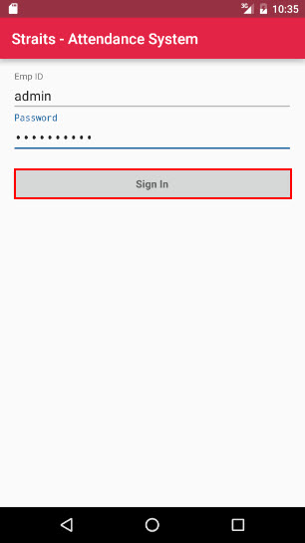

1. Calendar

Login as a admin will show the menu like this.

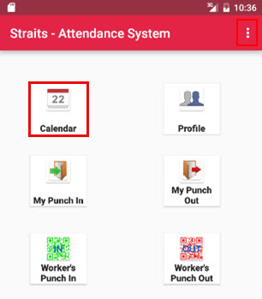

Clicking ‘Calendar’ menu will display default month calendar.

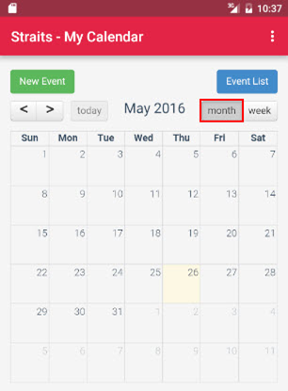

For viewing the calendar in week basis, click the ‘week’ button.

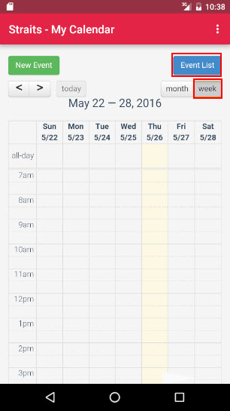

Click ‘Even List’ will show the list of events.

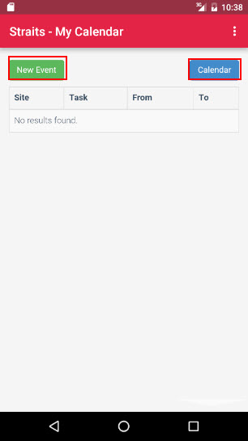

Click ‘New Event’ button to create new event. Fill the below details and click ‘Submit’ to save the details of new event.

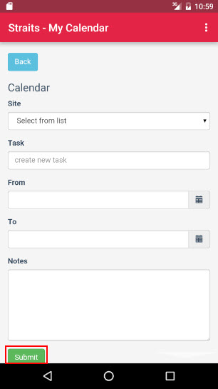

1. Profile

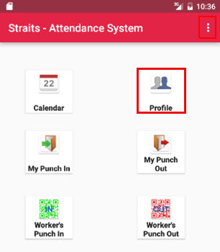

Click ‘Profile’ menu will show the user details like below image.

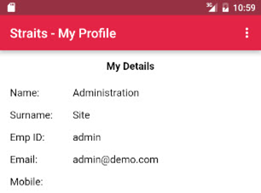

1. My Punch In

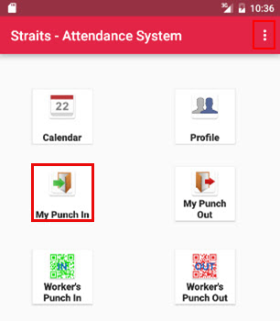

Click ‘My Punch In’ menu will show the Page like below. Here click ‘Confirm to Punch In’ button to punch in.

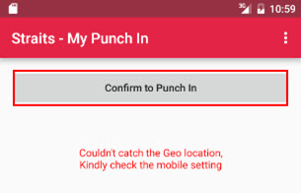

1. My Punch Out

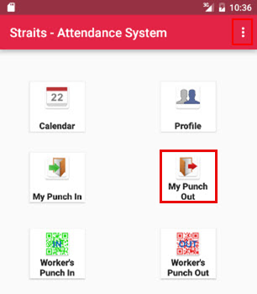

Click ‘My Punch Out’ menu will show the page like below. Here click ‘Confirm to Punch Out’ button to punch out.

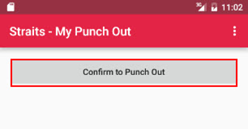

1. Worker’s Punch In

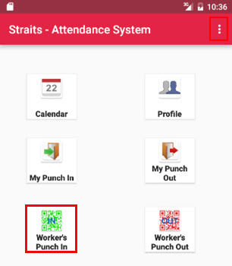

Click ‘Worker’s Punch In’ menu will show the page like below.

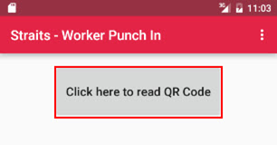

Click ‘Click here to read QR code’ to will show the page like below. Here click ‘Allow’ button in the camera to read the QR code.

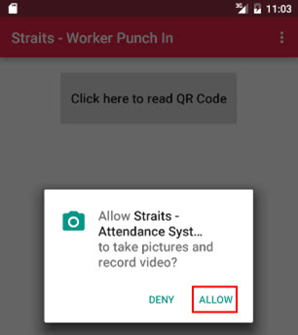

Show the mobile on the QR code to read the QR code. And Punch In will be automatically updated to the attendance.

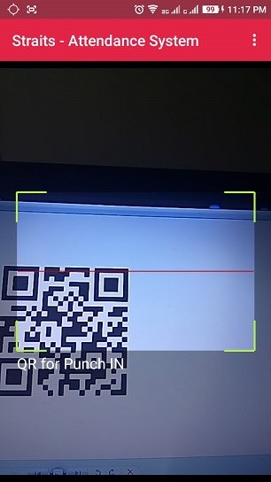

1. Worker’s Punch Out

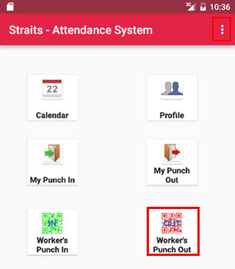

Click ‘Worker’s Punch Out’ menu will show the page like below.

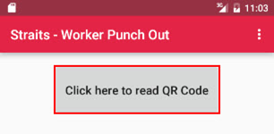

Show the mobile on the QR code to read the QR code. And Punch Out will automatically updated to the attendance.

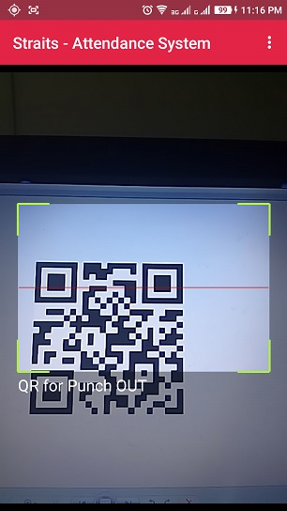

1. Sign In as a Supervisor

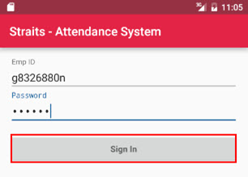

Sign In as ‘Supervisor’ will show like below. Click ‘Menu’ icon in the below image, the responsive menu display like the next image.

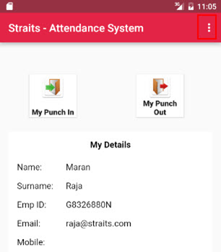

1. My Punch In

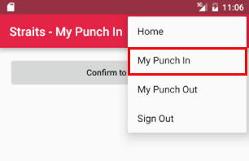

Click ‘My Punch In’ from menu will show the page like below. Here click ‘Confirm to Punch In’ button and the punch in details will be automatically updated to the attendance.



1. My Punch Out

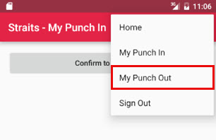

Click ‘My Punch Out’ from menu will show the page like below. Here click ‘Confirm to Punch Out’ button and the punch out details will be automatically updated to the attendance.

