N-8000 kernel – HowTo
Introduction:
During this tutorial, we will explain how to compile an Android kernel from source for the Samsung n-8000, using the default configuration. After that, we will explain how to make changes in the default configuration and compile the kernel changing some of this configurations. At last, we will introduce you to AUFS technology, and explain how to patch and compile the kernel to support it.

Compiling kernel with default Configuration:

1. Getting the source code

In order to compile a n-8000 kernel you need download the source code from samsung website:
http://opensource.samsung.com/reception/receptionSub.do?method=search&searchValue=N8000

There you will find many versions of the source codes zipped, you could download the last one, but in this document we used GT-N8000_JB_Opensource_Update3.zip

Unzip it to a folder, where inside you will find a Kernel.tar.gz file. This compressed file, containing the hole source code of the kernel. In order to work with it, we will need to create some files to place the kernel files and some other auxiliary files we may need, this is done typing the following commands in the terminal

mkdir ~/n-8000
mkdir ~/n-8000/kernel

Now copy the Kernel.tar.gz there:

cp <UNZIPPED_PATH/Kernel.tar.gz ~/n-8000/kernel/

and un-tar it
cd ~/n-8000/kernel
tar -zxvf Kernel.tar.gz

2. Getting the right gcc toolchain

We are using a x86 compatible computer, but this kernel will be running in an ARM processor, so we need to compile it for this architecture. In order to do this, we have to download a gcc toolchain to cross compile it. This can be done as follow:

- Download prebuilt gcc toolchain for cross compiling:

cd ..
git clone https://android.googlesource.com/platform/prebuilt

for more information about this toolchain, please visit the official website http://source.android.com/source/building-kernels.html

3. Configuring everything

Before we proceed, we need to configure the gcc toolchain that we just downloaded and we are going to use, and to point the makefile for what architecture it should compile.

To point out which toolchain to use, you should execute, depending the OS you are using:

- if you are using Mac OSX:

export CROSS_COMPILE=~/n-8000/prebuilt/darwin- x86/toolchain/arm-eabi-4.4.3/bin/arm-eabi-

- if using linux:

export CROSS_COMPILE=~/n-8000/prebuilt/linux-x86/toolchain/arm-eabi-4.4.3/bin/arm-eabi-

finally we need to point out the architecture to build, executing:

export ARCH=arm

now you only need to load the kernel's default configuration doing:

cd ~/n-8000/kernel
make p4notepq_00_defconfig

4. Building the kernel

Finally build it! just buy entering:

make

after some minutes, you will have your kernel in the file zImage under the path: arch/arm/boot/

5. Troubleshooting

If you experience some issues while compiling, for example some symbols and definitions couldn't be found, please try downloading the patch from
https://github.com/luckpizza/n-8000/blob/master/default_configuration/patches/recordmcount.patch
copy it to the kernel source directory

cp <PATH_OF_PATCH>/recordmcount.patch ~/n-8000/kernel/

and execute

cd ~/n-8000/kernel
patch -p1 < recordmcount.patch

This is a temporally workaround till a real patch is submitted
Changing the default configuration of the Kernel
In order to build the kernel with a custom configuration, we need to follow the steps of the section before, till item number 4. Right before executing the last make we can introduce the changes we want. As you can imagine, the linux kernel in which the android kernel is based, has a huge amount of configuration options, that's why we start from a default, preset, configuration (this configuration is loaded in step 3 of the section above, by executing make p4notepq_00_defconfig )

1. Configuring the kernel

There are many ways and tools to configure the kernel. The most basic one is opening with your favorite editor the .config file located in the root directory of the kernel source code. In that file you will see an endless list of entries starting with the prefix “CONFIG_” or “# CONFIG_” each of which represents a configuration option.
The first represents a feature enabled, and the sub-fix =m indicate that it should be compiled as a module. The second one, (the one that start with # ) represents a feature turned off. The problem of editing this file by hand, is that some configurations depend on other ones, or are related, so it may lead to some configuration errors.
In this tutorial we will use a configuration tool, provided with the kernel source for many years already, and it is call menuconfig. In order to run it, just go to the kernel root directory and run:
cd ~/n-8000/kernel
make menuconfig

it should open a window like the following:
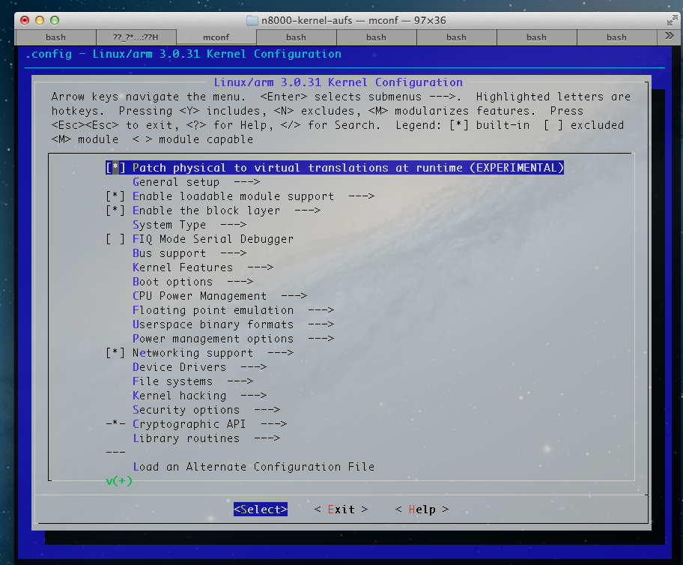
You can move through the menu options with the up and down arrows, press enter to enter a submenu (the ones with the sub-fix --->) and with the space bar you can select to include a feature, include the feature as a module (not always available) or not to include it. This is marked with the character inside the “[ ]”, with a star (*) , m or empty respectively.

TIP: If you need to find a specific configuration, you can search throw he hole menus by pressing “/” and entering the CONFIG_xxx option you are looking for in the popup window

2. Example

In this subsection, we will suppose a customer ask as to configure a kernel with some specific configuration, for example, he wants to add the following configurations:

CONFIG_GROUP_SCHED=y
CONFIG_FAIR_GROUP_SCHED=y
CONFIG_RT_GROUP_SCHED=y
CONFIG_CGROUP_SCHED=y
CONFIG_CGROUPS=y
CONFIG_CGROUP_FREEZER=y
CONFIG_CGROUP_DEVICE=y
CONFIG_CPUSETS=y
CONFIG_PROC_PID_CPUSET=y
CONFIG_CGROUP_CPUACCT=y
CONFIG_RESOURCE_COUNTERS=y
CONFIG_CGROUP_MEM_RES_CTLR=y
CONFIG_CGROUP_MEM_RES_CTLR_SWAP=y
CONFIG_MM_OWNER=y
CONFIG_NAMESPACES=y
CONFIG_UTS_NS=y
CONFIG_IPC_NS=y
CONFIG_USER_NS=y
CONFIG_PID_NS=y
CONFIG_NET_NS=y
CONFIG_NET_CLS_CGROUP=y
CONFIG_SECURITY_FILE_CAPABILITIES=y
CONFIG_DEVPTS_MULTIPLE_INSTANCES=y
CONFIG_VETH=y

one by one we should search the different configurations using the "/" shortcut and enable them with the start (“*”) symbol between the brackets. This way is easier to avoid miss-configurations by forgetting mandatory dependencies of the desired configurations.

IMPORTANT: The kernel configurations options vary a lot between releases, and it is common that some disappear, change names, or new dependencies are added. So configuring it exactly as desired may not be possible in many cases, or it is necessary to patch the kernel.

In this particular case, the following configurations were not found, and we decided to drop them:
CONFIG_CGROUP_MEM_RES_CTLR_SWAP=y
CONFIG_SECURITY_FILE_CAPABILITIES=y

when you are done with the modifications, just save it by exiting menuconfig (a popup window will ask you to save the configuration). We recommend to save old kernel configuration files in case something goes wrong.

3. Compiling
Now we just have to compile as before, executing:

make

again, after some minutes, you will have your kernel in the file zImage under the path: arch/arm/boot/

4. TroubleShooting

While compiling the kernel, we found out a compiling error, the one was:

arch/arm/mvp/commkm/check_kconfig.c:74:2: error: #error "MVP not tested with migration features other than CONFIG_MEMORY_HOTPLUG and CONFIG_COMPACTION"
make[2]: *** [arch/arm/mvp/commkm/check_kconfig.o] Error 1
make[1]: *** [arch/arm/mvp/commkm] Error 2
make: *** [arch/arm/mvp] Error 2

This can be solve changing the configuration (this is how the .config file looked before and after the fix)
From:

CONFIG_VMWARE_MVP=y
To:
# CONFIG_VMWARE_MVP is not set

after all this change, the kernel compiles correctly with all the modules

5. Already compiled kernel

You can find the compiled kernel with this options, modules and the final configuration file in their respective folders in the repository
https://github.com/luckpizza/n-8000/tree/master/alternative_configuration

Adding AUFS support to the kernel

Before we start with this section, we are going to do a brief introduction to AUFS

Whats AUFS?

AUFS is a stackable unification file system. What does this mean? That you can merge and use many directories as they where only one, keeping the physical division intact, so in fact this is only a logical union.
It supports read-only or read-write permissions, what means that if you are writing files to this unified directory, it will store the files physically in the different directories that compose this “logical” directory. This is done totally transparent, so the user actually does't know that he is writing in different places physically.

Why do I want AUFS in my system?

One useful use of this technology is, for example, if you have the disk divided in many small partitions, or you have many small disks but you need a big directory, add them all together to one logical directory and problem solve. AUFS will automatically balance where to write and will know from where to read.
Another important feature is that it supports a huge amount of branches ( directories mounted in other big directories).

Lets add it to our kernel!

1. Get the AUFS sources:

Lets go to our working directory

cd ~/n-8000/kernel

and clone the source with:

git clone git://aufs.git.sourceforge.net/gitroot/aufs/aufs3-standalone.git

cd aufs3-standalone

Now we have to checkout to the right branch, in our case the N-8000 kernel is base on linux 3.0 kernel, so we can do this by doing:

git checkout origin/aufs3.0

2. Copy necessary files

Now we have to copy the source files to add AUFS support to the kernel, this is done by coping files from
~/n-8000/aufs3-standalone/Documentation,
~/n-8000/aufs3-standalone/fs
~/n-8000/aufs3-standalone/include/linux/aufs_type.h

to the corresponding kernel folders (remember, the kernel is under ~/n-8000/kernel )

Now we should copy some patch files to the kernel root directory. We can do executing

cp aufs3-base.patch ../n8000-kernel/

cp aufs3-kbuild.patch ../n8000-kernel/

cp aufs3-proc_map.patch ../n8000-kernel/

cp aufs3-standalone.patch ../n8000-kernel/

3. Apply the patches

Now we have to apply this patches, but before, lets see what patches are.
Patches are files that summarizes the difference between two versions of files and they are mainly used to modify existing files. They explain to the patch program where to put some lines in some files, and where to delete others. This way we can modify some source code in a controlled and ordered way (a patch can be undone very easy).
In this case, the patches contain information about how to compile the new files we added in the step before, add the new configuration symbols and add some useful information needed to compile the kernel, and, in this case, the module that will give as compatibility with AUFS.
So, lets move to our kernel root directory:

cd ~/n-8000/kernel

add start patching:

patch -p1 < aufs3-base.patch

patch -p1 < aufs3-kbuild.patch

patch -p1 < aufs3-proc_map.patch

patch -p1 < aufs3-standalone.patch

4. Compile the kernel

Compiling the kernel and modules should be as easy as executing:

make

The compiled kernel should be as usual in
arch/arm/boot/zImage

and the new module should be in:
fs/aufs/aufs.ko

5. Troubleshooting

- While applying patches:

While we were applying the aufs3-kbuild.patch, we ran into the following error:

patching file fs/Makefile
Hunk #1 FAILED at 124.
1 out of 1 hunk FAILED -- saving rejects to file fs/Makefile.rej

The error appear because it was expecting a larger file that the one we downloaded with the kernel source, but the patch only tried to add at the end of the file a entry to let know the makefile how to handle a new configuration option. As a workaround we opened the fs/Makefile and add the patch my hand. To do this, we only needed to add at the end of the file the following lines:

#Patched for AUFS
obj-$(CONFIG_AUFS_FS) += aufs/

- When compiling:

While we were compiling, we ran into the next compilation error:

Building modules, stage 2.
MODPOST 4 modules
ERROR: "deny_write_access" [fs/aufs/aufs.ko] undefined!
ERROR: "do_truncate" [fs/aufs/aufs.ko] undefined!
ERROR: "do_splice_from" [fs/aufs/aufs.ko] undefined!
ERROR: "cap_file_mmap" [fs/aufs/aufs.ko] undefined!
ERROR: "lookup_hash" [fs/aufs/aufs.ko] undefined!
ERROR: "__devcgroup_inode_permission" [fs/aufs/aufs.ko] undefined!
ERROR: "do_splice_to" [fs/aufs/aufs.ko] undefined!
ERROR: "file_sb_list_del" [fs/aufs/aufs.ko] undefined!
ERROR: "inode_sb_list_lock" [fs/aufs/aufs.ko] undefined!
make[1]: *** [__modpost] Error 1
make: *** [modules] Error 2

This was because we didn't apply aufs3-standalone patch, and it is necessary. So applying this patch solved the problem (this step was already added in the above)

5. Already compiled kernel

You can find this kernel compiled with this options, modules, AUFS support and the final configuration file in their respective folders in the repository
https://github.com/luckpizza/n-8000/tree/master/aufs_configuration

6. Ready to compile kernel

Additionally, I uploaded the hole kernel source, with all the patches already applied in the following repository:
https://github.com/luckpizza/n8000-kernel-aufs
You should only configure the gcc toolchain location and the arch and it should compile with AUFS support

