|  |
| --- |
|  |

|  |
| --- |
| **Ngnms - wptest.py** |
| Low level design |
|  |
| This document describes the main running test cases functionality and program implementation. |
|  |
| **Vitalie Ghelbert - Moldova** |
| **4/15/2013** |
|  |

Contents

Main info and program options 2

Show option flow chart diagram 3

Check option flow chart diagram 4

Run option flow chart diagram 5

# Main info and program options

C:\Documents and Settings\VitalieG\git\ngnms>wptest.py -h

Usage: wptest.py [options]

Copyright 2013 Gilat

Options:

--version show program's version number and exit

-h, --help show this help message and exit

-c DEVICE, --check=DEVICE

check [hub, vsat]'s status.

-n NAME, --name=NAME vsat name to check.

-s INFO, --show=INFO show [all, hub, vsat, test]'s info.

-d, --disabled show disabled rows only.

-i INFILE, --in-file=INFILE

testcases input file [default: data/demo.xls]

-o OUTFILE, --out-file=OUTFILE

save result to file [default: data/output.xls]

-r, --run run one or [default:enabled] test cases

wptest.py - read and run test cases from excel file.

# Show option flow chart diagram

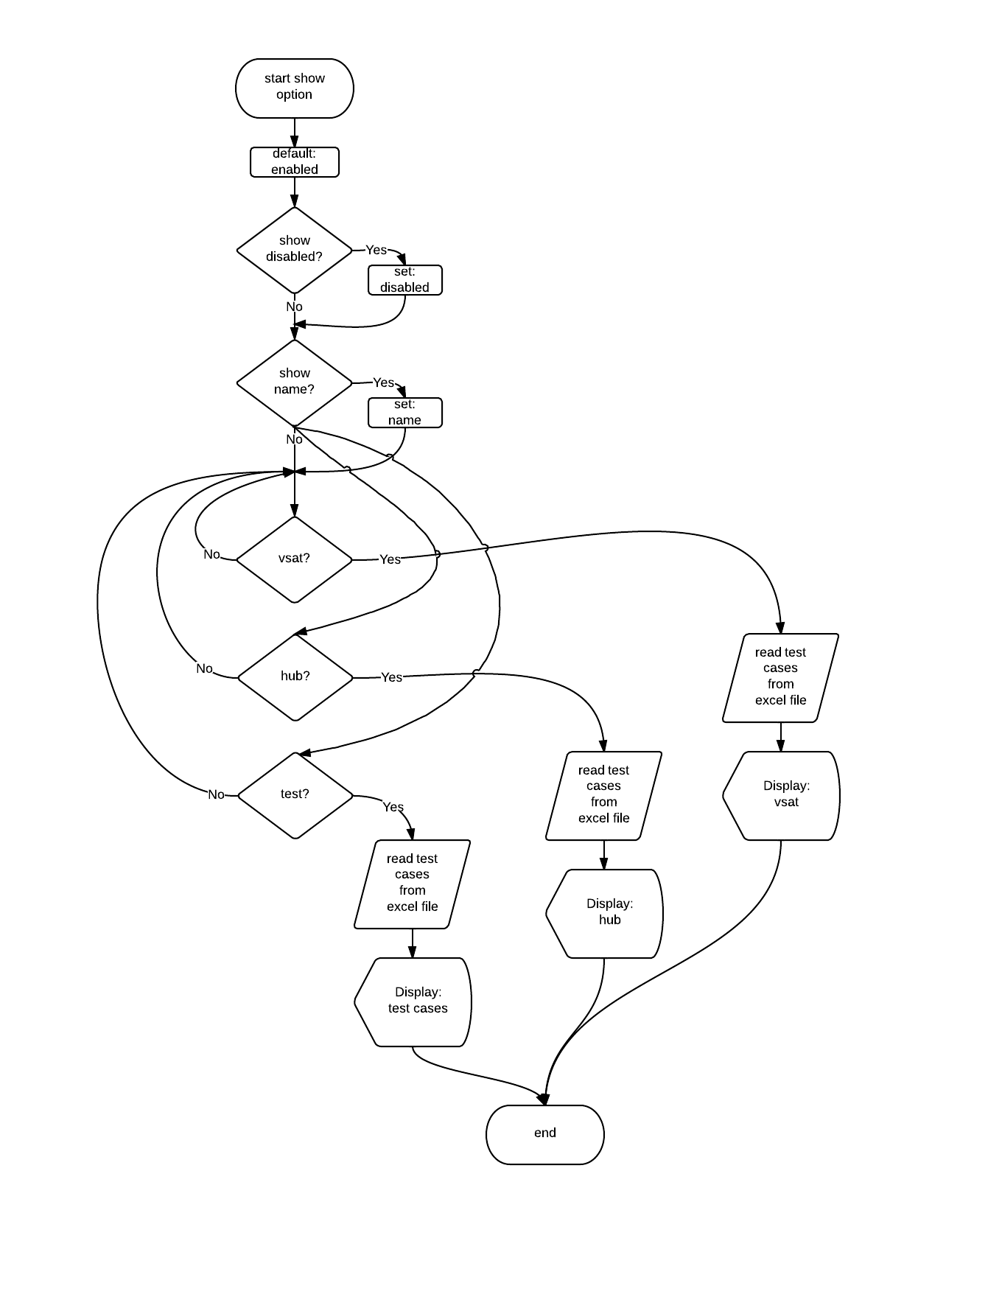

# Check option flow chart diagram

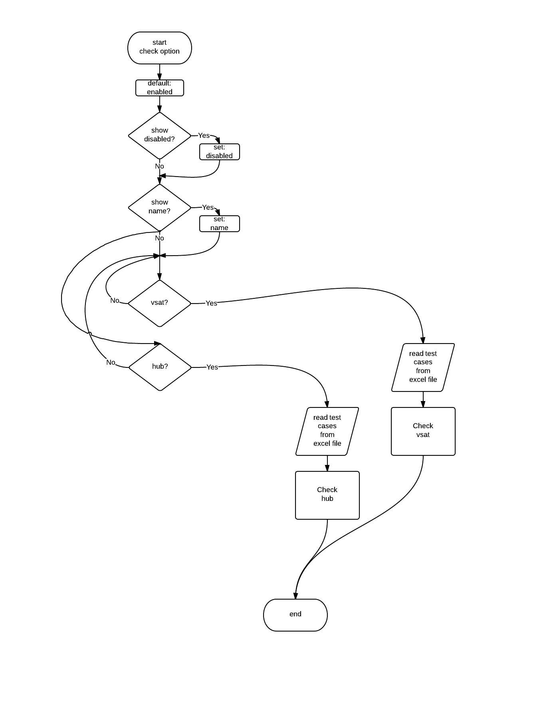

# Run option flow chart diagram

