**GLA University**

**­­**

Department of Computer Science & Application

## Institute of Engineering & Technology

**TOPIC: FULLSTACK PROJECT ON RENTAL SYSTEM**

**Submitted By** **Submitted To**

Name: Vaibhav Jain Faculty Name: Mr. Akash kumar Choudhary

Id: 201500764 (Technical Trainer)

**DECLARATION**

I hereby declare that the work which is being presented in the Bachelor of technology. Project ‘**Rental System**’, in partial fulfilment of the requirements for the award of the Bachelor of Technology in Computer Science and Engineering and submitted to the Department of Computer Engineering and Applications of GLA University, Mathura, is an authentic record of my/our own work carried under the Mentorship of Mr. Akash Kumar Choudhary, Technical Trainee, Dept. of CEA, GLA University.

The contents of this synopsis, in full or in parts, have not been submitted to any other Institute or University for the award of any degree.

**Sign: ………………**

**Name of candidate:** Vaibhav Jain

**ACKNOWLEDGEMENT**

It gives us a great sense of pleasure to present the synopsis of the B.Tech Fullstack project undertaken during B. Tech III Year. This project is going to be an acknowledgment of the inspiration, drive, and technical assistance that will be contributed to it by many individuals. I owe a special debt of gratitude to Mr. Akash kumar Choudhry, Technical Trainer, for providing me with an encouraging platform to develop this project, which thus helped me in shaping my abilities towards a constructive goal, and for his constant support and guidance to my work.

His sincerity, thoroughness, and perseverance have been a constant source of inspiration for me. I believe that he will shower me with all his extensively experienced ideas and insightful comments at different stages of the project & also will teach me about the latest industry-oriented technologies. I would like to acknowledge the contribution of all faculty members of the department for their kind guidance and cooperation.

Vaibhav Jain(201500764)

**CERTIFICATE**

This is to certify that the project entitled ‘Deal In’, carried out in Full Stack Project , is a bonafide work by Vaibhav Jain and is submitted in partial fulfilment of the requirements for the award of the degree Bachelor of Technology (Computer Science & Engineering).

**Mentor:** Mr. Akash kumar Choudhary

**INDEX**

|  |  |
| --- | --- |
| **S.NO** | **TOPIC** |
| **1** | **Introduction** |
| **2** | **System Requirements** |
| **3** | **Hardware Requirements** |
| **4** | **Front End Technologies** |
| **5** | **Back End Technologies** |
| **6** | **Idea** |
| **7** | **Module Description** |
| **8** | **Availability** |
| **9** | **Future Scope** |
| **10** | **DFD** |
| **11** | **Bibliography** |

**INTRODUCTION**

**Abstract:-**

The motivation behind this application is to provide a platform for users and rental products owners to communicate in an effective and efficient manner. The growing popularity and usage of online applications has led to a need to explore the industrial services who could tap into and enhance their services to the customers. Nowadays, there is online rental system curated for things like furniture, car, house etc. which benefits the user. A rental service is a service in which customers arrive to request the hiring of the rental unit. It is more convenient than carrying the cost of owning and maintaining the unit. In this paper we are introducing an Application – **Deal In**, which provides services like renting out day-to-day products like books, clothes, accessories, fitness gadgets, mechatronics etc. Our target audience is mainly anyone who prefers renting out products rather than buying them, they may be either localities, or non-localities or the ones who are up to date. This application aims to rent out products for duration ranging from an hour to a week or a month. It is an extended form of giving out things often organized with numerous local branches and complemented by an application allowing online reservations.

**Introduction :-**

It is an internet application which includes clothes, electronic gadgets, books and other accessories. It presents you the system for rentals or buying as a very strenuous work. With the massive expansion of Internet and e-commerce technology, Internet platform is providing a lot of services and advantages for online businesses, especially for online shopping portal. Online shopping has expanded in business more effectively and online services are collaborating with customers and other associations. For this we use an open-source board ESP 32 to create a seamless Mesh network which send, receive and propagate data collected from various sensors to all its node.

**SYSTEM REQUIREMENTS**

**Hardware Requirements :-**

The Website will smoothly run or operate on any system with –

* Processors above or equal to Intel core i3.
* Any system with Ram (4 GB or higher).
* System with any operating system.
* A web browser is needed.
* Active Internet Connection( atleast 120kbps)

**Software Requirements :-**

***Front End :-***

HTML - HTML stands for Hyper Text terminology HTML is that the standard terminology for creating sites HTML describes the structure of an internet page HTML consists of a series of elements HTML elements tell the browser the way to display the content.

CSS - CSS stands for Cascading Style Sheets CSS describes how HTML elements are to be displayed on screen, paper, or in other media CSS saves tons of labour. It can control the layout of multiple sites all directly External stylesheets are stored in CSS files.

Java Script - JavaScript is the world's most popular programming language. JavaScript is that the dominant client-side scripting language of the online. JavaScript is easy to learn. JavaScript, often abbreviated JS, may be a programing language that's one among the core technologies of the planet Wide Web, alongside HTML and CSS.

React - React is a library for building composable user interfaces. It encourages the creation of reusable UI components, which present data that changes over time. React abstracts away the DOM from you, offering a simpler programming model and better performance. React can also render on the server using Node, and it can power native apps using React Native. React implements one-way reactive data flow, which reduces the boilerplate and is easier to reason about than traditional data binding.

***Back End :-***

Node.JS - Node.js is a popular open-source, cross-platform, back-end JavaScript runtime environment. It is built on the Chrome V8 JavaScript engine and enables developers to create highly scalable and fast network applications. Node.js uses an event-driven, non-blocking I/O model that makes it ideal for building real-time applications, such as chat applications and online games. Node.js offers a vast library of pre-built modules, making it easier for developers to add functionality to their applications. Node.js is also highly flexible, as it can run on a variety of platforms, including Linux, macOS, and Windows.

Express.JS - Express.js, or just Express, may be a rear web application framework for Node.js, released as free and open-source software under the MIT License. It can be used for developing web applications and APIs. It has been called the standard server framework for Node.js. The original author, TJ Holowaychuk, described it as a Sinatra-inspired server, meaning that it is relatively minimal with features available as plugins. Express is that the back-end component of popular development.

Mongoose - Mongoose is an Object Data Modelling (ODM) library for MongoDB and Node.js and it manages relationships between data, provides schema validation, and is employed to translate between objects in code and therefore the representation of these objects in MongoDB.

***Data Base :-***

MongoDB - MongoDB is a source-available cross-platform document-oriented database program. Classified as a NoSQL database program, MongoDB uses JSON-like documents with discretionary schemas. MongoDB is originally developed by MongoDB Inc. and licensed under the Server Side Public License.

**IDEA**

As a student it never hurts to get some extra pocket money. We all have electronic devices like Bluetooth speaker, camera, clothing, etc. So the idea is that to put out these stuff and put them out for rent. Using this application people can put out their stuff which they aren’t currently using and earn some money without putting in extra effort.

**OBJECTIVE**

As the production of electronics is increasing day by day, it is increasing the pollution which is harmful for our planet and is expensive to buy as well. Not everyone is able to afford them as well. So to make this feasible this website will allow people to rent out their stuff. The device which the owner isn’t using can put it on rent and those who can’t afford to buy new electronics can take it and pay for the time period they are using.

**MODULE DESCRIPTION**

Here are some of the main modules that make up the ‘*Deal In*’:

**Login/Registration Module:-** The login module authenticates the user and once the authentication is done, the user can post or view the products. The login page will provide users with three separate options to login via Google account, phone number or email id.

**User Dashboard Module:-** Here, the user will be able to put products on rent or can take products on rent. That means user can view products or can put products on rent. They will also have access to local system or google drive in order to pick pictures of the products within the application.

**Search & Filtering :-** This module allows users to search for desired items based on their need.

**AVAILABILITY**

The project will be completed over three phases:- planning, design, and development. The expected start date for the project is March 5, 2023, and the estimated completion date is April 5, 2023. The planning phase is expected to take one weeks, from March 5 to March 7, during which the project team will plan the project cycle & identify the problem statement more precisely. Then design phase will follow, starting on March 8 and lasting for one week until March 15, during which the team will develop wireframes and figma designs for the website. Finally, the development phase will begin on March 16 and run for about three weeks until April 3, during which I will code and implement the new website design.

During whole development phase the project will live on github through which the live progress of project can be monitor.

**FUTURE SCOPE**

Location Wise Filtering:- This is the next add on we will be working on, wherein using Google Maps services we would be connecting buyers and sellers staying in the same or nearby locality, this would the process of renting out. This way we target to mainly saving on travelling time and enhance the process of renting out amongst the users.

**DATA FLOW DIAGRAMS (DFD)**

**DFD Level - 0**

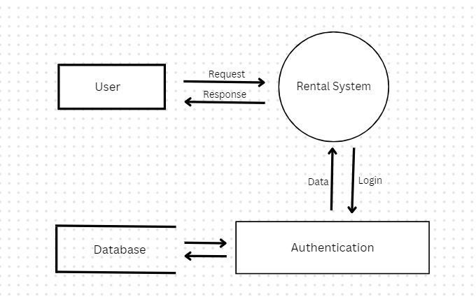

**DFD Level -1**

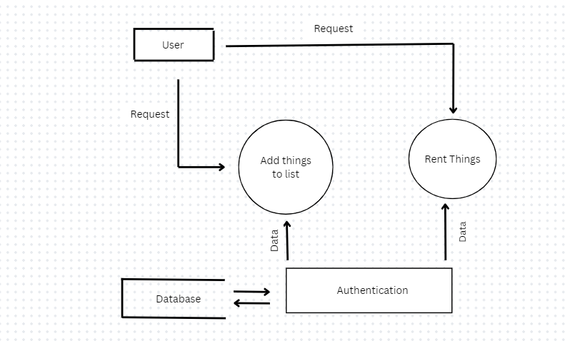

**DFD Level -2**

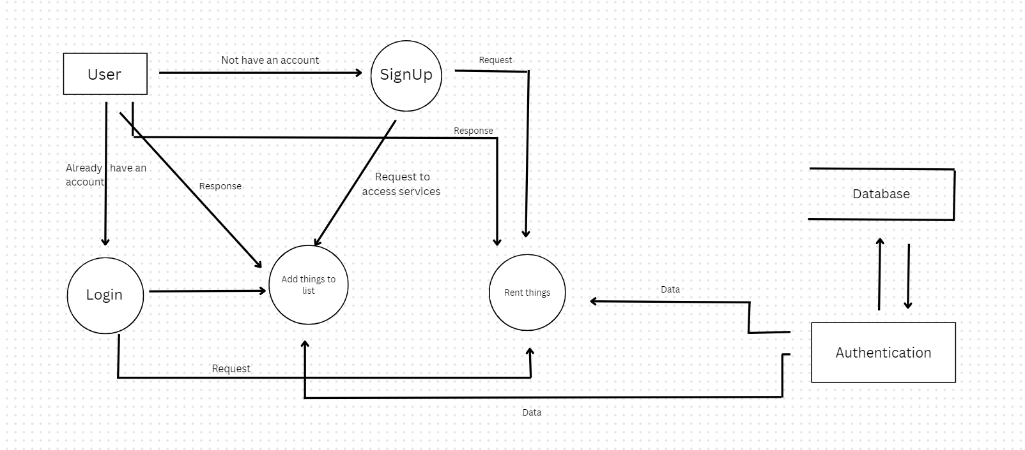

**BIBLIOGRAPHY**

1. Github

<https://github.com/>

1. Mdn Web Docs

<https://developer.mozilla.org/en-US/docs/Web/>

1. Mongodb Atlas

<https://cloud.mongodb.com/>

1. Mongoose Docs

https://mongoosejs.com/docs/guide.html

1. Node.js documentation

<https://nodejs.org/api/>

1. Stack Overflow

<https://stackoverflow.com/>