Health Insurance EDA — Medical Cost Personal Dataset
Author: Lucky Saxena
Dataset: US Health Insurance — Kaggle (mirichoi0218)
IBM SkillsBuild Data Analytics with AI Academic Internship Program
Date: July 2025

Table of Contents
1. Introduction & Objective
2. Dataset Overview
3. Data Cleaning
4. Exploratory Data Analysis
4.1 Age Distribution
4.2 BMI Distribution
4.3 Charges Distribution
4.4 Charges vs Smoker Status
4.5 Age vs Charges (by Smoker)
4.6 BMI vs Charges (by Smoker)
4.7 Charges vs Region
4.8 Charges vs Children
4.9 Correlation Heatmap
4.10 Outlier Detection & Analysis
5. Key Insights & Questions Answered
6. Key Findings Summary
7. Conclusion

1. Introduction & Objective
Health insurance costs in the United States are driven by a complex interplay of personal health metrics, lifestyle choices, and demographic factors. For insurers, actuaries, and healthcare policy analysts, understanding which factors most strongly predict high-cost customers is both operationally important and strategically valuable — it enables better risk segmentation, pricing, and preventative care targeting.
This project performs a complete Exploratory Data Analysis (EDA) on the Medical Cost Personal Dataset (Kaggle), using Python (pandas, numpy, matplotlib, seaborn) to investigate the relationships between customer characteristics and annual insurance charges. No machine-learning models are built; the objective is purely analytical understanding.

Central Business Question
"Which customer characteristics (smoking status, BMI, age, region, number of children) are associated with unusually high insurance charges, and which individuals represent cost outliers worth flagging for review?"
This central question is broken into six targeted sub-questions, each answered by a specific chart and written insight in Section 4.

2. Dataset Overview
Source: https://www.kaggle.com/datasets/mirichoi0218/insurance
The dataset contains 1,338 rows and 7 columns representing individual insurance policy holders in the United States. Each row corresponds to one individual and their associated annual medical insurance charge.

Column Descriptions
Column | Type | Description
age | int | Age of the primary beneficiary (18–64)
sex | object | Biological sex of the insured (male / female)
bmi | float | Body Mass Index — weight (kg) / height (m)^2
children | int | Number of children / dependents covered (0–5)
smoker | object | Whether the individual smokes (yes / no)
region | object | US region of residence (northeast / northwest / southeast / southwest)
charges | float | Annual medical insurance cost billed by insurer (USD) — TARGET variable

Dataset Snapshot (df.head())
The first five rows of the raw dataset are shown below:
age | sex | bmi | children | smoker | region | charges
19 | female | 27.90 | 0 | yes | southwest | $16,884.92
18 | male | 33.77 | 1 | no | southeast | $1,725.55
28 | male | 33.00 | 3 | no | southeast | $4,449.46
33 | male | 22.705 | 0 | no | northwest | $21,984.47
32 | male | 28.88 | 0 | no | northwest | $3,866.86

df.info() Summary
<class 'pandas.core.frame.DataFrame'>
RangeIndex: 1338 entries, 0 to 1337
Data columns (total 7 columns):
# Column Non-Null Count Dtype
--- ------ -------------- -----
0 age 1338 non-null int64
1 sex 1338 non-null object
2 bmi 1338 non-null float64
3 children 1338 non-null int64
4 smoker 1338 non-null object
5 region 1338 non-null object
6 charges 1338 non-null float64
dtypes: float64(2), int64(2), object(3)
memory usage: 73.3+ KB

3. Data Cleaning
The raw dataset was clean overall — no missing values were found. A duplicate row check was performed and one duplicate was removed, leaving 1,337 records. Categorical columns were cast to the category dtype for efficiency.

Code: Duplicate Check & Removal
# Check for duplicate rows
duplicates_before = df.duplicated().sum()
print(f'Duplicate rows before: {duplicates_before}')

df.drop_duplicates(inplace=True)
df.reset_index(drop=True, inplace=True)

print(f'Duplicate rows after: {df.duplicated().sum()}')
print(f'Clean dataset shape: {df.shape}')

Code: Null Value Check
print(df.isnull().sum())
print('Total nulls:', df.isnull().sum().sum())

Code: Categorical Dtype Conversion
for col in ['sex', 'smoker', 'region']:
df[col] = df[col].astype('category')

Before/After Summary
Check | Before Cleaning | After Cleaning
Total Rows | 1,338 | 1,337
Duplicate Rows | 1 | 0
Null Values | 0 | 0

4. Exploratory Data Analysis
Each analysis step below follows the same structure: (1) the relevant code snippet, (2) the resulting chart, (3) the business question addressed, and (4) a written insight answering that question.

4.1 Age Distribution
fig, axes = plt.subplots(1, 2, figsize=(13, 4))
axes[0].hist(df['age'], bins=20, color='steelblue', edgecolor='white')
axes[0].set_title('Age Distribution — Histogram')
df['age'].plot.kde(ax=axes[1], color='steelblue', linewidth=2)
axes[1].set_title('Age Distribution — KDE')
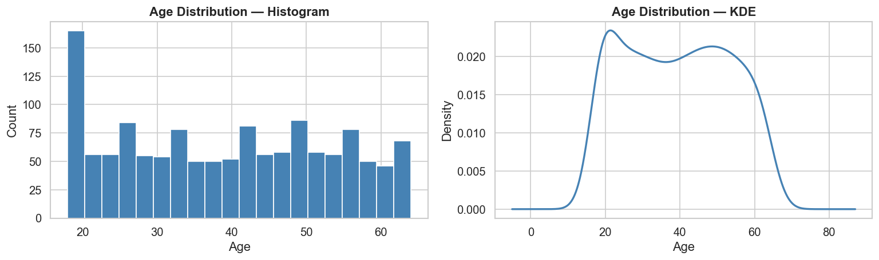
Question: What is the age profile of insured individuals?
Age is approximately uniformly distributed between 18 and 64 years. Mean age is 39.2 (median 39.0, std 14.0). The dataset represents all adult age groups fairly evenly, with a slight concentration of 18–19-year-old entries. This distribution ensures the EDA is not age-biased.

4.2 BMI Distribution
fig, axes = plt.subplots(1, 2, figsize=(13, 4))
axes[0].hist(df['bmi'], bins=30, color='darkorange', edgecolor='white')
axes[0].axvline(30, color='red', linestyle='--', label='Obese threshold')
df['bmi'].plot.kde(ax=axes[1], color='darkorange', linewidth=2)
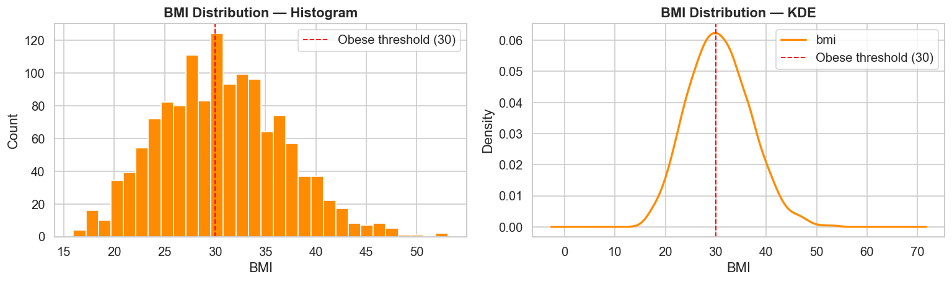
Question: What is the BMI profile of the insured population?
BMI is approximately normally distributed with a mean of 30.66 and median of 30.40 — right at the clinical obesity threshold. 52.8% of individuals have BMI >= 30, indicating the insured population skews toward higher metabolic risk. This high prevalence of obesity is likely a significant co-driver of elevated charges.

4.3 Charges Distribution
fig, axes = plt.subplots(1, 2, figsize=(13, 4))
axes[0].hist(df['charges'], bins=40, color='mediumseagreen', edgecolor='white')
df['charges'].plot.kde(ax=axes[1], color='mediumseagreen', linewidth=2)
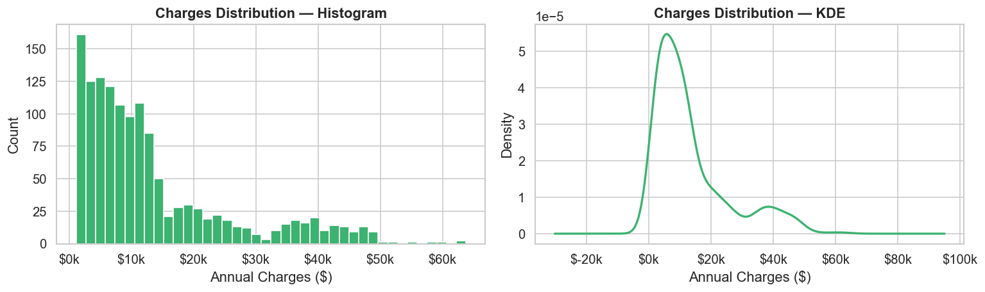
Question: What does the distribution of insurance charges look like?
Charges are strongly right-skewed. The majority of individuals pay $1k–$15k annually, but a visible secondary cluster exists around $30k–$50k+, indicating a distinct high-risk subgroup. Mean charges ($13,279) are significantly higher than the median ($9,386), confirming the distorting influence of a high-charge outlier group.

4.4 Charges vs Smoker Status
palette = {'yes': '#e05454', 'no': '#5b9bd5'}
sns.boxplot(data=df, x='smoker', y='charges', palette=palette, order=['yes','no'])

smoker_mean = df.groupby('smoker')['charges'].mean()
print(smoker_mean)
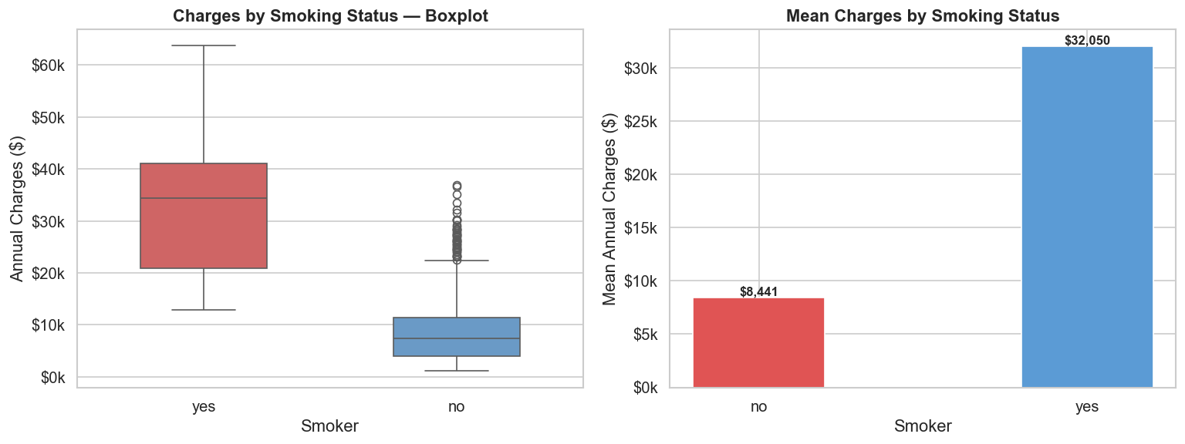
Question: Does smoking status significantly affect insurance charges?
Yes — smoking is the dominant driver of high insurance charges. Smokers pay an average of $32,050/year versus $8,441 for non-smokers — a 3.8x difference. The boxplot also shows far greater variance in smoker charges, suggesting that other compounding factors (age, BMI) push costs even higher for some smokers.

4.5 Age vs Charges (Colored by Smoker Status)
for smoker_val, color in {'yes':'#e05454','no':'#5b9bd5'}.items():
subset = df[df['smoker'] == smoker_val]
ax.scatter(subset['age'], subset['charges'], c=color, alpha=0.55, s=30)
z = np.polyfit(subset['age'], subset['charges'], 1)
ax.plot(x_line, np.poly1d(z)(x_line), color=color, linestyle='--')
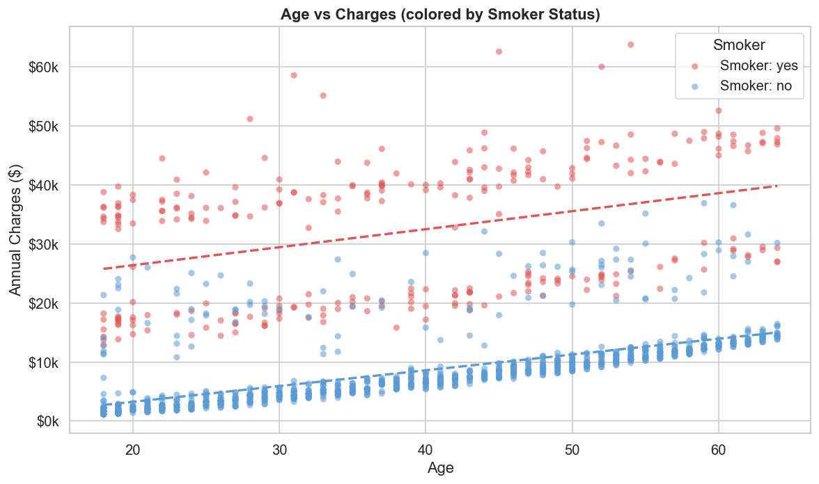
Question: How does age correlate with charges, and does smoking change that relationship?
Age has a moderate positive correlation with charges (r = 0.298). The scatter plot reveals three distinct cost bands: a low non-smoker band, a higher non-smoker band (driven by BMI), and a permanently elevated smoker band. Smoking creates a cost ceiling that even young smokers exceed relative to middle-aged non-smokers.

4.6 BMI vs Charges (Colored by Smoker Status)
for smoker_val, color in {'yes':'#e05454','no':'#5b9bd5'}.items():
subset = df[df['smoker'] == smoker_val]
ax.scatter(subset['bmi'], subset['charges'], c=color, alpha=0.55, s=30)
z = np.polyfit(subset['bmi'], subset['charges'], 1)
ax.plot(x_line, np.poly1d(z)(x_line), color=color, linestyle='--')
ax.axvline(30, color='black', linestyle=':', label='BMI=30 threshold')
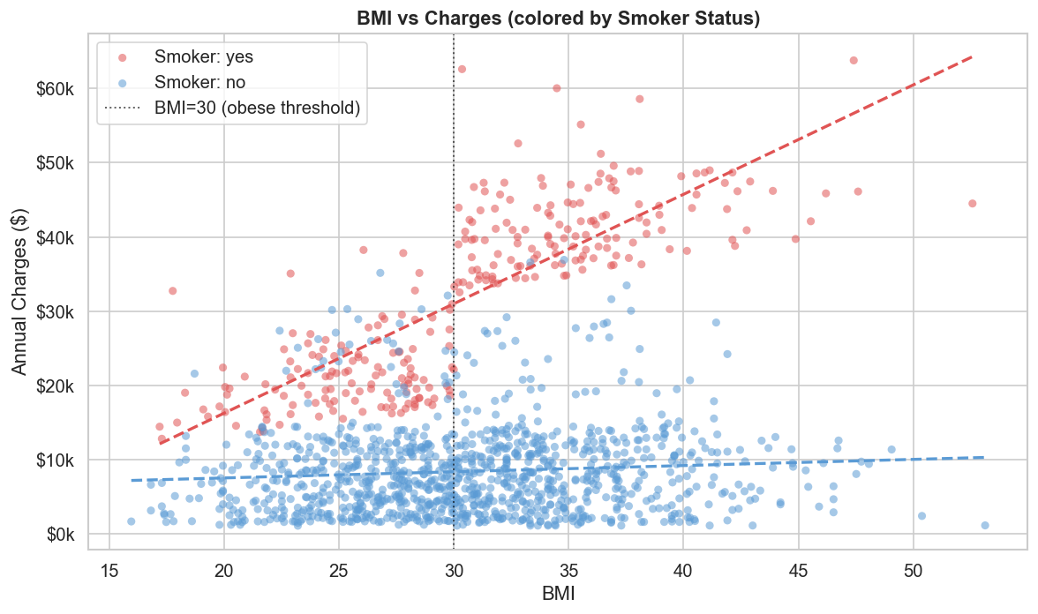
Question: Is there a combined effect of BMI and smoking on charges?
A strong interaction exists: for non-smokers, BMI has a modest impact on charges. For smokers, crossing BMI >= 30 (obesity threshold) produces a dramatic jump. The top-right cluster of the chart — obese smokers — represents the most expensive cases in the dataset, confirming a compounding risk effect.

4.7 Charges vs Region
region_order = df.groupby('region')['charges'].median().sort_values(ascending=False).index
sns.boxplot(data=df, x='region', y='charges', order=region_order, palette='pastel')

mean_region = df.groupby('region')['charges'].mean()
axes[1].bar(mean_region.index, mean_region.values)
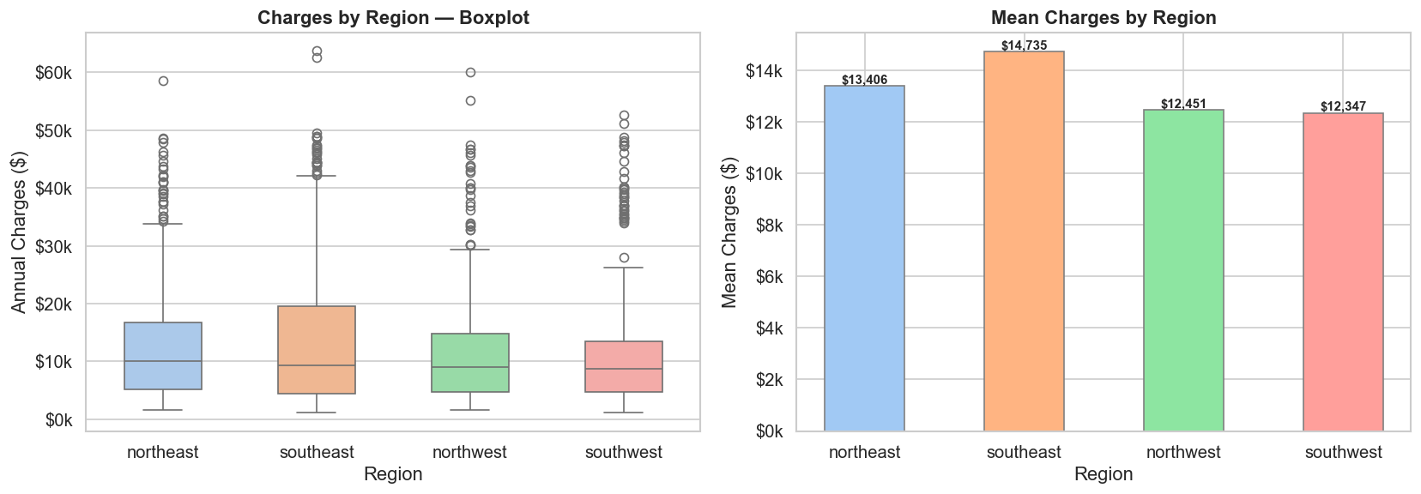
Question: Do charges vary meaningfully by region?
Regional differences are modest and all four regions show overlapping distributions. The Southeast has the highest mean ($14,735) while Southwest has the lowest ($12,347). This small gap is likely explained by regional differences in smoking prevalence and BMI averages, rather than geographic pricing effects.

4.8 Charges vs Number of Children
sns.boxplot(data=df, x='children', y='charges', palette='Blues')

mean_children = df.groupby('children')['charges'].mean()
axes[1].bar(mean_children.index.astype(str), mean_children.values)
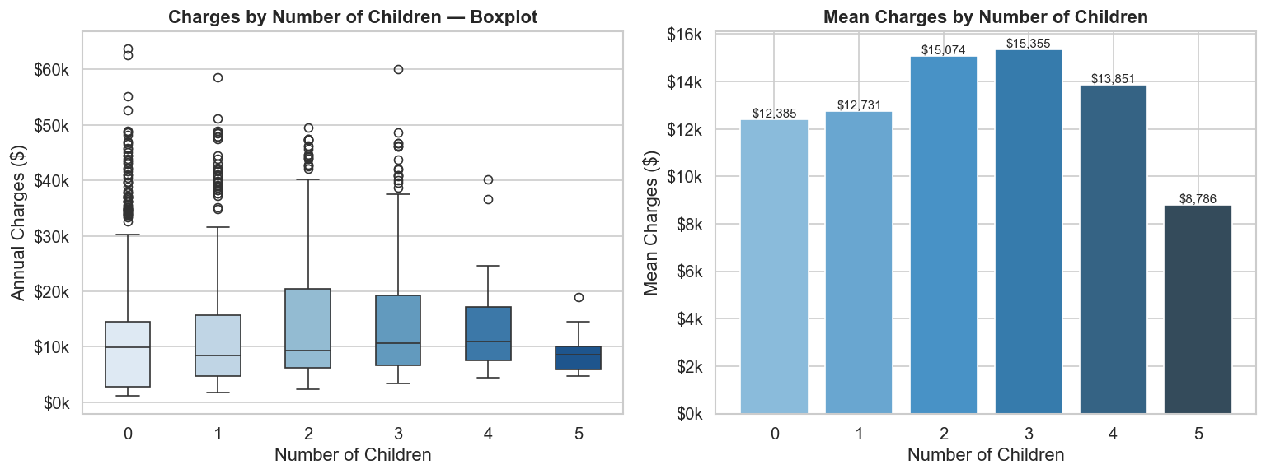
Question: Does number of children influence insurance charges?
The number of dependents has a weak, non-linear relationship with charges. Mean charges are broadly similar across 0–3 children. Individuals with 4–5 children show slightly lower means, possibly due to smaller sample sizes. Number of children is not a reliable standalone predictor of high individual insurance costs.

4.9 Correlation Heatmap
df_corr['smoker_enc'] = (df_corr['smoker'] == 'yes').astype(int)
numeric_cols = ['age', 'bmi', 'children', 'smoker_enc', 'sex_enc', 'charges']
corr_matrix = df_corr[numeric_cols].corr()
sns.heatmap(corr_matrix, annot=True, fmt='.2f', cmap='coolwarm', vmin=-1, vmax=1)
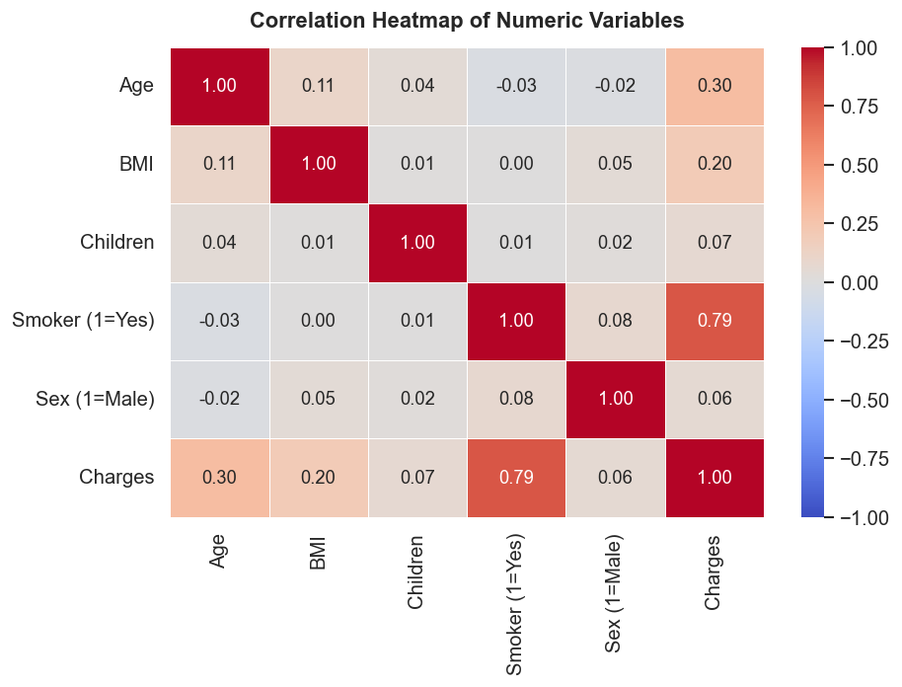

Question: Which variables are most correlated with charges?
Smoker status has the highest correlation with charges (r = 0.787), far exceeding all other variables. Age is second (r = 0.298), followed by BMI (r = 0.198). Sex and number of children have near-zero correlations, confirming they are weak standalone predictors. The heatmap provides a clear priority ranking of risk factors.

4.10 Outlier Detection & Analysis
# IQR Method
Q1 = df['charges'].quantile(0.25)
Q3 = df['charges'].quantile(0.75)
IQR = Q3 - Q1
upper_fence = Q3 + 1.5 * IQR
outliers_iqr = df[df['charges'] > upper_fence]

print(f'IQR Upper Fence: ${upper_fence:,.2f}')
print(f'Outlier count: {len(outliers_iqr)}')
print(f'Smoker pct among outliers: {(outliers_iqr["smoker"]=="yes").mean()*100:.1f}%')
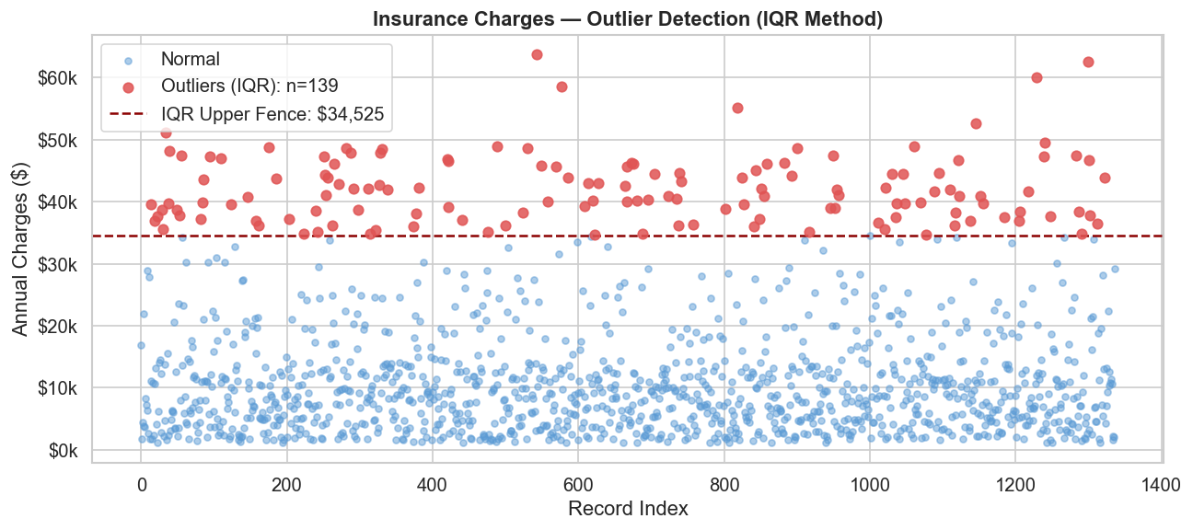
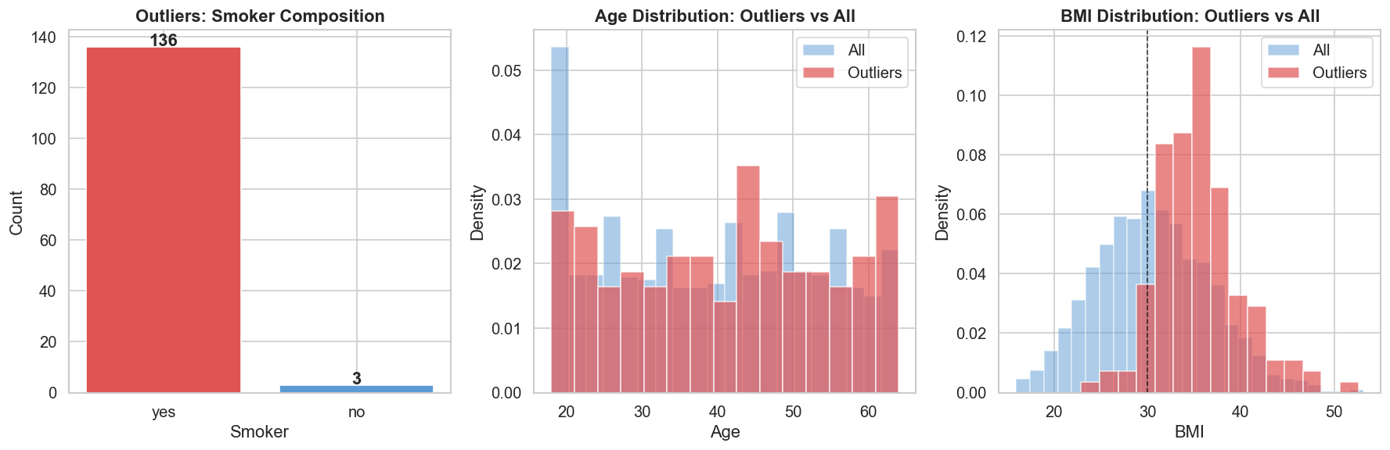
Question: Who are the cost outliers, and what risk factors do they share?
Using the IQR upper fence of $34,525, 139 individuals (10.4% of the dataset) are flagged as high-cost outliers. Among these, 97.8% are smokers (vs 20.5% in the full dataset). Their average age is 41.1 (vs 39.2) and average BMI is 35.56 (vs 30.66). These individuals — predominantly older, obese smokers — are the most actionable targets for risk management and preventative care intervention.

5. Key Insights & Questions Answered
The following is a comprehensive Q&A summary of every analytical question explored during this EDA:
Q1: Does smoking status significantly affect insurance charges?
Yes. Smokers pay an average of $32,050/year vs $8,441 for non-smokers — a 3.8x multiple. Smoking is the single strongest predictor of insurance charges (correlation r = 0.787). Even controlling for other variables, smoking status alone explains the majority of high-cost cases.
Q2: How does age correlate with charges, and does smoking change that relationship?
Age has a moderate positive correlation (r = 0.298) with charges. The scatter plot reveals that smoking creates a permanently elevated cost band — even 18-year-old smokers frequently have charges exceeding those of 60-year-old non-smokers. Both groups show an upward age trend, but the intercepts (base costs) are entirely different.
Q3: Is there a combined effect of BMI and smoking on charges?
Yes — a strong interaction effect. For non-smokers, BMI has minimal impact on charges (flat trend line). For smokers, charges rise steeply with BMI above 30. The combination of smoking + obesity produces the highest charges in the entire dataset, often exceeding $60,000/year.
Q4: Do charges vary meaningfully by region?
No — regional variation is modest. The Southeast has the highest mean ($14,735) and Southwest the lowest ($12,347), but distributions overlap substantially. Region is not a meaningful standalone predictor; any regional differences are likely driven by demographic composition (smoking rates, BMI) rather than geography itself.
Q5: Does number of children influence insurance charges?
No meaningful effect. Charges are broadly similar across 0–3 children. The correlation is near zero (r = 0.067). Number of dependents does not appear to predict personal insurance costs in this dataset.
Q6: Who are the cost outliers, and what risk factors do they share?
139 individuals are flagged as high-cost outliers (charges > $34,525, IQR upper fence). Of these, 97.8% are smokers. Their average age (41.1) and BMI (35.56) both exceed dataset averages. These individuals represent an identifiable high-risk subgroup — predominantly older, obese smokers — who would benefit from targeted wellness programs or revised risk pricing.

6. Key Findings Summary
- Smoking is by far the most powerful predictor of high insurance charges, with smokers paying 3.8x more on average (r = 0.787 with charges).
- Age increases charges steadily (r = 0.298), but smoking creates a parallel cost band that is elevated at every age from 18 onward.
- BMI and smoking interact strongly: obese smokers (BMI >= 30) represent the highest-cost cluster in the entire dataset, often exceeding $60,000/year.
- Region has minimal predictive power. All four US regions show overlapping charge distributions; the Southeast is marginally higher.
- Number of children is not a meaningful predictor of individual insurance charges (r = 0.067).
- 139 high-cost outliers (charges > $34,525) were identified using the IQR method. 97.8% are smokers, with higher-than-average age and BMI. This is a clearly identifiable, high-risk subgroup.

7. Conclusion
This EDA project demonstrates that insurance charges are not uniformly distributed across customers — they are heavily concentrated in a specific subgroup characterised by smoking, high BMI, and older age. Smoking status alone accounts for the majority of cost variability, and its interaction with BMI creates a compounding risk effect that pushes a subset of customers into an entirely different cost tier.
The outlier analysis identifies 139 high-cost individuals whose profile — primarily older, obese smokers — makes them candidates for targeted interventions such as wellness programmes, cessation support, and revised risk-based pricing. Region and number of children, by contrast, appear to have negligible direct impact on charges and should not be primary factors in risk stratification.
This analysis was produced using IBM BOB within VS Code as part of the IBM SkillsBuild Data Analytics with AI Academic Internship Program, demonstrating how AI-assisted development tools can accelerate structured analytical workflows.

