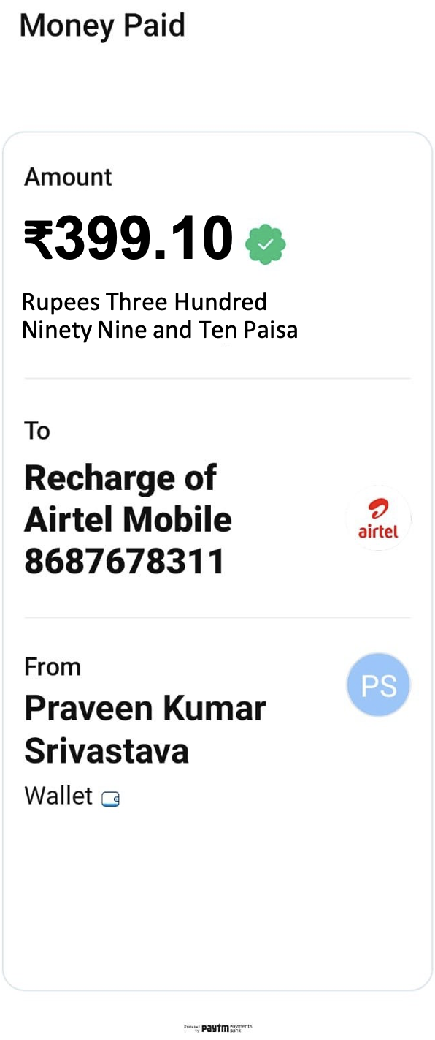

₹399.10

Rupees Three Hundred Ninety Nine and Ten Paisa

Paid at **{{date}}**

Order ID: **{{order}}**

Wallet Ref No: **{{ref}}**