**Group Task**

1. Consider the following graph:

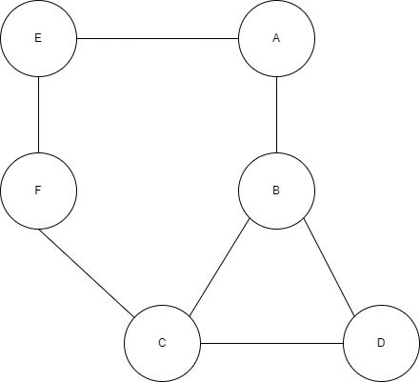

* Calculate Node Degree for this graph.
* Which node has highest node degree?

**Hint:** The degree of a node is the number of edges connected to the node.

1. Calculate Betweenness Centrality of the graph. Which node has 0 and which node has highest betweenness Centrality?

**Hint**: It measure the node falling in the shortest paths of other pairs of nodes.

1. Calculate Closeness Centrality of the graph. Find the highest and lowest closeness centrality nodes?

**Hint**: Length of the Shortest path between nodes i and j.

1. Draw the Bipartite projection for the Given graph.

**Hint**: Convert this into graph where all nodes are of similar type. Use the one Hop Neighbors for finding the edge presence.

* 1. Draw projection only for the Alphabetical nodes.

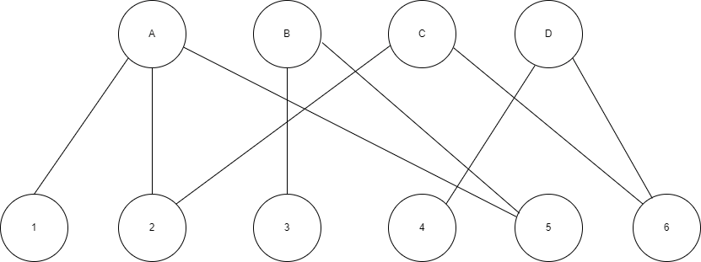

* 1. Draw projection only for the numerical nodes

1. Mark the following Graphs as either Balanced or Unbalanced?

**Hint**: Solid lines are representing positive edges and dashed lines are representing negative edges.

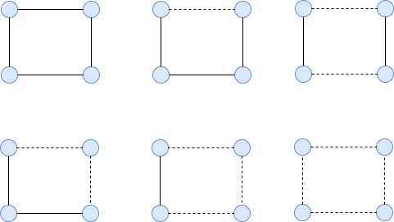

**SUBMIT**

|  |  |
| --- | --- |
| Full Name | Signature |
|  |  |
|  |  |
|  |  |
|  |  |