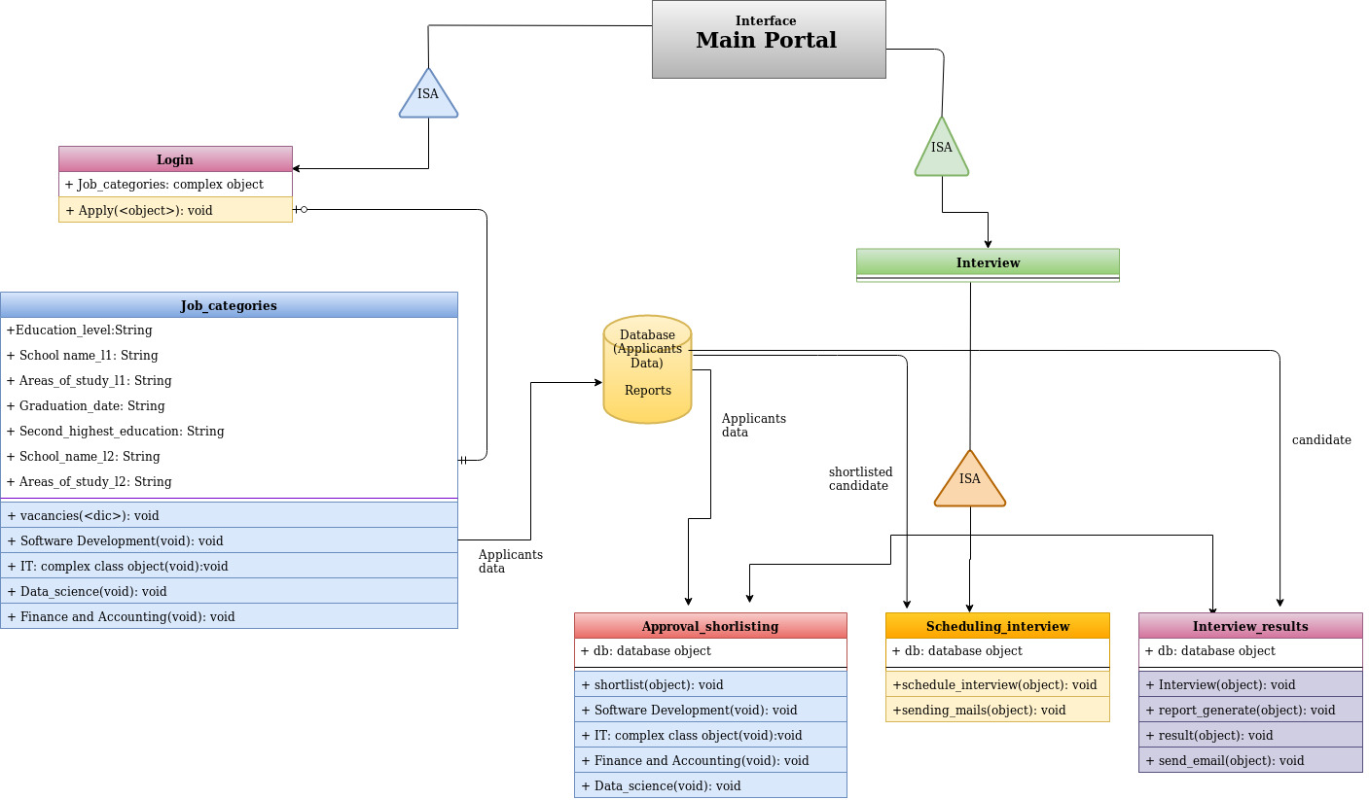
Development of Recruitment Process System for the HR group of a company
Dimpy Varshni(MT19022) andLucky Agarwal(MT19125)

