**1 *INTRODUCTION***

* 1. **COMPANY PROFILE**

**1.1.1 CS Group**

CS Group founded by Mr. Chhotu Sharma is an amalgam of CS Infotech and CS Soft Solutions Pvt. Ltd. CS Soft Solutions is a complete IT solutions providing company with huge clientele all over the world. CS Infotech is a pioneer institution which is engaged in providing computer education in Microsoft Technologies, to students as well as professional executives.

**1.1.2 CS InfoTech**

CS Infotech is a pioneer institution engaged in providing computer education to numerous students every year. The company provides comprehensive learning environment to individuals and is also engaged in honing the technical skills of the professional executives to help them achieve excellence in their working fields. Students are also provided with opportunity to handle live projects during industrial training. The motive behind providing industrial training is to facilitate students with live projects and to keep them abreast of the latest technologies used in market. The institution takes immense pride in having empowered thousands of students across the entire region in all these years. CS Infotech has a good record of getting students placed in reputed firms.

**1.1.3 CS Soft Solutions Pvt. Ltd.**

CS Soft Solutions is a complete IT solutions providing company based in Mohali. CS Soft Solutions was created to achieve the goal of providing its clients state-of-art web development services comparable with best in the world.

The services provided by CS Soft Solutions Pvt. Ltd. are

* Web Development
* Web Designing
* Online Marketing
* Mobile Application Development

CS Soft Solutions Pvt. Ltd. was conceptualized in October 2009 by Mr. Chhotu Sharma and Mrs. Shalini Sharma. The goal was to build a company that worked on solid principals, to develop world class IT products and provide a congenial environment and adequately encouraging work culture for all the team members at CS Soft Solutions Pvt. Ltd. Consequently, there is a huge clientele from all across the world. For assistance please refer to our website [www.cssoftsolutions.com](http://www.cssoftsolutions.com). One of the methods of paying back to the industry that has been adopted by the CS Group is to recruit students from CS Infotech into CS Soft Solutions Pvt. Ltd. on the basis of their performance and ability to perform in the industry.

**1.1.4 Founders**

**Mr. Chhotu Sharma** is the founder of the CS Group. He is a Microsoft Certified Software Developer and has been training IT professionals in different Microsoft Technologies since last 12 years. He is recognized as “The Guru of Microsoft Technologies”. For his excellent work in field of education, he has been conferred with title of “Himachal Gaurav” by the Chief Minister, Sh. Prem Kumar Dhumal in the year 2007.His students have been picked up by Fortune 500

companies including Microsoft, Accenture, TCS, Infosys and others. In the year 2009, he established CS Soft Solutions Pvt. Ltd, a company offering complete IT services in multifarious IT applications. He has been instrumental in shaping the goals and evolving values of CS Soft Solutions Pvt. Ltd. His strong penchant for excellence at professional as well as personal front, backed by a sincere and an honest approach towards life are the basic reasons for the success of the ventures he has launched and actively developed. These qualities of sincerity and honesty easily percolate among students, ensuring their success in future lives too.

**Mrs. Shalini Sharma** is Director of CS Soft Solutions Pvt. Ltd. and an a dept teacher at CS InfoTech. She is an embodiment optimism and bears a sharp analytical acumen coupled with excellent People Management skills. She has received Bachelor’s Degree from Guru Nanak Dev University, Amritsar. She has trained thousands of students during last decade. She has expertise in a wide array of languages and she meticulously imparts technical training to her wards with endeavour to make them fully equipped in dealing with various requirements of the IT industry, in their careers.   
99

* 1. **PROJECT UNDERTAKEN**

**Project Title :** EDUCOM

**Project Manager :** Mrs. Shalini Sharma

**Project Advisor :** Mrs. Richa Arora

**Project Duration :** 6 Months

**Project Category :** Web Based Application

**1.2.2 Front End - ASP.NET 4.5**

**Why Frond-End ASP.NET?**

1**. ASP.NET is integrated with the .NET Framework**

The .NET Framework is divided into an almost painstaking collection of functional parts, with a staggering total of more than 10,000 types(the .NET term for classes, structures, interfaces, and other core programming ingredients). The massive collection of functionality that the .NET Framework provides is organized in a way that traditional Windows programmers will see as a happy improvement. Each one of the thousands of classes in the .NET Framework is grouped into a logical, hierarchical container called a namespace.

Different namespaces provide different features. Taken together, the .NET namespaces offer functionality for nearly every aspect of distributed development from message queuing to security. This massive toolkit is called the class library.

2: **ASP.NET Is Compiled, Not Interpreted**

One of the major reasons for performance degradation in classic ASP pages is its use of interpreted script code. Every time an ASP page is executed, a scripting host on the web server needs to interpret the script code and translate it to lower-level machine code, line by line. ASP.NET applications are always compiled—in fact, it’s impossible to execute C# or Visual Basic code without it being compiled first.

3**. ASP.NET Is Multilanguage**

IL is a stepping stone for every managed application. (A *managed application* is any application that’s written for .NET and executes inside the managed environment of the CLR.) In a sense, IL is *the* language of .NET, and it’s the only language that the CLR recognizes.

4**. ASP.NET Is Hosted by the Common Language Runtime**

The most important aspect of the ASP.NET engine is that it runs inside the runtime environment of the CLR.

**5. ASP.NET Is Object-Oriented:**

ASP provides a relatively feeble object model. It provides a small set of objects; these objects are really just a thin layer over the raw details of HTTP and HTML. On the other hand, ASP.NET is truly object-oriented. Not only does your code have full access to all objects in the .NET Framework, but you can also exploit all the conventions of an OOP (object-oriented programming) environment. For example, you can create reusable classes, standardize code with interfaces, extend existing classes with inheritance, and bundle useful functionality in a distributable, compiled component.

6. **ASP.NET Is Multi device and Multi browser:**

One of the greatest challenges web developers face is the wide variety of browsers they need to support. Different browsers, versions, and configurations differ in their support of HTML. Web developers need to choose whether they should render their content according to HTML 3.2, HTML 4.0, or something else entirely—such as XHTML 1.0 or even WML (Wireless Markup Language) for mobile devices. This problem, fueled by the various browser companies, has plagued developers since the World Wide Web Consortium (W3C) proposed the first version of HTML. Life gets even more complicated if you want to use an HTML extension such as JavaScript to create a more dynamic page or provide validation.

**1.2.3 Back End-SQL Server 2008**

**Why Back End SQLServer 2008?**

**Back end a description**

* The back-end comprises the components that process the output from the front-end. Back-end is hidden from the user.
* A back-end database is a database that is accessed by users indirectly through an external application rather than by application programming stored within the database itself or by low level manipulation of the data (e.g. through SQL commands).
* A back-end database stores data but does not include end-user application elements such as stored queries, forms, macros or reports.

**1.3 OBJECTIVE**

* Provide a safe environment for differentiating instruction with one-to-one or whole group communication.
* Provide easy access to lesson collection.
* Expand your Professional Learning Network (PLN).
* Improve communication by connecting all students of a course in a closed, private community.
* Sharing allow students to show off what they've learned to the teacher and the EduCom community.
* Facilitate communication within teacher and learner.

**1.4 NEED TO CHOSE THIS PROJECT**

In the past decade, online education has significantly increased in popularity among students of all ages. Educom also believes great teachers are as valuable to society as great business leaders or academic thinkers. We wonder why there are hundreds of high-tech ways to share silly photos, and military-grade technology can help us find our friends at a bar, but teachers have few quality tools to help them succeed online. We believe teachers are some of society’s greatest entrepreneurs and should be treated as such. It is focused on the untapped segment of the online education market– online lifelong learning– currently a $55B market. Educom is not focused on K-12, higher ed or employee training. Instead, it moves beyond just the academic, to give people access to engaging lessons that are uniquely applicable to their lives, such as conversational french, wine tasting, yoga, integral solving, or jewelry making. Passive video is not sufficient to master a new skill or learn something in depth. And there is no easy way for online teachers to make money so there is no incentive to make the content better. This idea tends to change those two things. The idea is to provide great teachers of all kinds with a platform to showcase and market their teachable talents and earn money in the process. The focus is not solely on professional teachers but great teachers from all walks of life. Unlike some of the other edtech companies, Educom is not focused on courses or formal education.In addition, we cater to the lifelong learner. We encourage people to use their discretionary time to pursue any topic of interest to them — from wine tasting to gardening to pilates to how to train for a race. It makes learning a pleasure and opens up new ways to interact with lessons, teachers, and the larger Educom community.

In view of these benefits and a discussion with my project guide produced enthusiastic response and I decided to take the challenge to develop this project.

**1.5 INDUSTRY APPLICATION**

Educom believes in lifelong learning. Learning for its own sake. Learning that happens beyond classrooms, and not only in academic subjects (unless you count beer brewing, pipe soldering, and organic gardening as academic). Learning as a necessity of living. It aims to provide an uncommonly inviting place to teach and be taught. Instructors can upload video on any subject — be it salsa dancing or making food— then divvy it up into lessons. Unlike YouTube, Educom lets teachers choose to charge for lessons, features an oversize playback window and generally feels friendly and constructive. There are no creepy comments from anonymous YouTubers here, and the site’s proprietors currently approve teachers and eyeball content to ensure that these online classes are, well, classy.

1. ***INTRODUCTION TO ASSIGNED JOB***
   1. **KEY TASKS**

* To prepare database
* To prepare stored procedures
* To prepare Business Logic Layer
* To prepare web pages
* To handle the control navigation from other pages
* Writing the Code Behind pages for the web pages

1. ***FEASIBILITY STUDY***

Feasibility study is carried out to test if the proposed system is worth being implemented. Given unlimited resources and infinite time, all projects are feasible. Unfortunately, such situations are not possible in real time. Hence it becomes necessary and prudent to evaluate the feasibility of the project at earliest possible time in order to avoid unnecessary wastage of time. Feasibility study is the test of the system proposed regarding its work ability, impact or organization’s ability to meet user’s needs and effective use of resources. It is usually carried out by a small group of people who are familiar with the information system techniques; understand the part of business that will be involved and affective by the people that are skilled in analysis and design.

A feasibility study is conducted to select the best system that meets the performance requirements. This entails an identification description, and emulation of candidate systems and selection of best system for the job.

The factors that should be included in the feasibility assessment can be as follows.

**Cost:** operating, maintenance, unit

**Accuracy:** frequency, significance and correction of errors

**Reliability:** stability, durability

**Capacity:** average, low and peak loads

**3.1 ECONOMIC FEASIBILITY**

Economic analysis is the most frequently used method for evaluating the effectiveness of a candidate system. More commonly known as cost/benefits and saving that are expected from a candidate system and compare them with cost. If benefits outweigh costs, then the decision is made to design and implement the system.Usually cost benefits analysis is made to find the savings or extra overheads that would arise new development. The technique of cost benefit analysis is often used as a basis for assessing economic feasibility.

The factors for evaluation are:

* + Cost of operation of existing system and proposed system
  + Cost of development of proposed system
  + Value of benefits of proposed system.
  1. **TECHNICAL FEASIBILITY**

Technical feasibility centers on existing computer system and to what extent it can support the proposed addition. This involves financial consideration to accumulate technical enhancement. E.g. if the current operating system is at 80% capacity and arbitrary ceiling then running another application could overload the system or require additional hardware. If the budget is serious constraint then the project is not feasible.

**3.3 OPERATIONAL FEASIBILITY**

The operational feasibility refers to the assessment of proposed system in the manner that how much this system is feasible for the end users. The system should have capabilities in it. That person with a simple knowledge can also use the system. Our proposed system is user-friendly interface. The user just have to click on the choice with the help of menu. Therefore the system is feasible on operational front too.Our system will improve the performance and save the time. Because of the simple interface user can easily navigate to the desired information page and hence can get the desired information.

**3.4 TIME FEASIBILITY**

Time feasibility determines whether system is implemented within stipulated time. This project will be completed within stipulated time frame

1. ***REQUIREMENT ANALYSIS***

**4.1 Hardware and Software Requirements**

* Server Hosting ASP.Net 4.5 application
  + Windows 2003 Server or Windows 2000 Server with ASP.Net 4.5 and SQL Server 2008 support
* Client machine accessing ASP.Net 4.5 application
  + Any machine that can access a webpage
* Development machine for ASP.Net 4.5 application
  + Operating System: Windows
  + Software: Visual Studio 2012,Sql Server 2008
  + Hardware: 160GB Hard Disk, 2GB RAM

***5 MODULAR DESCRIPTION OF THE PROJECT***

**5.1 MODULES**:

* **Account Maintenance**

**I) Administration**

1. Adds Lessons.
2. Categorizes lessons according To requirements.
3. Uploading new lessons.
4. Uploading information of lessons from time to time.
5. Decides modes and policies of payment.

**II) Teacher**

1. Teachers register themselves.
2. Put the lessons that they offer on display.
3. Responsible for downloading and uploading of lessons.
4. Responsible for searching of new lessons.
5. Enter information regarding the lessons, including pictures.

**III) User**

1. Users can search for the lessons of their choice.
2. Users can specify registration
3. If User Is Registered Then:-
4. Buy any product.

ii. Add a product to his wish-list.

iii. Get notifications regarding sale or extra coupons on his E-mail id.

iv. Pre-order any product which is about to come in the market.

v. Write a review about the product they bought and also rate the product.

* **Search lesson collection**
* **Enrollment Module**
* **Payment Module**
* **Sharing Module**

**5.2 ARCHITECTURE OF PROJECT**

**3 Tier-Architecture**

In a three-tiered application, the presentation services are responsible for gathering information from the user, sending the user information to the business services for processing, receiving the results of the business services processing, and presenting those results to the user. The most popular architecture on the web currently, mostly taking the form of web browser processing client side presentation in the form of HTML/DHTML, etc, the web server using some scripting language (ASP) and the database server (SQL Server for example) serving up the data.

**The basic functionalities of 3 – Tier or N-Tier follows are**

**The presentation services tier is responsible for:**

• Gathering information from the user.

• Sending the user information to the business services for processing.

• Receiving the results of the business services processing.

• Presenting those results to the user.

**The business services tier is responsible for:**

• Receiving input from the presentation tier.

• Interacting with the data services to perform the business operations.

• Sending the processed results to the presentation tier.

**The data services tier is responsible for the:**

• Storage of data.

• Retrieval of data.

• Maintenance of data.

• Integrity of data.

In Windows DNA applications commonly implement their business logic using one or more of three implementation options.

• ASP Pages

• COM components

• Stored procedures running in the DBMS.

Writing much business logic in ASP pages is a bad idea. Since simple languages are used, such as Microsoft Visual Basic Script, and the code is interpreted each time it is executed, which hurts the performance. Code in ASP pages is also hard to maintain, largely because business logic is commonly intermixed with presentation code that creates the user interface.

One recommended approach for writing middle-tier business logic is to implement that logic as COM objects. This approach is a bit more complex than writing a pure ASP application. Wrapping business logic in COM objects also cleanly separates this code from the presentation code contained in ASP pages, making the application easier to maintain.

The Third option for writing business logic is to create some of that code as stored Procedures running in the database management system (DBMS). Although a primary reason for using stored procedures is to isolate the details of database schema from business logic to simplify code management and security, having code in such a close proximity to data can also help optimize performance.

**Presentation Tier**

Master Pages

HTML & CSS

AJAX

Java-Script

Data Bound Controls

State Management

**Business Logic Tier**

ASP.NET using C#.NET

Interfaces and Properties

Main Class

**Data Base Tier**

SQL Server 2008 ER-Model   
11 Tables Stored Procedures

**5.2.1 DATA BASE TIER**

**MICROSOFT SQL SERVER**Microsoft SQL Server is a full-featured relational database management system (RDBMS) that offers a variety of administrative tools to ease the burdens of database development, maintenance and administration. In this article, we'll cover six of the more frequently used tools: Enterprise Manager, Query Analyzer, SQL Profiler, Service Manager, Data Transformation Services and Books Online.  
  
**Enterprise Manager:** It is the main administrative console for SQL Server installations. It provides you with a graphical "birds-eye" view of all of the SQL Server installations on your network. You can perform high-level administrative functions that affect one or more servers, schedule common maintenance tasks or create and modify the structure of individual databases.

**Query Analyzer:**   
It offers a quick and dirty method for performing queries against any of your SQL Server databases. It's a great way to quickly pull information out of a database in response to a user request, test queries before implementing them in other applications, create/modify stored procedures and execute administrative tasks.

**SQL Profiler:**   
It provides a window into the inner workings of your database. You can monitor many different event types and observe database performance in real time. SQL Profiler allows you to capture and replay system "traces" that log various activities. It's a great tool for optimizing databases with performance issues or troubleshooting particular problems.

**Service Manager:**   
It is used to control the MSSQLServer (the main SQL Server process), MSDTC (Microsoft Distributed Transaction Coordinator) and SQLServerAgent processes. An icon for this service normally resides in the system tray of machines running SQL Server. You can use Service Manager to start, stop or pause any one of these services.

**Data Transformation Services (DTS):**

Provide an extremely flexible method for importing and exporting data between a Microsoft SQL Server installation and a large variety of other formats. The most commonly used DTS application is the "Import and Export Data" wizard found in the SQL Server program group.

**Books Online:**

Is an often overlooked resource provided with SQL Server that contains answers to a variety of administrative, development and installation issues. It's a great resource to consult before turning to the Internet or technical support.

**Database Tier includes:**

* Data Flow Diagram
* Creating Tables
* Creating Store procedure

**Naming Convention/Symbols For Tables**

1. Each table start with tb.

2. Database name start with db.

3. Three character naming convention is followed for ex. Table name consist of tb and three character name which represent the table as tbcnt which is used to store the countries.

**Stored Procedure:**

There are five kinds of stored procedures for each table. They are:

Insert, Update, Delete, Find, Display

1. They are Compiled objects
2. Store in database
3. Execute in database
4. High performance
5. Secure

Naming Convention/Symbols for Store Procedures

1. ins-tablename (for inserting values in the particular tables)

2. upd-table name (for updating data in the tables)

3. del-table name (for deleting data in the tables)

4. find-table name (for finding particular data in the tables)

5. disp-table name (for displaying tables data onto screen)

**5.2.2 BUSINESS LOGIC TIER**

**ASP.NET**

ASP.NET is a set of web application development technologies marketed by Microsoft. Programmers can use it to build dynamic web sites, web applications and XML web services. It is part of Microsoft’s .NET platform and is the successor to Microsoft’s Active Server Pages (ASP) technology.

Even though ASP.NET takes its name from Microsoft’s old web development technology ASP, the two differ significantly. Microsoft has completed rebuilt ASP.NET, based on the Common Language Runtime (CLR) shared by all Microsoft.Net applications. Programmers can write ASP.NET code using any of different Programming languages supported by the .NET Framework, usually C#, VB.NET, or JScript.NET, but also including open-source languages such as Perl and Python. ASP.NET has performance benefits over other script-based technologies because the server-side code is compiled to one or a few DLL files on web server.

ASP.NET attempts to simplify developer’s transition from Windows application development to web development by offering the ability to build pages composed of controls similar to a Window user interface. A web control, such as a button or label, functions in very much the same way as its window counterpart: code can assign it properties and respond to its events. Controls know how to render themselves: whereas windows controls draw themselves to the screen, web controls produce segments of HTML and JavaScript which form part of resulting page sent to the end-user’s browser.

ASP.NET encourages the programmer to develop applications using an event-driven GUI paradigm, rather than in conventional web-scripting environments like ASP and PHP. The framework attempts to combine existing technologies such as JavaScript with internal components like “View state” to bring persistent (inter-request) state to inherently stateless web environment.

ASP.NET uses .NET Framework as an interface. The .NET Framework offers a managed runtime environment (like java), providing a virtual machine with JIT and a class library.

**C# LANGUAGE**

An objective of C# in its very best style. The version we are using is C# 3.0 on the .NET 3.5 Beta 2 Framework (August 2007). C# 1.0 came out in December 2002, embodying much of the research in OOP that had taken place since Java was launched seven years previously. C# 2.0 was released in final form in September 2005, and the ECMA standard was made available in June 2006. C# 2.0 added five significant features to C# 1.0. Within Microsoft, work continued on the language, with a particular emphasis on the integration of SQL database interfacing and the associated dynamic typing required. The report on Version 3.0 of the language, finalized in May 2006, includes substantial advances in integrating the functional and database programming paradigms into mainline object-orientation:

**Some of the features of C# are:**

* It has no global variables or functions. All methods and members must be declared within classes. Static members of public classes can substitute for global variables and functions.
* Local variables cannot shadow variables of the enclosing block, unlike C and C++.
* C# supports a strict Boolean data type, bool. Statements that take conditions, such as while and if, require an expression of a type that implements the true operator, such as the boolean type. While C++ also has a boolean type, it can be freely converted to and from integers, and expressions such as if(a) require only that a is convertible to bool, allowing a to be an int, or a pointer. C# disallows this "integer meaning true or false" approach, on the grounds that forcing programmers to use expressions that return exactly bool can prevent certain types of common programming mistakes in C or C++ such as if (a = b) (use of assignment = instead of equality ==).
* In addition to the try...catch construct to handle exceptions, C# has a try...finally construct to guarantee execution of the code in the finally block.
* Multiple inheritances is not supported, although a class can implement any number of interfaces. This was a design decision by the language's lead architect to avoid complication and simplify architectural requirements throughout CLI.
* C#, like C++, but unlike Java, supports operator overloading.
* C# is more type safe than C++. The only implicit conversions by default are those that are considered safe, such as widening of integers. This is enforced at compile-time, during JIT, and, in some cases, at runtime. No implicit conversions occur between Booleans and integers, nor between enumeration members and integers (except for literal 0, which can be implicitly converted to any enumerated type). Any user-defined conversion must be explicitly marked as explicit or implicit, unlike C++ copy constructors and conversion operators, which are both implicit by default. Starting with version 4.0, C# supports a "dynamic" data type that enforces type checking at runtime only.

**Business Tier includes**

**Interfaces:-**

* Use for declaration.
* We can inherit a interface with in interface.
* We can implement multiple interface in single class.
* If interface is public all its members will be public.

**Properties:-**

* May be read only, may be write only.
* Properties apply validation checks.
* Developer has control over properties.
* To pass data to property SET Block is used.
* To read data from properties GET Block is used.
* Get means read only, SET means write only. If both blocks, property is read, write only.

**Dynamic Link Library:-**

* Compiled class
* Reusable Scope
* Multiple application

**5.2.3 PRESENTATION TIER**

**Master Pages:-**

* A common template added in ASP 2.0.
* Apply on more than one Web Page.
* It may nested or multiple in Single Application
* Content Place Holder controls apply on master page.
* It is used for content pages.
* More than One Master Pages are there to manage the design.

**HTML Templates:-**

* + HTML templates are used to Design the Web Pages in Master Pages.
  + CSS is applied to formatting purpose.
  + According to the need of Content Page Design is modified.

**Data Bound Controls:-**

* Various Data bound controls are used like Grid View, Data List, Details View etc.
* Along with those controls Various Templates are used.

**Logic Implementation:-**

* **ADO.NET** is used to access the Data from Data Base.
* Abstract Connection Class to provide Connection with Data Base.
* Main classes are created to implement the Logic.
* Main class inherits the Connection Class.

**5.3 METHODOLOGY USED**

**Prototyping Model** has been used for software development according to which a throwaway prototype of the proposed system, based on the currently known requirements, is given to the user so that he has a fair idea about how the proposed system is going to be like. This will help him in deciding the interface, input and output requirements.

It can be easily adjudged that inputs and outputs are big in number, can increase exponentially and may create a big chaos if not restricted properly. As the user spends some time on the prototype, he will become more precise about his own input and output requirements. This prototype will provide him with an environment analogous to the proposed system’s environment.

Because of object oriented support in .NET, various concepts (like reusability, polymorphism, isolation etc.) are already there but for the efficient management of system components, Component based Software Engineering will also be exercised which will help in a resultant library of components, the benefit of which will be reusability and fast development.

Because of lack of hierarchical structure in object oriented approach, there is no meaning of Bottom-up or Top-down testing. Testing will begin from the most rudimentary levels of the system and will move towards higher level components which will be based on design phase rather than coding phase. In little words, it can be said that ‘CLUSTER Testing’ will be exercised to scrutinize all the parts and their associative functionality.

**REQUIREMENT SPECIFICATIONS**

Requirement analysis is a software engineering task that bridges the gap between system level software analysis and software design. Requirement analysis enables the system engineer to specify software function and performance indicate s/w interface with other system elements and establish constraints that software must meet. Requirements analysis allows the software engineer to refine the software allocation and build modules of the data, function and behavior domain that will be treated by software. Requirement specification provides the description to the developer and the customer with the mean to access quality rule.

There are four basic elements in system requirements analysis:

**Output**

First of all, we must determine what the objectives or goals are, what do we intend to achieve, what is the purpose of our work; in other words what is the main aim behind the system. Defining aim is very vital in system work. If we do not know where we want to go, we will not know when we have reached there; we shall be unnecessarily wasting our time and energy in the system. The user department has to define these objectives in terms of their needs. These become the output, which the system analyst keeps into mind.

**Input**

Once we know the output, we can easily determine when the inputs should be sometimes, it may happen that the required information may not be readily available in the proper form. This may be because of the existing terms we are not properly designed. Sometimes, it may not be possible to get the required information without the help of top management. If the information is vital to the system, we should make all possible help of top management.

**Accuracy**

If the data is not accurate the output will be also not be correct.

**Timeliness**

If data is not obtained in time, the entire system is considered to be a bad system.

**SYSTEM ANALYSIS**

Analysis is a detailed study of the various operations performed by a system and their relationship within and outside of the system. In general view system is collection of people, procedures and equipments. People are not the only important component of any information system. Information is produced and used by people in an organization in their everyday activities to make decisions. Information system establishes procedures ensuring that right people receive right data at right time. These procedures determine what is to be done at it enter and passed through the system. System analysis is the method that is used to analyze the system, design them and build them. Analysis is used to gain an understanding of existing and what is required in system. The analysis phase ends with the system description and a set of requirement of the new system. Analysis is a process of diagnosis the situation with the boundaries of system kept in mind to produce a report based own findings.

For our project Analysis we used DFD and ER Diagrams tools

***6 DESIGN***

**Data Flow Diagram**

In our DFD, we give names to data flows, processes, and data stores. Although the names are descriptive of the data, they do not give details. So the following the DFD, our interest is to build some structured place to keep details of the contents of data flow, processes, and data store. A data dictionary is a structured repository of data about data. It is a set of rigorous definition of all DFD data element and data structure

**DFD Symbols**

In the DFD, there are four symbols,

1. A Square defines a source (originator) or destination of system data.

2. An Arrow identifies data flow- data in motion .It is pipeline through which information flows.

3. A circle or a bubble (or a oval bubble) represents a process that transforms incoming data flow(s) into outgoing data flow(s)

4. An Open rectangle is a data store-data at rest, or temporary repository of data.

The DFD was first developed by “Larry Constatine” as a way of expressing system requirements in a graphical form. A DFD, also referred to as a bubble chart has a purpose of clarifying system requirements and identifying major transformations that will become the program in this system design.

A square defines a source of destination or system data.

1. An arrow line identifies the data flow or data in motion. It is a pipeline through which information flows.

a) A circle or bubble represents a process transform incoming data flow in to outgoing data flow.

1. A horizontal line represents data stored or data at rest or a temporary rest repository of data.

2. An open rectangle refers to the database storage

**6.1 DFD**

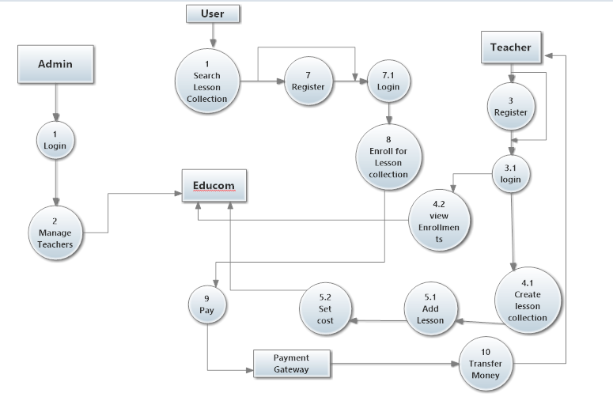

**6.2 ER Diagram**

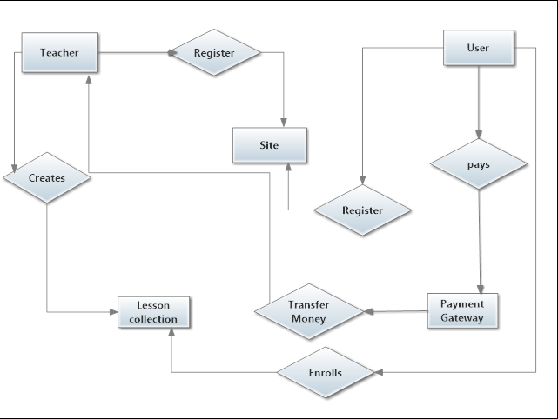

***7 TESTING***

**7.1 Test Phases**

The basic goal of the software development process is to produce software that as no errors or very few errors. In an effort to detect errors soon after they are introduced, each phase ends with verification activity such as a review.

As testing is the last phase before the final software is delivered, it has the enormous responsibility of detecting any type of error that may in the software. Software typically undergoes changes even after it has been delivered. And to validate that a change has not affected some old functionality of software regression testing is performed.

**Levels of Testing:**

The basic levels of testing are unit testing, integration testing and system and acceptance testing. These different levels of testing attempt to detect different types of faults.

|  |  |
| --- | --- |
| Client Needs | Acceptance Testing |
| Requirements | System Testing |
| Design | Integration Testing |
| Code | Unit Testing |

**Acceptance Testing:**

Acceptance was performed in the real environment with realistic data of the client to demonstrate if the software developed is working satisfactorily. Here the main focus was on the external behavior of the system; the internal logic of the program was not emphasized.

**System Testing:**

System testing is performed on the entire system in the context of a Functional Requirement Specification(s) (FRS) and/or a System Requirement Specification (SRS). System testing tests not only the design, but also the behaviour and even the believed expectations of the customer. It is also intended to test up to and beyond the bounds defined in the software/hardware requirements specification(s).

**Unit Testing:**

During the phase of unit testing different constituent modules were testing against the specifications produced during the design for the modules. Unit testing is essentially for the verification of the code produced during the coding the phase, and goal is to test the internal logic of the modules. The modules once tested were then considered for integration and use by others.

**Integration Testing:**

The next level testing that was performed is often referred to as integration testing. During this phase many unit tested modules were combined into subsystems, which were then tested. The goal here was to see if modules can be integrated properly. Here the emphasis was on testing interfaces between different constituent modules of system.

**7.2 Snapshots**

1. tbuser

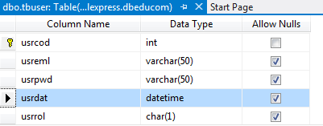

1. tbprf

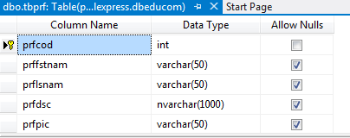

1. tbcat

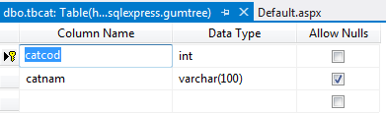

1. tblescol

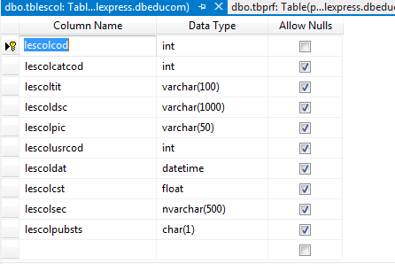

1. tbles

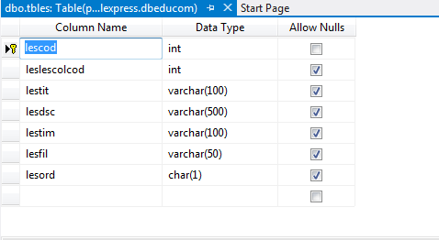

1. tblesatt

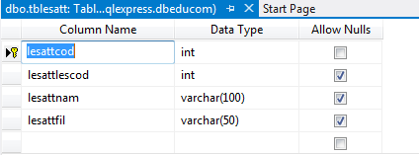

1. tblesexr

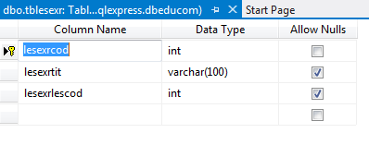

1. tbqst

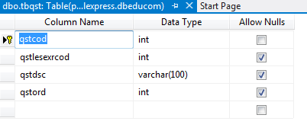

1. tbopt

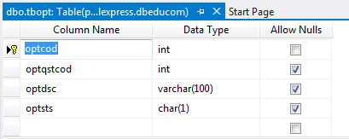

1. tbenr

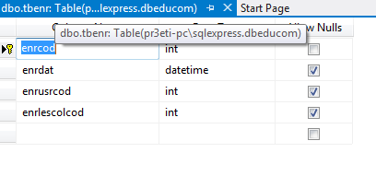

1. tbdis

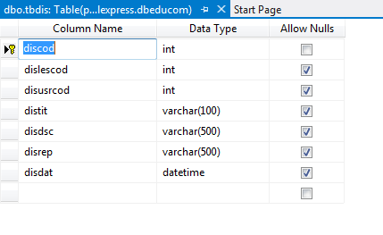

**Stored Procedures :** 5 Procedures Associated with Each table for

Insert, Delete, Select, Update & Find

1. tbuser

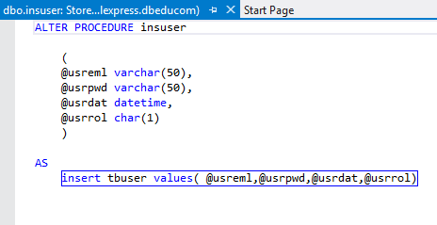

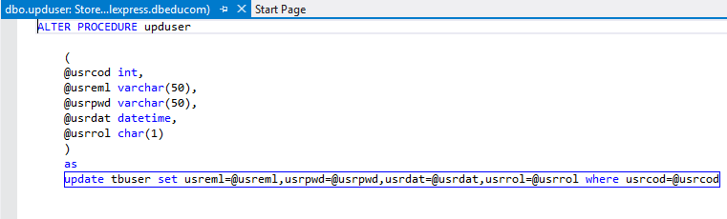

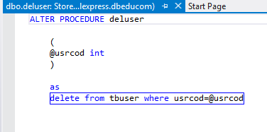

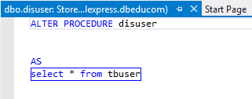

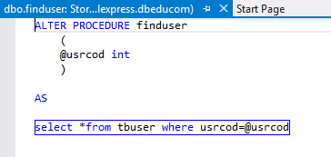

‘

1. tbprf

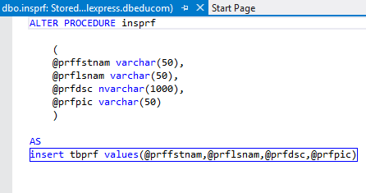

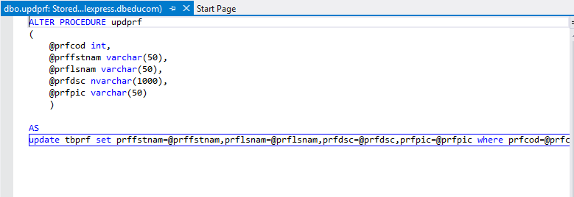

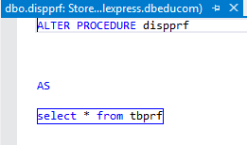

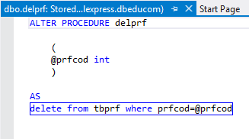

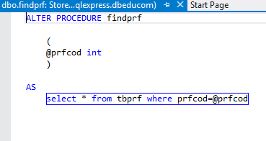

1. tbqst

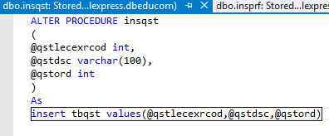

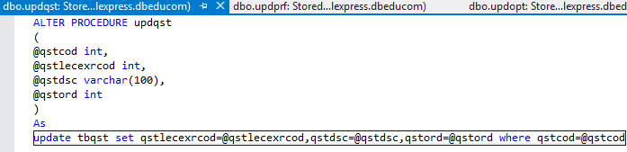

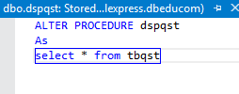

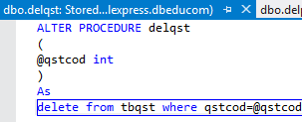

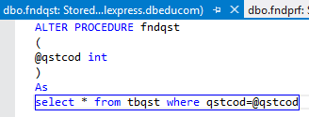

1. tbdis

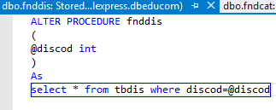

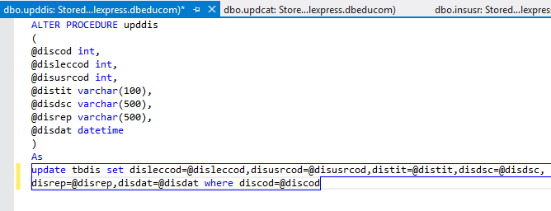

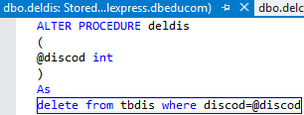

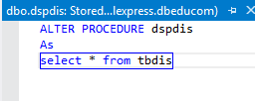

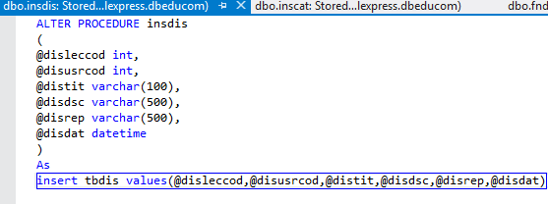

1. tbenr

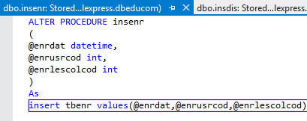

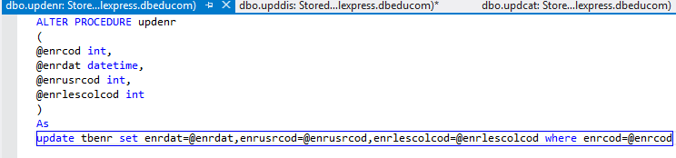

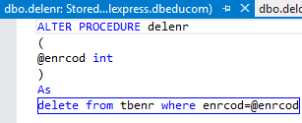

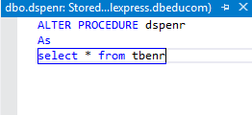

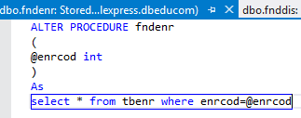

1. tbles

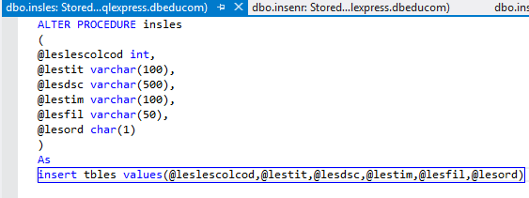

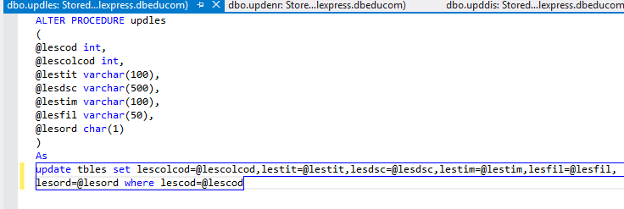

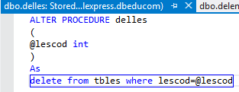

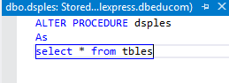

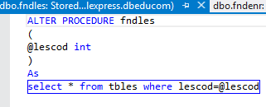

1. tblesatt

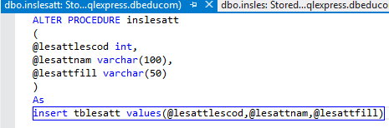

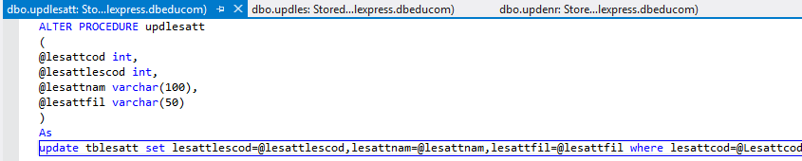

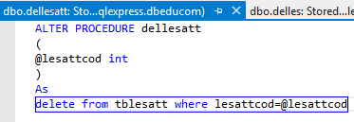

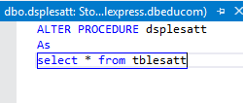

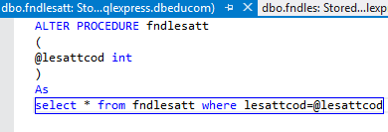

1. tblescol

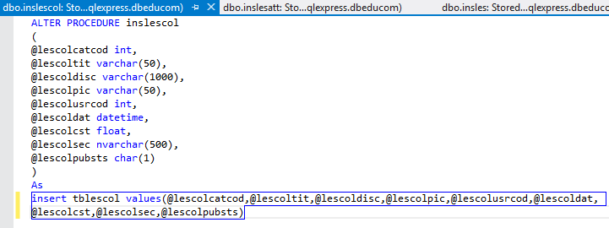

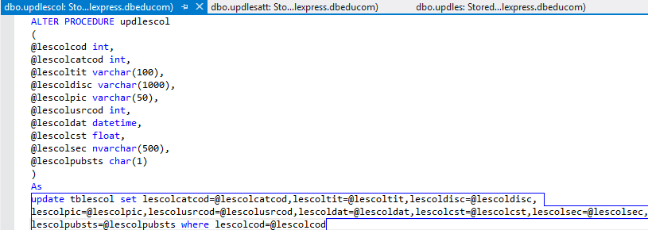

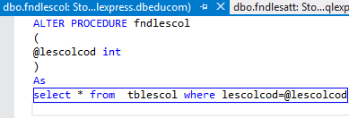

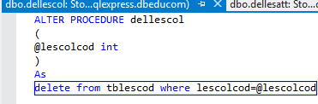

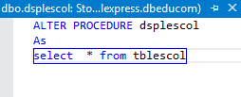

1. tblesexr

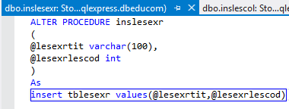

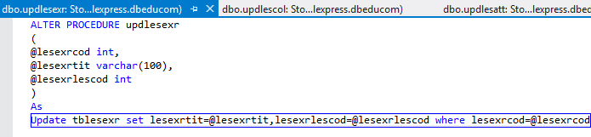

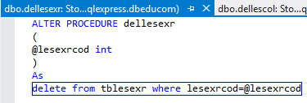

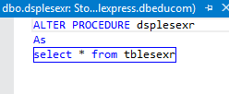

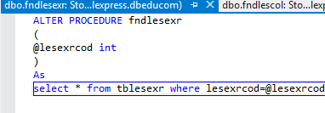

1. tbopt

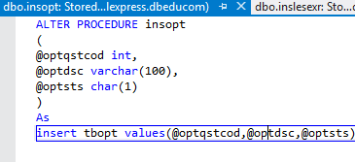

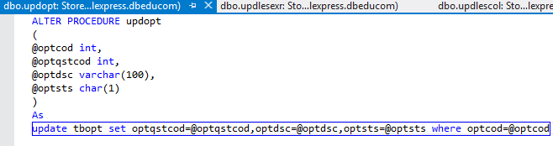

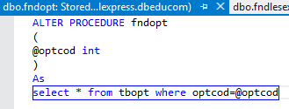

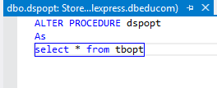

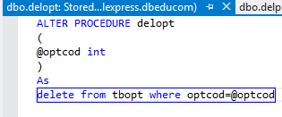

1. tbcat

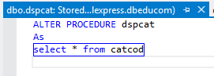

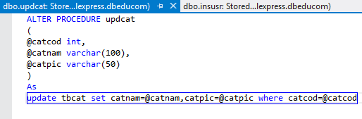

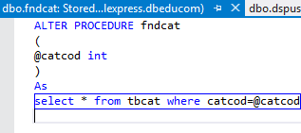

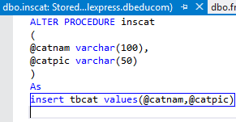

**Business Tier:**It includes

* Interfaces
* Property Classes
* Methods

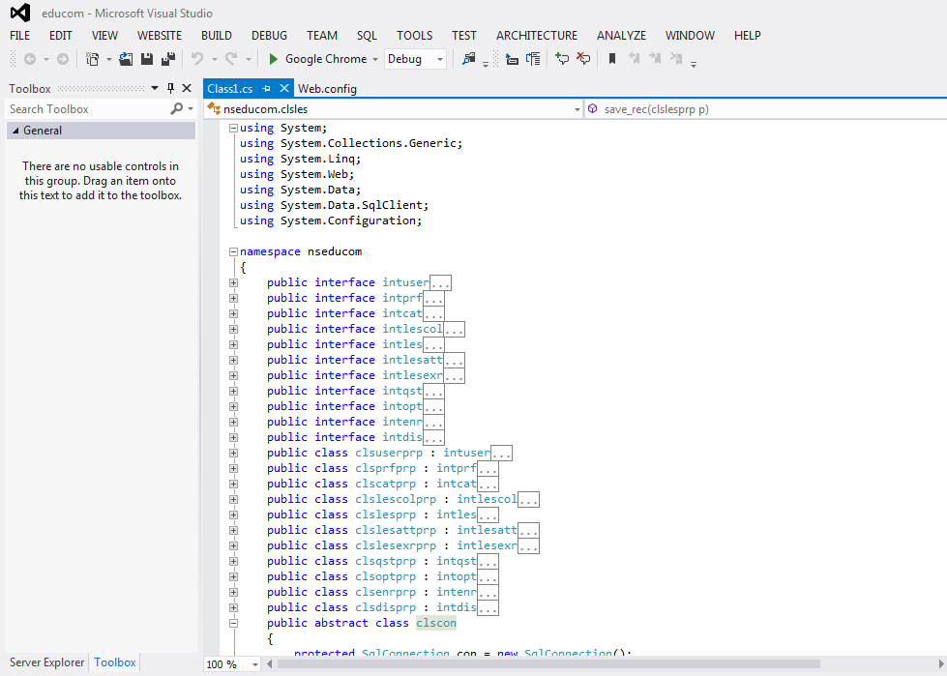

**Presentation Tier:**

**Index Page**

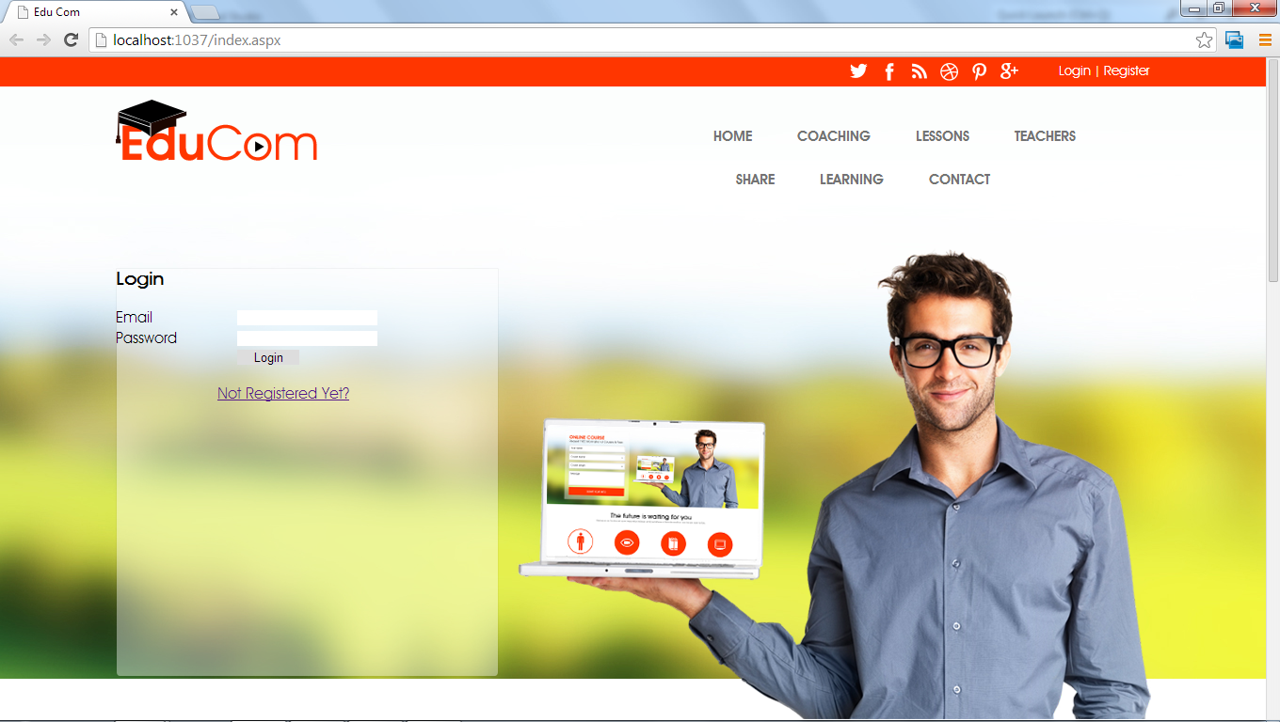

**Admin Login**

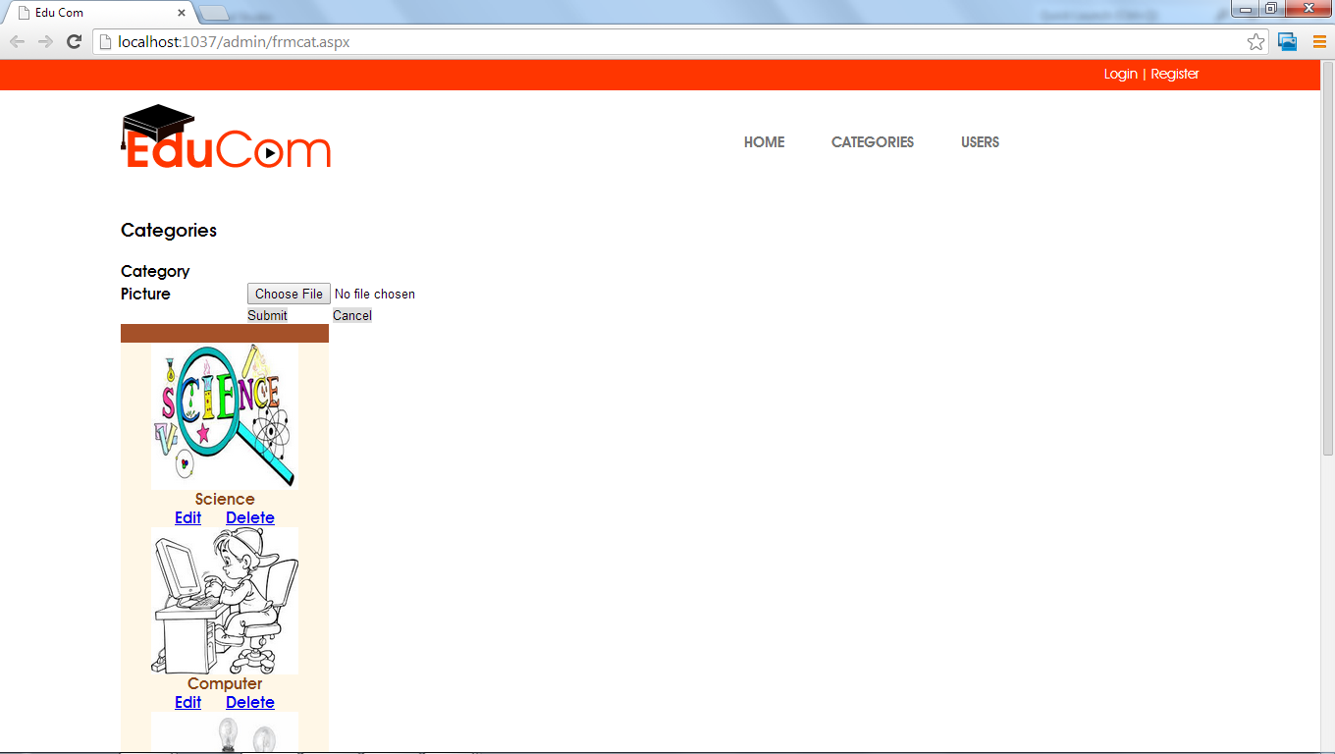

**Teacher Login**

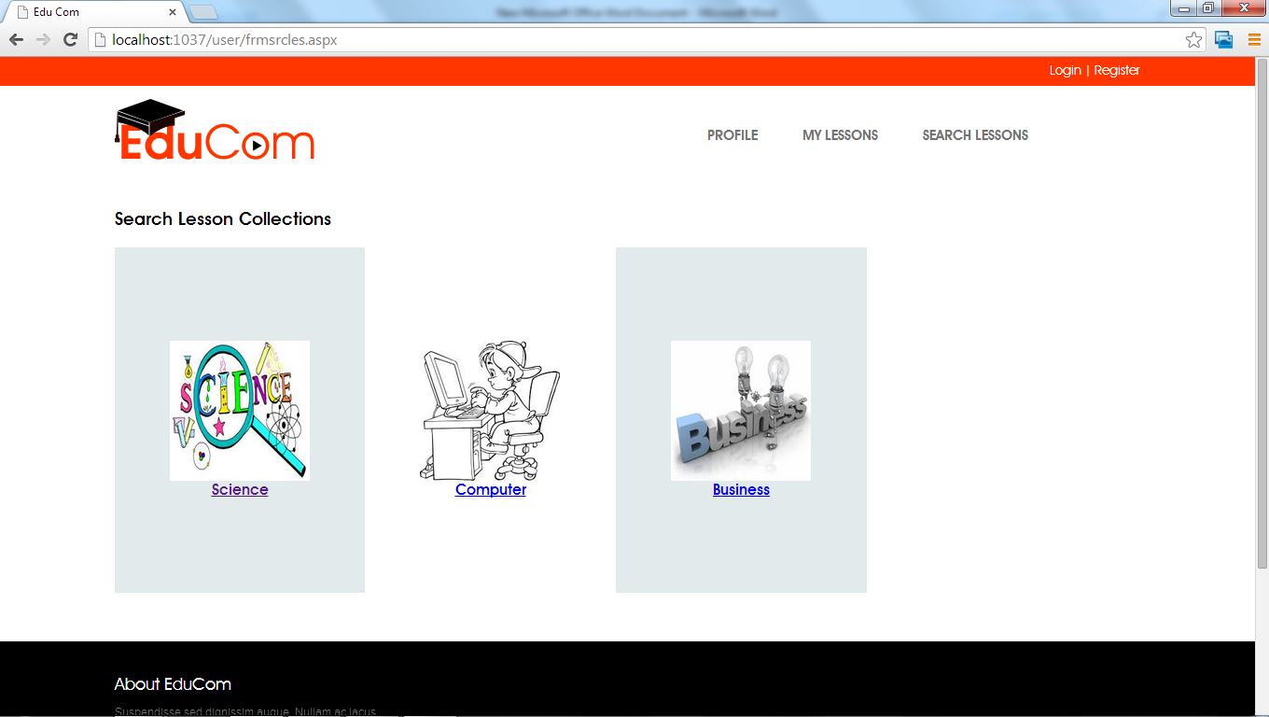

**Published Lessons**

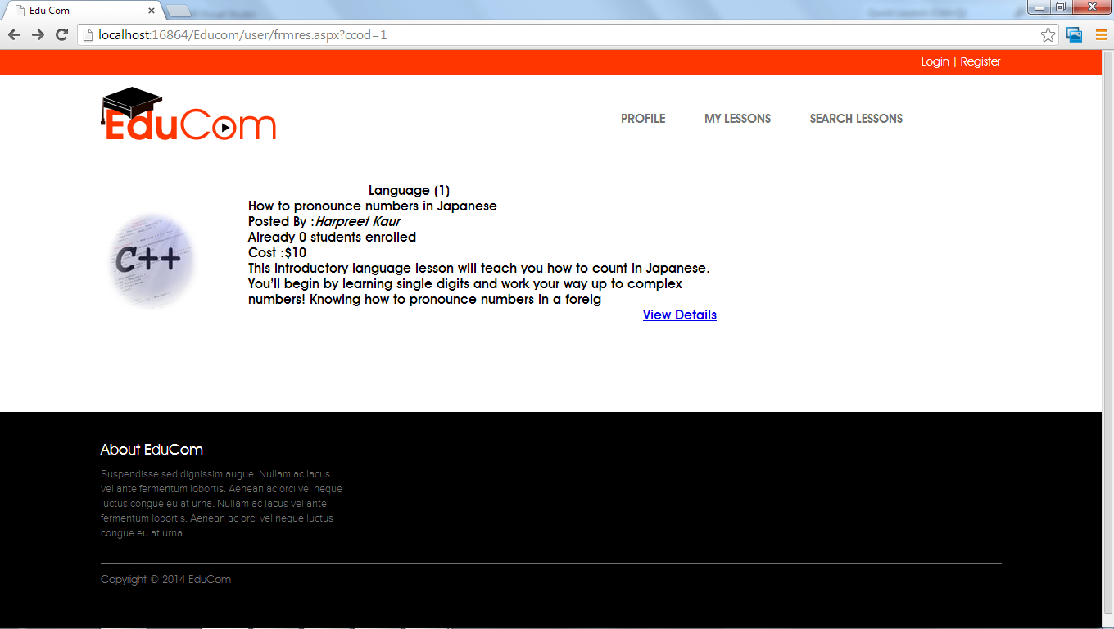

**Teacher’s Profile**

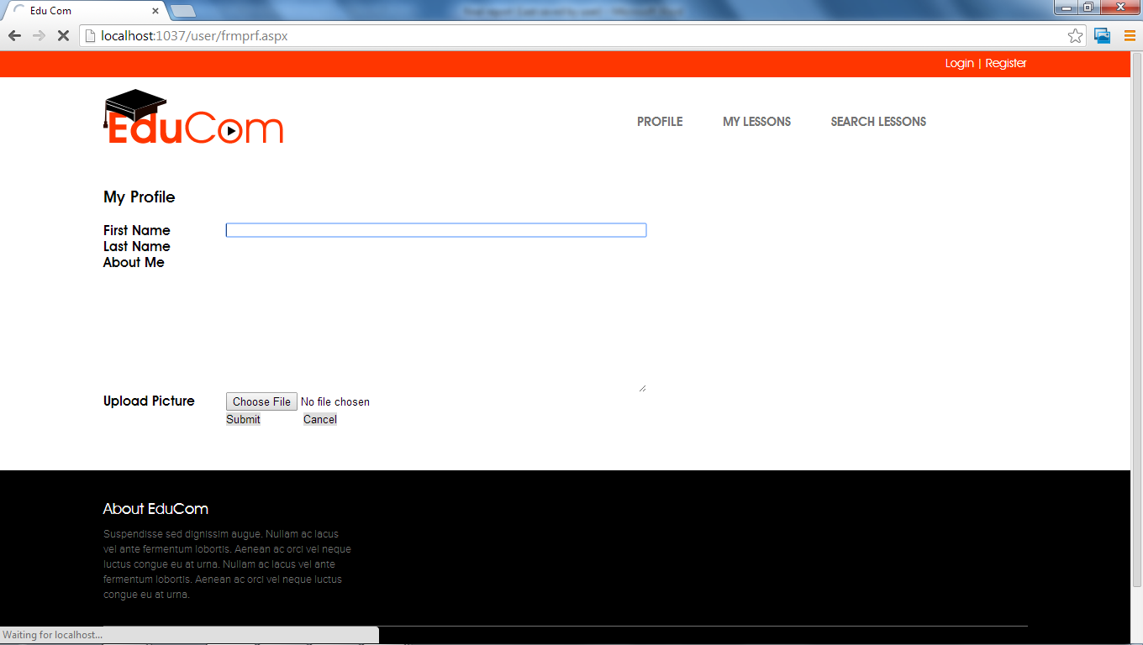

**Teacher Panel**

* **My Lessons**

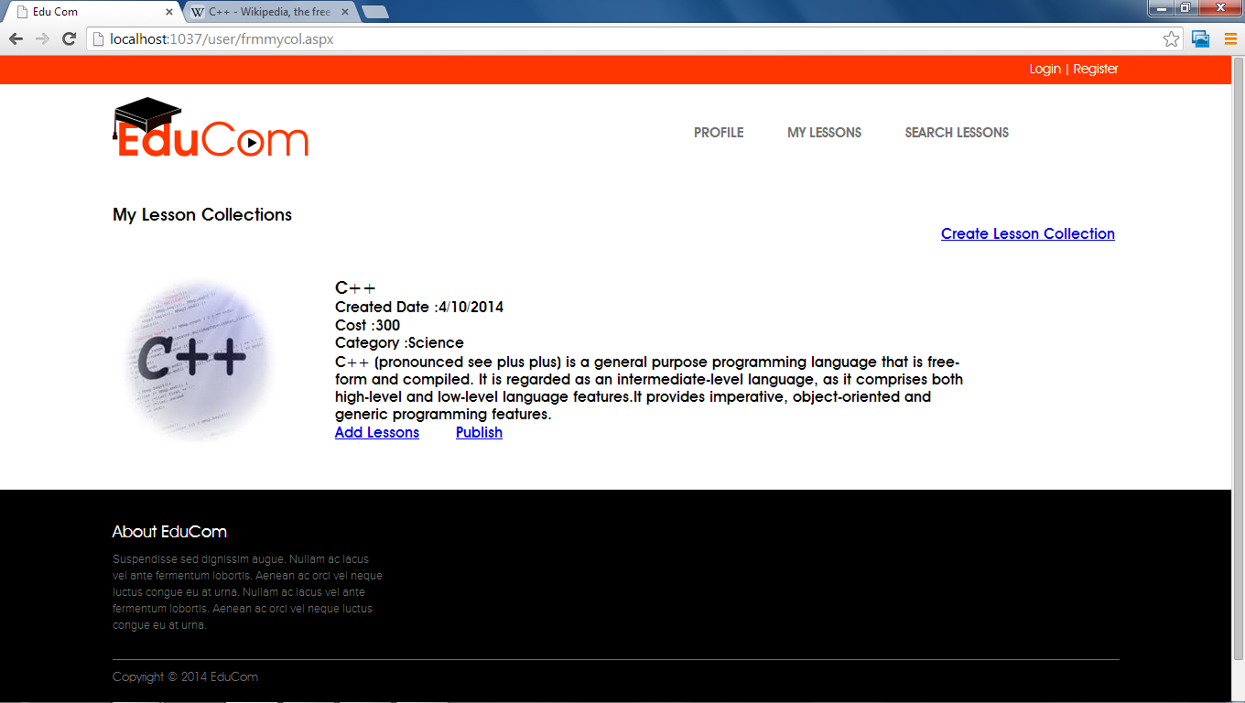

* **Create Lesson Collection**

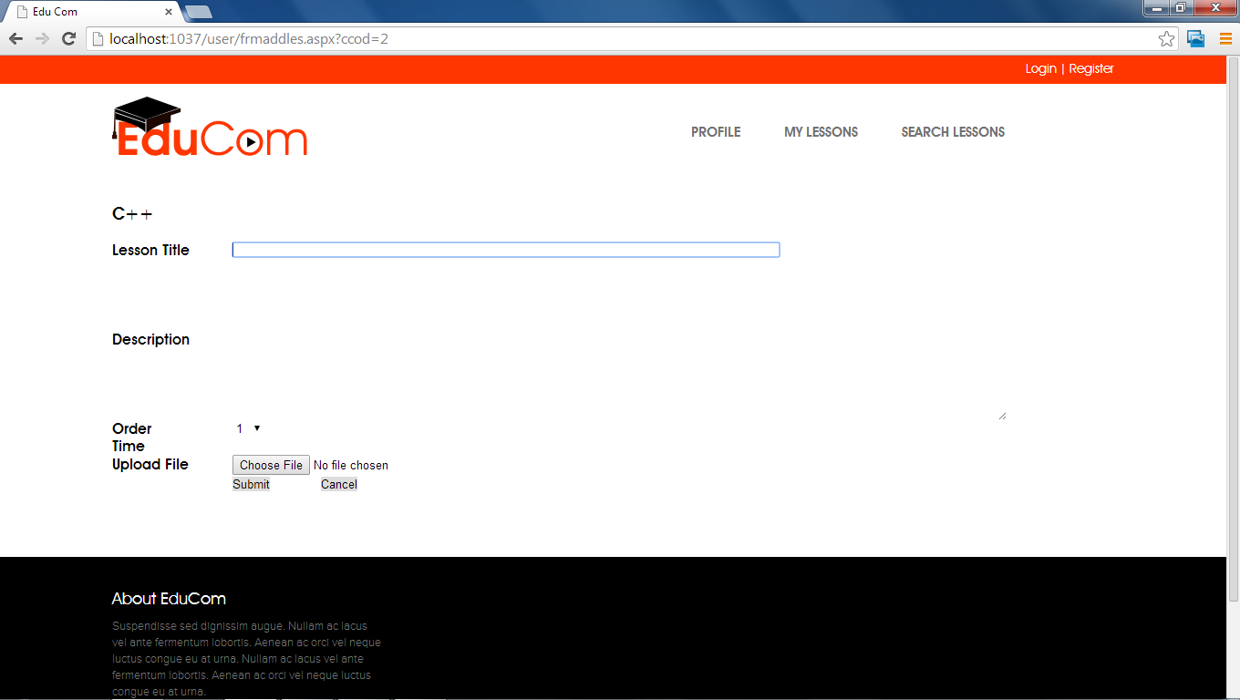

* **Add Attachment or Add Exercise**

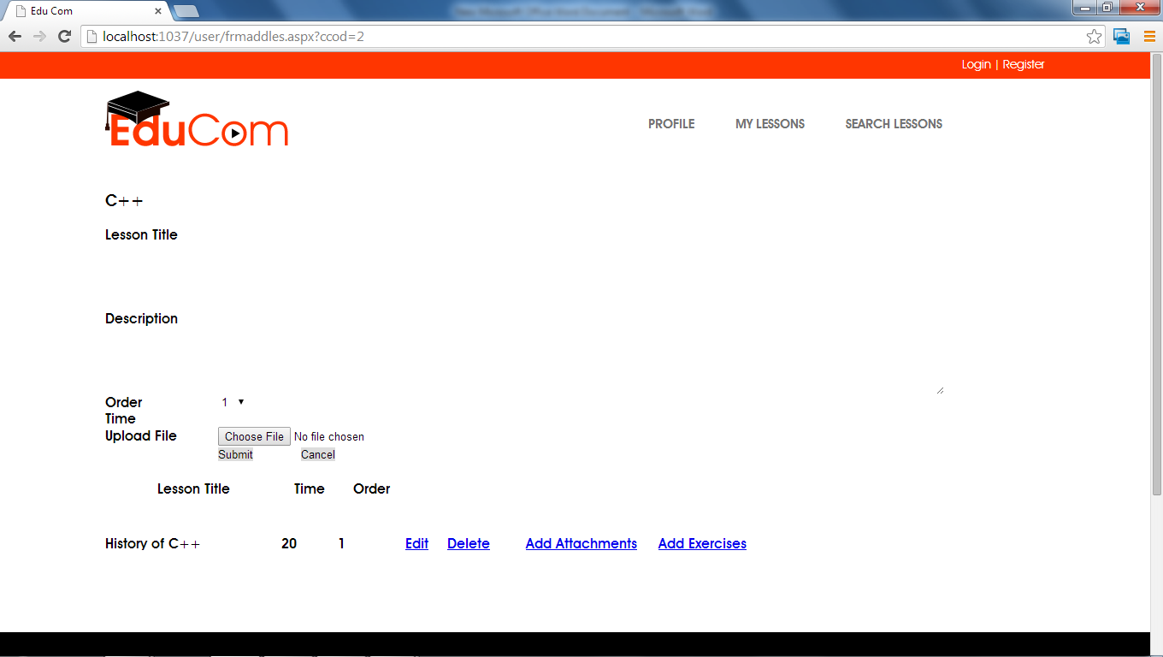

* **Add Attachment**

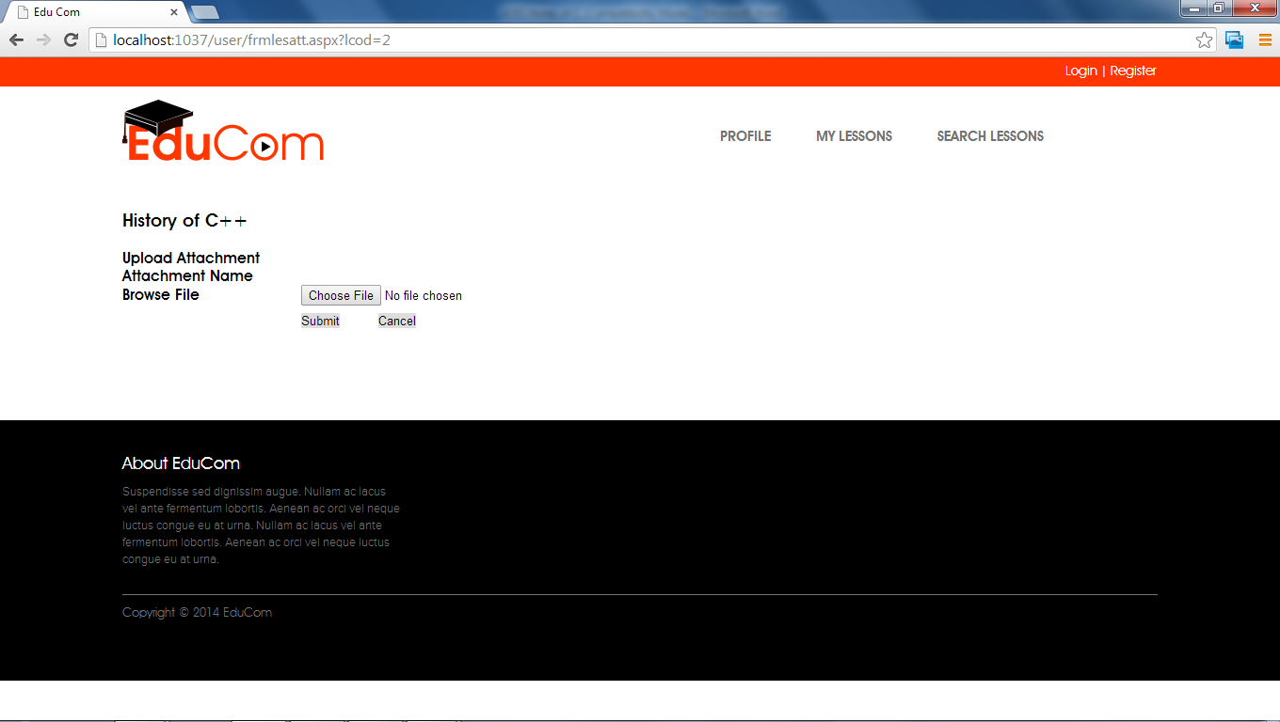

* **Download Attachment**

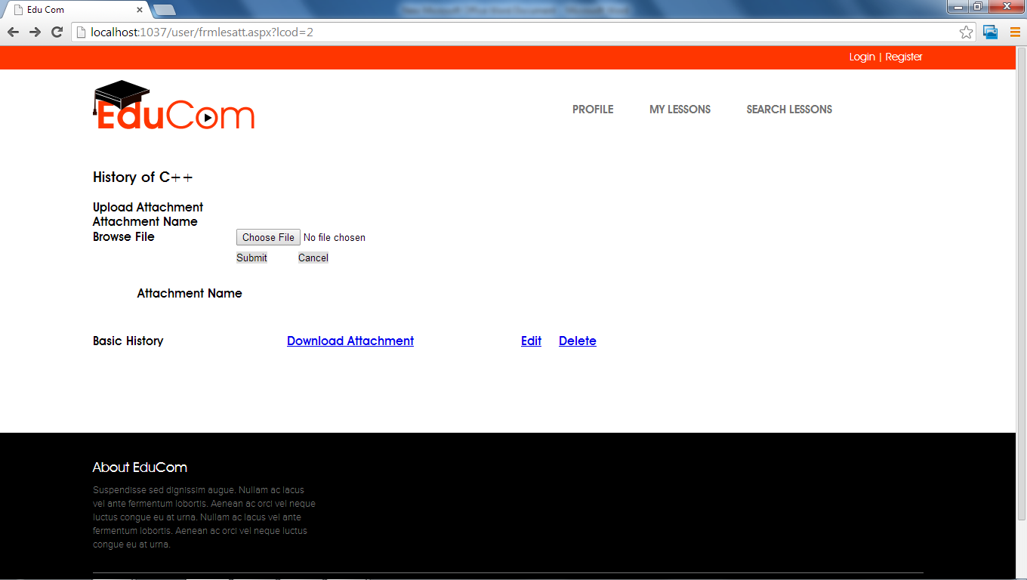

* **Edit Attachment**

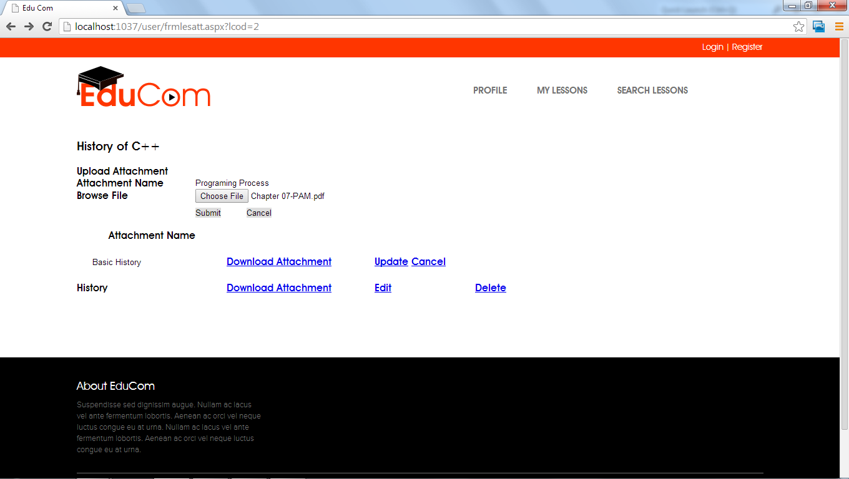

* **Add Exercise**

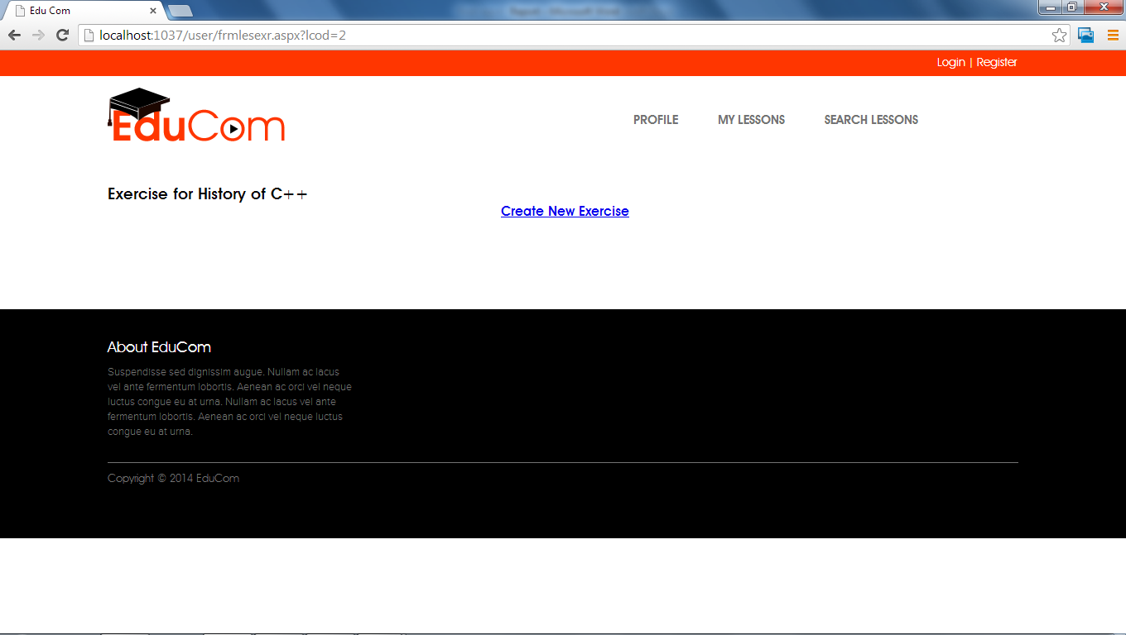

* **Create New Exercise**

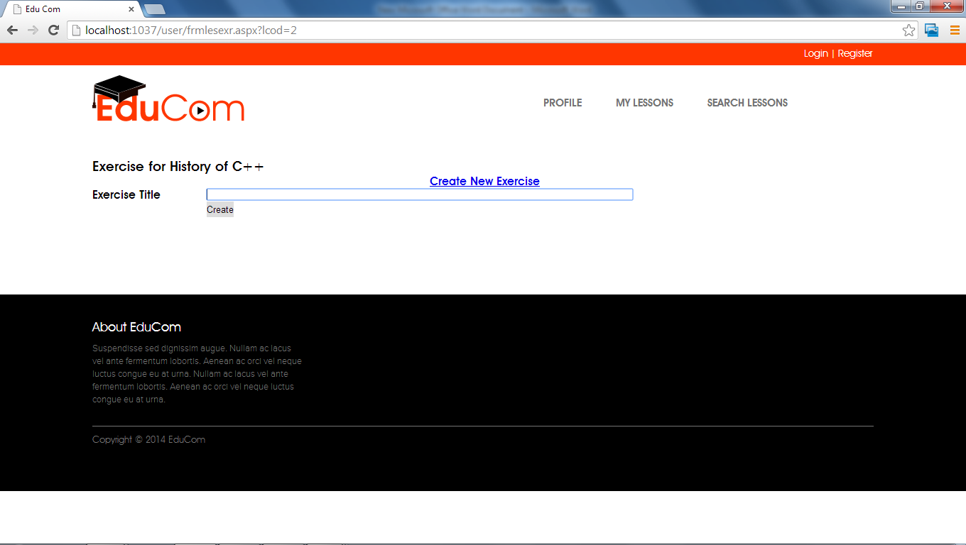

* **View Detail**

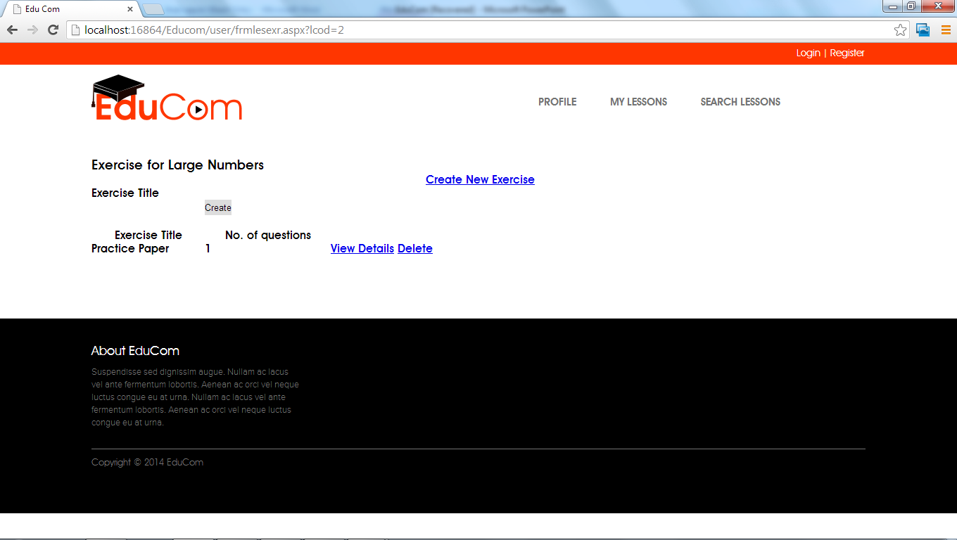

* **Create New Exercise**

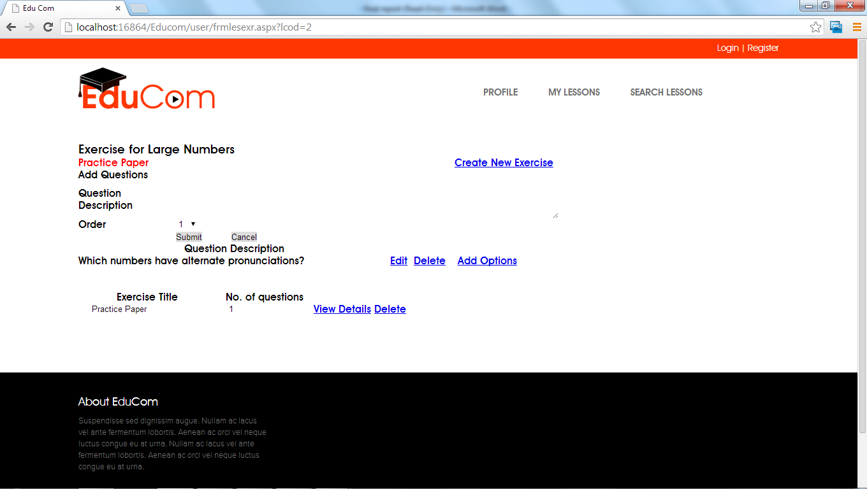

* **Registration Page**

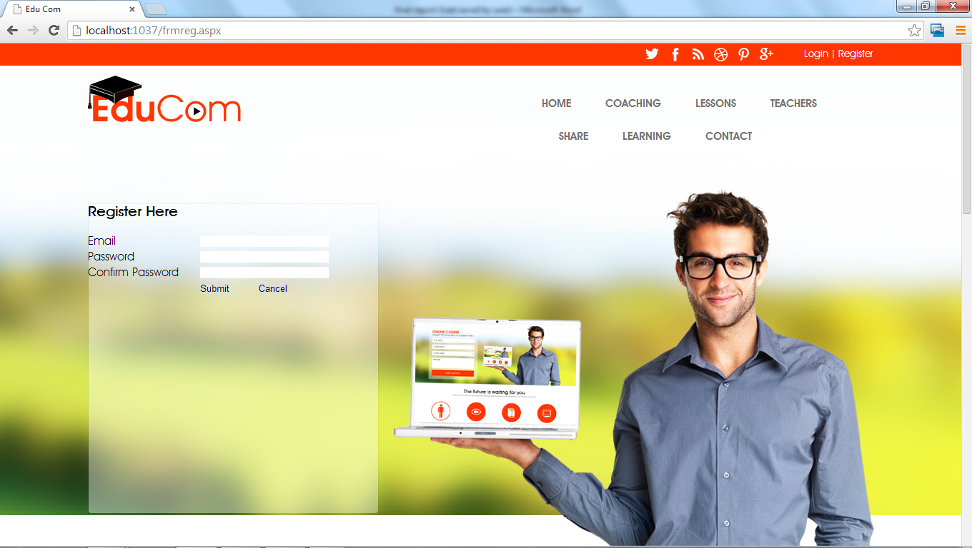

***8 CONCLUSION***

As a member of the team under the guidance of my trainer, I have been educated about the .net technologies .The particular area of EduCom to which my project serves extremely helpful. I am required to understand and learn the intricacy involved in this area. I would design input interfaces, design database, develop code, input test data, output interfaces, and output test data. Completion of the development process will result in a software package that will provide user friendly environment which is very easy to work with, even for people with very little knowledge of computer. Management of various tasks is incorporated in the package and will deliver the required information in a very easy to use and easy to access manner. This package will provide accuracy, efficiency, speed and easiness to the end user.

**9 *FUTURE SCOPE***

At this stage we have made this project for Creating Lesson Collections in which Teachers can add lessons of their choice according to the available lesson collection or they can add new lesson collection various and in admin panel admin can add lesson types .In Future we will implement the various security features and Multilanguage capabilities and various other features that will provide more efficiency and user friendly environment.

***10 BIBLIOGRAPHY***

**Catalogues**

* Training Session Conducted by Company Itself.
* Manual provided by project In charge.

**Websites:-**

* [www.msdn.microsoft.com](http://www.msdn.microsoft.com)
* [www.4guysfromrolla.com](http://www.4guysfromrolla.com)
* [www.w3schools.com/ASPNET](http://www.w3schools.com/ASPNET)