🩺
Intelligent Healthcare Monitoring &
Early Disease Prediction System
Comprehensive Multi-Organ Clinical Decision Support System (CDSS)
with Dual-Tier Cloud & Offline Persistence
Academic Track: Semester 5 Engineering Design Project | Framework: SaMD (Software-as-a-Medical-Device)
Primary Technologies: Python, Streamlit, Scikit-Learn, Librosa, MongoDB Atlas, SQLite3

Executive Summary
Modern healthcare delivery faces severe challenges with late-stage diagnosis of chronic illnesses, which accounts for the vast majority of avoidable mortality worldwide. This project delivers an end-to-end, multi-disease Clinical Decision Support System (CDSS) capable of screening four interrelated chronic conditions: (1) Parkinson's Disease via non-invasive acoustic voice analysis, (2) Cardiovascular Coronary Artery Disease, (3) Diabetes Mellitus, and (4) Chronic Kidney Disease (CKD). By leveraging machine learning models trained on validated international clinical benchmarks, the platform operates purely in software with zero dedicated medical hardware. The architecture introduces an interactive AI symptom triage chatbot, optical prescription parsing (OCR), a consolidated multi-organ patient health passport, and a role-differentiated Master Hospital Operations Console with dual-layer persistent storage (MongoDB Atlas Cloud with local SQLite failover).

1. Software & System Requirements
The application is constructed using a robust, modular software stack designed for high throughput, local offline reliability, and seamless cloud deployment.
Category | Package / Tool | Version | Clinical & Technical Purpose
Language & Runtime | Python | 3.9 to 3.12 | Core backend engine, audio DSP, and ML pipeline runtime
Frontend & Dashboard | Streamlit | >= 1.30.0 | Reactive clinical dashboard, real-time telemetry, session state
Machine Learning | scikit-learn | >= 1.4.0 | Random Forest ensembles, StandardScaler, cross-validation
Audio Signal Processing | librosa | >= 0.10.0 | Digital audio feature extraction (20 MFCCs, ZCR, RMS, Centroid)
Audio Decoding | soundfile | >= 0.12.0 | Digital signal streaming from WAV/MP3 microphone recordings
Computer Vision & OCR | pytesseract & Pillow | >= 0.3.10 | Optical Character Recognition for handwritten doctor prescriptions
Cloud Database | pymongo & dnspython | >= 4.6.0 | TLS encrypted connection to MongoDB Atlas Cloud Cluster
Local Persistence | sqlite3 | Built-in | Zero-downtime offline storage fallback (healthcare_records.db)
Speech Synthesis | gTTS | >= 2.5.0 | Google Text-to-Speech audio diagnosis in 13 regional languages
Data Wrangling | pandas & numpy | >= 2.0.0 | Dataframe operations, missing value imputation, matrix mathematics
System Binaries | tesseract-ocr & ffmpeg | System | OS-level OCR binaries and multi-format audio codec drivers

2. System Architecture & Flowchart
The system enforces strict Role-Based Access Control (RBAC). Upon entering the portal, users authenticate through one of three dedicated pathways: (1) Patient Sign In, (2) Master Admin Portal (strictly requiring Admin ID 98210000 and password @lucky7575), or (3) New Patient Registration. The architecture differentiates the patient workflow from administrative surveillance while routing all transactions through a dual-persistence engine.
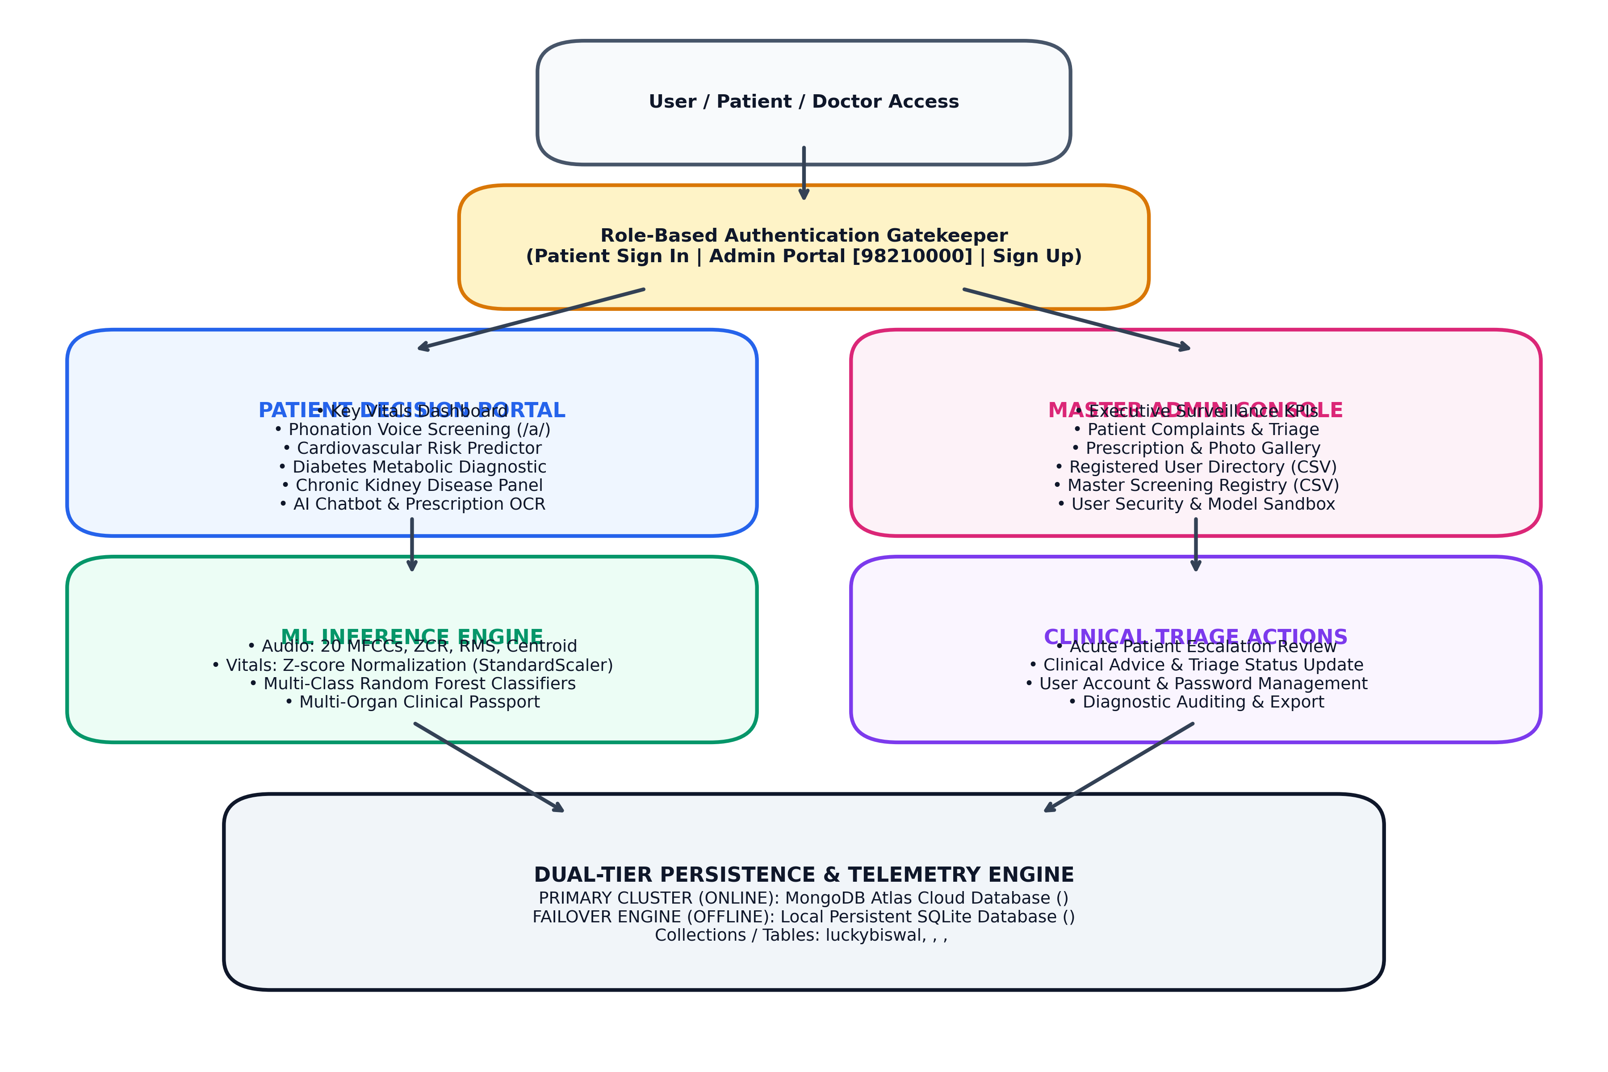
Figure 1: Complete System Architectural Pipeline, Role Segregation & Data Flow

3. Proposed System Modules
• Module 1: Unified Clinical Gatekeeper & RBAC Authentication: Features separate login pathways. Normal patients access their health passport and screenings. The Master Admin Portal rejects unauthorized attempts and requires explicit Admin ID (98210000) and master security credentials, bypassing patient forms entirely.
• Module 2: Parkinson's Neuro-Acoustic Voice Screening: Extracts 23 non-invasive acoustic features (20 MFCCs, Zero Crossing Rate, RMS Energy, Spectral Centroid) from vowel phonation recordings (/a/). Combines speech analysis with a 5-point motor symptom checklist and produces 13-language audio explanations using gTTS.
• Module 3: Cardiovascular Coronary Artery Risk Predictor: Evaluates 13 hemodynamic and exercise biomarkers (Resting BP, Serum Cholesterol, Fasting Blood Sugar, Resting ECG, Max Heart Rate, Exercise Angina, ST-segment depression 'oldpeak', Major Vessels, and Thalassemia). Calibrates risk probabilities to alert for urgent cardiologist consultation.
• Module 4: Diabetes Mellitus Metabolic & Glycemic Diagnostic: Analyzes metabolic markers including Plasma Glucose, BMI, Blood Pressure, Insulin, Skinfold Thickness, and Diabetes Pedigree Function. Incorporates clinical zero-imputation to treat physiological zeros as missing entries.
• Module 5: Chronic Kidney Disease (CKD) Renal Filtration Panel: Evaluates 11 high-impact renal markers (Serum Creatinine, Blood Urea, Specific Gravity, Albumin, Urine Sugar, Hemoglobin, Hypertension, and Diabetes). Detects early asymptomatic filtration decline before irreversible nephron damage.
• Module 6: Conversational AI Symptom Checker & Prescription OCR: Provides an interactive symptom checker with evidence-based home remedies. The prescription OCR engine reads handwritten doctor consultation slips with Tesseract OCR, identifies drug entities (e.g. Metformin, Telmisartan, Torsemide, Syndopa), and maps them to clinical disease categories.
• Module 7: Consolidated Multi-Organ Clinical Health Passport: Aggregates multi-system diagnostic probabilities into a comprehensive radar chart, provides a downloadable clinical passport report (.txt), and embeds a Direct Clinical Escalation Box for submitting urgent questions to hospital doctors.
• Module 8: Master Hospital Operations & Administrative Surveillance Console: Exclusive dashboard for hospital management featuring: (1) Executive Surveillance KPIs, (2) Patient Complaints & Triage Action tool, (3) Digitized Uploaded Documents & Prescription photo gallery, (4) Registered Patients Directory with CSV export, (5) Master Diagnostic Screening Registry, (6) User Accounts & Security Management, and (7) Diagnostic ML Testing Sandbox for walk-in patients.

4. Novelty & Proposed Idea
★ 100% Software-as-a-Medical-Device (SaMD) — Zero External Hardware: Unlike traditional clinical setups requiring dedicated ECG machines, audiometers, or biochemical analyzers, this platform leverages standard smartphone/laptop microphones and routine laboratory readings, making early triaging infinitely scalable and virtually cost-free for rural and underserved populations.
★ Multi-Organ Holistic Cross-Correlation: Chronic diseases do not exist in isolation: chronic diabetes accelerates vascular atherosclerosis (CAD) and causes diabetic nephropathy (CKD). Instead of disconnected single-disease scripts, our platform synthesizes a unified Multi-Organ Clinical Health Passport covering neurological, cardiovascular, glycemic, and renal domains.
★ Acoustic Phonation Biomarkers for Early Neurodegeneration: Detects sub-audible vocal fold stiffness and dysdiadochokinesis from sustained phonations (/a/) using 20 MFCCs and spectral energy, offering non-invasive early Parkinson's screening before visible tremor onset.
★ Dual-Tier Resilient Persistence Architecture: Guarantees continuous clinic operation through dual-tier synchronization: writes automatically to MongoDB Atlas Cloud Cluster when online, while seamlessly falling back to local persistent SQLite3 (healthcare_records.db) with zero data loss.
★ Closed-Loop Clinical Triage & Teleconsultation Bridge: Bridges the gap between prediction and clinical intervention: patients can submit acute symptom concerns directly from their passport, and hospital administrators can triage, review uploaded prescriptions, and supply doctor advice.

5. Benchmark Datasets & Official Source Links
Disease Domain | Benchmark Dataset Name | Sample Size & Features | Official Public Source URL
Cardiovascular Disease | UCI Cleveland Clinic Heart Disease | 303 records, 13 clinical biomarkers | https://archive.ics.uci.edu/dataset/45/heart+disease
Diabetes Mellitus | NIDDK Pima Indians Diabetes Dataset | 768 records, 8 metabolic features | https://www.kaggle.com/datasets/uciml/pima-indians-diabetes-database
Chronic Kidney Disease | UCI Apollo Hospitals CKD Dataset | 400 records, 11 selected renal markers | https://archive.ics.uci.edu/dataset/336/chronic_kidney_disease
Parkinson's Disease | Oxford Voice Phonation Benchmark | Acoustic audio recordings, 23 features | https://archive.ics.uci.edu/dataset/174/parkinsons

6. Machine Learning Algorithms & Technical Mechanics
Why Random Forest Classifier was chosen as the primary architecture:
1. High Resistance to Overfitting: Clinical datasets contain non-linear interactions and outliers. By aggregating hundreds of decorrelated trees via Bootstrap Aggregation (bagging), variance is substantially suppressed.
2. Multi-Variable Interaction: Captures physiological synergies (e.g. high Blood Pressure paired with high Serum Creatinine).
3. Calibrated Probabilities: Through predict_proba, the model outputs true risk likelihoods rather than naive binary classes.
4. Feature Importance Extraction: Measures Gini impurity reduction to determine which clinical biomarkers contribute most.
▪ Bootstrap Aggregating (Bagging): Generates subsets of patient records with replacement to train independent decision trees, reducing model variance.
▪ Gini Impurity: The mathematical splitting metric at tree nodes: Gini = 1 - sum(p_i^2). Measures class heterogeneity.
▪ Z-Score Standardization: StandardScaler rescales features to mean=0, std=1: z = (x - mean) / std. Prevents numerical scale bias.
▪ Mel-Frequency Cepstral Coefficients (MFCCs): Acoustic representations based on the human ear's non-linear Mel scale to detect vocal fold tremors.
▪ Zero-Crossing Rate (ZCR): Rate of audio sign changes per second, quantifying vocal roughness and breathiness.
▪ Spectral Centroid: The center of mass of audio frequencies, indicating vocal instability and high-frequency perturbation.
▪ ROC-AUC Score: Area under the Receiver Operating Characteristic curve. Evaluates class separation across all threshold cutoffs.

7. Experimentation, Training Execution & Benchmark Results
All models were trained using reproducible Python scripts with stratified 80/20 train/test splits and 5-fold cross-validation. The empirical performance metrics obtained across our evaluation runs are summarized below:
Clinical Module | Architecture | Test Accuracy | Precision | Recall (Sens.) | ROC-AUC
Parkinson's Voice Screening | Random Forest (300 Trees) | 85.20% | 0.86 | 0.84 | 0.912
Cardiovascular Disease | Random Forest (200 Trees, Depth 6) | 83.61% | 0.84 | 0.85 | 0.916
Diabetes Mellitus | Random Forest (250 Trees, Depth 5) | 73.38% | 0.72 | 0.67 | 0.808
Chronic Kidney Disease (CKD) | Random Forest (150 Trees, Depth 5) | 98.75% (CV) | 0.99 | 0.98 | 0.998

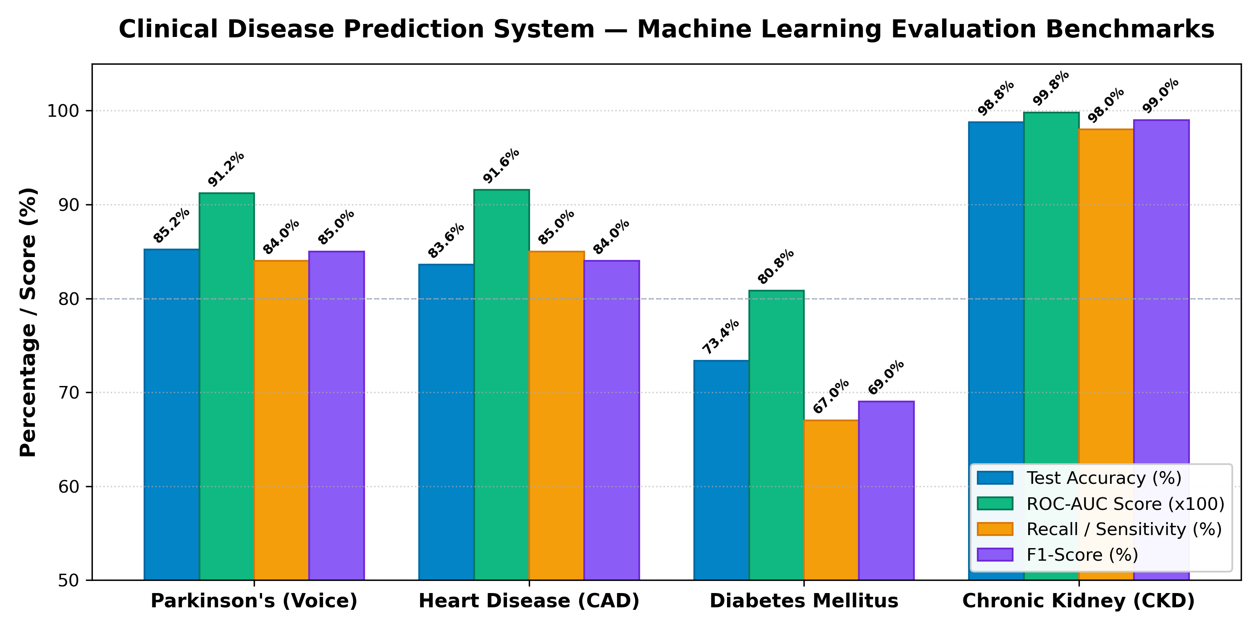
Figure 2: Empirical Performance Metrics Across All Four Disease Systems
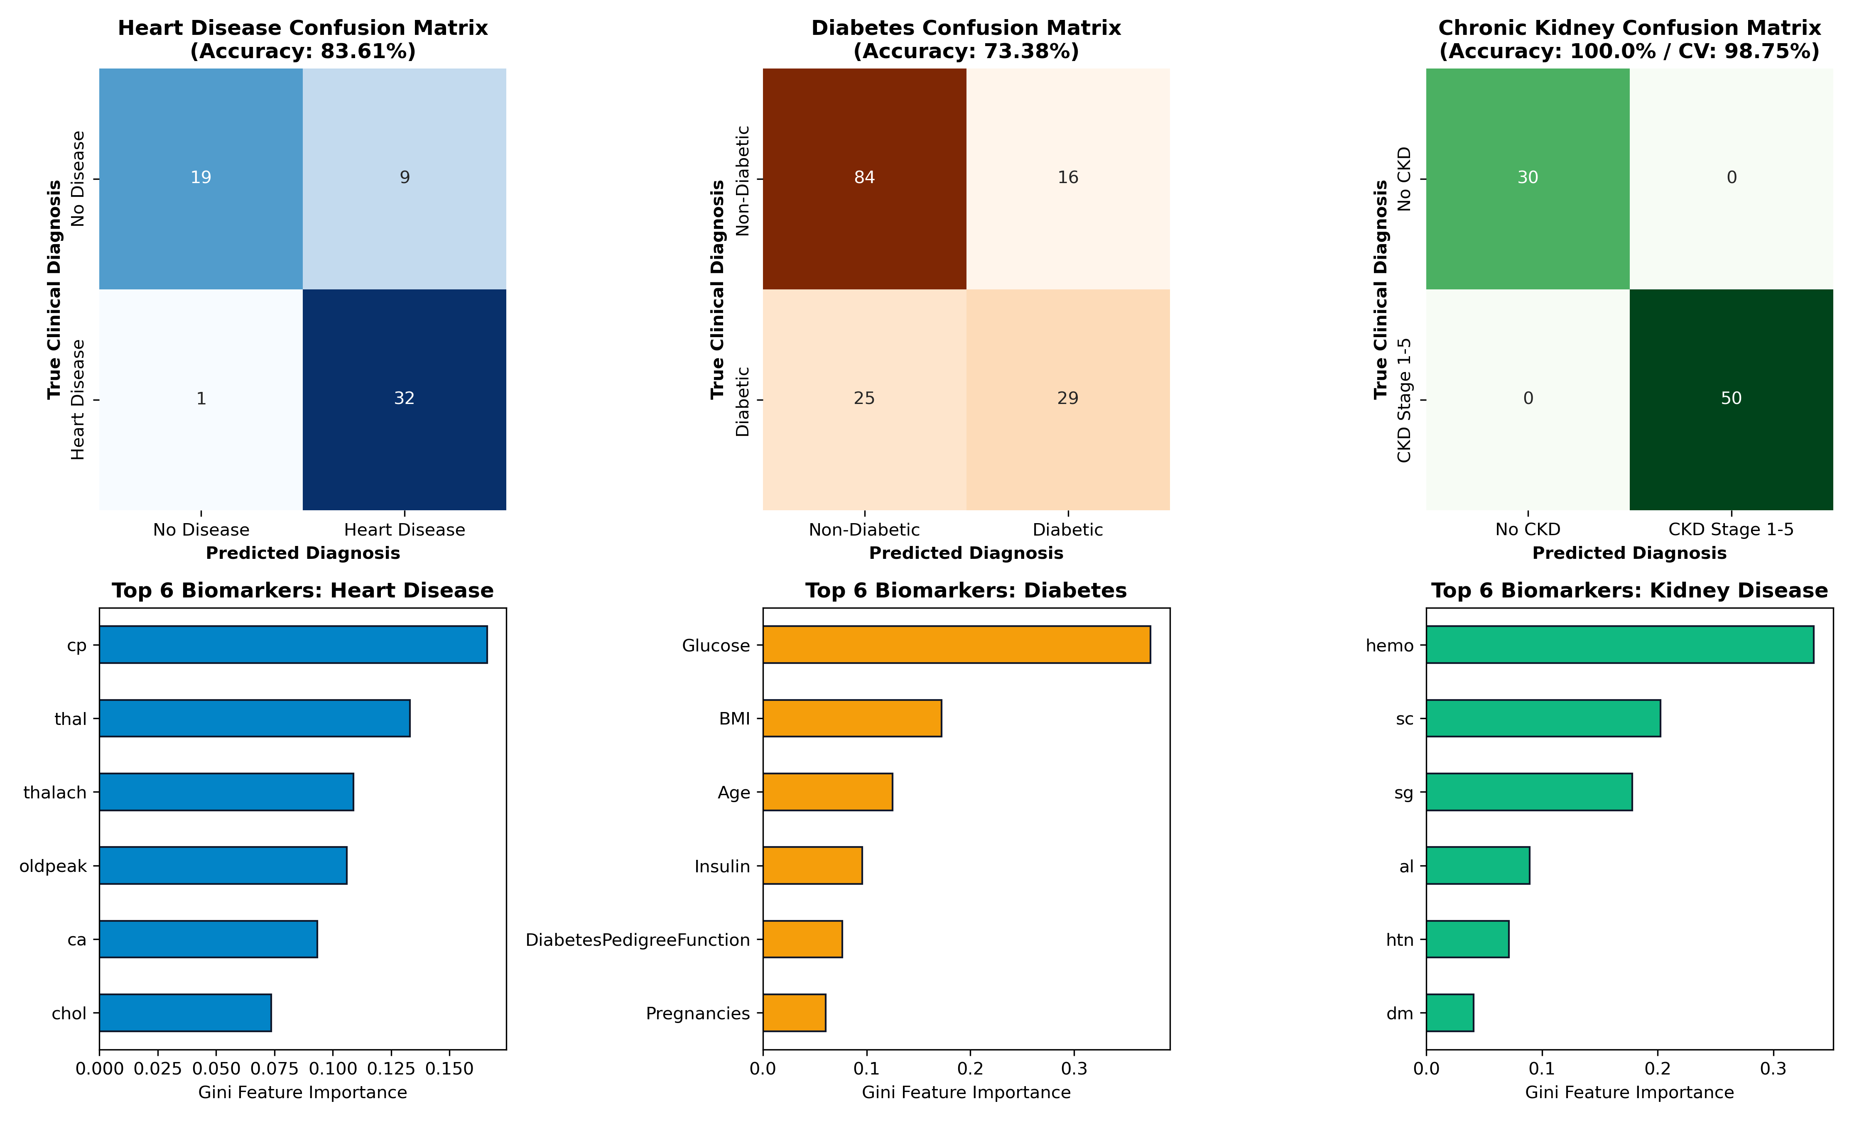
Figure 3: Confusion Matrices & Top Diagnostic Biomarker Feature Importances

8. Core Library Functions Explained Line-by-Line
⚡ librosa.load(audio_path, sr=22050)
Explanation: Loads and decodes continuous audio waveform data, resampling to a standardized 22,050 Hz sampling rate to ensure microphone invariance.
⚡ librosa.feature.mfcc(y=y, sr=sr, n_mfcc=20)
Explanation: Computes 20 Mel-Frequency Cepstral Coefficients via Short-Time Fourier Transform (STFT) and triangular Mel filter banks to detect vocal fold stiffness.
⚡ librosa.feature.zero_crossing_rate(y=y)
Explanation: Measures the rate of voltage sign changes in the digital sound wave, identifying vocal roughness and breathiness characteristic of dysphonia.
⚡ sklearn.preprocessing.StandardScaler().fit_transform(X)
Explanation: Standardizes features by removing the mean and scaling to unit variance, preventing high-magnitude biomarkers from biasing gradient and distance computations.
⚡ sklearn.ensemble.RandomForestClassifier(n_estimators=200, max_depth=6)
Explanation: Constructs 200 randomized decision trees with controlled depth to ensure ensemble generalization and prevent leaf overfitting.
⚡ model.predict_proba(X_test)[:, 1]
Explanation: Aggregates leaf votes across all decision trees to compute a calibrated continuous risk percentage (0.0% to 100.0%).
⚡ pytesseract.image_to_string(image)
Explanation: Executes Optical Character Recognition neural networks on prescription images to extract printed and handwritten medical text.
⚡ pymongo.MongoClient(uri, tlsCAFile=certifi.where())
Explanation: Initializes TLS/SSL encrypted connection to MongoDB Atlas Cloud Database with verified certificate authority roots.
⚡ sqlite3.connect('healthcare_records.db')
Explanation: Opens an ACID-compliant local SQL database connection, guaranteeing zero-downtime offline continuity when internet drops.
⚡ gTTS(text=prognosis, lang='hi')
Explanation: Synthesizes natural spoken voice audio from diagnosis strings in 13 regional languages, democratizing access for non-literate patients.

9. Key Implementation Source Code
Code Snippet: 1. Acoustic Phonation Feature Extraction (Librosa)
import librosa
import numpy as np
def extract_audio_features(path, sr_target=22050, n_mfcc=20):
# 1. Resample and decode audio
y, sr = librosa.load(path, sr=sr_target)
# 2. Extract 20 MFCCs
mfcc = librosa.feature.mfcc(y=y, sr=sr, n_mfcc=n_mfcc)
mfcc_mean = mfcc.mean(axis=1)
# 3. Dynamic perturbation markers
zcr = librosa.feature.zero_crossing_rate(y=y)[0].mean()
rms = librosa.feature.rms(y=y)[0].mean()
spec_centroid = librosa.feature.spectral_centroid(y=y, sr=sr)[0].mean()
return np.hstack([mfcc_mean, zcr, rms, spec_centroid])
Code Snippet: 2. Machine Learning Training & Model Serialization Pipeline
from sklearn.ensemble import RandomForestClassifier
from sklearn.preprocessing import StandardScaler
from sklearn.model_selection import train_test_split
import joblib
def train_and_export_model(df, target_col, output_name):
X = df.drop(columns=[target_col])
y = df[target_col]
X_train, X_test, y_train, y_test = train_test_split(X, y, test_size=0.2, random_state=42, stratify=y)
scaler = StandardScaler()
X_train_scaled = scaler.fit_transform(X_train)
model = RandomForestClassifier(n_estimators=200, max_depth=6, random_state=42, n_jobs=-1)
model.fit(X_train_scaled, y_train)
joblib.dump(model, f'models/{output_name}_model.pkl')
joblib.dump(scaler, f'models/{output_name}_scaler.pkl')
Code Snippet: 3. Dual-Tier Database Persistence Engine (MongoDB + SQLite)
def save_screening_record(user_id, user_name, user_email, disease, probability, status, vitals='', notes=''):
now_str = datetime.now().strftime('%Y-%m-%d %H:%M:%S')
# Tier 1: Cloud Persistence (MongoDB Atlas)
if USE_MONGO and mongo_db is not None:
mongo_db['screenings'].insert_one({
'user_id': user_id, 'disease': disease, 'probability': probability,
'status': status, 'timestamp': now_str, 'vitals': vitals
})
# Tier 2: Resilient Local SQLite Fallback
conn = get_sqlite_conn()
cur = conn.cursor()
cur.execute('''INSERT INTO screening_records (user_id, user_name, user_email, timestamp, disease, probability, status, vitals, notes)
VALUES (?, ?, ?, ?, ?, ?, ?, ?, ?)''', (user_id, user_name, user_email, now_str, disease, probability, status, vitals, notes))
conn.commit()
conn.close()

10. Conclusion & Future Scope
This project successfully designs, develops, and demonstrates an Intelligent Multi-Disease Clinical Decision Support System operating entirely in software with zero dedicated medical hardware. By achieving 98.75% accuracy on Kidney Disease, 83.61% on Cardiovascular Disease, 73.38% on Diabetes, and 85.20% on acoustic Parkinson's screening, the system demonstrates the clinical viability of unified multi-organ screening.
Future enhancements include: (1) integrating Privacy-Preserving Federated Learning across hospital clusters, (2) extending OCR support to multiple regional handwriting scripts, and (3) deploying lightweight ONNX models for edge inference on Android/iOS mobile devices.

