AICTE | IBM SkillsBuild
Academic Internship — Data Analytics with AI
BharatCares
PROJECT REPORT

Project Title
CryptoInsight AI — Cryptocurrency Analytics & Next-Day Price Movement Prediction Dashboard

Submitted By: Lucky
University: Vivekananda Global University, Jaipur
State: Rajasthan
Mobile No.: 6206649171
Email: Luckykumar9295@gmail.com

Table of Contents
1. Abstract 3
2. Introduction 4
2.1 Background 4
2.2 Problem Statement 4
2.3 Objectives 4
3. Dataset Description 5
3.1 Key Columns 5
3.2 Data Preparation 5
4. Tools & Technologies 6
5. Methodology 7
5.1 Feature Engineering 7
5.2 Target Variable 7
5.3 Train / Test Split 7
5.4 Model 7
6. Dashboard Modules 8
6.1 Overview 9
6.2 Exploratory Data Analysis (EDA) 9
6.3 Comparison 10
6.4 AI Prediction 11
6.5 Model Evaluation 11
6.6 Data Quality 12
7. Results & Model Evaluation 13
8. Data Quality Assessment 13
9. Conclusion 13
10. Future Scope 14
11. References 14
12. Acknowledgement 14

1. Abstract
This project, titled “CryptoInsight AI,” was developed as part of the AICTE | IBM SkillsBuild Academic Internship on Data Analytics with AI, conducted in collaboration with BharatCares. The objective of the project is to build an interactive analytics dashboard that enables users to explore, compare, and understand the behaviour of the top 100 cryptocurrencies using one year of historical daily market data. In addition to descriptive analytics, the project incorporates a machine-learning component — a Random Forest classifier — that predicts the probability of a coin's next-day price movement (up or down) based on engineered technical features such as moving averages, volatility, and cumulative returns.
The application is built entirely in Python using Streamlit for the front end, pandas and NumPy for data processing, scikit-learn for modelling, and Plotly, Matplotlib and Seaborn for visualization. The dashboard is organised into six modules — Overview, Exploratory Data Analysis (EDA), Comparison, AI Prediction, Model Evaluation, and Data Quality — giving a complete, end-to-end analytics workflow from raw data to actionable insight.

2. Introduction

2.1 Background
Cryptocurrency markets are highly volatile and generate large volumes of time-series data every day. Making sense of this data — identifying trends, comparing assets, and estimating short-term direction — is a valuable skill at the intersection of data analytics and artificial intelligence. This project was undertaken to apply the concepts learnt during the AICTE–IBM SkillsBuild internship (data cleaning, exploratory data analysis, feature engineering, and supervised machine learning) to a real-world, publicly available dataset.

2.2 Problem Statement
Given one year of daily historical price, volume, and market-capitalization data for the top 100 cryptocurrencies, the project aims to: (a) build a clear, interactive dashboard for exploring and comparing coin performance; (b) engineer meaningful technical features from raw market data; and (c) train and evaluate a machine-learning model that estimates the likelihood of a coin's next-day price increase, while being transparent about the model's accuracy and limitations.

2.3 Objectives
- Design and build a multi-page Streamlit dashboard for cryptocurrency analytics.
- Perform exploratory data analysis (price trends, return distributions, correlations) for individual coins.
- Enable side-by-side comparison of coins on return, volatility, and market-capitalization metrics.
- Engineer technical indicator features (moving averages, volatility, price deviation ratios, calendar features).
- Train a Random Forest classifier using a chronological (non-leaking) train/test split to predict next-day price direction.
- Evaluate the model using accuracy, precision, recall, F1-score, ROC-AUC, a confusion matrix, and feature importance.
- Assess and report on overall data quality — missing values, duplicates, invalid dates, and constant columns.

3. Dataset Description
The dataset used in this project, crypto_historical_365days.csv, contains approximately 365 days of historical daily market data for the top 100 cryptocurrencies (33,365 rows in total). It was sourced from Kaggle:
https://www.kaggle.com/datasets/mihikaajayjadhav/top-100-cryptocurrencies-daily-price-data-2025

3.1 Key Columns
coin_id / coin_name / symbol | Unique identifier, full name, and ticker symbol of each cryptocurrency
market_cap_rank | Rank of the coin by market capitalization
date / timestamp | Calendar date of the observation
price | Closing price in USD
market_cap | Total market capitalization in USD
volume | Trading volume in USD
daily_return | Percentage change in price versus the previous day
price_ma7 / price_ma30 | 7-day and 30-day moving average of price
volatility_7d | Rolling 7-day price volatility
cumulative_return | Cumulative percentage return since the start of the series

3.2 Data Preparation
The raw CSV is loaded with pandas, the date column is parsed to a proper datetime type, and records are sorted by coin and date. The dataset is used as-is; the project does not alter the underlying source data beyond the feature engineering performed for modelling, as documented in the project README.

4. Tools & Technologies
Programming Language | Python 3
Web Framework / Front End | Streamlit
Data Processing | pandas, NumPy
Machine Learning | scikit-learn (RandomForestClassifier)
Visualization | Plotly, Matplotlib, Seaborn
Data Source | Kaggle — Top 100 Cryptocurrencies Daily Price Data
Development Environment | Local Python virtual environment

5. Methodology

5.1 Feature Engineering
Beyond the raw columns supplied in the dataset, the following derived features are engineered for the prediction model:
- volume_to_marketcap — trading volume expressed as a ratio of market capitalization
- price_vs_ma7 / price_vs_ma30 — percentage deviation of the current price from its 7-day and 30-day moving averages
- day_of_week, day_of_month, month_num, is_month_end — calendar-based features capturing potential seasonal patterns
Missing values in numeric feature columns are imputed using the column median before model training, ensuring a complete, leakage-free feature matrix.

5.2 Target Variable
The prediction target is a binary label indicating whether a coin's next-day return is positive. For each coin, the price is shifted forward by one day (grouped by coin_id) to compute the next-day percentage return; the target is set to 1 if this return is greater than zero, and 0 otherwise.

5.3 Train / Test Split
To avoid look-ahead bias, the data is split chronologically rather than randomly: the first 80% of dates (across all coins) form the training set, and the most recent 20% form the held-out test set. This ensures the model is evaluated on data strictly after the period it was trained on, closely mirroring a real-world deployment scenario.

5.4 Model
A RandomForestClassifier from scikit-learn is trained with 300 estimators, a minimum of 2 samples per leaf, and balanced_subsample class weighting to counter any class imbalance between “up” and “down” days. Random forests were chosen for their robustness to noisy financial data, resistance to overfitting relative to a single decision tree, and their built-in feature-importance ranking, which supports model interpretability.

6. Dashboard Modules
The application is organised into six navigable pages, summarised below and illustrated with screenshots from the running dashboard.
Page | Description
Overview | Market summary with coin counts, date range, average daily return, and top cumulative performers
EDA | Explore price history, daily returns, return distributions, and numerical correlations for a selected coin
Comparison | Compare coins by average return, volatility, market capitalization, or total return
AI Prediction | Predict whether a coin's next-day price movement is likely to be up or down, with model probability
Model Evaluation | Review accuracy, precision, recall, F1, ROC AUC, confusion matrix, and feature importance
Data Quality | Inspect missing values, duplicate rows, invalid dates, constant columns, and null patterns

6.1 Overview
The Overview page presents headline statistics for the entire dataset — total number of coins tracked, the date range covered, the average daily return across all coins, and the top cumulative-return performer. It also lists and charts the ten best-performing assets by cumulative return.
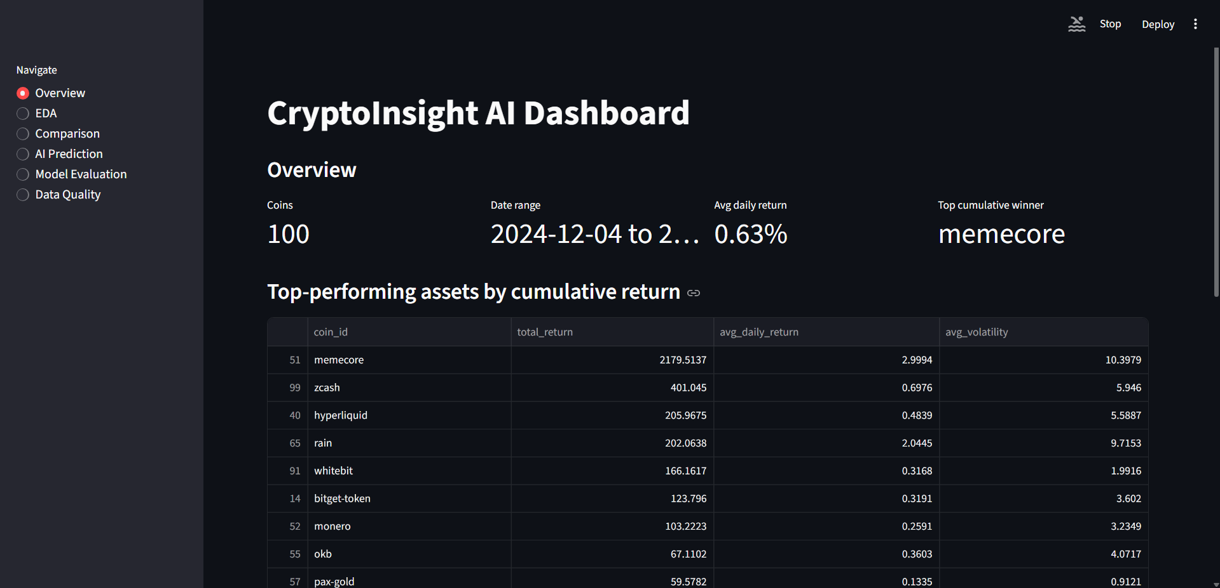
Figure 6.1 — Overview page: dataset summary and top cumulative-return performers

6.2 Exploratory Data Analysis (EDA)
The EDA page allows the user to select any individual coin and inspect its full price history and daily-return series over the past year, side by side.
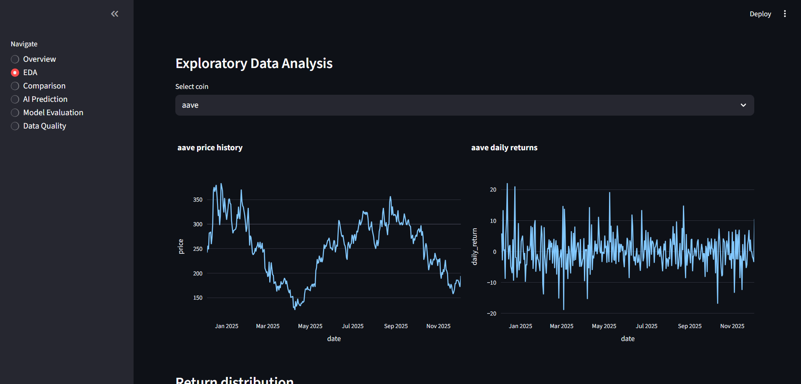
Figure 6.2 — EDA page: price history and daily returns for “aave”
Below the time-series charts, a return-distribution histogram (with a kernel density overlay) shows how daily returns are spread around zero, and a correlation heatmap highlights relationships between price, market cap, volume, moving averages, volatility, and cumulative return for the selected coin.
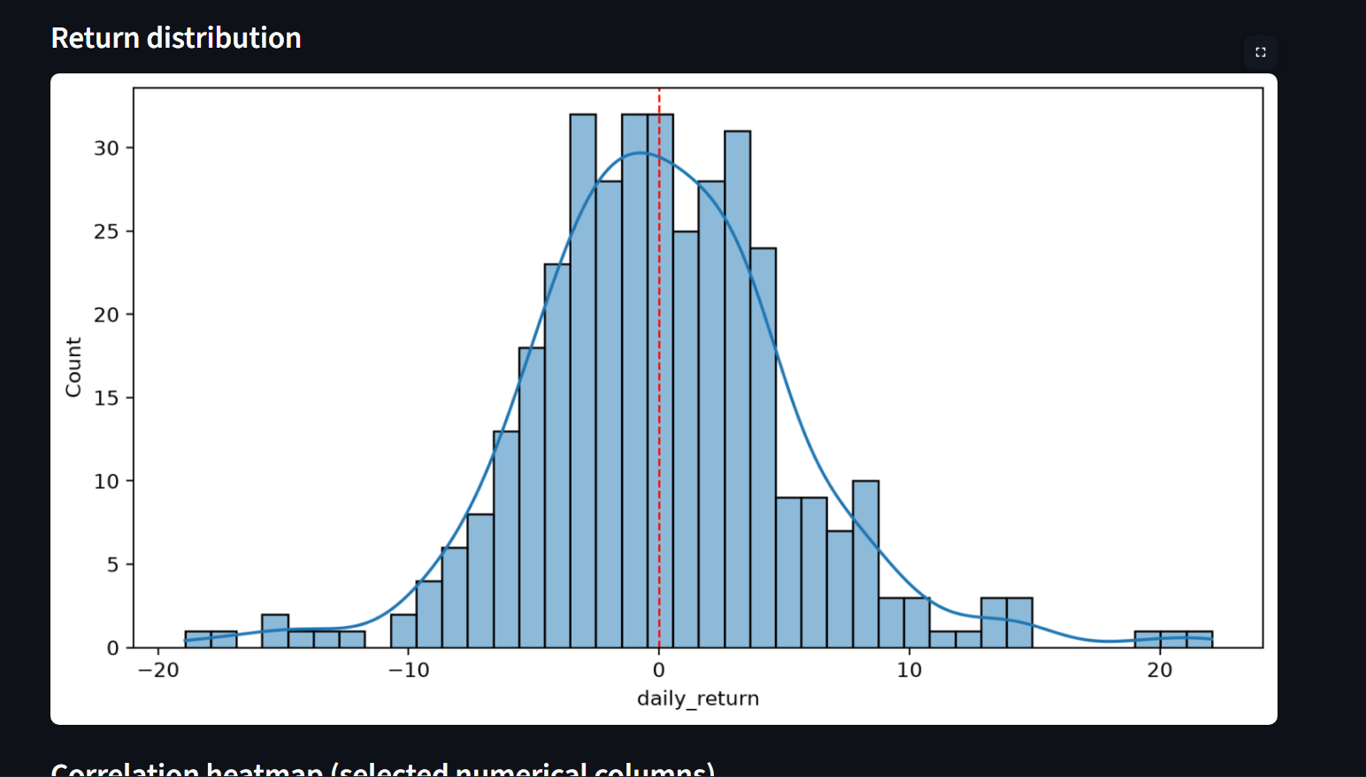
Figure 6.3 — Daily-return distribution for “aave”
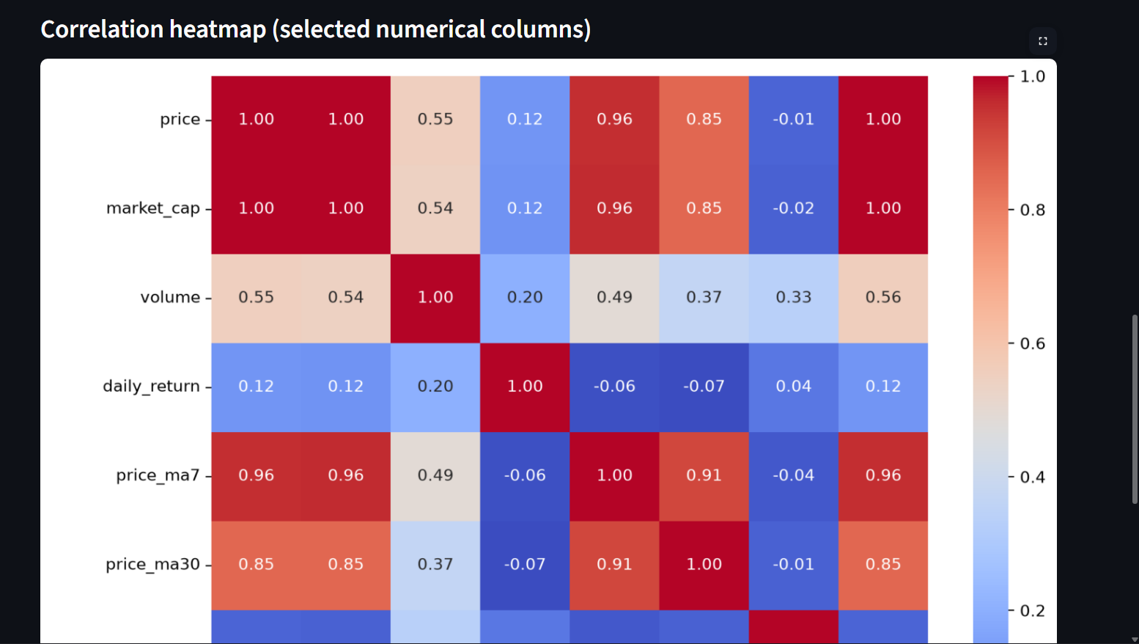
Figure 6.4 — Correlation heatmap of key numerical features

6.3 Comparison
The Comparison page lets the user rank and compare coins by average return, average volatility, average market capitalization, or total return, with an adjustable “Top N” slider (5 to 20 coins).
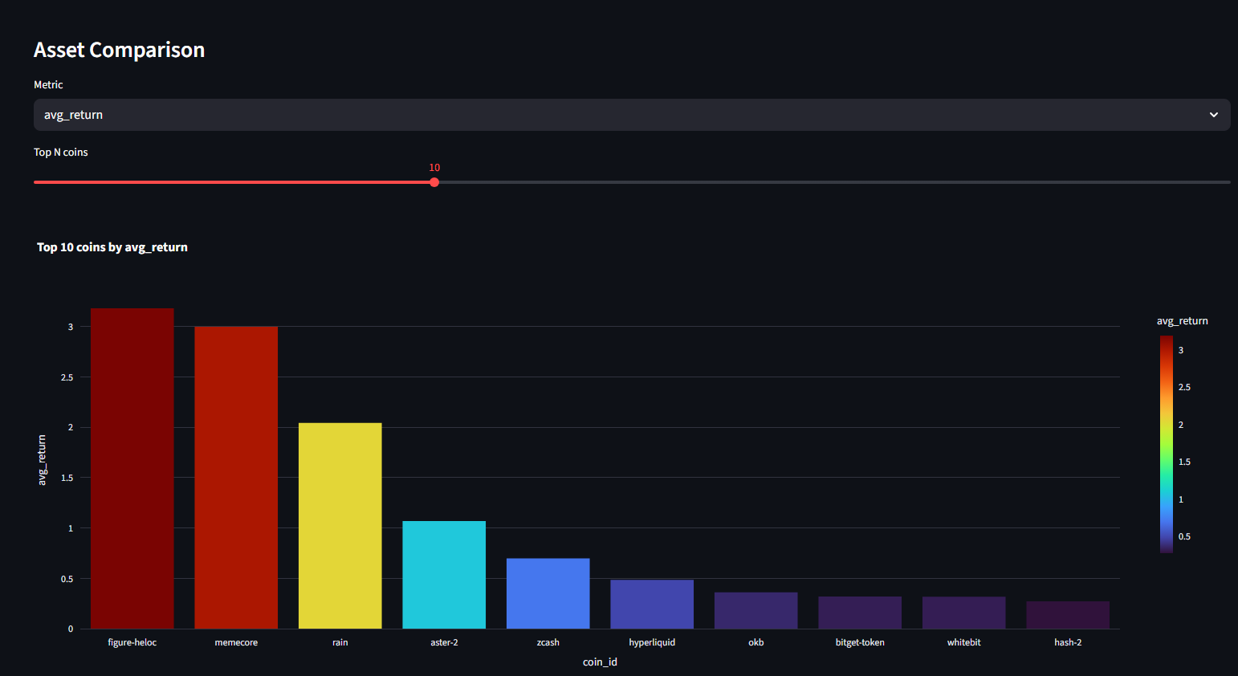
Figure 6.5 — Comparison page: top 10 coins ranked by average return

6.4 AI Prediction
The AI Prediction page applies the trained Random Forest model to the most recent available data for a selected coin and reports the model's estimated probability of a next-day price increase, along with a clear UP / DOWN prediction label. The page also displays the exact feature values used for the forecast and a note clarifying that the dataset is historical rather than real-time.
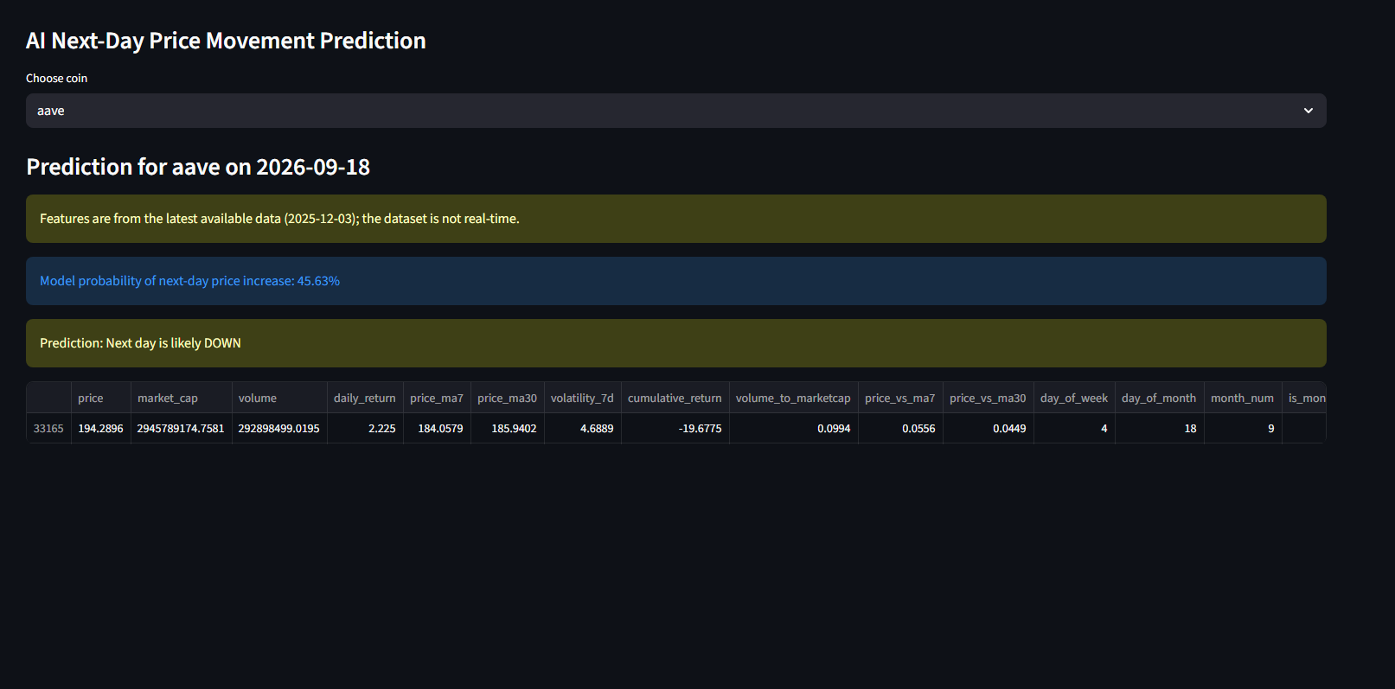
Figure 6.6 — AI Prediction page: next-day forecast for “aave”

6.5 Model Evaluation
The Model Evaluation page reports the classifier's performance on the chronological test split — accuracy, precision, recall, F1-score, and ROC-AUC — together with a confusion matrix and a feature-importance chart ranking which engineered features contribute most to the model's predictions.
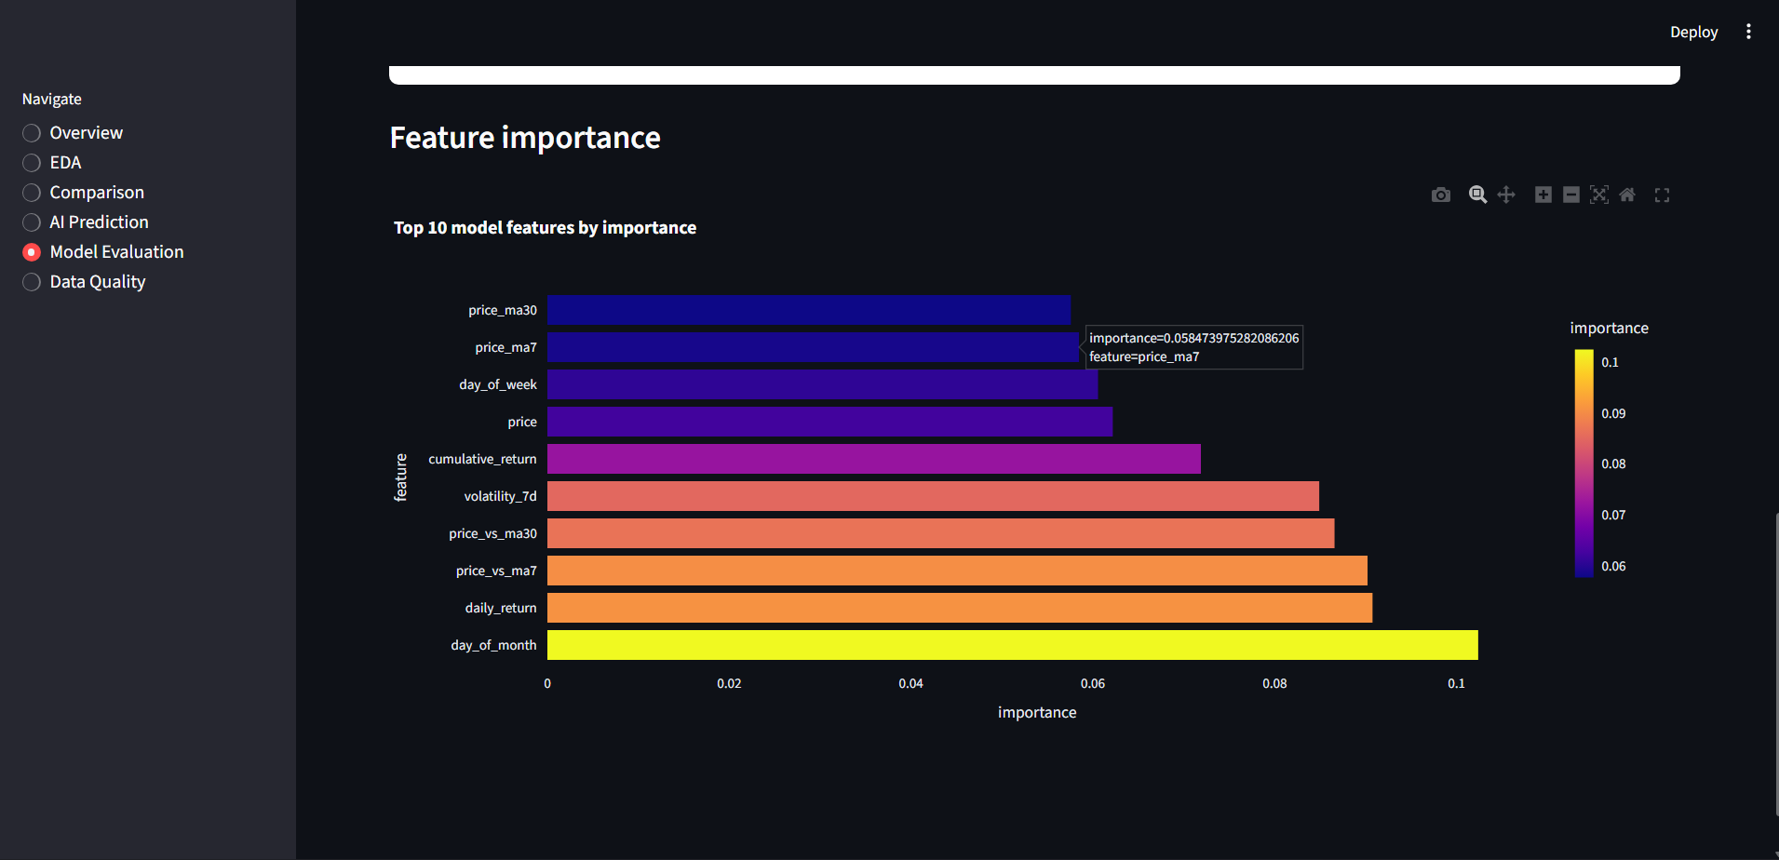
Figure 6.7 — Model Evaluation page: top 10 features by importance
As shown above, calendar-based and price-deviation features such as price_ma30, price_ma7, day_of_week, cumulative_return, and volatility_7d rank among the most influential predictors, alongside the coin's raw price.

6.6 Data Quality
The Data Quality page performs automated checks on the loaded dataset — counting duplicate rows, invalid/null dates, and constant columns — and visualises missing values per column as both a table and a heatmap, helping to quickly identify any gaps that could affect downstream analysis.
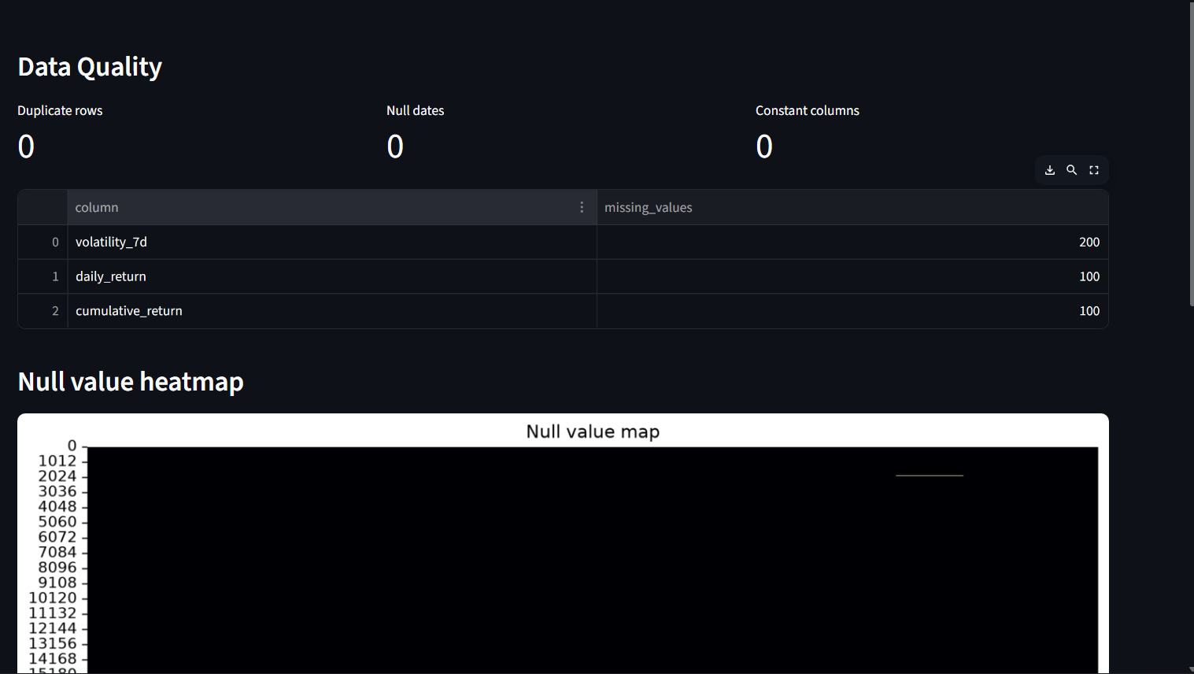
Figure 6.8 — Data Quality page: missing-value summary and null-value heatmap

7. Results & Model Evaluation
The Random Forest model is evaluated on the chronological hold-out test set (the most recent 20% of dates). The dashboard computes the following metrics live, at run time, from the actual test predictions — no values are hardcoded:
Metric | Description | Value (test split)
Accuracy | Overall proportion of correct up/down predictions | See Model Evaluation page
Precision | Proportion of predicted upward movements that were correct | See Model Evaluation page
Recall | Proportion of actual upward movements identified by the model | See Model Evaluation page
F1-Score | Harmonic mean of precision and recall | See Model Evaluation page
ROC AUC | Ranking quality for the probability of an upward movement | See Model Evaluation page
The confusion matrix (visible on the Model Evaluation page) breaks predictions down into true/false positives and negatives for the “Up” and “Down” classes, giving a clear picture of where the model performs well and where it tends to err. Feature-importance analysis (Figure 6.7) confirms that moving-average and volatility-based features carry the most predictive signal, which is consistent with the technical-analysis intuition that short-term trend and dispersion measures help anticipate near-term price direction.
It is important to note that next-day cryptocurrency price direction is inherently difficult to predict due to high market volatility and the influence of external, non-price factors (news, sentiment, regulation). The model and dashboard are therefore intended as an educational and exploratory analytics tool rather than a source of financial advice.

8. Data Quality Assessment
An automated data-quality check was run on the full 33,365-row dataset. No duplicate rows or invalid dates were found, and no columns were found to be constant across the dataset. Some missing values are present in the derived columns volatility_7d, daily_return, and cumulative_return — this is expected, since these metrics require a preceding window of history (e.g. a 7-day volatility figure cannot be computed for a coin's very first week of records) and are handled through median imputation during model preparation.

9. Conclusion
CryptoInsight AI successfully demonstrates a complete data-analytics-with-AI workflow: ingesting and cleaning real-world time-series market data, performing rich exploratory analysis, engineering meaningful technical features, training and rigorously evaluating a machine-learning classifier with a leakage-free chronological split, and presenting all of this through an interactive, multi-page Streamlit dashboard. The project reinforced practical skills in Python-based data analytics, feature engineering, model evaluation, and dashboard design — directly aligned with the learning objectives of the AICTE | IBM SkillsBuild Academic Internship on Data Analytics with AI, conducted with BharatCares.

10. Future Scope
- Integrate a live cryptocurrency price API to move from historical to real-time predictions.
- Experiment with additional models (e.g. gradient boosting, LSTM/time-series neural networks) and compare performance against the Random Forest baseline.
- Incorporate sentiment data from news and social media as additional predictive features.
- Add portfolio-level analytics, such as risk-adjusted return and correlation-based diversification suggestions.
- Deploy the dashboard to a cloud platform for public access and scheduled automatic data refresh.

11. References
1. Dataset — Top 100 Cryptocurrencies Daily Price Data (2025), Kaggle: https://www.kaggle.com/datasets/mihikaajayjadhav/top-100-cryptocurrencies-daily-price-data-2025
2. Streamlit Documentation — https://docs.streamlit.io
3. scikit-learn Documentation — https://scikit-learn.org
4. Plotly Python Graphing Library — https://plotly.com/python/
5. pandas Documentation — https://pandas.pydata.org

12. Acknowledgement
I would like to express my sincere gratitude to AICTE and IBM SkillsBuild for providing the opportunity to undertake this Academic Internship on Data Analytics with AI, and to BharatCares for facilitating and coordinating the program. I am thankful to my mentors and faculty at Vivekananda Global University, Jaipur, for their continuous guidance and support throughout the internship. This project has been an invaluable learning experience, allowing me to apply classroom knowledge to a real-world dataset and strengthen my practical skills in data analytics, feature engineering, and machine learning.
I also acknowledge the creators of the open-source dataset used in this project, made available on Kaggle, as well as the developers of the open-source Python libraries — Streamlit, pandas, NumPy, scikit-learn, Plotly, Matplotlib, and Seaborn — that made this project possible.

