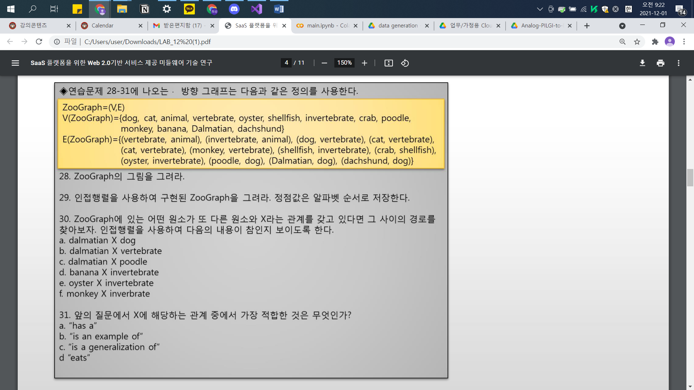

28.

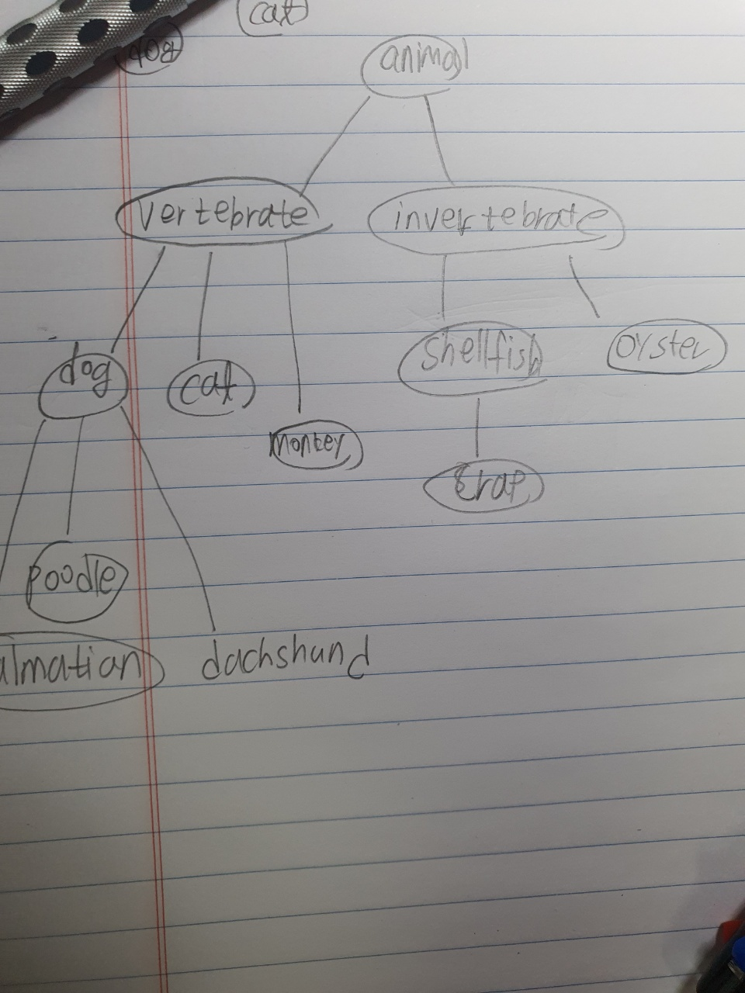

|  |  |  |  |  |  |  |  |  |  |  |  |  |  |
| --- | --- | --- | --- | --- | --- | --- | --- | --- | --- | --- | --- | --- | --- |
|  | Animal | banana | cat | crab | dachshund | Dalmatian | Dog | invertebrate | monkey | oyster | poodle | shellfish | vertebrate |
| Animal |  |  |  |  |  |  |  | ㅇ |  |  |  |  | ㅇ |
| Banana |  |  |  |  |  |  |  |  |  |  |  |  |  |
| Cat |  |  |  |  |  |  |  |  |  |  |  |  | ㅇ |
| Crab |  |  |  |  |  |  |  |  |  |  |  | ㅇ |  |
| Dachshund |  |  |  |  |  |  | ㅇ |  |  |  |  |  |  |
| Dalmatian |  |  |  |  |  |  | ㅇ |  |  |  |  |  |  |
| Dog |  |  |  |  | ㅇ | ㅇ |  |  |  |  | ㅇ |  | ㅇ |
| Invertebrate | ㅇ |  |  |  |  |  |  |  |  | ㅇ |  | ㅇ |  |
| monkey |  |  |  |  |  |  |  |  |  |  |  |  | ㅇ |
| Oyster |  |  |  |  |  |  |  | ㅇ |  |  |  |  |  |
| poodle |  |  |  |  |  |  | ㅇ |  |  |  |  |  |  |
| shellfish |  |  |  | ㅇ |  |  |  | ㅇ |  |  |  |  |  |
| vertebrate | ㅇ |  | ㅇ |  |  |  | ㅇ |  | ㅇ |  |  |  |  |

아래의 포함관계를 고려하지 않았을 때, direction이 없는 graph로 나타냈다.

29.

포함관계를 나타내는 graph이다.

a. T

b. T

C. F

d. F

e. T

f. F

31.

Is an example of

Exercise2.

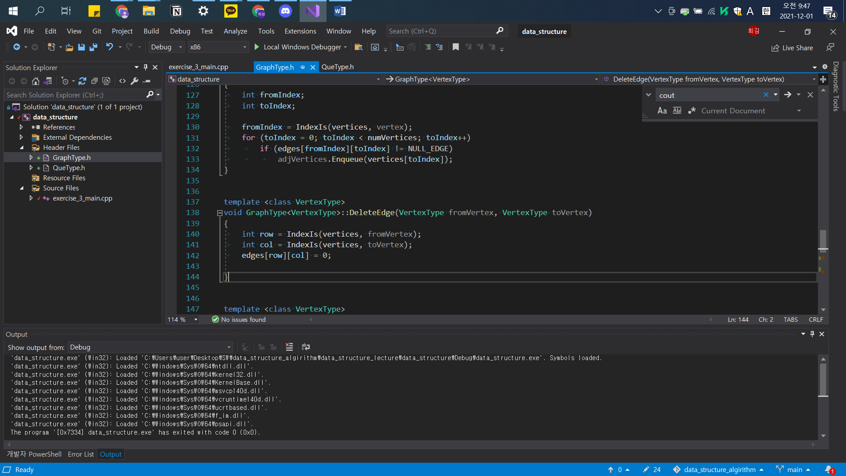

Exercise3

