Bankers Algorithm 구현

1. Is the System is safe state? Yes.

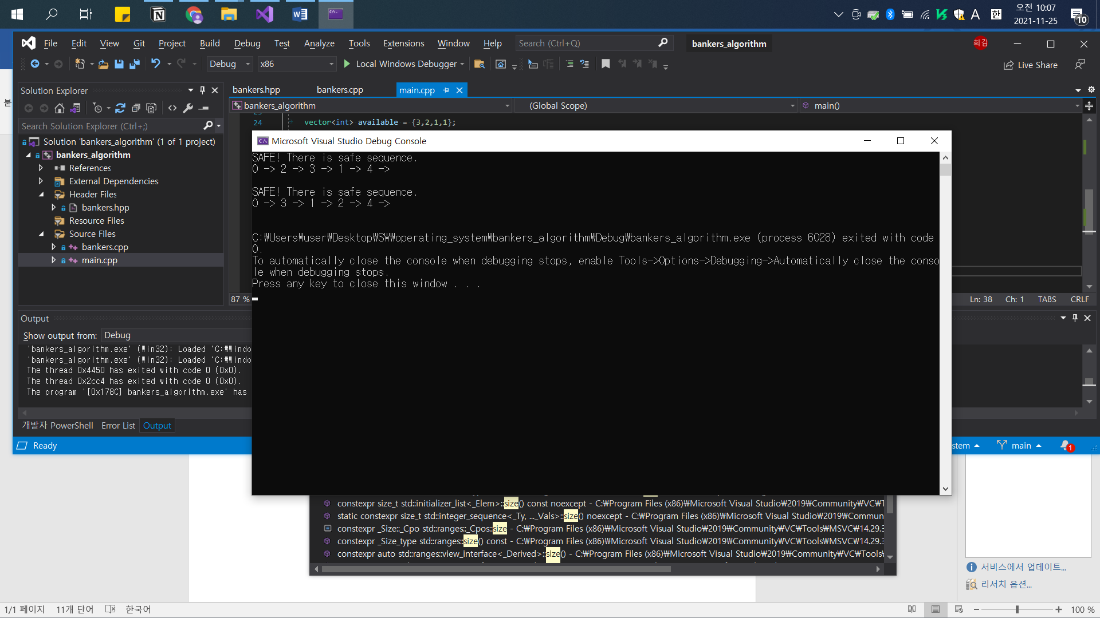

1. Can request for (1,2,0,0) by P4 be granted? Yes

