|  |  |
| --- | --- |
| **(Confidential)** | |
| Scope of disclosure | [Company] for XX-PJ only |
| Period of confidentiality | Until YYYY-MM-DD |
| Head of Information Owner | Mr. / Ms. XXXXX |
| Handling restriction | Not for XXXX |

**Investigation Report**

SCRATCH

**Toshiba Software Development (Vietnam) Co., Ltd**

|  |
| --- |
| Document ID: TSDV-21A-EPH-Investigation-Report-Scratch |
| Total: 23 Page No. 1 |

**Revision History**

|  |  |  |  |  |  |  |
| --- | --- | --- | --- | --- | --- | --- |
| Rev. No.  (X.YY) | Date (YYYY-MM-DD) | Section No. Changed | Change Description | Author | Reviewed by | Approved by |
| 0.01 | 2021-10-20 | All | Initialize | ThanhBX |  |  |
|  |  |  |  |  |  |  |
|  |  |  |  |  |  |  |
|  |  |  |  |  |  |  |
|  |  |  |  |  |  |  |
|  |  |  |  |  |  |  |
|  |  |  |  |  |  |  |
|  |  |  |  |  |  |  |
|  |  |  |  |  |  |  |
|  |  |  |  |  |  |  |
|  |  |  |  |  |  |  |

**Contents**

*1.* Introduction 5

1.1. Purpose 5

1.2. Scope 5

1.3. Definitions, Acronyms, Abbreviations 5

1.4. References 5

*2.* Overall Description 6

2.1. Product Perspective 6

2.2. Technical Standards 6

2.3. User characteristics/Operational Scenarios 6

2.4. Operating Environment 6

*3.* Dependencies, Constraints & Limitations 7

*4.* Functional Requirements 8

4.1. Start application 8

4.2. Open editor 8

4.3. Save editor 8

4.4. Close editor 8

4.5. Reload 8

4.6. Setting color 8

4.7. Integrate NcEdit into main project received from customer 8

4.8. Copy 8

4.9. Paste 8

4.10. Cut 8

4.11. Update setting 8

4.12. Replace data 8

4.13. Setting parameter 8

4.14. Search data 8

4.15. Jump 8

4.16. Check program 10

4.16.1. NC plotting check 10

4.16.2. NC plotting check and program check 10

4.16.3. NEST lines 11

4.16.4. BF list 12

4.17. Rename 13

4.18. Change data 13

4.19. Change sequence number 14

4.20. Delete sequence number 14

4.21. Insert space between words 14

4.22. Delete space between words 15

4.23. S.F auto setting 15

4.24. Pattern cycle division into NC 15

4.25. Message 15

4.26. Setting shortcut 16

4.26.1. Edit shortcut 17

4.26.2. Use shortcut 18

4.27. Soft menu 18

4.28. Add word 18

4.29. Multi language 18

4.30. Increase editable capacity (Maximum data size of each editor will be 200 MB) 18

4.31. Undo/Redo 18

4.32. Setting color 19

*5.* External Interface Requirements 20

*6.* Non-functional Requirements 21

6.1. Performance Requirements 21

6.2. Memory Requirements 21

6.3. Error Handling 21

6.4. Other Requirements & Attributes 21

*7.* Acceptance criteria 22

*8.* Appendix 23

# Introduction

## Purpose

TEC wants to build a GUI environment for programming, developers can program without writing code in the GUI to interact with the SDK, which is developed by TSDV in term 21A. Scratch was selected as the development.

This document describes:

* How to create new extension and add it to Scratch application.
* Protocol communicates between new extension with SDK.

## Scope

## Definitions, Acronyms, Abbreviations

|  |  |  |
| --- | --- | --- |
| ID No | Acronyms | Definition |
| 1 | SDK | Software Development Kit |
| 2 | DDS | Data Distribution Service, a Pub/Sub technology for ubiquitous, polyglot, efficient and secure data sharing |
| 3 | TTEC | Toshiba Tec Corporation |
| 4 | TSDV | Toshiba Software Development Vietnam |
| 5 | API | Application Programming Interface |
| 6 | DCPS | Data-Centric Publish-Subscribe |
| 7 | EPH | Endpoint Hub, a TTEC device which target SDK will be run on |
| 8 | DNN | Deep Neural Network (for image recognition) |

## References

|  |  |  |  |  |  |
| --- | --- | --- | --- | --- | --- |
| ID No | Reference | Version Number | Document Name/Source & Location reference | Brief Description | Remarks |
| 1 | Requirement | 20210805 | TSDV様_21A作業のご相談.pdf | Requirement of customer | NA |

# Overall Description

## Product Perspective

Raspberry PI

Scratch

Extensions

Local

communication

SDK

DDS

Network

EPH board

Figure 2‑1: Structure Overview

Investigative subjects in this document are “Extensions” and “Local communication”.

Table 2‑1: Component list

|  |  |  |  |
| --- | --- | --- | --- |
| **No** | **Function name** | **Description** | **Remark** |
| 1 | Raspberry PI | The Raspberry Pi is a low-cost computer | NA |
| 2 | Scratch | Scratch is a free programming language and online community where you can create your own interactive stories, games, and animations.  https://scratch.mit.edu/ | NA |
| 3 | Extensions | This is an Extension that needs to be added to Scratch so that users can programmatically interact with the SDK | NA |
| 4 | Local communication | Protocol communication between extensions and SDK | NA |
| 5 | SDK | Software Development Kit | NA |
| 6 | DDS network | Data Distribution Service, a Pub/Sub technology for ubiquitous, polyglot, efficient and secure data sharing | NA |
| 7 | EPH board | Endpoint Hub, a TTEC device which target SDK will be run on | NA |

## Technical Standards

* Scratch 3.0
* C++
* JavaScript

## User characteristics/Operational Scenarios

## Operating Environment

* Development Environment:
  + OS: Windows 10
  + IDE:
    - npm: v6.4.1
    - node: v11.2.0
* Testing environment:
  + OS: Windows 10
  + IDE:
    - npm: v6.14.15
    - node: v14.18.0

# Dependencies, Constraints & Limitations

* NA

# Functional Requirements

## Add an extension into Scratch

### Prepare development environment

Download clones of 2 git repositories (scratch-vm, scratch-gui)

$ git clone https://github.com/LLK/scratch-vm.git

$ git clone https://github.com/LLK/scratch-gui.git

### Implement your block

We create a new extension called “newblocks”. Each extension can have multiple blocks, but this **newblocks extension has only one block.**

Add (★) and update (★★) some files.

/Scratch-vm

|  |  |
| --- | --- |
|  | ├── LICENSE |
|  | ├── node_modules |
|  | ├── package.json |
|  | ├── package-lock.json |
|  | ├── README.md |
|  | ├── src |
|  | │   ├── blocks |
|  | │   ├── dispatch |
|  | │   ├── engine |
|  | │   ├── extensions |
|  | │   │   ├── scratch3_ev3 |
|  | │   │   ├── scratch3_newblocks 【★ ADDED】 |
|  | │   │   │   └── index.js【★ ADDED File 1】 |
|  | │   │   ├── 【OTHERS】 |
|  | │   │   └── scratch3_wedo2 |
|  | │   ├── extension-support |
|  | │   │   ├── argument-type.js |
|  | │   │   ├── extension-manager.js　【★★ MODIFIED File 2】 |
|  | │   │   └── 【OTHERS】 |
|  | │   ├── import |
|  | │   ├── index.js |
|  | │   ├── util |
|  | │   └── virtual-machine.js |
|  | ├── test |
|  | ├── TRADEMARK |
|  | ├── webpack.config.js |
|  |  |
|  |  |

…

(★) In File 1 **src/extension/scratch3_newblocks/index.js**, add a block interface and process.



(★★) File 2 **src/extension-support/extension-manager.js** is for an extension menu implementation.

In this file, add **scratch3_newblocks defined** in previous File 1.



### Implement GUI

Add some lines at the last of **src/lib/libraries/extensions/index.jsx** file in the same directory **scratch-gui**



* Add background image as name **newBlockImage.png** in the **newBlock** directory.
* Add menu icon image as name **newBlockButtonImage.png** in the **newBlock** directory.

|  |
| --- |
| . |
|  | ├── LICENSE |
|  | ├── package.json |
|  | ├── prune-gh-pages.sh |
|  | ├── README.md |
|  | ├── src |
|  | │   ├── components |
|  | │   ├── containers |
|  | │   ├── css |
|  | │   ├── examples |
|  | │   ├── index.js |
|  | │   ├── lib |
|  | │   │   ├── alerts |
|  | │   │   ├── libraries |
|  | │   │   │   └── extensions/ |
|  | │   │   │   │   ├── index.jsx　【★　MODIFIED】 |
|  | │   │   │   │   ├── 【OTHERS】  | | | | ├── newBlock 【★　ADDED】 |
|  | | | | | | └── newBlockButtonImage.png 【★　ADDED】 |
|  | | | | | | ├── newBlockImage.png.png 【★　ADDED】 |
|  | │   │   ├── log.js |
|  | │   ├── playground |
|  | │   ├── reducers |
|  | │   └── test.js |
|  | ├── static |
|  | ├── test |
|  | ├── TRADEMARK |
|  | ├── translations |
|  | ├── webpack.config.js |
|  | ├── npm-error.log |
|  | └── npm.lock |

### Confirm extension added

$ cd scratch-vm && npm install && npm link

$ cd scratch-gui && npm install && npm link scratch-vm

$ cd scratch-gui

$ npm start

After compiling, access to the following address with your browser.

<http://localhost:8601>

**Result**:

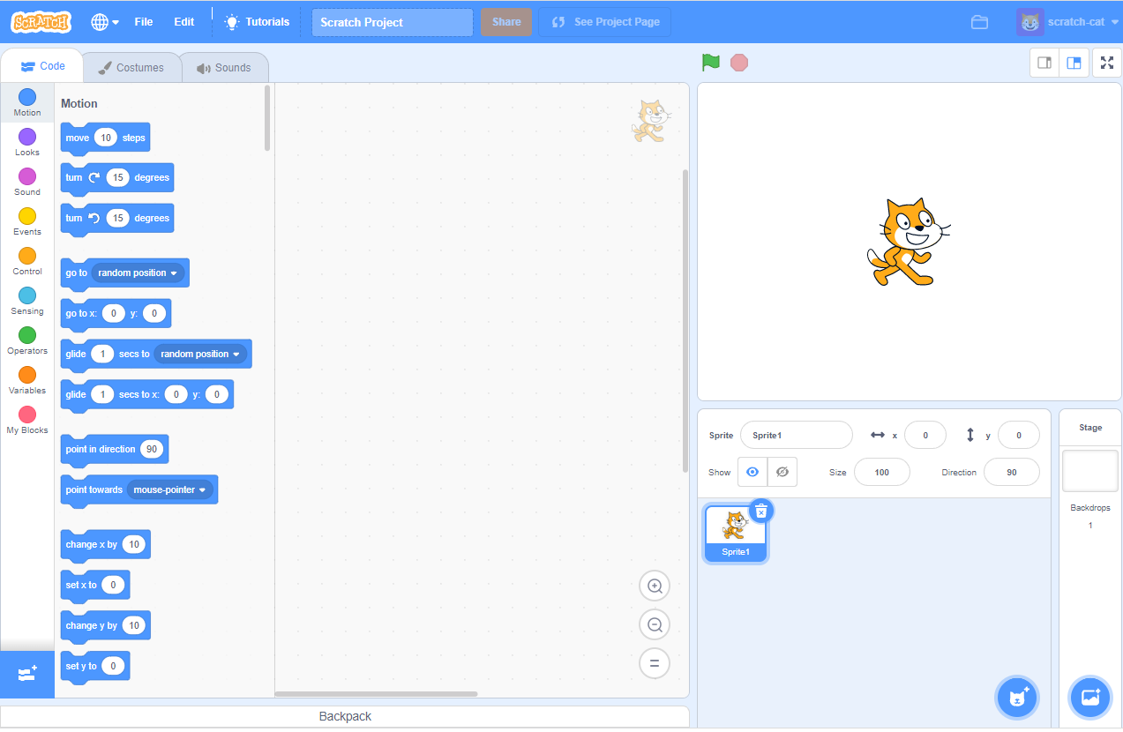

“Add extension” button

Click “Add extension” button:

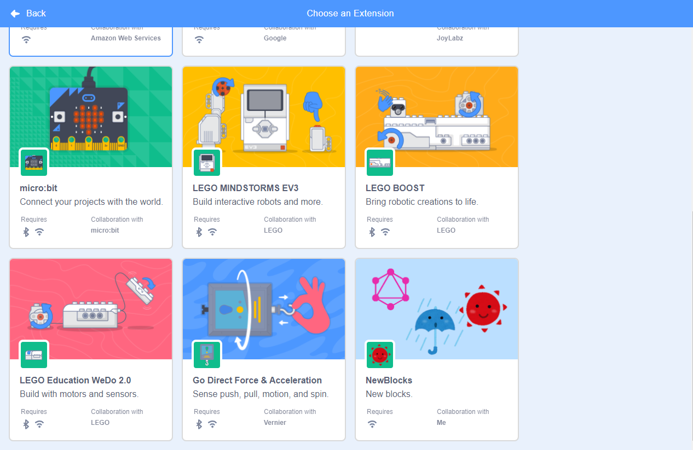

* NewBlocks extension is created successful.

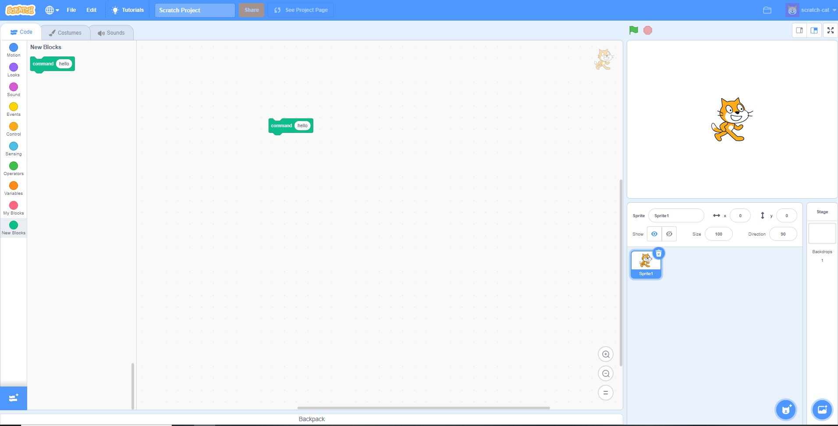

## Communicate between extension and SDK

# External Interface Requirements

NA

# Non-functional Requirements

* This software will support multi editors, each editor can reach 200 MBs of data

## Performance Requirements

*NA*

## Memory Requirements

*NA*

## Error Handling

*NA*

## Other Requirements & Attributes

*NA*

# Acceptance criteria

* No missing character all dialog, menu and message.
* No crashing when application runs

# Appendix

*NA*

***Template's*** ***Revision History***

|  |  |  |  |  |  |  |
| --- | --- | --- | --- | --- | --- | --- |
| Rev. No.  (X.YY) | Date (YYYY-MM-DD) | Section No. Changed | Change Description | Author | Reviewed by | Approved by |
| 2.01 | 2012-05-08 | Revision History | Fix date format | ToanDT |  |  |
| 3.00 | 2012-06-06 | Template's RH | Approved by manager | ToanDT |  | AnhPT |
| 3.01 | 2016-10-21 | 2.4 | Update guideline and example table | CucNT | TrinhNTT | Kawahara |
| 3.02 | 2018-11-06 | All | Change document into new template/logo | HienNN | [QAM] T.Ninomiya | [GD] K.Shigenaka  [PM] TrungDV, ThinhND |
|  |  |  |  |  |  |  |
|  |  |  |  |  |  |  |
|  |  |  |  |  |  |  |
|  |  |  |  |  |  |  |
|  |  |  |  |  |  |  |
|  |  |  |  |  |  |  |
|  |  |  |  |  |  |  |