**Cypress Cucumber Tutorial #1 - Project Setup**

<https://www.youtube.com/watch?v=TGLQN3xEnaU>

<https://www.youtube.com/watch?v=AZ5YlWg9JMw&list=PLQKDzuA2cCjrHFelJTVP60NPcVpdGnWHS>

Cypress beginner Guide-🡪

<https://www.youtube.com/watch?v=_QIJ9JLBYB4&list=PLQKDzuA2cCjoZigzUCOYs1esHedCTCLUr>

All 6 parts in above link…

1. npm init - - y
2. npm install cypress - -save-dev
3. npm install -D cypress cypress-cucumber-preprocessor
4. npm install - -save-dev cypress-cucumber-preprocessor
5. add below line in cypress.config file
6. const cucumber = require('cypress-cucumber-preprocessor').default
7. setupNodeEvents(on, config) {
8. on('file:preprocessor', cucumber())
9. },
10. specPattern: "cypress/e2e/*.feature",
11. },

Complete config file looks like-🡪

6. Need to add below manually under package.json file..

  "cypress-cucumber-preprocessor": {

    "nonGlobalStepDefinitions": true,

    "step_definitions": "cypress/e2e/newtours"

  }

}

Complete file🡪

  "devDependencies": {

    "cypress": "^12.8.1",

    "cypress-cucumber-preprocessor": "^4.3.1"

  },

  "cypress-cucumber-preprocessor": {

    "nonGlobalStepDefinitions": true,

    "step_definitions": "cypress/e2e/newtours"

  }

}

7. create folder under e2e as newtours

Create file under e2e as newtours.feature

Create new file under newtours folder as newtours.js (step definition)

**8. I installed cucumber gherkins from marketplace on visualstudio and worked**

**Type fea and u should see prompt intelli in featurefie..**

**Add your feature and scenario Outline..given when and then**

**9. Under, step definition add below line:**

import {Given, When, Then } from "cypress-cucumber-preprocessor/steps";

Ensure feature file GIVEN WHEN THEn Statements are exactly same when writing step definitions For same FIVEN WHEN THEN…

Run npx cypress open and select featurefile..

<https://www.youtube.com/watch?v=ReOTUmYFQiQ>

# Part 2 -> Cypress with Cucumber Part 2: Parameters as a String | DataTable in Cucumber | Cypres

PARAMETERS AS A STRING🡪 pass username and password

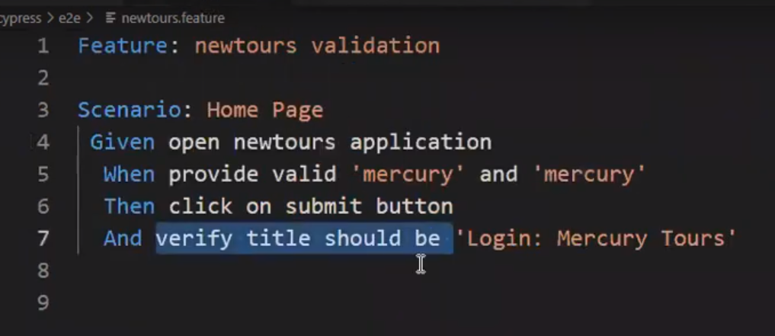

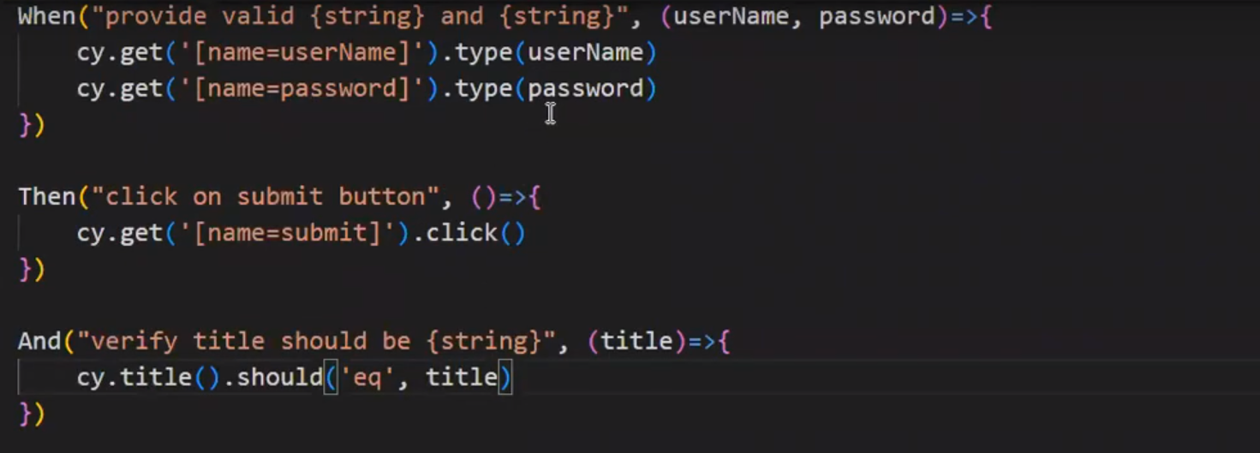

USING DATA TABLE PASS MULTIPLE VALUES-🡪

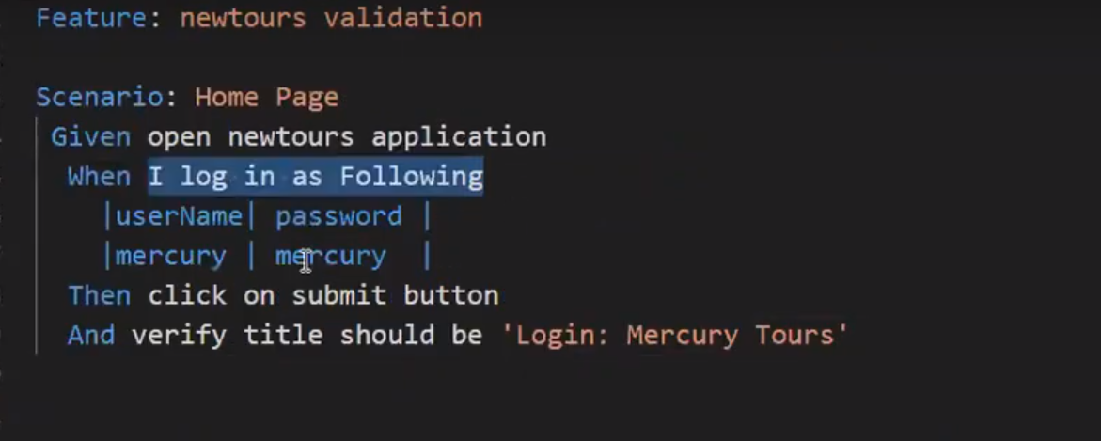

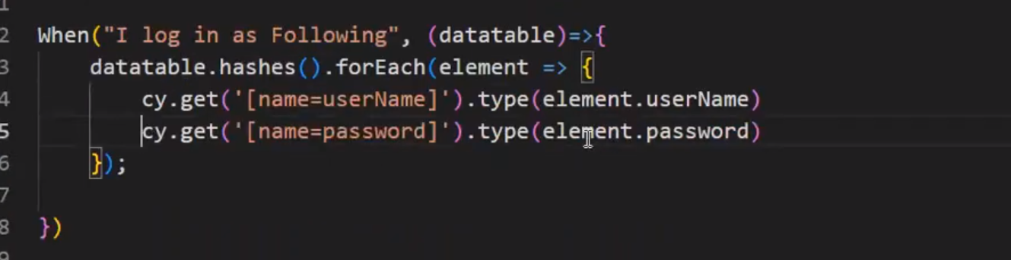

USE OF BACKGROUND FEATURE🡪

Assume you have 10 scenarios in feature file and GIVEN part is launching application then, we can use in following way, instead of using Beforeeach hook..

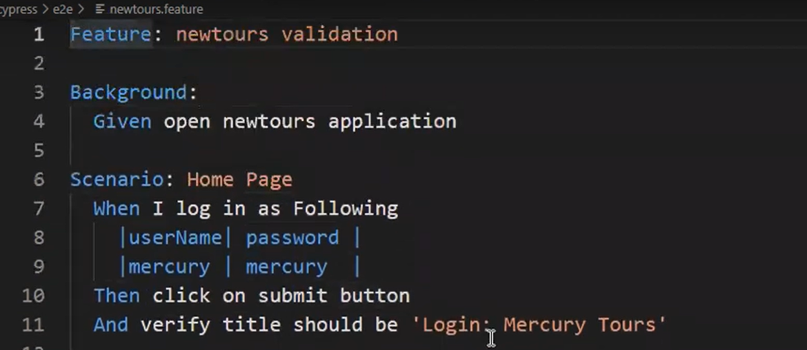

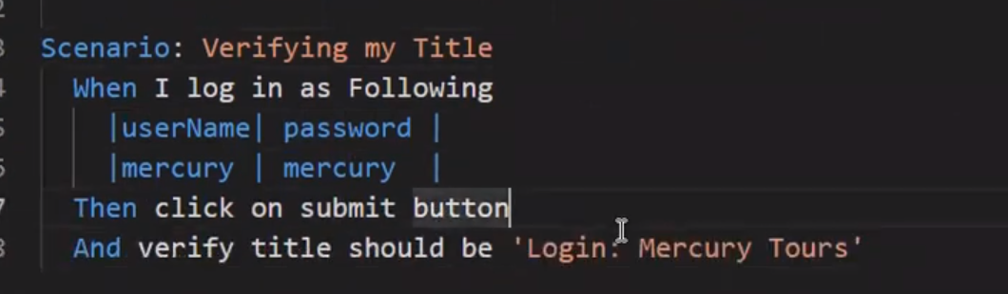

We have removed given statement for all scenarios and ket as background..

Run as npx cypress open..

HOOKS USAGE BEFOR AND AFTER-🡪

We only provide in step definition following way..

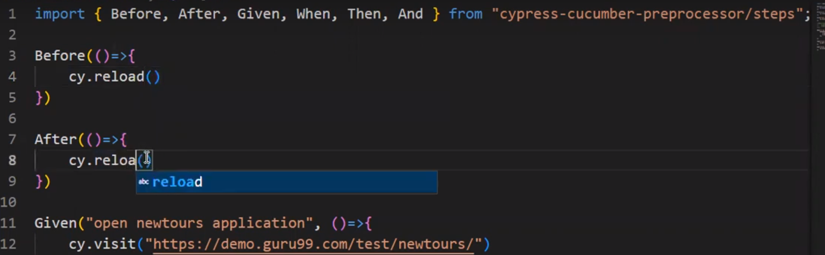

USING TAGS to execute🡪

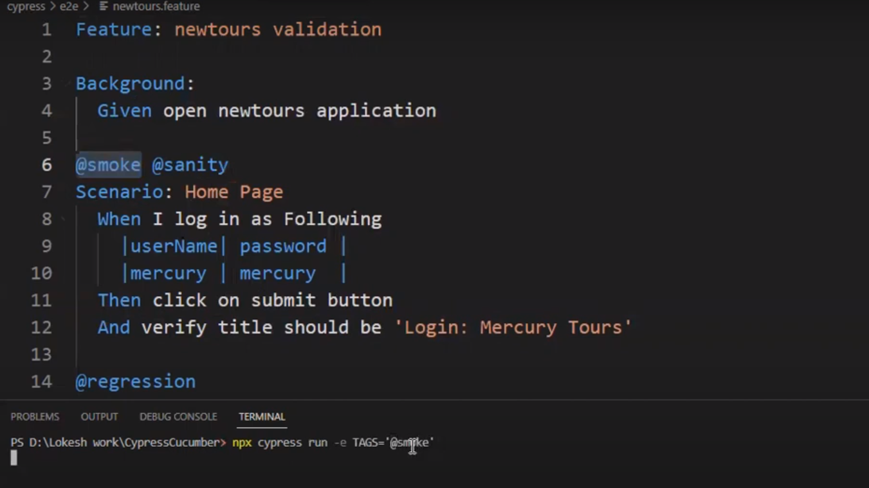

@regression and can use combination as well..

EXECUTE MULTIPLE Feature files and STEP DEFINITION FILES-🡪

Set1: create folder under e2e as newtours

**Create file under e2e as newtours.feature**

Create new file under newtours folder as newtours.js (step definition)

Set2: create folder under e2e as testapp2

**Create file under e2e as testapp2.feature**

Create new file under newtours folder as testapp2.js (step definition)

We can create n number of feature files and step definitions..

Update package.json as cypress/e2e

