<https://www.youtube.com/watch?v=BWD8woHxCVM&t=305s>

**API/Webservices Testing using RestAssured Part-5 | Rest Assured Framework**

Forward the video to last part for GIT…

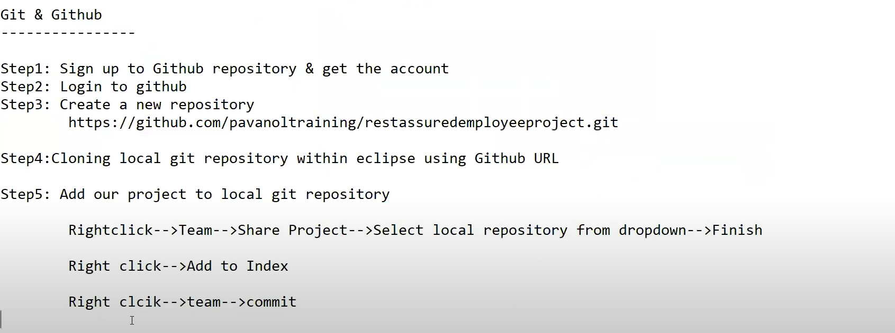

Teams – Pull – To get newly added files to repo from github

Teams – add change – add index – commit – mergetohub.

ECLIPSE and GITHUB-🡪

<https://www.youtube.com/watch?v=mR9jhYD3bnI>

<https://www.youtube.com/watch?v=SW3emX9TJ4g>

Go to VS Code Extensions🡪 search for github

Select and install below:

1. Github pull request and issues
2. Github codespaces
3. Github repositories

Go to remote explorer on VS code and click sign in to git hub

Click allow – Authorise – select open vsc code -select allow extension.

Now our VSC code is connected to github account…

Now, create repositoty – create folder on local drive and open same folder from VSC code editor..

Explorer – open folder created..

Download GITHUB for windows first if not done… (google or click from source control)

from command prompt type below….

1. git config --global user.name "luckygit9"
2. git config --global user.email “[vamshik25@gmail.com](mailto:vamshik25@gmail.com)”
3. git config --list --show-origin --show-scope ( u should see global config and rest all)

Reload or restart VSC after installing githib exe locally and running exe..

Click on Publishtogit and select repo and select files .. OK

Extensions – search – githistory – install

Go to view pallettee- add >githistory

To view git log…

Add files 🡪 to project🡪 or changes🡪

Click on + and add descrition and click Commit

Now, again go to : and select Push OR view palette -- >Publishtogit

You can see changes on GITHIB repositoty

Open existing project🡪 go to github repo and get URL. –

On VSC Pallete - > clone—and paste URL - will ask for FOLDER to create local- create and select folder.- Open - project loaded locally…

Add file- testfile.txt -source control – Click + - comment- commit. From [ :] select Push..

New files sent to GITHUB…

From hub add new files – commt – on VSC -from source control select : select PULL…new file loaded locally..