<https://www.youtube.com/watch?v=AcdUHv5xjPo>

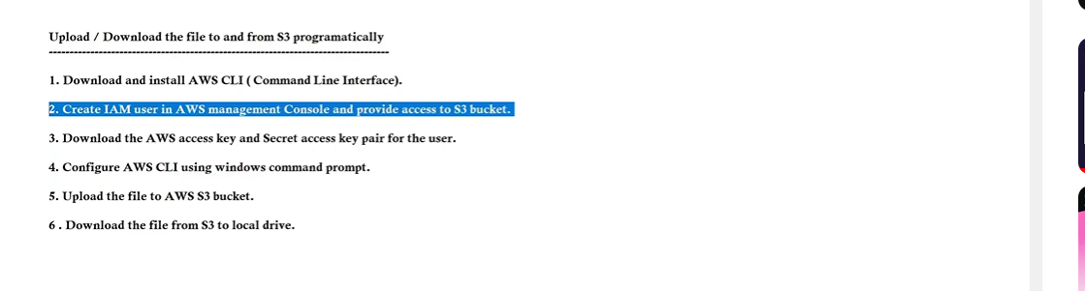

Download AWS cli for windows – and check cmd aws--version

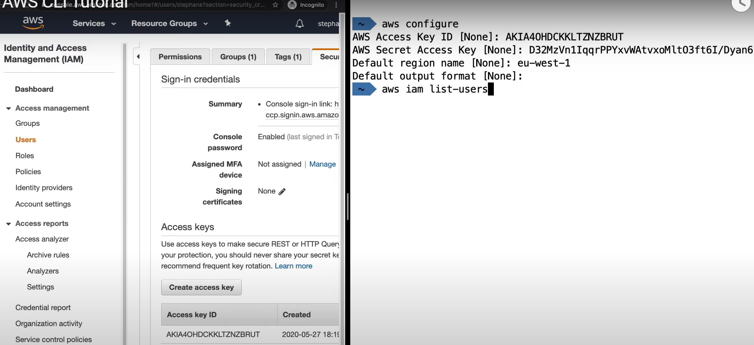

AWS configure for cli commands…

* aws s3 ls [ list the buckets]

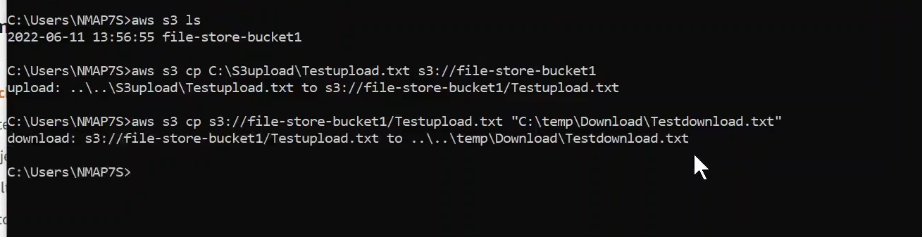

To upload a file from local to S3 bucket…

Download file from s3 ( from aws get copy S3 url of file) and provide in command

<https://www.youtube.com/watch?v=Rp-A84oh4G8>

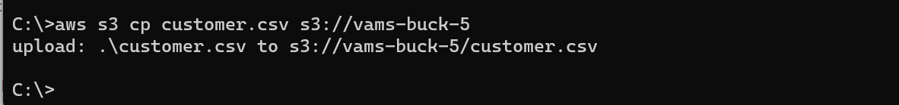

Place file in c drive and run command to bucket where file needs to be placed..

Visual code editor—Nodejs – Connect to S3 Read/delete/write data..

**Access S3 using nodejs sdk (AWS cloud)**

<https://www.youtube.com/watch?v=Wbcmk26-4w0&list=PLd0lZIptCEwMcyxLjPuM5ZaQqwP3nLVSf&index=34>

* Create new folder and run npm init -y

🡪 npm I aws-sdk

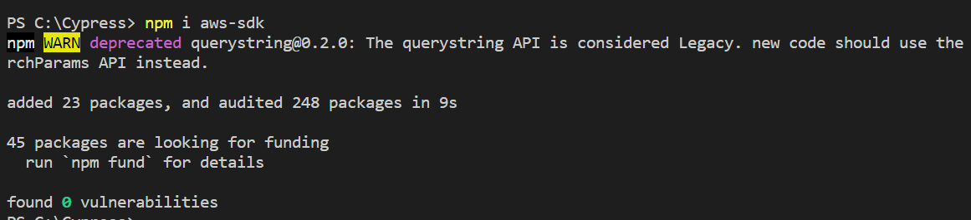

Check under node_modules u will find now aws-sdk

Create new file as createbucket.js

var AWS = require("aws-sdk");

var s3 = new AWS.S3();

var params = {

    Bucket: "vams-buck-9"

};

s3.createBucket(params, function (err,data) {

    if (err) console.log(err, err.stack);  //an error occurred

    else console.log("successfully created..");

});

Syccessfully create s3 bucket..

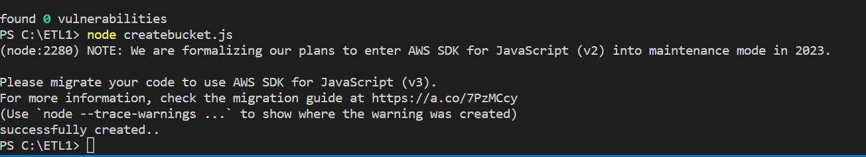

DB Connect MYSQl from extensions – add server connection details on visual cod

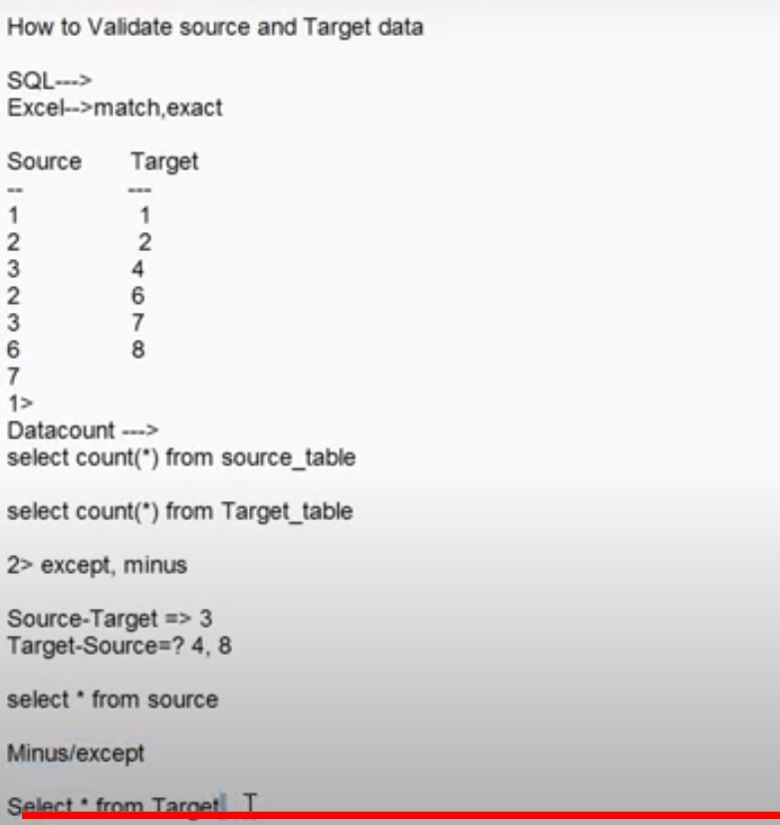

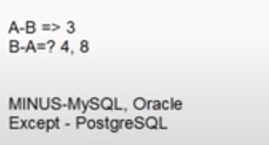

<https://www.youtube.com/watch?v=V7ALcBu--rc>

# Automate your SQL queries to run on a daily schedule

# Thru Visual studio connect to DB and run queries…

# Also, check how to run any Command job if required thru glue aws…command line

<https://www.youtube.com/watch?v=YNN3nSrT-lc>

# How to Connect Node js to MySQL Database and Fetch Data in 5 minutes

Npm install mysql

<https://www.youtube.com/watch?v=6Nt-Jl3CzxE>

# Connect to MySQL on AWS RDS using NodeJS

Npm I mysql

Aws glue start-crawler –name customerdata (name of crawler)

Then go to athena and check data loaded