<https://www.youtube.com/watch?v=NJ3_apdjFZY>

SDET – Pawan

**SQL Tutorial 14: JDBC | Java Database Connectivity with MySQL**

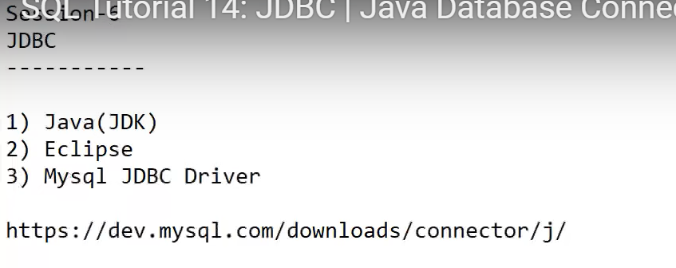

1. Download mysql JDBC driver for windows (google)

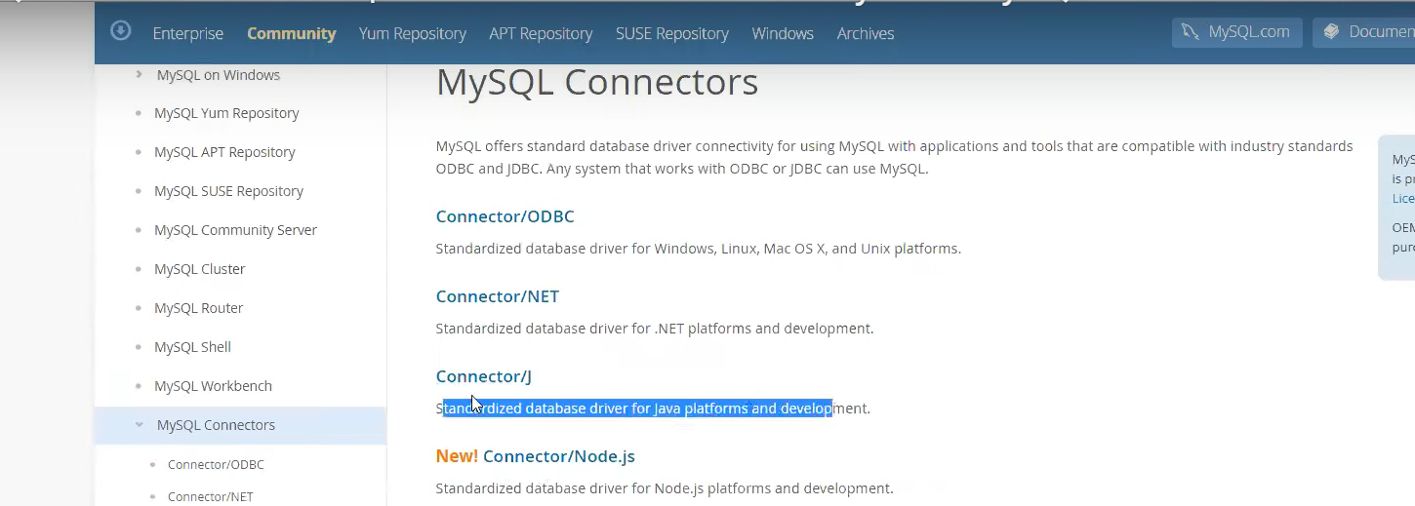

Select this connector/J and go to downloads page – select MYSQL Connectors –

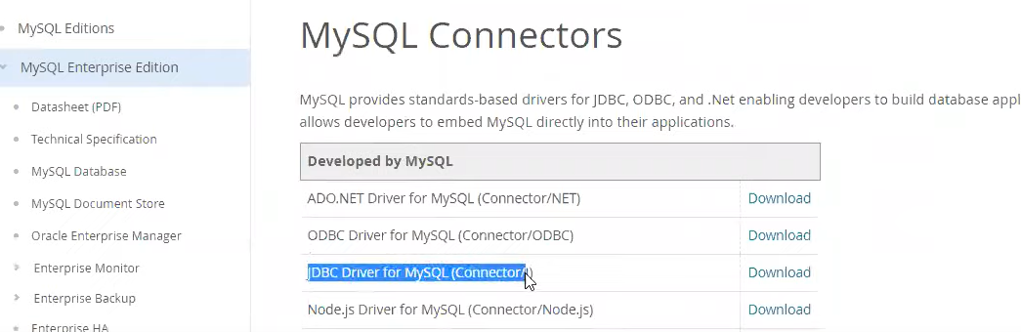

Download JDBC..

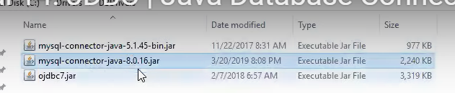

Yu can use either 5.1.45 or 8.0.16

Eclipse – r.click on java project – build path – add externl jar files – select driver 8.0.16 -apply/close.

Under src/test – u can create package or create class write code..

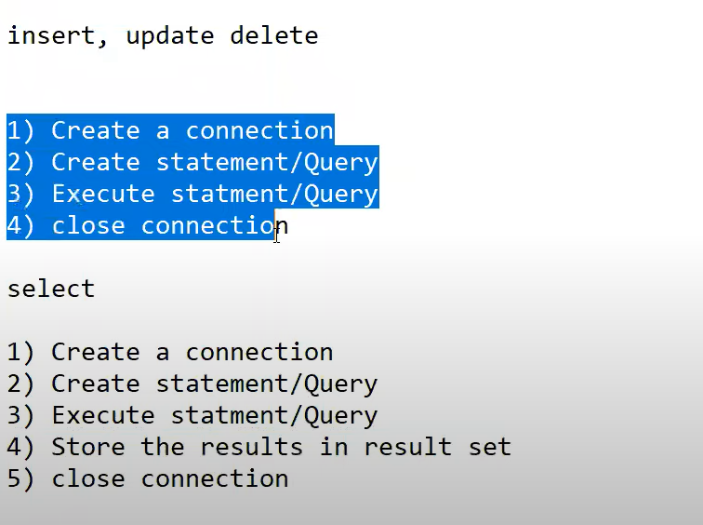

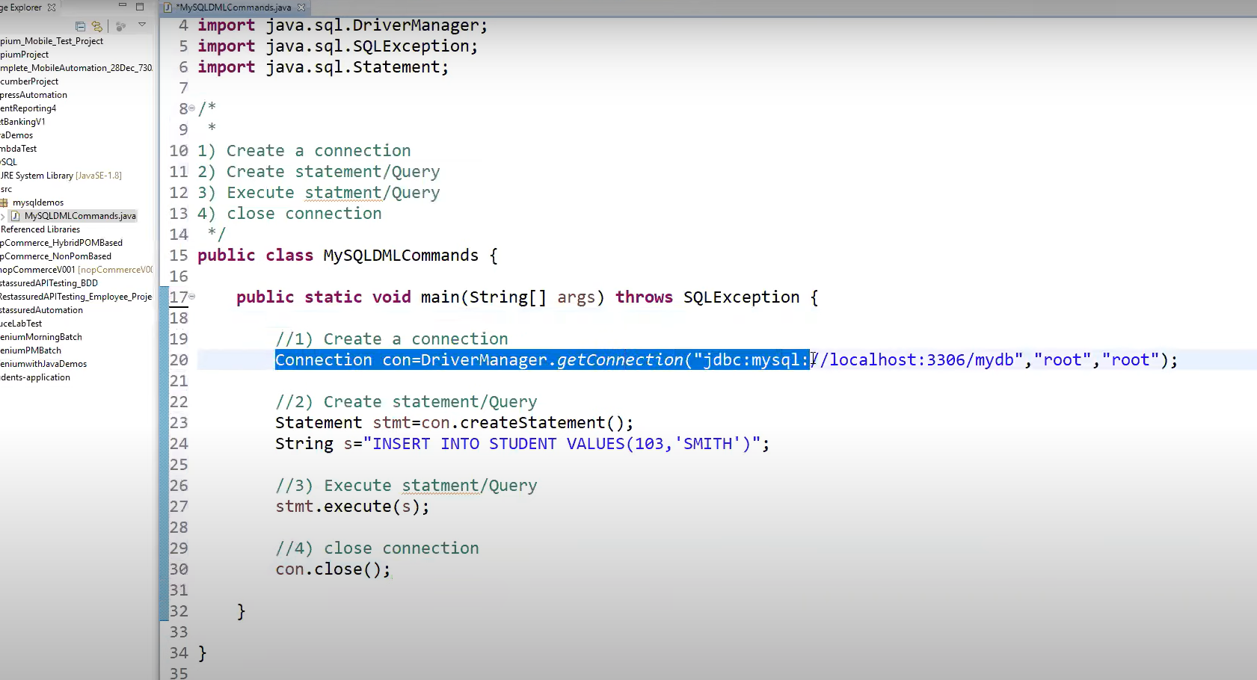

Import java.sql.Drivermanager;

Import java.sql.SQLException;

Import java.sql.Statement;

Connection con =DriverManager.getConnection(“jdbc:mysql://localhost:3306/mydb”,”root”,”root”);

Statement stmt=con.createStatement();

String s = “INSERT INTO STUDENT VALUES(103,’SMITH’)”;

Stmt.execute(s);

con.close();

FOR UPDATE QUERY – Just change query🡪

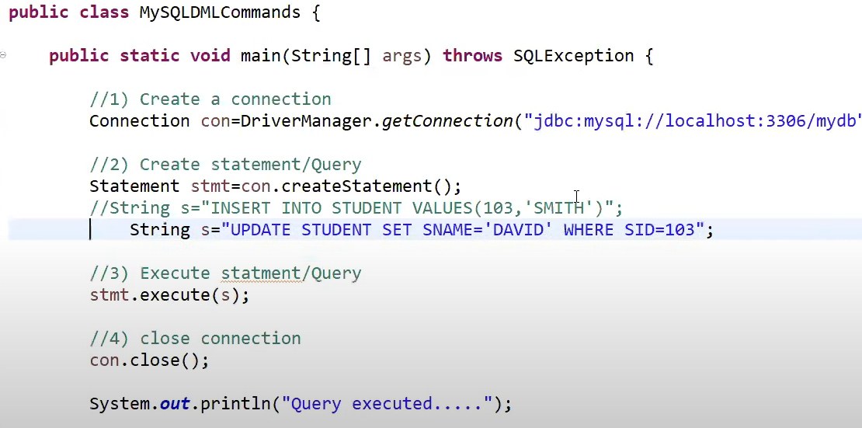

Below is Code for Select Query, Slight changes in execut and Store results🡪

Import resultset class to store results of query

Use while loop to find until next value in DB and execute all data..for select

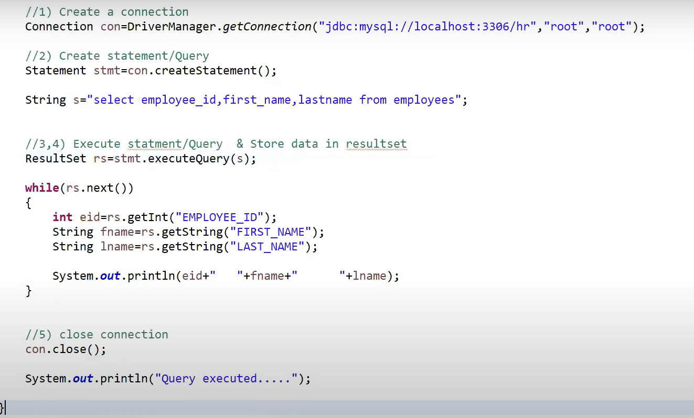

Additional Videos:

<https://www.youtube.com/watch?v=CYK-ywqobyA&list=PLUDwpEzHYYLt0aRs7gvyEEviMp_CoTO3q&index=16>

# SQL Tutorial 15: ODBC | Open Database Connectivity with MySQL

# SQL Tutorial 16: MySQL Command Line Tools/Clients | Connecting to Remote MySQL Database Server