Rogue Puzzle fighters
(Name Subject To Change)

Boilerplate
Since everyone has their own ideas what a game document should be like, I've opted to structure my game documents to follow the National STEM Challenge outline for game documents with modifications.

http://stemchallenge.org/resources/game-design-documents/

Primarily:
- Vision and similar games
- Target audience
- Platform
- Genre
- Game mechanics – what are you doing
- Goals – what is the win state, how do you win, how do you lose
- Components – what objects are in the game
- Controls – how does the player control the game
- Art Details – a statement of overall art style
- User Experience – what steps do they follow and what screens do they see
- Characters and story line
- Accessibility options

Vision and similar games
The game is essentially a 1-player or 2-player vs game that is a fighting game, but the matches are resolved by a puzzle game. The games that inspired this idea were Super Puzzle Fighter II Turbo and a flash game called BIOGEMs.

- https://youtu.be/DPQyp0fnyyg
- https://youtu.be/_hBoeRuOtbU
- https://youtu.be/IH_gpi8AvNs

There are now several other Match 3 Fighting games, like from Marvel and DC. However, BIOGEMs is the one that inspired it (however, it no longer exists).

Target Audience
People that like fun puzzle games.

Platform
Windows and Linux

Genre
Fighting Puzzle Game

GAME MECHANICS
What are you doing?

There are two game modes: MATCH BATTLE and GEM BATTLE

MATCH FIGHTER
1v1 only

This is essentially a match 3 game, set up as a fighting game, like street fighter, that uses the gems matched during a player’s turn to perform an action. The player wins when the opposing player loses all their health, and loses when the player loses all their health.

Example game play from different game:
https://youtu.be/IH_gpi8AvNs

* Grids are always 8 gems high by 8 gems wide
* When gems are matched they disappear with animation
* Gems from the top fall down to fill missing spots
* Empty spots from the falling gems are replaced with random gems that fall in from the top of the screen
* Human player always starts first
* In versus match, person joining the match starts first
* Matches set up like a fighting game:
- health bars for each player on top left/right
- turn timer set in the middle between health bars
- match 3 grid is in the center of the play field
- human/host player is on left with character portrait
- computer/joining player is on the right with character portrait

* Health bars are 100 blocks
* Health blocks you have are colored, health lost is blocks removed
* The timer gives each player 15 seconds to make a match
* If no matches are possible, all the gems turn gray, and then are turned back into a new grid
* If 4 or more gems are matched, the player gets an extra turn with +5 seconds added to the turn clock\
* There are 8 characters, each player getting a bonus in 1 gem type for 7 normal characters, and a last boss character; you can pick any character except the boss in VS matches
* Each fighter/character gets a bonus in at least 1 gem (like 10% or 15% extra bonus, rounding behind the scenes math up)
* Boss character maybe gets 25% bonus in all gem effects (rounding fractions up)

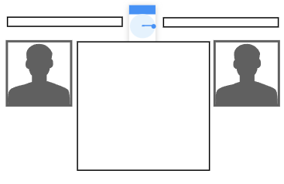

* There are 7 gem types

GEMS | EFFECT
Attack | Deals 3 damage per gem matched
Special Attack | Deals 6 damage per 1 energy player has
Health | Adds 3 health per gem matched
Energy | Adds 2 energy per gem matched
Counter | For the next turn if the player is damaged, it will automatically return attack the enemy back for 2 damage per gem matched when struck
Shield | For the next turn if the player is attacked, it will prevent 2 damage per gem matched
Spirit | Adds 1 spirit energy per gem matched, once 20 spirit or more is built up, attacks enemy for 3 damage per spirit point automatically

* Every time a player makes a match, the type of match is displayed in text underneath the player’s portrait (so ATTACKING!, SPECIAL ATTACK!, HEALING!, ENERGY UP!, COUNTER READY!, SHIELD!, SPECIAL ENERGY UP!); along with a sound effect to indicate the type of match made
* Sound effects for
- selecting a gem
- making a match
- gems falling/landing sound
- gem breaking sound
- gem effects happening (attacking, special attack, healing, energy up, preparing to counter, spirit energy up)
- being hit/taking damage
- shield being hit
- dying gasp

CONTROLS
keyboard
WASD or arrow keys to move gem cursor or on character select
ESC key back out of menu/cancel/pause game with menu
ENTER menu select and select gem (for which two to move)
SPACE menu select and select gem (for which two to move)

controller
D-pad to move gem cursor or on character select
START back out of menu/cancel/pause game with menu
X/Y back out of menu/cancel
A/B menu select and select gem (for which two to move)

GEM FIGHTER
1v1, 1v1v1, or 1v1v1v1

Example game play:
https://youtu.be/xhl9u3oaUkk
https://youtu.be/DPQyp0fnyyg
https://youtu.be/_hBoeRuOtbU

* Each player’s play field is 6 gems wide by 12 gems high
* There are 3 gem types:
- colored normal gems
- colored break gems
- counter gems
- diamond break gems
* Normal gems, when in a square or other rectangular pattern, form a bigger gem, called a “power gem”
* Normal gems and power gems are destroyed when a matching break gem touches them
* When destroyed, cleared gems generate counter gems, the number of counter gems is the same count for all opponents
* Diamond break gems also destroy normal and power gems at a lower value
* If gems exceed the height of columns 1, 2, 3, 5, and 6—those gems stay off screen, but still present
* New gem pairs always generate in column 4
* If the gems exceed the height of column 4 reaches 13 gems, the player loses
* All players get the same sequence of gems; the next gem pair should appear right next to the player’s character avatar
* This is a real-time game, gems fall at a constant rate, with a slight pause for the player as a gem lands, and can be sped up by pushing down
* There are 8 characters, 7 characters with various counter gem patterns, and a last boss character; you can pick any character except the boss in VS matches
* When counter gems are generated, they fall down quickly from any random column, and they only fall after the player’s gem pair has landed, and before the next gem pair is introduced
* There are four gem colors: Red, Blue, Yellow and Green
* Maybe to help with colorblindness gems should have an icon in them? (red fire, blue water, yellow sun?, green flower?)

* Counter gems that are touching a normal gem (left, right, top or bottom, but not diagonally) or crash gem that is breaking, it will also break, although a counter gem has a reduced value count towards a gem total for that player’s own counter gems

SCORING
* Normal gem, bottom rows 1-8, +1 counter gem per gem
* Normal gem, top rows, 9-12, +2 counter gem per gem
* Break gem, +1 counter gem per gem
* Counter gems, +1/2 (round down) counter gem per counter gem
* Diamond Break gem, +1 counter gem per gem, power gems are multiplied by 1 instead of 3 (so a 2x4 gem would return 8, and not 24; see below)
* Power gem are the larger, merged square and rectangular gems; see below for values:
* Dimension of gem x3 (so a 2x4 gem would yield 24 counter gems)

CHAINS
* This is when you break gems, then the remaining gems fall, and then break again, and so on
* Chains as multipliers – a 3 chain combo multiples the counter gems a player gives by 3; we might game balance this so that chains are n-1 multipliers. So a 1 and 2 chain is a x1 multiplier, 3 chain is x2, 4 chain is x3, etc

A NOTE ABOUT COUNTER GEMS
Any counter gems you are about to receive, first deduct from any counter gives you are about to give (this is per-player math). So if you are about to receive 20 counter gems, but are giving 10 counter gems, when it comes time to receive the counter gems, you will only get 10 (20-10=10).

* Sound effects for
- moving a gem
- rotating a gem
- gems falling/landing sound
- gem breaking sound (repeated for power gems)
- player dying gasp (losing)

CONTROLS
keyboard
WASD or arrow keys to move gem pair or on character select
ESC key back out of menu/cancel/pause game with menu
ENTER rotate gem pair right
SPACE rotate gem pair left

controller
D-pad to move gem cursor or on character select
START back out of menu/cancel/pause game with menu
X/Y back out of menu/cancel
A rotate gem pair right
B rotate gem pair left

A 2-player match screen example:

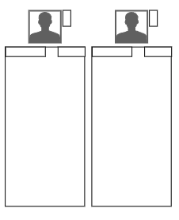

A 4-player match screen example:

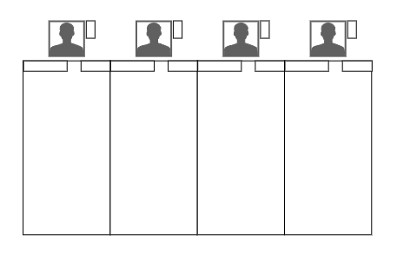

GOALS
What is the win state? How do you win? How do you lose?
In match battle, by reducing your enemy’s health
In gem battle, by eliminating other players with too many gems

COMPONENTS
What objects are in the game?

CONTROLS
How does the player control the game?

ART DETAILS
A statement of art style

USER EXPERIENCE
What steps do they follow and what screens do they see?

TITLE SCREEN

 |  |  | TITLE
 | MENU |  | TITLE

MENU Options:

Match Arcade
Match VS Battle
Gem Arcade
Gem VS Battle
Settings
Exit

MATCH ARCADE
(single player against the computer)
→ Goes right into Character Select

HOST/JOIN MATCH

CHARACTER SELECT
Characters are presented with a player 1 cursor frame, and in 2 player mode, an additional player 2 cursor frame. This is the same character select screen for both puzzle modes.

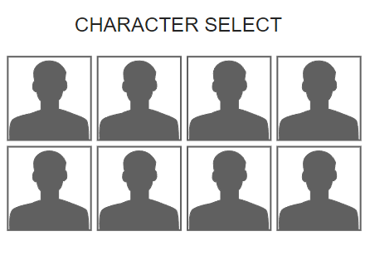
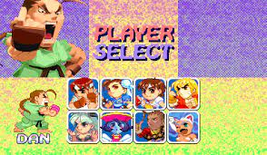

SINGLE PLAYER NEXT CHALLENGE MODE
The player sees the list of opponents slowly revealed as they face their opponents. There would be no stage graphic as shown here, or top/background elements. The last character will always be the same, this is the game’s “boss” character. This is the same single player match up screen for both puzzle modes.

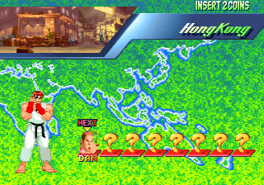

MATCH BATTLE SCREEN
This is the screen for 1v1, computer or human opponent. The match grid is 8 gems by 8 gems.

GEM ARCADE
(single player against the computer)
→ Goes right into Character Select

GEM VS BATTLE

A 2-player match screen example:

A 4-player match screen example:

Characters and Story line
There are 8 characters in the game. For MATCH KOMBAT, each character gets an extra bonus from certain matches. For GEM KOMBAT, each character has their own specific counter pattern.

Accessibility Options
There should be the following options:

- Gamma correction options
- Contrast filter options
- Subtitles for sound effects and speech
- Ability to increase text size for subtitles and speech

# Information Gathering & Requirements Gathering

Talk to game designers (group of game designers, programmer, etc.).
Talk to the people that are designing the actual system.
Usually there is some designer that is taking the lead on this system.
You want to talk to them in depth, in person, on a phone, using Skype, Discord, etc.
You want to be screen sharing and just going back and forth, understanding:
- What they want to have
- What they want to see
- Writing all of this down as detailed notes. Write down everything that they are saying that makes sense or is important

This is not just a process of writing down what they say. This should be a two-way conversation.
You should be looking at things that they are saying that maybe could be expanded or simplified,
to make better use of the game systems that already exist.

For instance, if they are designing a system that gives out items e.g. a crafting system,
maybe we got loottables or itemsets instead of setting up an item, should it use that?

Maybe it gives stats. It may not make sense to complicate the stats system more and having a bunch of things that interact with stats.
When I could just have a system that gives a buff to the player and handle the stats like that.

Sometimes the would just be this big system that does one little thing, that semi-interacts with another system, and we don't want to overcomplicate those things.
We want to use the systems that are already in place.

We don't want to just do that on a whim. We want to talk about this with the game designers and make sure that it makes sense to them as well
and they are not thinking of something a little bit more advanced down the line.
Ask questions non-stop. If something is not absolutely clear, ask and find out.
Sometimes the answer will be obvious, sometimes it will be something that you could never have imagined.
This is why these questions need to be asked.

# Talk to the Team
N/A

# Sketch out the UI / Wireframes
This helps with identifying data structures and getting cool ideas

Once these sketches are done, don't just start with implementing things / coding.
Instead, talk about the designs with the designers.

Try to get an idea of what this would look like, filled out with real stuff.
But don't worry about it being perfect. It's not supposed to be the actual UI or design document.
It's for experimenting and getting an idea of what you'd actually like to build.

# Data Structures
Data structures are one of these important things we get from the UI sketches.
There are a couple of different data structures that we need to know about / use.
The ones that really come from the UI sketches are the ones for `data that the client is seing`.

In an MMO for example, we only want to send the clients data that we really want them to know about.
We don't want to send anything that we don't want the client to know. Everything that should be a secret,
should never be sent. Eventually the players would find out and exploit / hack it.

We want to find out what those structures are but we also need the data structures for saving player data, etc.

# Content Data
One other type of data structure that we need to know about is the `content data`.
This could end up going into a database or coming from somewhere else.
We need to know what that data looks like.

In the case of a crafting system, it could be: What does a receipt look like?
- Does it have a name?
- Does it have an ID?
- Does it have a list of ingredients?
- Does it have a list of skills or abilities that are related to it?
We need to know what these things are which are related to the system and put those into the data structures that
are going to be used for saving.

For example:
- Crafting receipts
- Ingredient Items
- Results Items

# Systems
The next step still is not coding. It's coming up with the systems that we need (Controllers, Classes, Processors, Structs, etc.).
All of the high-level ideas of the code part that we need.
They should be sketched out as well. Not in detail but more as a block-out to get an overview, showing the key parts of the system.

These designs can change, and they often do change. It's just a rough idea to get started and have an architectural idea of what
we are building.

A system is generally a class that is running an entire system.
If something is happening on the world level (e.g. a world zone event, a world variabl, etc.), that stuff would go into a system.
We generally want to have a system which is responsible for one thing.

# Controllers

