* IDE:Eclipse
* JDK 1.7
* “stop_words”,”docset” and my output are all in the root of my program path.
* The four arguments in HW2Main1.java are as follows:
* trectext docset.trectext stop_words.txt index_text
* trecweb docset.trecweb stop_words.txt index_web
* The two arguments in HW2Main2.java are as follows:
* index_text variance (can be any token that you are searching for)
* index_web variance (can be any token that you are searching for)
* In the folder “index_text” or “index_web”, there are four kinds of files:
* posting list
* dictionary
* docid
* docno
* 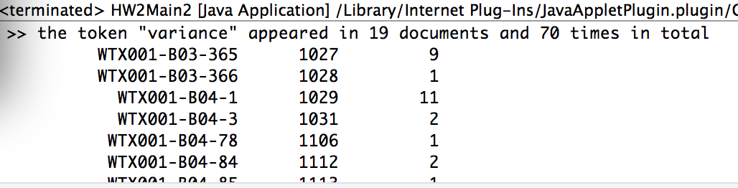When running HW2Main2.java in Eclipse, the output is as follows: