RealSpend Desktop Version usage

Note:
- Please use Google latest Chrome browser to run it, later we will support more browser (we use D3, it can’t support IE)
- Please add following argument “--args --disable-web-security --ignore-certificate-errors --allow-running-insecure-content” to run the chrome, otherwise, it will meet following error
Origin null is not allowed by Access-Control-Allow-Origin.

RealSpend different version history

iPad version
First version, front-end made by USA AppHause, backend by FIN zhiqiang’s team.
See https://wiki.wdf.sap.corp/wiki/display/suiteconsu/SAP+RealSpend+Desktop+version+by+SAPUI5

Desktop version by IMS Mobile team
Start from 2012/08, the odata part reuse the iPad version. At the sametime, zhiqiang’s team add HANA support.
See https://wiki.wdf.sap.corp/wiki/display/suiteconsu/SAP+RealSpend+Desktop+version+by+SAPUI5
First we only asked to supported desktop, later we refactor the code to support both desktop and device. Most of source code is same.
User name: guest, password: guest
Desktop version SVN url: https://PVGN50803578A.dhcp.pvgl.sap.corp/svn/RealSpend/trunk
Mobile version SVN url: https://PVGN50803578A.dhcp.pvgl.sap.corp/svn/RealSpend/branches/snow_android

Temporary version by 群硕 (Third-part company, work for SAP)
In beginning, they are asked to build Android version. They reuse part of our source code and build one version which can run on iPad and implemented part of functions.
Later they suspend the project and transfer to us, but we found it is hard to continue the mobile version based on their version, so we do some change from our desktop to let it support both.

BlackVersion
They build from scratch, source code from SVN https://PVGN50803578A.dhcp.pvgl.sap.corp/svn/RealSpend-BlackBerry/
(this is the old source code, if need latest version, see
https://wiki.wdf.sap.corp/wiki/display/suiteconsu/SAP+Real+Spend+BB10

mySpend
In Fiori wave1, they implement part of the iPad RealSpend functions. They reuse part of our Desktop source code.

How to work with SAPUI5 Eclipse

How to import project

Method 1, directly import the project
Choose the File→Import, choose the ‘file system’ and select the project download from SVN.

Method 2, import from SVN server
- From SAPUI5 Eclipse help->Install New Software, add this site:
http://download.eclipse.org/technology/subversive/1.0/update-site/

- After finished install, when restart SAPUI5 Eclipse, it ask to install the svnconnector , choose the Second one (others I not try, but second one is ok)

- FileàImport , choose SVN, type following address https://10.58.88.69/svn/RealSpend/trunk, then it ask you input your name and password, chose follow:

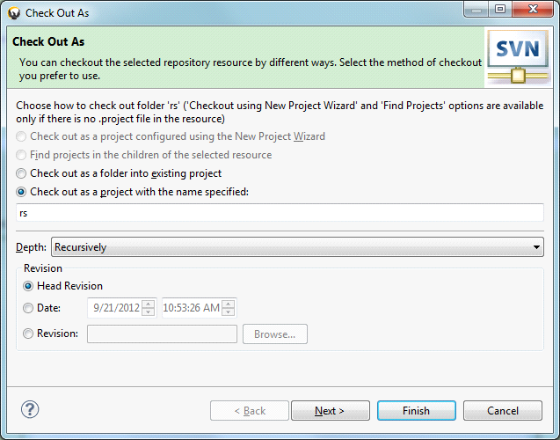

4: Just select one file, right click, then all the SVN command is available under “Team” command, and you can easily compare with the base version by “Compare With…”.

How to run
Choose the project, click ‘Run’ button and choose ‘Web App Preview’. Then copy the url 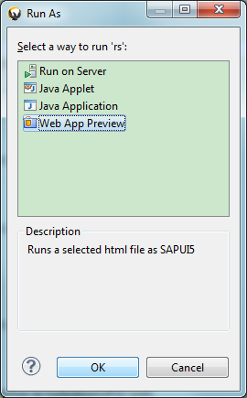

Liking http://localhost:60425/rs/index.html into Google Chrome browser.

How to debug into the SAPUI5 source code
Just change the ‘index.html’ the sapui5 library from resources/sap-ui-core.js to
resources/sap-ui-core-all-dbg.js, then you can set debug in the sapui5 source code.

