RealSpend Desktop Version usage

Note:
- Please use Google latest Chrome browser to run it, later we will support more browser (we use D3, it can’t support IE)
- Please add following argument “--args --disable-web-security --ignore-certificate-errors --allow-running-insecure-content” to run the chrome, otherwise, it will meet following error
Origin null is not allowed by Access-Control-Allow-Origin.

How to work with SAPUI5 Eclipse

How to import project

Method 1, directly import the project
Choose the File→Import, choose the ‘file system’ and select the project download from SVN.

Method 2, import from SVN server
- From SAPUI5 Eclipse help->Install New Software, add this site:
http://download.eclipse.org/technology/subversive/1.0/update-site/

- After finished install, when restart SAPUI5 Eclipse, it ask to install the svnconnector , choose the Second one (others I not try, but second one is ok)

- FileàImport , choose SVN, type following address https://10.58.88.69/svn/RealSpend/trunk, then it ask you input your name and password, chose follow:

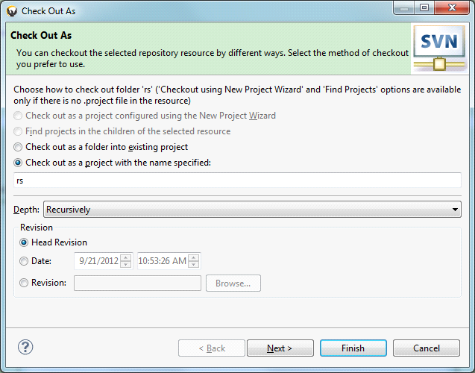

4: Just select one file, right click, then all the SVN command is available under “Team” command, and you can easily compare with the base version by “Compare With…”.

How to run
Choose the project, click ‘Run’ button and choose ‘Web App Preview’. Then copy the url 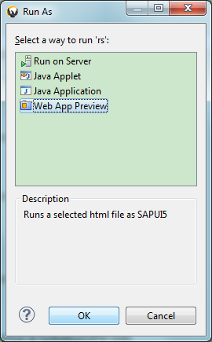

Liking http://localhost:60425/rs/index.html into Google Chrome browser.

How to debug into the SAPUI5 source code
Just change the ‘index.html’ the sapui5 library from resources/sap-ui-core.js to
resources/sap-ui-core-all-dbg.js, then you can set debug in the sapui5 source code.

