电 子 科 技 大 学
实 验 报 告
学生姓名：孙振竣 学 号：2018081303008 指导教师：俸志刚

一、实验室名称：程序设计基础
二、实验项目名称：五子棋AI
三、实验原理：利用C语言写个五子棋的人机对战游戏

四、实验目的：
利用C语言写个五子棋的人机对战游戏

五、实验内容：
利用C语言写个五子棋的人机对战游戏,通过对活三、岷三等棋盘状态特点，改写为代码形式，运用人工穷举，按代码顺序先进行防御，再进行进攻

六、实验器材（设备、元器件）：PC微机一台，IDE版本：C-Free5
编译器：MinGW5

七、实验步骤：
(1)主函数：main.c
主函数主要实现了玩家输入，黑子为“X”，白子为“O”。并执行自定义的其他函数。
#include <time.h>
#include "functions.h"
int main(int argc, char *argv[])
{
int i,j,n,s,line,column;
int liner,columnr;
char columnc,key,linec;
char *a[100];
n=0;
for(i=0;i<30;i++)
{
a[i] = (char*)malloc(sizeof(char)*100);
}
createmap(a);
while(1)
{
printf("人工智障版五子棋 BY 孙*竣 \n");
printmap(a);
check_5(a);
printf("输入格式，输入坐标即可，如：A 1(注意字母与数字之间的空格)\n");
printf("请输入");
point1:scanf("%s %d",&columnc,&line);
line=line*2-1;
column=((int)columnc-64)*2-2;
if((a[line][column]=='X')||(a[line][column]=='O'))
{
printf("这个位置已经被下过了\n");
goto point1;
}
if(column>=0)a[line][column]='X';//如果不对column进行判断，column每次都会先=-110，然后才是正确的坐标，很迷的BUG
printf("\n");
deal_live_3(a);
system("cls");
}
return 0;
}
/*随机乱下版的残骸：
time_t t1,t2;
point2:srand((unsigned) time(0));
columnr=(rand()%14+1)*2;
liner=(rand()%15+1)*2-3;
if((a[liner][columnr]=='X')||(a[liner][columnr]=='O'))goto point2;
if(columnr>=0)a[liner][columnr]='O';
*/
- 头文件：functions.h
该程序一共有四个自定义的函数
#include <stdio.h>
void createmap();
void check_5(char *a[30]);
void printmap(char *a[30]);
void deal_live_3(char *a[30]);
- 棋盘编辑函数：createmap.c
该程序采用循环语句手动画格子，下棋时棋子落在空格处。
#include <stdio.h>
#include <string.h>
#include <stdlib.h>
#include <time.h>
#include "functions.h"
void createmap(char *a[30])
{
int i;
char columnc;
for(i=1;i<30;i++)
{
if(i%2==1)
{
columnc=(char)((i+1)/2);
strcpy(a[i]," | | | | | | | | | | | | | | |");
}
if(i%2==0)
{
strcpy(a[i],"------------------------------");
}
}
}
- 棋盘打印函数：printmap.c
将棋盘以及棋盘的变化，存入30*30的状态数组中，玩家与AI每执行一次，状态数组都会改变，每回合把状态数组输出一次
#include <stdio.h>
#include <string.h>
#include <stdlib.h>
#include <time.h>
void printmap(char *a[30])
{
int i;
for(i=65;i<=79;i++)
{
printf("%c ",i);
}
printf("\n");
for(i=1;i<30;i++)
{
if(i%2==1)
{
printf("%s%d\n",a[i],((i+1)/2));
}
else
{
printf("%s\n",a[i]);
}
}
}
- 输赢判断函数：check_5.c
根据输赢时的棋子位置特点：黑子为：XXXXX，白子为：OOOOO
默认玩家为黑子先走，AI为白子后走。
五子的特点为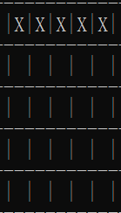或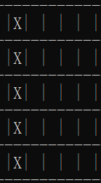或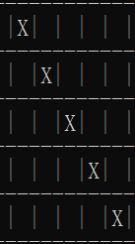或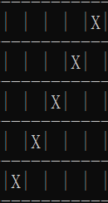
对整个棋盘的每个子进行遍历，若发现坐标有：(i,j)=X,(i+1,j)=X,(i+2,j)=X,(i+3,j)=X,(i+4,j)=X
那么就判断黑子赢，游戏结束。
同理，如果这5个都是白的，那么就是白子赢，游戏结束
#include <stdio.h>
void check_5(char *a[30])
{
int i,j;
for(i=1;i<30;i=i+2)
{
for(j=0;j<29;j=j+2)
{
if((a[i][j]=='X')&&(a[i][j+2]=='X')&&(a[i][j+4]=='X')&&(a[i][j+6]=='X')&&(a[i][j+8]=='X'))
{
printf("你赢了\n");exit(0);
break;
}
if((a[i][j]=='X')&&(a[i+2][j]=='X')&&(a[i+4][j]=='X')&&(a[i+6][j]=='X')&&(a[i+8][j]=='X'))
{
printf("你赢了\n");exit(0);
break;
}
if((a[i][j]=='X')&&(a[i+2][j+2]=='X')&&(a[i+4][j+4]=='X')&&(a[i+6][j+6]=='X')&&(a[i+8][j+8]=='X'))
{
printf("你赢了\n");exit(0);
break;
}
if((a[i][j]=='X')&&(a[i+2][j-2]=='X')&&(a[i+4][j-4]=='X')&&(a[i+6][j-6]=='X')&&(a[i+8][j-8]=='X')&&(j>10))
{
printf("你赢了\n");exit(0);
break;
}
if((a[i][j]=='O')&&(a[i][j+2]=='O')&&(a[i][j+4]=='O')&&(a[i][j+6]=='O')&&(a[i][j+8]=='O'))
{
printf("你输了\n");exit(0);
break;
}
if((a[i][j]=='O')&&(a[i+2][j]=='O')&&(a[i+4][j]=='O')&&(a[i+6][j]=='O')&&(a[i+8][j]=='O'))
{
printf("你输了\n");exit(0);
break;
}
if((a[i][j]=='O')&&(a[i+2][j+2]=='O')&&(a[i+4][j+4]=='O')&&(a[i+6][j+6]=='O')&&(a[i+8][j+8]=='O'))
{
printf("你输了\n");exit(0);
break;
}
if((a[i][j]=='O')&&(a[i+2][j-2]=='O')&&(a[i+4][j-4]=='O')&&(a[i+6][j-6]=='O')&&(a[i+8][j-8]=='O')&&(j>10))
{
printf("你输了\n");exit(0);
break;
}
}
}
}
- AI判断函数deal_live_3.c
类似判断输赢的方法，判断输赢是5个棋子是否连续，而判断活三，岷三等状态，只用看棋子是否为“空XXX空”或“空XXX”即可
本程序对：冲四“XXXX”,”XX空XX”
活三“空XXX空”，“空XX空X空”,“空X空XX空”
岷三“空XXX”,“空XX空X”，“空X空XX”
按认为规定的代码顺序进行先后防御
如果不需要防御，则利用“OOO”型，和“OO空O”型进行进攻
#include <stdio.h>
#include <stdlib.h>
#include "functions.h"
void deal_live_3(char *a[30])//检查活三，黑子有活三返回1，白子有活三返回2
{
int i, j, n = 0;//n用来判断进攻或者防御是否成功
int liner, columnr;
for(i=1;i<30;i=i+2)
{
if(n==1)break;//以下为判断“XXXX”型的活四，最为要紧，所以最先判断
for(j=0;j<29;j=j+2)
{
if((((a[i][j]==' ')||(a[i+10][j]==' '))&&(a[i+2][j]=='X')&&(a[i+4][j]=='X')&&(a[i+6][j]=='X'))&&(a[i+8][j]=='X'))
{
if(a[i][j]==' ')
{
a[i][j]='O';
}
else a[i+10][j]='O';n=1;
break;
}
if((((a[i][j]==' ')||(a[i][j+10]==' '))&&(a[i][j+2]=='X')&&(a[i][j+4]=='X')&&(a[i][j+6]=='X'))&&(a[i][j+8]=='X'))
{
if(a[i][j]==' ')
{
a[i][j]='O';
}
else a[i][j+10]='O';n=1;
break;
}
if((((a[i][j]==' ')||(a[i+10][j+10]==' '))&&(a[i+2][j+2]=='X')&&(a[i+4][j+4]==' ')&&(a[i+6][j+6]=='X'))&&(a[i+8][j+8]=='X'))
{
if(a[i][j]==' ')
{
a[i][j]='O';
}
else a[i=10][j+10]='O';n=1;
break;
}
if(((((a[i][j]==' ')||(a[i+10][j-10]==' '))&&(a[i+2][j-2]=='X')&&(a[i+4][j-4]==' ')&&(a[i+6][j-6]=='X'))&&(a[i+8][j-8]=='X'))&&(j>12))
{
if(a[i][j]==' ')
{
a[i][j]='O';
}
else a[i+10][j-10]='O';n=1;
break;
}
}
}
if(n==0)//判断“XX XX型冲四”
{
for(i=1;i<30;i=i+2)
{
for(j=0;j<29;j=j+2)
{
if((((a[i][j]!='X')&&(a[i][j]!='O'))||((a[i][j+12]!='X')&&(a[i][j+12]!='O')))&&((a[i][j+2]=='X')&&(a[i][j+4]=='X')&&(a[i][j+6]==' ')&&(a[i][j+8]=='X')&&(a[i][j+10]=='X'))&&(j<19))
{
a[i][j+6]='O';
break;
}
if((((a[i][j]!='X')&&(a[i][j]!='O'))||((a[i+12][j+12]!='X')&&(a[i+12][j+12]!='O')))&&((a[i+2][j+2]=='X')&&(a[i+4][j+4]=='X')&&(a[i+6][j+6]==' ')&&(a[i+8][j+8]=='X')&&(a[i+10][j+10]=='X'))&&(j<19)&&(i<19))
{
a[i+6][j+6]='O';
break;
}
if((((a[i][j]!='X')&&(a[i][j]!='O'))||((a[i+12][j]!='X')&&(a[i+12][j]!='O')))&&((a[i+2][j]=='X')&&(a[i+4][j]=='X')&&(a[i+6][j]==' ')&&(a[i+8][j]=='X')&&(a[i+10][j]=='X'))&&(i<19))
{
a[i][j+6]='O';
break;
}
if((((a[i][j]!='X')&&(a[i][j]!='O'))||((a[i+12][j-12]!='X')&&(a[i+12][j-12]!='O')))&&((a[i+2][j-2]=='X')&&(a[i+4][j-4]=='X')&&(a[i+6][j-6]==' ')&&(a[i+8][j-8]=='X')&&(a[i+10][j-10]=='X'))&&(j>14))
{
a[i][j+6]='O';
break;
}
}
}
}
if(n==0)
{
for (i = 1; i < 30; i = i + 2)//防御有两边空的“XXX”活三
{
if (n == 1)break;
for (j = 2; j < 29; j = j + 2)
{
if ((a[i][j] == ' ') && (a[i][j + 2] == 'X') && (a[i][j + 4] == 'X') && (a[i][j + 6] == 'X') && (a[i][j + 8] == ' '))
{
if (a[i][j] == ' ')
{
a[i][j] = 'O';
}
else a[i][j + 8] = 'O'; n = 1;
break;
}
if ((a[i][j] == ' ') && (a[i+2][j] == 'X') && (a[i+4][j] == 'X') && (a[i+6][j] == 'X') && (a[i+8][j] == ' '))
{
if (a[i][j] == ' ')
{
a[i][j] = 'O';
}
else a[i + 8][j] = 'O'; n = 1;
break;
}
if ((a[i][j] == ' ') && (a[i+2][j + 2] == 'X') && (a[i+4][j + 4] == 'X') && (a[i+6][j + 6] == 'X') && (a[i+8][j + 8] == ' '))
{
if (a[i][j] == ' ')
{
a[i][j] = 'O';
}
else a[i + 8][j + 8] = 'O'; n = 1;
break;
}
if (((a[i][j] == ' ') && (a[i+2][j - 2] == 'X') && (a[i+4][j - 4] == 'X') && (a[i+6][j - 6] == 'X') && (a[i+8][j - 8] == ' ')) && (j > 10))
{
if (a[i][j] == ' ')
{
a[i][j] = 'O';
}
else a[i + 8][j - 8] = 'O'; n = 1;
break;
}
}
}
}
if(n==0)//判断防御是否成功
{
for (i = 1; i < 30; i = i + 2)
{
if (n == 1)break;
for (j = 0; j < 29; j = j + 2)//防御有两边空的“X XX”和“XX X”岷三
{
if ((a[i][j] == ' ') && (a[i][j + 2] == 'X') && (a[i][j + 4] == ' ') && (a[i][j + 6] == 'X') && (a[i][j + 8] == 'X') && (a[i][j + 10] == ' '))
{
a[i][j + 4] = 'O'; n = 1;
break;
}
if ((a[i][j] == ' ') && (a[i][j + 2] == 'X') && (a[i][j + 4] == 'X') && (a[i][j + 6] == ' ') && (a[i][j + 8] == 'X') && (a[i][j + 10] == ' '))
{
a[i][j + 6] = 'O'; n = 1;
break;
}
if ((a[i][j] == ' ') && (a[i+2][j + 2] == 'X') && (a[i+4][j + 4] == ' ') && (a[i+6][j + 6] == 'X') && (a[i+8][j + 8] == 'X') && (a[i+10][j + 10] == ' '))
{
a[i + 4][j + 4] = 'O'; n = 1;
break;
}
if ((a[i][j] == ' ') && (a[i+2][j + 2] == 'X') && (a[i+4][j + 4] == 'X') && (a[i+6][j + 6] == ' ') && (a[i+8][j + 8] == 'X') && (a[i+10][j + 10] == ' '))
{
a[i + 6][j + 6] = 'O'; n = 1;
break;
}
if ((a[i][j] == ' ') && (a[i + 2][j] == 'X') && (a[i + 4][j] == ' ') && (a[i + 6][j] == 'X') && (a[i + 8][j] == 'X') && (a[i + 10][j] == ' '))
{
a[i + 4][j] = 'O'; n = 1;
break;
}
if ((a[i][j] == ' ') && (a[i + 2][j] == 'X') && (a[i + 4][j] == 'X') && (a[i + 6][j] == ' ') && (a[i + 8][j] == 'X') && (a[i + 10][j] == ' '))
{
a[i + 6][j] = 'O'; n = 1;
break;
}
if (((a[i][j] == ' ') && (a[i + 2][j-2] == 'X') && (a[i + 4][j-4] == ' ') && (a[i + 6][j-6] == 'X') && (a[i + 8][j-8] == 'X') && (a[i + 10][j-10] == ' ')) && (j > 12))
{
a[i + 4][j - 4] = 'O'; n = 1;
break;
}
if (((a[i][j] == ' ') && (a[i + 2][j-2] == 'X') && (a[i + 4][j-4] == 'X') && (a[i + 6][j-6] == ' ') && (a[i + 8][j-8] == 'X') && (a[i + 10][j-10] == ' ')) && (j > 12))
{
a[i + 6][j - 6] = 'O'; n = 1;
break;
}
}
}
}
if(n==0)//判断防御是否成功
{
for (i = 1; i < 30; i = i + 2)
{
if (n == 1)break;
for (j = 0; j < 29; j = j + 2)//防御一边空的“XXX”岷三
{
if (((a[i][j] == ' ') || (a[i][j + 8] == ' ')) && (a[i][j + 2] == 'X') && (a[i][j + 4] == 'X') && (a[i][j + 6] == 'X'))
{
if (a[i][j] == ' ')
{
a[i][j] = 'O';
}
else a[i][j + 8] = 'O'; n = 1;
break;
}
if (((a[i][j] == ' ') || (a[i + 8][j] == ' ')) && (a[i + 2][j] == 'X') && (a[i + 4][j] == 'X') && (a[i + 6][j] == 'X'))
{
if (a[i][j] == ' ')
{
a[i][j] = 'O';
}
else a[i + 8][j] = 'O'; n = 1;
break;
}
if (((a[i][j] == ' ') || (a[i + 8][j + 8] == ' ')) && (a[i + 2][j + 2] == 'X') && (a[i + 4][j + 4] == 'X') && (a[i + 6][j + 6] == 'X'))
{
if (a[i][j] == ' ')
{
a[i][j] = 'O';
}
else a[i + 8][j + 8] = 'O'; n = 1;
break;
}
if ((((a[i][j] == ' ') || (a[i + 8][j - 8] == ' ')) && (a[i + 2][j - 2] == 'X') && (a[i + 4][j - 4] == 'X') && (a[i + 6][j - 6] == 'X')) && (j > 10))
{
if (a[i][j] == ' ')
{
a[i][j] = 'O';
}
else a[i + 8][j - 8] = 'O'; n = 1;
break;
}
}
}
}
if(n==0)//判断防御是否成功
{
for (i = 1; i < 30; i = i + 2)
{
if (n == 1)break;
for (j = 0; j < 29; j = j + 2)//防御有一边空的“X XX”和“XX X”岷三
{
if ((((a[i][j] == ' ') || (a[i][j + 10] == ' ')) && (a[i][j + 2] == 'X') && (a[i][j + 4] == ' ') && (a[i][j + 6] == 'X')) && (a[i][j + 8] == 'X'))
{
a[i][j + 4] = 'O'; n = 1;
break;
}
if ((((a[i][j] == ' ') || (a[i][j + 10] == ' ')) && (a[i][j + 2] == 'X') && (a[i][j + 4] == 'X') && (a[i][j + 6] == ' ')) && (a[i][j + 8] == 'X'))
{
a[i][j + 6] = 'O'; n = 1;
break;
}
if ((((a[i][j] == ' ') || (a[i + 10][j + 10] == ' ')) && (a[i + 2][j + 2] == 'X') && (a[i + 4][j + 4] == ' ') && (a[i + 6][j + 6] == 'X')) && (a[i + 8][j + 8]) == 'X')
{
a[i + 4][j + 4] = 'O'; n = 1;
break;
}
if ((((a[i][j] == ' ') || (a[i + 10][j + 10] == ' ')) && (a[i + 2][j + 2] == 'X') && (a[i + 4][j + 4] == 'X') && (a[i + 6][j + 6] == ' ')) && (a[i + 8][j + 8]) == 'X')
{
a[i + 6][j + 6] = 'O'; n = 1;
break;
}
if ((((a[i][j] == ' ') || (a[i + 10][j] == ' ')) && (a[i + 2][j] == 'X') && (a[i + 4][j] == ' ') && (a[i + 6][j] == 'X')) && (a[i + 8][j] == 'X'))
{
a[i + 4][j] = 'O'; n = 1;
break;
}
if ((((a[i][j] == ' ') || (a[i + 10][j] == ' ')) && (a[i + 2][j] == 'X') && (a[i + 4][j] == 'X') && (a[i + 6][j] == ' ')) && (a[i + 8][j] == 'X'))
{
a[i + 6][j] = 'O'; n = 1;
break;
}
if ((((a[i][j] == ' ') || (a[i + 10][j - 10] == ' ')) && (a[i + 2][j - 2] == 'X') && (a[i + 4][j - 4] == ' ') && (a[i + 6][j - 6] == 'X') && (a[i + 8][j - 8] == 'X')) && (j > 12))
{
a[i + 4][j - 4] = 'O'; n = 1;
break;
}
if ((((a[i][j] == ' ') || (a[i + 10][j - 10] == ' ')) && (a[i + 2][j - 2] == 'X') && (a[i + 4][j - 4] == 'X') && (a[i + 6][j - 6] == ' ') && (a[i + 8][j - 8] == 'X')) && (j > 12))
{
a[i + 6][j - 6] = 'O'; n = 1;
break;
}
}
}
}
if (n == 0)//判断是否防御成功
{
for (i = 1; i < 30; i = i + 2)//利用“OOO”型活三进攻
{
if (n == 1)break;
for (j = 0; j < 29; j = j + 2)
{
if (((a[i][j] == ' ') || (a[i][j + 8] == ' ')) && (a[i][j + 2] == 'O') && (a[i][j + 4] == 'O') && (a[i][j + 6] == 'O'))
{
if (a[i][j] == ' ')
{
a[i][j] = 'O';
}
else a[i][j + 8] = 'O'; n = 1;
break;
}
if (((a[i][j] == ' ') || (a[i + 8][j] == ' ')) && (a[i + 2][j] == 'O') && (a[i + 4][j] == 'O') && (a[i + 6][j] == 'O'))
{
if (a[i][j] == ' ')
{
a[i][j] = 'O';
}
else a[i + 8][j] = 'O'; n = 1;
break;
}
if (((a[i][j] == ' ') || (a[i + 8][j + 8] == ' ')) && (a[i + 2][j + 2] == 'O') && (a[i + 4][j + 4] == 'O') && (a[i + 6][j + 6] == 'O'))
{
if (a[i][j] == ' ')
{
a[i][j] = 'O';
}
else a[i + 8][j + 8] = 'O'; n = 1;
break;
}
if ((((a[i][j] == ' ') || (a[i + 8][j - 8] == ' ')) && (a[i + 2][j - 2] == 'O') && (a[i + 4][j - 4] == 'O') && (a[i + 6][j - 6] == 'O')) && (j > 10))
{
if (a[i][j] == ' ')
{
a[i][j] = 'O';
}
else a[i + 8][j - 8] = 'O'; n = 1;
break;
}
}
}
}
if (n == 0)//判断是否防御成功
{
for (i = 1; i < 30; i = i + 2)//利用“O OO”和“OO O”型活三进攻
{
if (n == 1)break;
for (j = 0; j < 29; j = j + 2)
{
if ((((a[i][j] == ' ') || (a[i][j + 10] == ' ')) && (a[i][j + 2] == 'O') && (a[i][j + 4] == ' ') && (a[i][j + 6] == 'O')) && (a[i][j + 8] == 'O'))
{
a[i][j + 4] = 'O'; n = 1;
break;
}
if ((((a[i][j] == ' ') || (a[i][j + 10] == ' ')) && (a[i][j + 2] == 'O') && (a[i][j + 4] == 'O') && (a[i][j + 6] == ' ')) && (a[i][j + 8] == 'O'))
{
a[i][j + 6] = 'O'; n = 1;
break;
}
if ((((a[i][j] == ' ') || (a[i + 10][j + 10] == ' ')) && (a[i + 2][j + 2] == 'O') && (a[i + 4][j + 4] == ' ') && (a[i + 6][j + 6] == 'O')) && (a[i + 8][j + 8]) == 'O')
{
a[i + 4][j + 4] = 'O'; n = 1;
break;
}
if ((((a[i][j] == ' ') || (a[i + 10][j + 10] == ' ')) && (a[i + 2][j + 2] == 'O') && (a[i + 4][j + 4] == 'O') && (a[i + 6][j + 6] == ' ')) && (a[i + 8][j + 8]) == 'O')
{
a[i + 6][j + 6] = 'O'; n = 1;
break;
}
if ((((a[i][j] == ' ') || (a[i + 10][j] == ' ')) && (a[i + 2][j] == 'O') && (a[i + 4][j] == ' ') && (a[i + 6][j] == 'O')) && (a[i + 8][j] == 'O'))
{
a[i + 4][j] = 'O'; n = 1;
break;
}
if ((((a[i][j] == ' ') || (a[i + 10][j] == ' ')) && (a[i + 2][j] == 'O') && (a[i + 4][j] == 'O') && (a[i + 6][j] == ' ')) && (a[i + 8][j] == 'O'))
{
a[i + 6][j] = 'O'; n = 1;
break;
}
if ((((a[i][j] == ' ') || (a[i + 10][j - 10] == ' ')) && (a[i + 2][j - 2] == 'O') && (a[i + 4][j - 4] == ' ') && (a[i + 6][j - 6] == 'O') && (a[i + 8][j - 8] == 'O')) && (j > 12))
{
a[i + 4][j - 4] = 'O'; n = 1;
break;
}
if ((((a[i][j] == ' ') || (a[i + 10][j - 10] == ' ')) && (a[i + 2][j - 2] == 'O') && (a[i + 4][j - 4] == 'O') && (a[i + 6][j - 6] == ' ') && (a[i + 8][j - 8] == 'O')) && (j > 12))
{
a[i + 6][j - 6] = 'O'; n = 1;
break;
}
}
}
}
if (n == 0)//判断进攻是否成功
{
for (i = 1; i < 30; i = i + 2)//在自己落单的子旁边增加子
{
if (n == 1)break;
for (j = 0; j < 29; j = j + 2)
{
if ((a[i][j] == 'O') && (a[i][j + 2] == ' '))
{
a[i][j + 2] = 'O'; n = 1; break;
}
else if ((a[i][j] == 'O') && (a[i][j - 2] == ' ') && (j > 2))
{
a[i][j - 2] = 'O'; n = 1; break;
}
else if ((a[i][j] == 'O') && (a[i + 2][j] == ' '))
{
a[i + 2][j] = 'O'; n = 1; break;
}
else if ((a[i][j] == 'O') && (a[i - 2][j] == ' ') && (i > 2))
{
a[i + 2][j - 2] = 'O'; n = 1; break;
}
else if ((a[i][j] == 'O') && (a[i + 2][j + 2] == ' '))
{
a[i + 2][j + 2] = 'O'; n = 1; break;
}
else if ((a[i][j] == 'O') && (a[i - 2][j - 2] == ' ') && (i > 2) && (j > 2))
{
a[i - 2][j - 2] = 'O'; n = 1; break;
}
else if ((a[i][j] == 'O') && (a[i + 2][j - 2] == ' ') && (j > 2))
{
a[i + 2][j - 2] = 'O'; n = 1; break;
}
else if ((a[i][j] == 'O') && (a[i - 2][j + 2] == ' ') && (i > 2))
{
a[i - 2][j + 2] = 'O'; n = 1; break;
}
}
}
}
if (n == 0)
{
for (i = 1; i < 30; i = i + 2)
{
for (j = 0; j < 29; j = j + 2)
{
if (a[i][j] == 'X')
{
a[i + 2][j + 2] = 'O'; break;
}
}
}
}
}

- 实验数据及结果分析：
该程序完全是按本人的下棋思路编写的，也就是本作者在无失误情况下进行下棋的套路。稍不注意，本作者就被打败了。
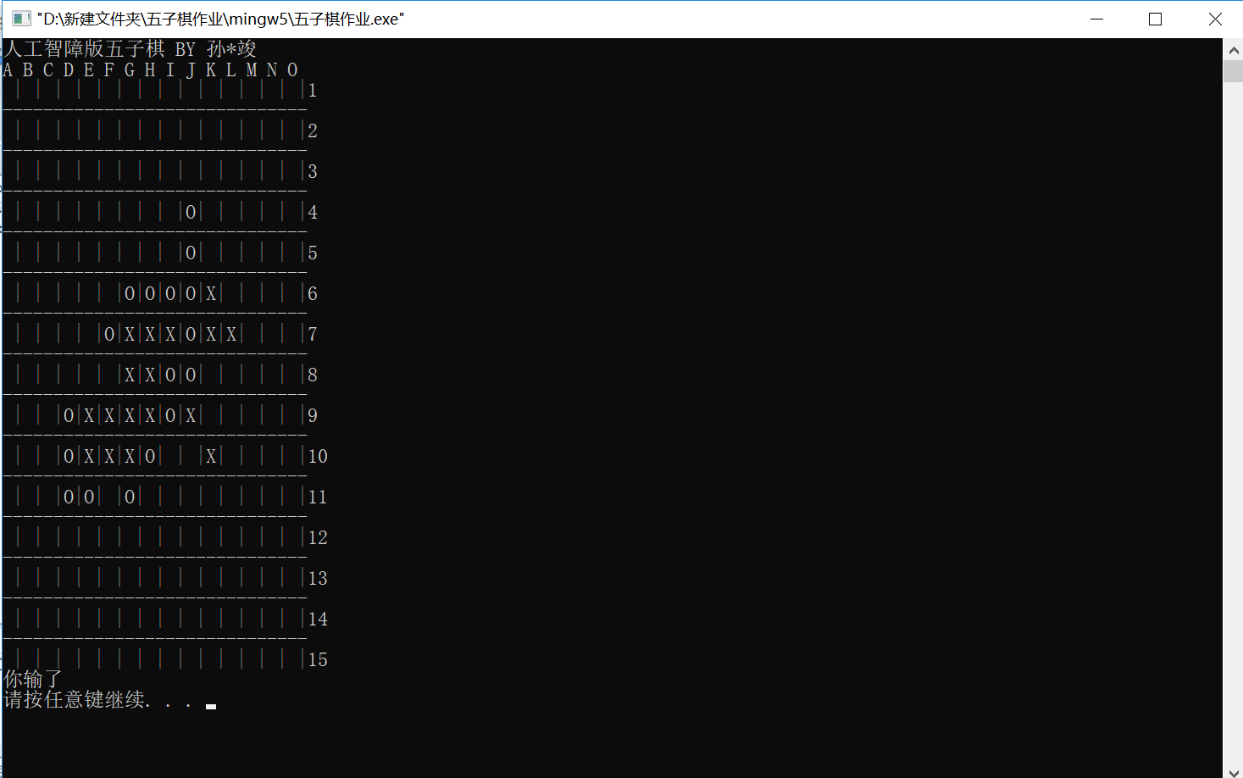
当然，该程序为进行先手禁手的判断，所以开局构造双活三还是能干掉电脑的。
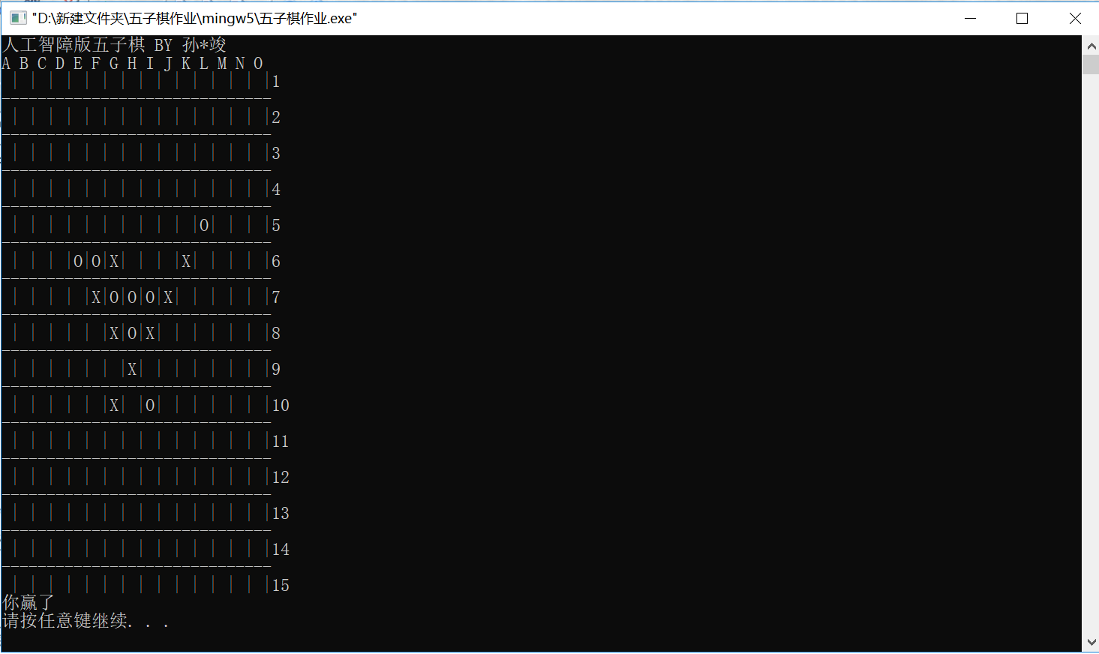

- 实验结论：
该程序能按照规则与真人玩家对弈，并且有一定难度

十、总结及心得体会：
自己写的程序把自己下赢，这输得比赢了还高兴

十一、对本实验过程及方法、手段的改进建议：
希望把棋盘改为鼠标点击输入，减少因坐标看错的失误
AI的算法可以改为估值，神经网络，遗传算法等更高级的算法

报告评分：
指导教师签字：

