**19. Sum of Digits in a String**

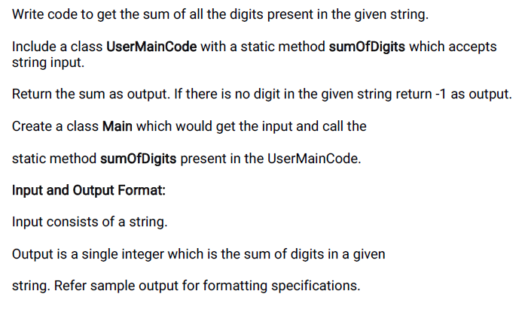

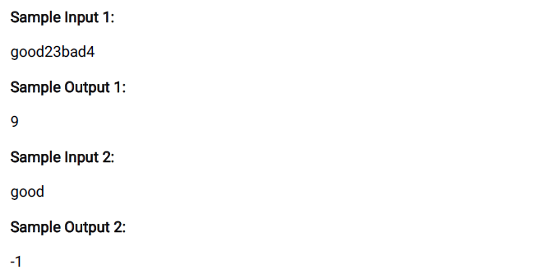

**Main:**

**=====**

**Import java.util.*;**

**public class Main {**

**public static void main (String [] args)**

**{**

**}**

**UserMainCode:**

**============**

**import java.util.*;**

**import java.text.*;**

**public class UserMainCode{**

**public static void sumOfDigits(String s1) {**

**}}**

**20. String Concatenation**

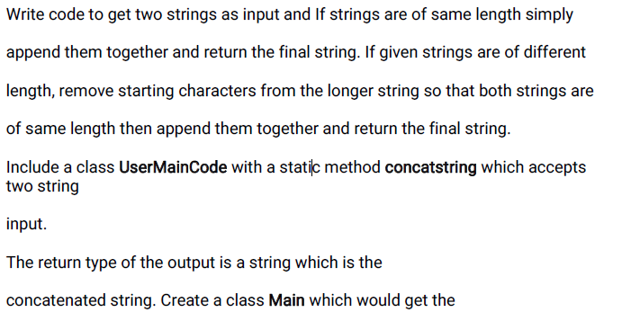

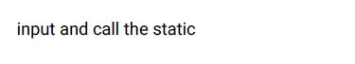

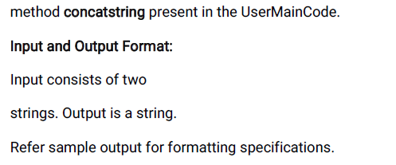

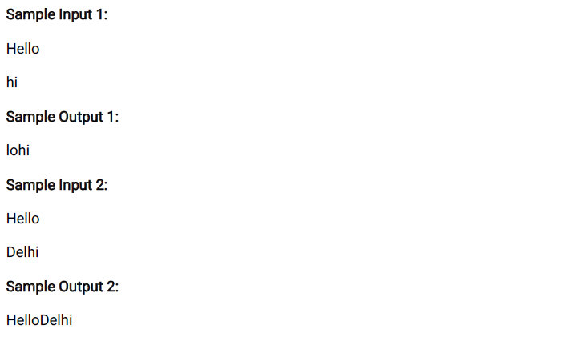

**import java.util.*;**

**public class Main {**

**public static void main (String [] args)**

**{**

**}**

**UserMainCode:**

**============**

**import java.util.*;**

**import java.text.*;**

**public class UserMainCode{**

**public static void concatstring(String s1,String s2){**

**}}**

**21. Color Code**

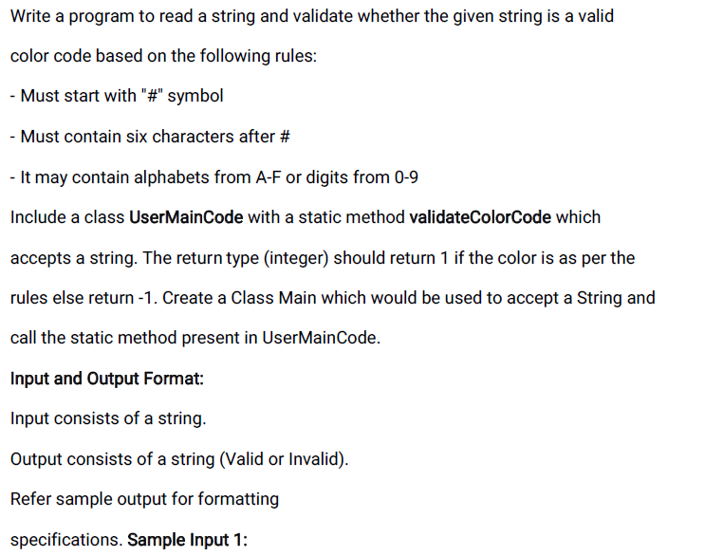

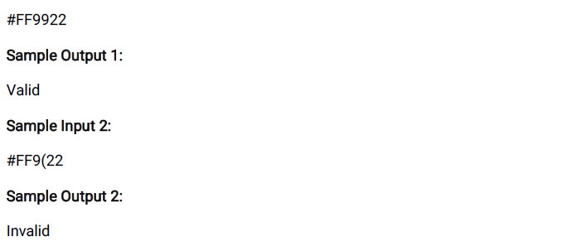

**Main**

**====**

**import java.util.*;**

**public class Main {**

**public static void main (String [] args)**

**{**

**}**

**UserMainCode:**

**============**

**import java.util.*;**

**import java.text.*;**

**public class UserMainCode{**

**public static int validateColorCode(String s1) {**

**}}**

**22. Three Digits**

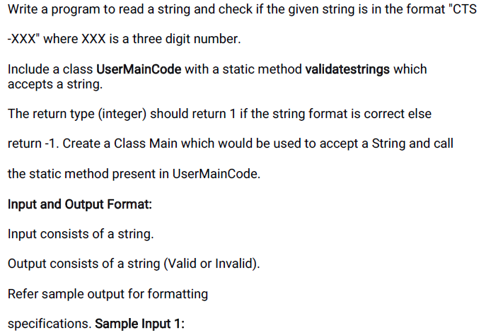

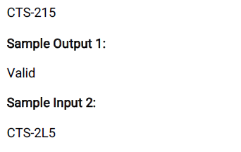

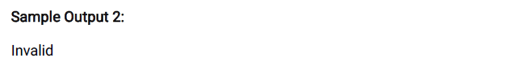

**Main**

**====**

**import java.util.*;**

**public class Main {**

**public static void main (String [] args)**

**{**

**}**

**UserMainCode:**

**============**

**import java.util.*;**

**import java.text.*;**

**public class UserMainCode{**

**public static int validatestrings(String s1){**

**}}**

**23. Removing Keys from HashMap**

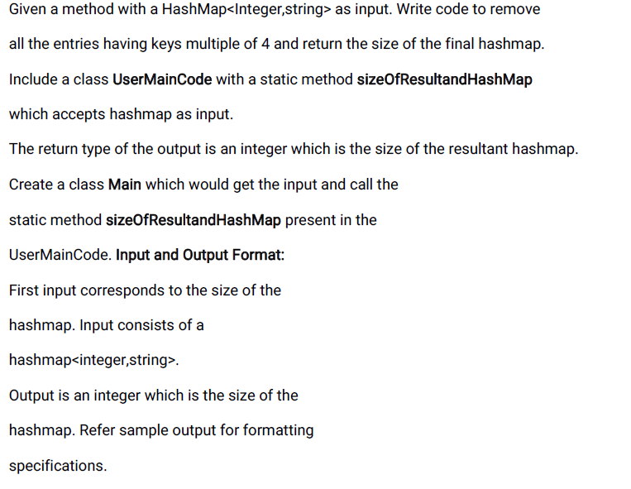

**SampleInput1:**

**3**

**2**

**hi**

**4**

**Hell**

**12**

**Helloworld**

**SampleOutput1:**

**1**

**SampleInput2:**

**3**

**2**

**hi**

**4**

**sdfsdf**

**3**

**asdf**

**SampleOutput2:**

**2**

**Main**

**====**

**import java.util.*;**

**public class Main {**

**public static void main (String [] args)**

**{**

**}**

**UserMainCode:**

**============**

**import java.util.*;**

**import java.text.*;**

**public class UserMainCode{**

**public static int sizeOfResultandHashMap(HashMap<Integer,String> hm){**

**}}**