**36. Initial Format**

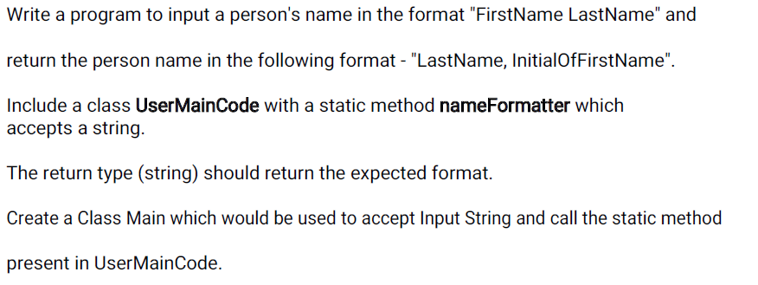



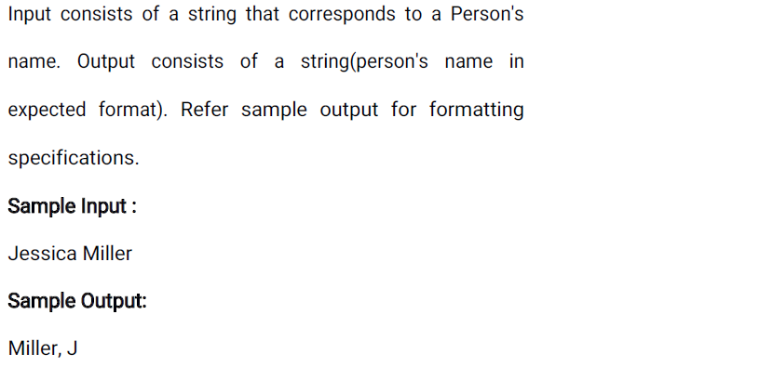

**Main**

**======**

**import java.util.*;**

**public class Main{**

**public static void main(String[] args){**

**}**

**UserMainCode**

**============**

**import java.util.*;**

**public class UserMainCode {**

**public static String nameFormatter (String s1){**

**}}**

**37. Character cleaning**

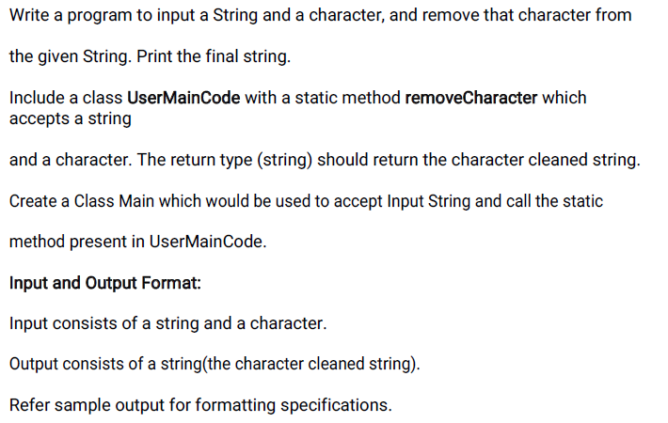

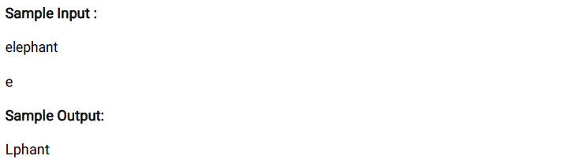

**Main**

**======**

**import java.util.*;**

**public class Main{**

**public static void main(String[] args){**

**}**

**UserMainCode**

**============**

**import java.util.*;**

**public class UserMainCode {**

**public static String removeCharacter(String s1,String c) {**

**}}**

**38. Vowel Check**

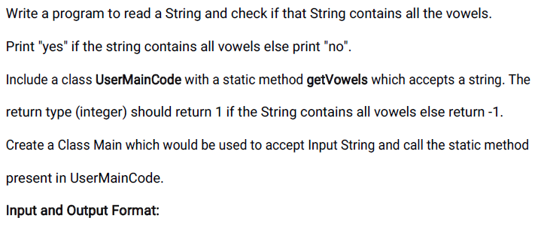

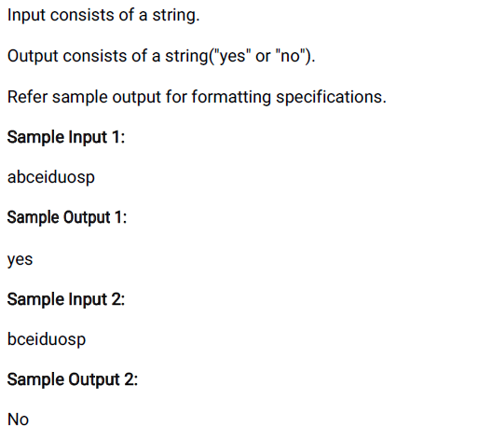

**Main**

**======**

**import java.util.*;**

**public class Main{**

**public static void main(String[] args){**

**}**

**UserMainCode**

**============**

**import java.util.*;**

**public class UserMainCode {**

**public static int getVowels(String s2){**

**}}**

**39. Swap Characters**

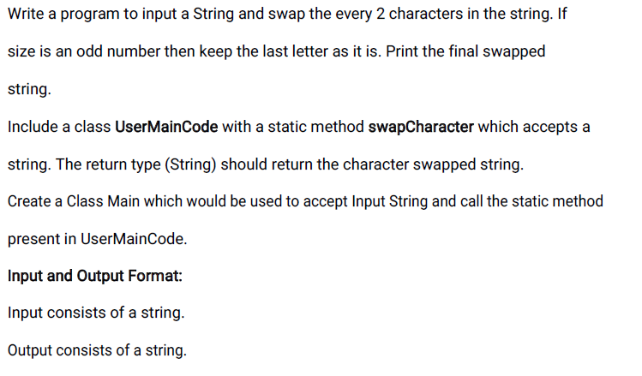

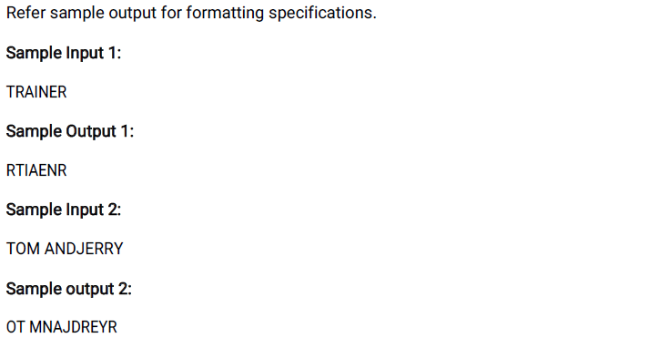

**Main**

**======**

**import java.util.*;**

**public class Main{**

**public static void main(String[] args){**

**}**

**UserMainCode**

**============**

**import java.util.*;**

**public class UserMainCode {**

**public static String swapCharacter(String s1) {**

**}}**

**45. Name Shrinking**

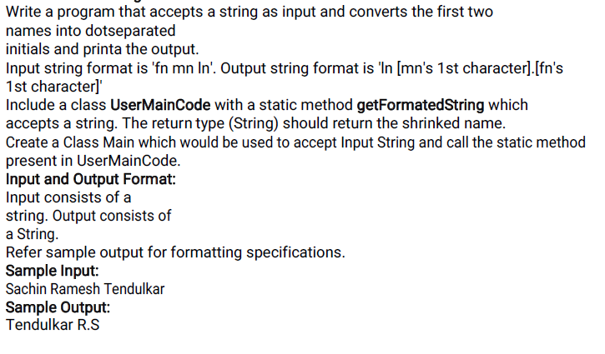

**Main**

**======**

**import java.util.*;**

**public class Main{**

**public static void main(String[] args){**

**}**

**UserMainCode**

**============**

**import java.util.*;**

**public class UserMainCode {**

**public static String getFormatedString(String s1) {**

**}}**