## User Management Web Application

Simple **User Management** web application that manages a collection of **users** with the basic feature: list, insert, update, delete (or CURD operations - Create, Update, Read and Delete).

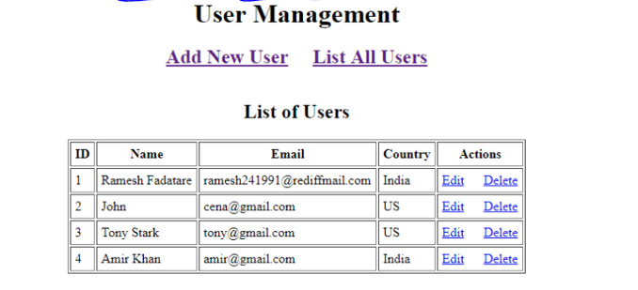Develop below simple basic features in our **User Management** web application:

1. Create a User
2. Update a User
3. Delete a User
4. Retrieve a User
5. List of all Users

**Tools and technologies used**

* JSP - 2.2 +
* IDE - Eclipse
* JDK - 1.8 or later
* Apache Tomcat - 8.5
* JSTL - 1.2.1
* Servlet API - 2.5
* MySQL - mysql-connector-java-8.0.13.jar

## Development Steps

1. Create an Eclipse Dynamic Web Project
2. Add Dependencies
3. Project Structure
4. MySQL Database Setup
5. Create a JavaBean - User.java
6. Create a UserDAO.java
7. Create a UserServlet.java
8. Creating User Listing JSP Page - user-list.jsp
9. Create a User Form JSP Page - user-form.jsp
10. Creating Error JSP page
11. Deploying and Testing the Application Demo

**Class Diagram**

Here is the class diagram of the **User Management** web application that we are going to develop in this tutorial:

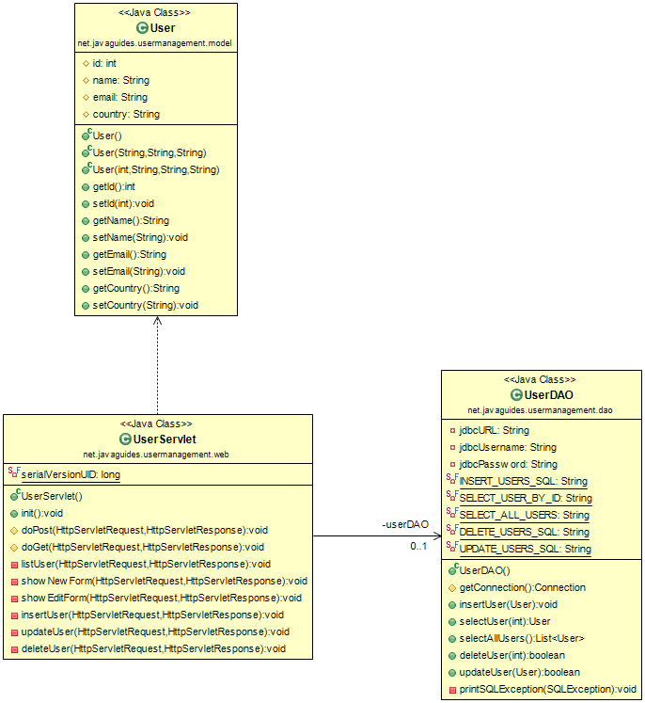

**MySQL Database Setup**

Let's create a database named "demo" in MySQL. Now, create a user’s table using below DDL script:

CREATE DATABASE 'demo';

USE demo;

create table users (

id int(3) NOT NULL AUTO_INCREMENT,

name varchar(120) NOT NULL,

email varchar(220) NOT NULL,

country varchar(120),

PRIMARY KEY (id)

);