**6. Forming New Word from a String**

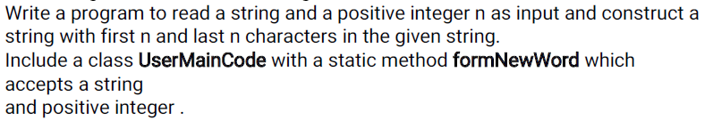

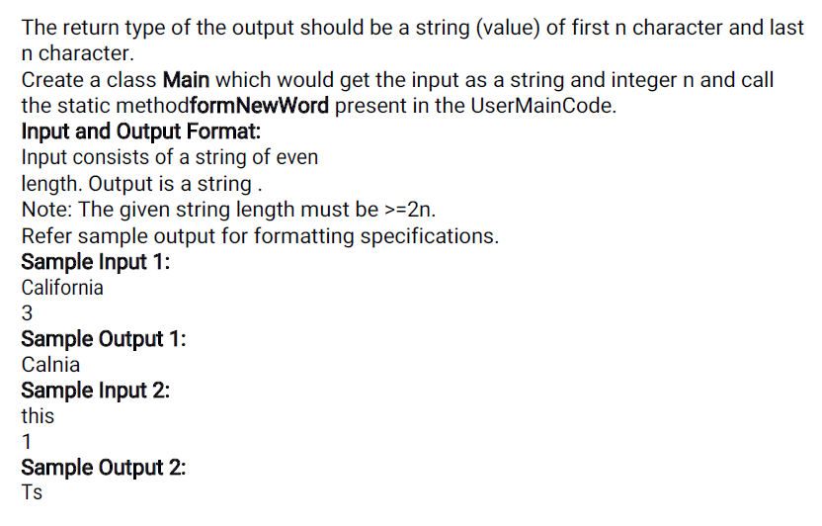

**MAIN:**

**=====**

**Import java.util.*;**

**Public class Main {**

**Public static void main (String [] args)**

**{**

**}}**

**USERMAINCODE:**

**==============**

**public class UserMainCode {**

**public static String formNewWord (String s1, int n) {**

**}}**

**7. Reversing a Number**

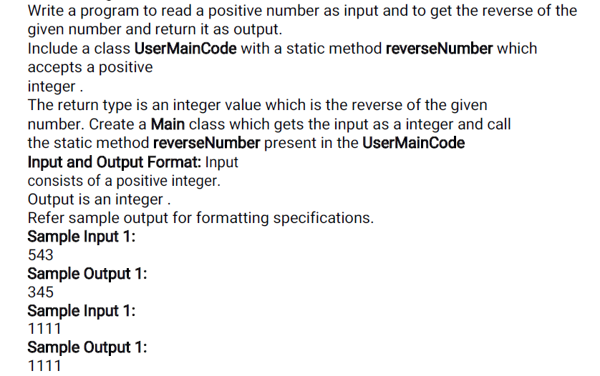

**MAIN:**

**=====**

**Import java.util.*;**

**Public class Main {**

**Public static void main (String [] args)**

**{**

**}}**

**USERMAINCODE:**

**==============**

**public class UserMainCode {**

**public static int reverseNumber(int n){**

**}**

**}**

**8. ArrayList Sorting and Merging**

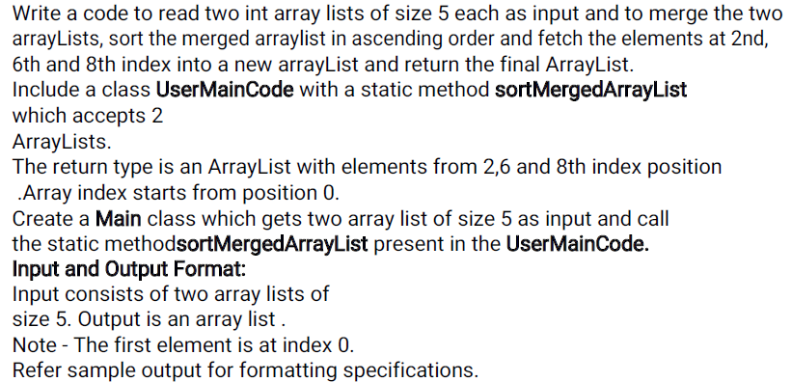

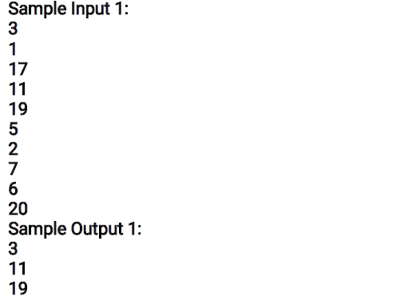

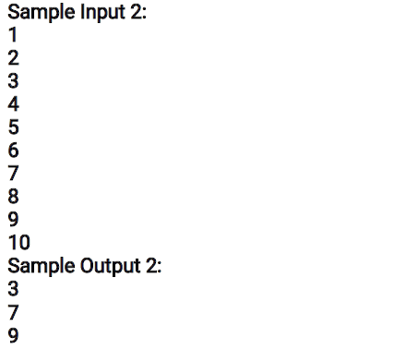

**MAIN:**

**=====**

**Import java.util.*;**

**Public class Main {**

**Public static void main (String [] args)**

**{**

**}}**

**USERMAINCODE:**

**==============**

**public class UserMainCode {**

**public static ArrayList<Integer> sortMergedArraylist (ArrayList<Integer>**

**list1, ArrayList<Integer>list2) {**

**}}**

**9. Password Validation**

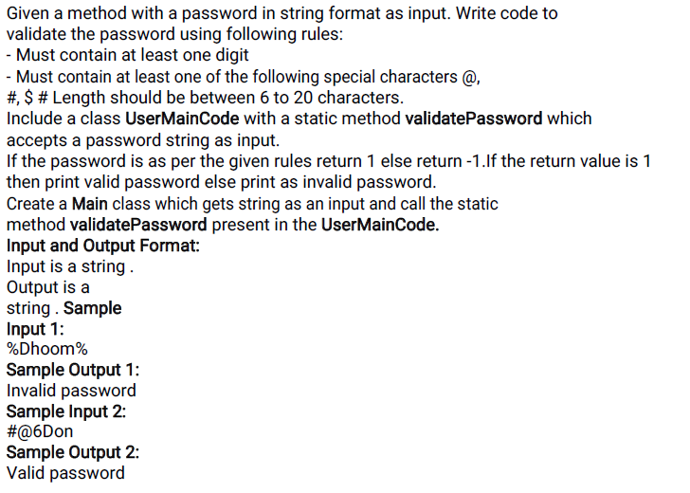

**MAIN:**

**=====**

**Import java.util.*;**

**Public class Main {**

**Public static void main (String [] args)**

**{**

**}}**

**USERMAINCODE:**

**==============**

**public class UserMainCode {**

**public static int validatePassword (String password){**

**}}**

**10. Sum of Powers of elements in an array**

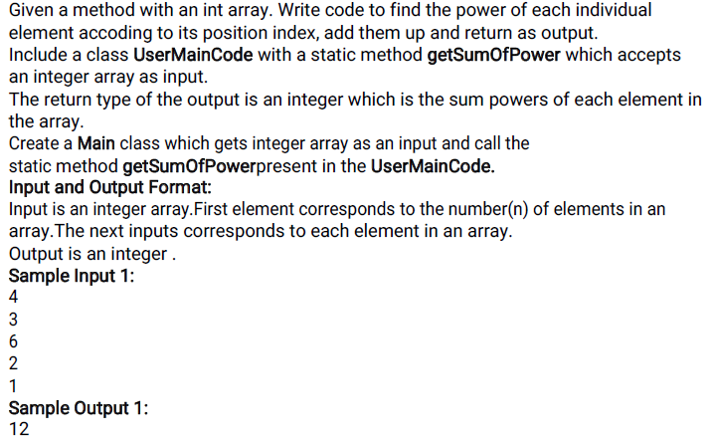

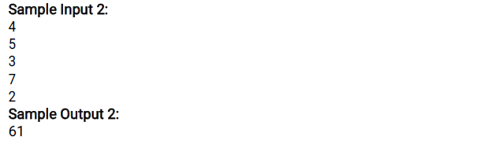

**MAIN:**

**=====**

**Import java.util.*;**

**Public class Main {**

**Public static void main (String [] args)**

**{**

**}}**

**USERMAINCODE:**

**==============**

**public class UserMainCode {**

**public static int getSumOfPower(int n ,int[] a)**

**}}**