**Q) Validating Date Format**

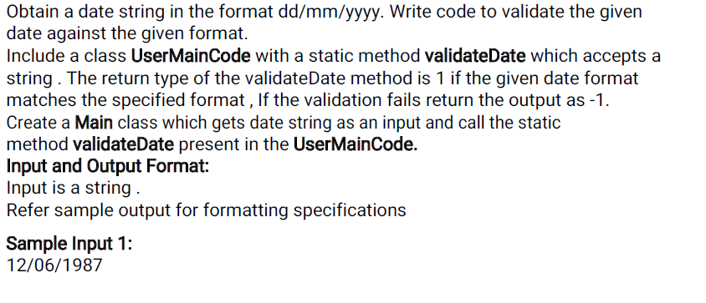

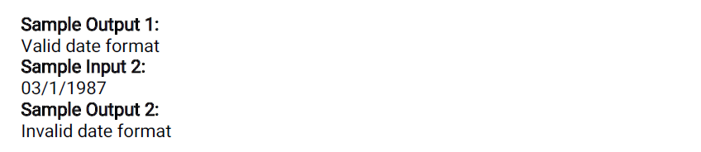

**Main:**

**=====**

**Import java.util.*;**

**Public class Main {**

**Public static void main (String [] args)**

**{**

**}**

**UserMainCode:**

**============**

**import java.util.*;**

**import java.text.*;**

**public class UserMainCode{**

**public static int validateDate(String s1){**

**}}**

**Q) Validate Time**

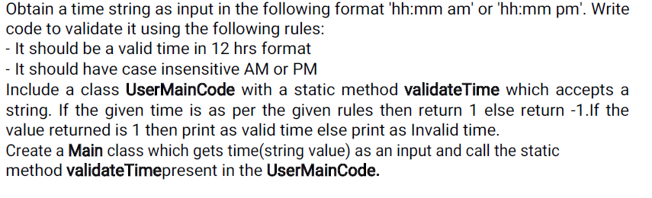

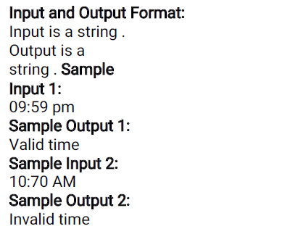

**Main:**

**=====**

**Import java.util.*;**

**Public class Main {**

**Public static void main (String [] args)**

**{**

**}**

**UserMainCode:**

**============**

**import java.util.*;**

**import java.text.*;**

**public class UserMainCode{**

**public static int validateDate(String str){**

**}}**

**15. Difference between largest and smallest elements in an array**

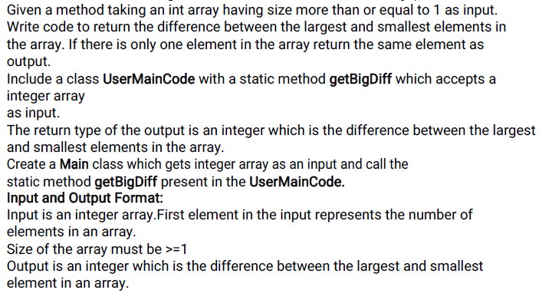

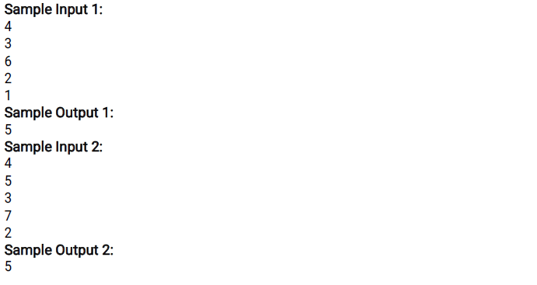

**Main:**

**=====**

**Import java.util.*;**

**public class Main {**

**public static void main (String [] args)**

**{**

**}**

**UserMainCode:**

**============**

**import java.util.*;**

**import java.text.*;**

**public class UserMainCode{**

**public static int getBigDiff(int[] a, int n){**

**}}**

**16. Find the element position in a reversed string array**

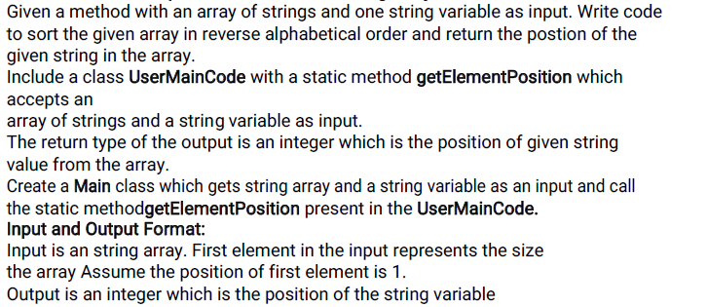

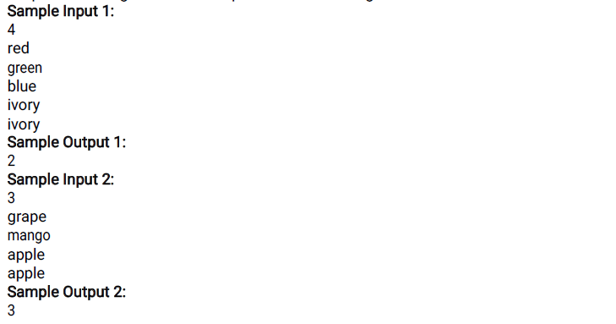

**Main:**

**=====**

**Import java.util.*;**

**public class Main {**

**public static void main (String [] args)**

**{**

**}**

**UserMainCode:**

**============**

**import java.util.*;**

**import java.text.*;**

**public class UserMainCode{**

**public static void getElementPosition(String[] a, String b) {**

**}}**

**18. Calculate Electricity Bill**

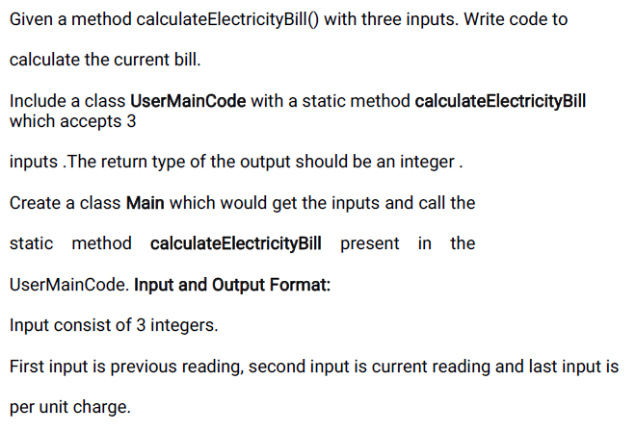

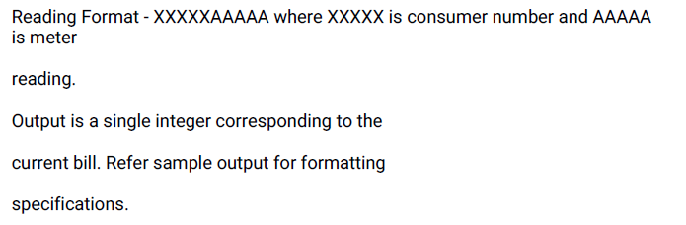

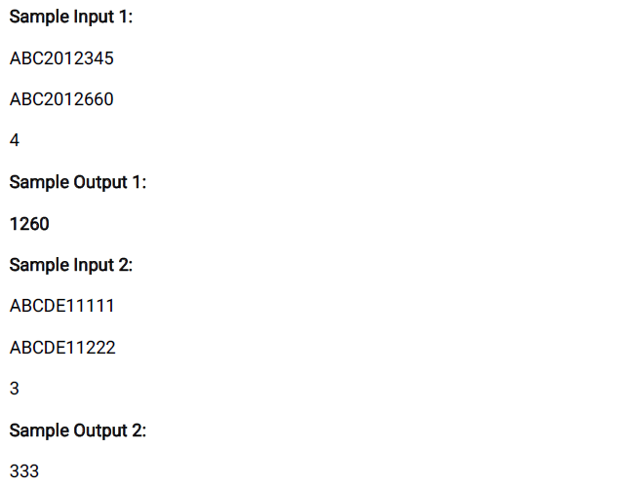

**Main:**

**=====**

**Import java.util.*;**

**public class Main {**

**public static void main (String [] args)**

**{**

**}**

**UserMainCode:**

**============**

**import java.util.*;**

**import java.text.*;**

**public class UserMainCode{**

**public static int calculateElectricityBill(String input1,String input2,int input3)****{**

**}}**

**Q)Removing Keys from HashMap**

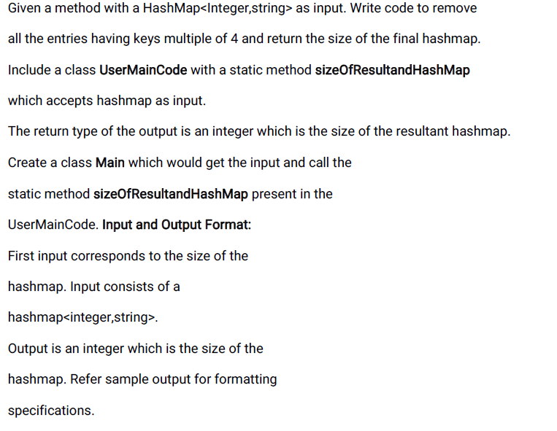

**SampleInput1:**

**3**

**2**

**hi**

**4**

**Hell**

**12**

**Helloworld**

**SampleOutput1:**

**1**

**SampleInput2:**

**3**

**2**

**hi**

**4**

**sdfsdf**

**3**

**asdf**

**SampleOutput2:**

**2**

**Main**

**====**

**import java.util.*;**

**public class Main {**

**public static void main (String [] args)**

**{**

**}**

**UserMainCode:**

**============**

**import java.util.*;**

**import java.text.*;**

**public class UserMainCode{**

**public static int sizeOfResultandHashMap(HashMap<Integer,String> hm){**

**}}**

**Q) Sum of Lowest marks**

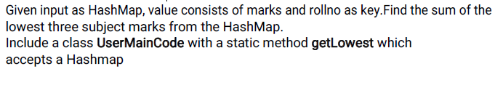

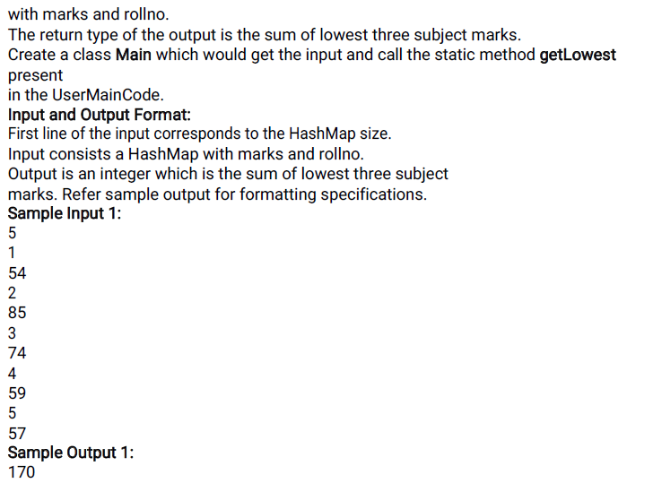

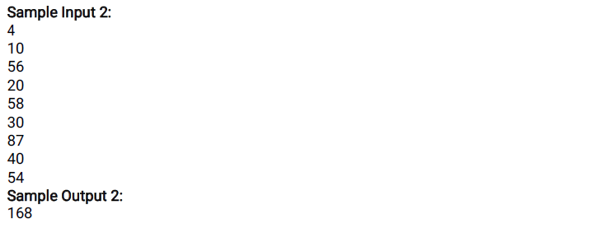

**Main**

**======**

**import java.util.*;**

**public class Main{**

**public static void main(String[] args){**

**}**

**UserMainCode**

**============**

**import java.util.*;**

**public class UserMainCode {**

**public static int getLowest(HashMap<Integer, Integer> h1){**

**}}**

**Q)ArrayList Sorting and Merging**

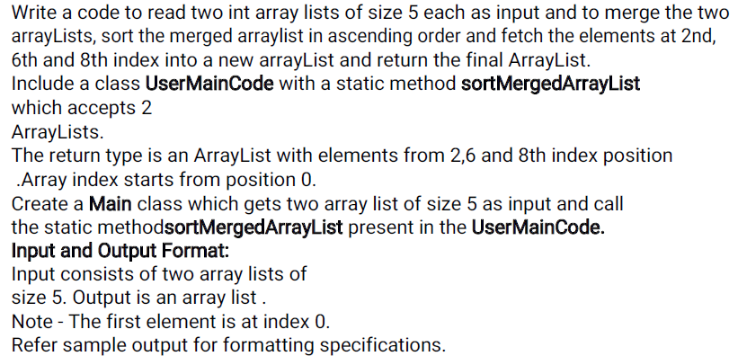

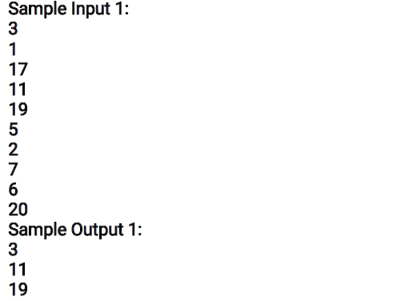

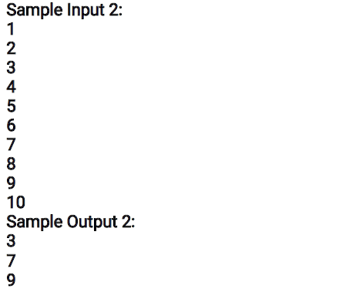

**MAIN:**

**=====**

**Import java.util.*;**

**Public class Main {**

**Public static void main (String [] args)**

**{**

**}}**

**USERMAINCODE:**

**==============**

**public class UserMainCode {**

**public static ArrayList<Integer> sortMergedArraylist (ArrayList<Integer>**

**list1, ArrayList<Integer>list2) {**

**}}**