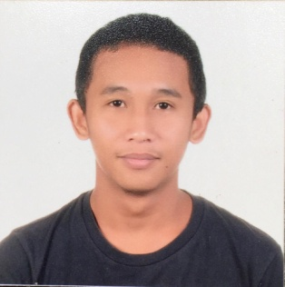**LUCKY C. PABALINAS**

16 waling-waling Street Brgy. Central Quezon City

0969-231-6056

Pabalinas0@gmail.com

**OBJECTIVE**

To succeed in an environment of growth and excellence and earn a job which provides me job satisfaction and self development and help me achieve personal as well as organization goals.

**PERSONAL INFORMATION**

Date of birth : August 25, 1998

Place of birth : Quezon City

Age : 24

Height : 5’6

Weight : 55 kg.

Citizenship : Filipino

Religion : INC

Civil status : Single

**EDUCATIONAL ATTAINMENT**

TERTIARY The University of Manila

Bachelor of Science in Computer Science (BSCS)

2015 - 2019

SECONDARY Ramon Magsaysay High School (Cubao)

2011 – 2015

PRIMARY San Vicente Elementary School

2005 – 2011

**WORK EXPERIENCE**

Encoder – Quezon City Hall (April 2020 – August 2020)

Contact Tracer – (November 2020 – March 2022)

**SKILLS:**

* HTML
* CSS
* Javascript.

**SEMINAR ATTENDED:**

* **Internet of Things**
* **Nuerotechnologies**
* **Robotics Evolution**

**REFERENCE**

Gemmuel Espiritu Dave Marquez

09756762382 09161611587

I hereby certify that the above informations are true and correct tp the best of my knowledge and belief.

Signature