# Go Notes

## Variable

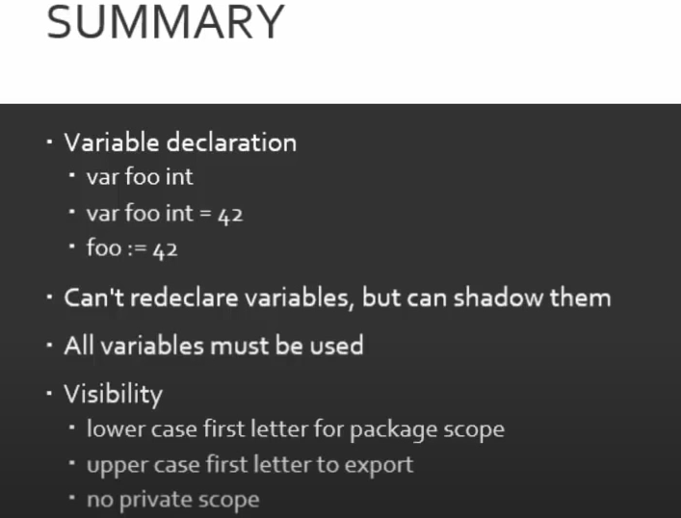

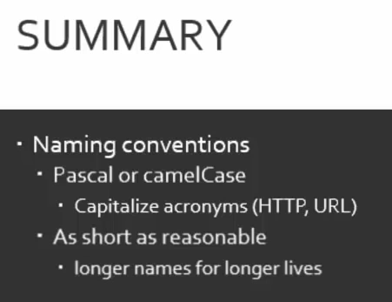

## Primitives

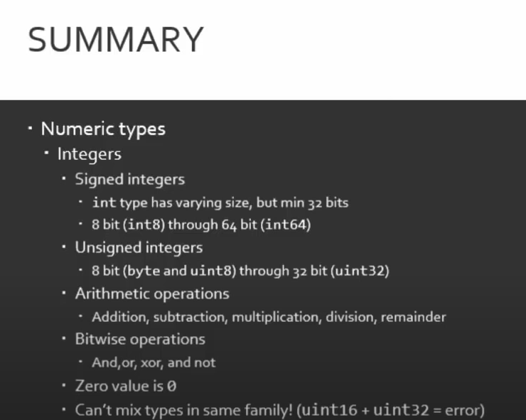

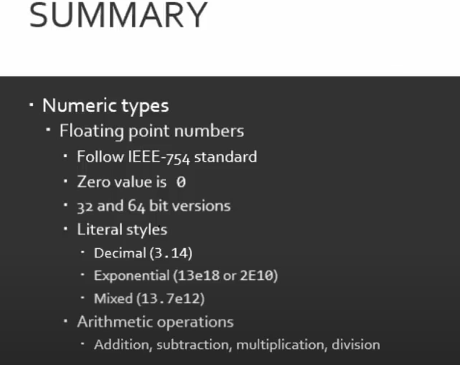

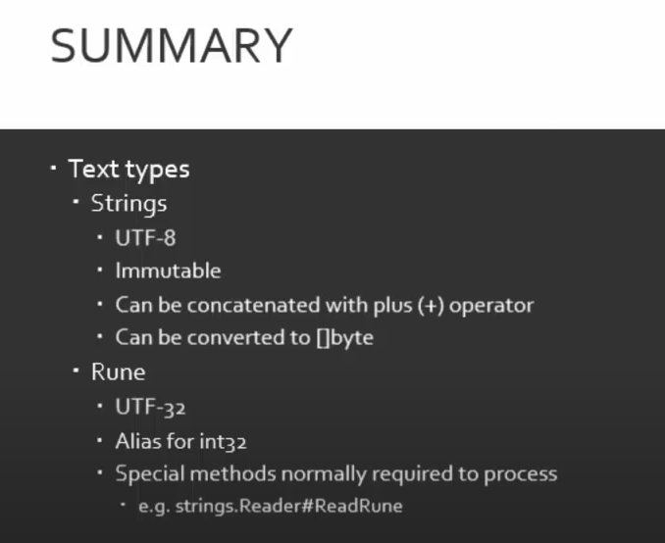

* UTF-8: Variable-width encoding, backwards compatible with ASCII. ASCII characters (U+0000 to U+007F) take 1 byte, code points U+0080 to U+07FF take 2 bytes, code points U+0800 to U+FFFF take 3 bytes, code points U+10000 to U+10FFFF take 4 bytes. Good for English text, not so good for Asian text.
* UTF-16: Variable-width encoding. Code points U+0000 to U+FFFF take 2 bytes, code points U+10000 to U+10FFFF take 4 bytes. Bad for English text, good for Asian text.

## Constants

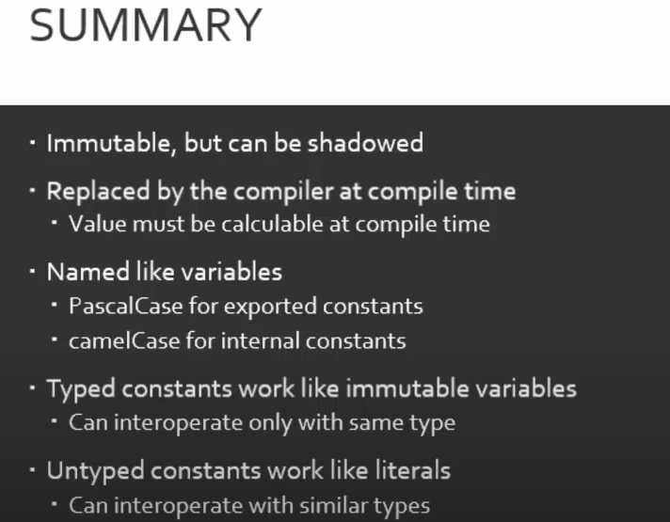

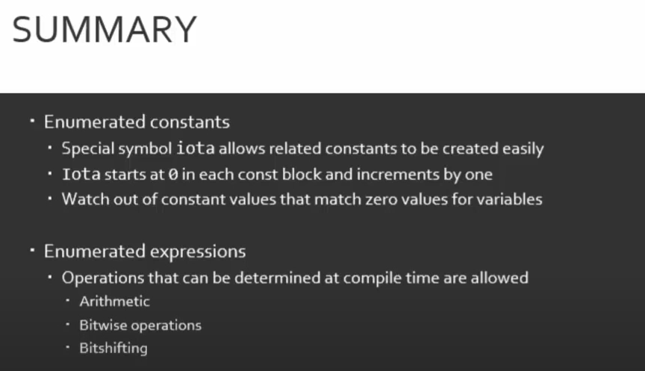

## Arrays & Slice

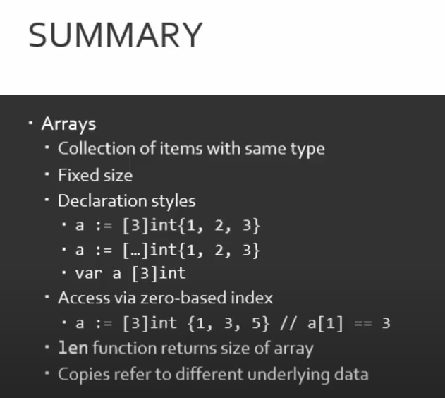

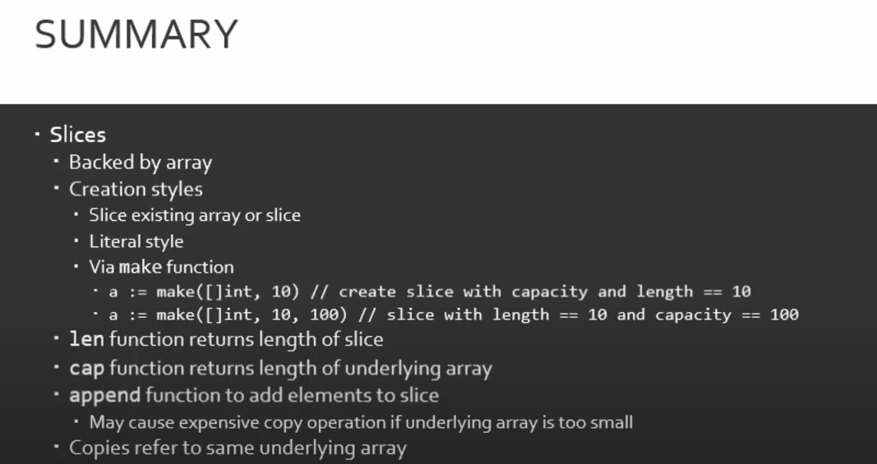

## Maps & Structs

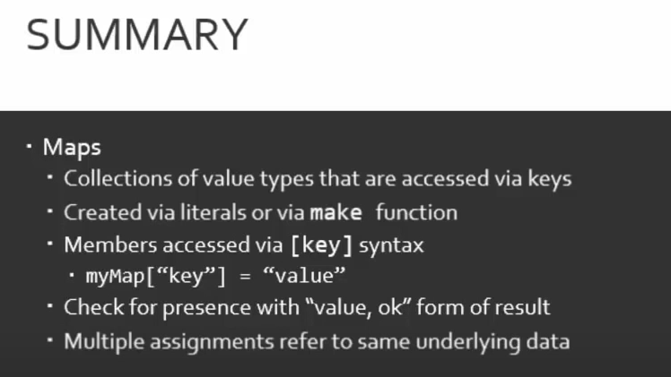

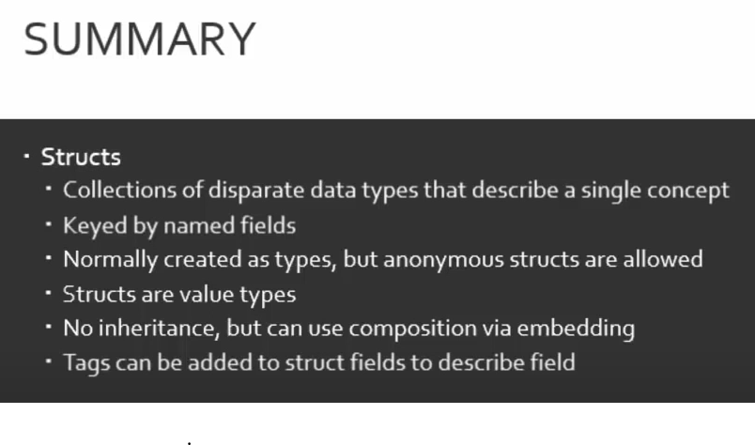

## If Else Switch

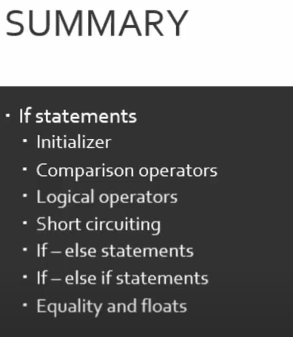

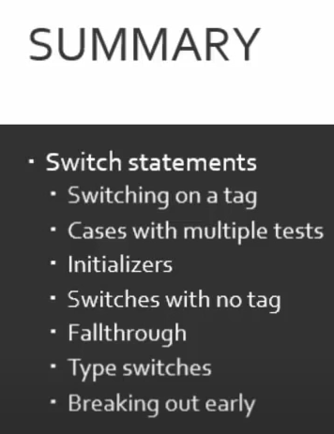

## Loop

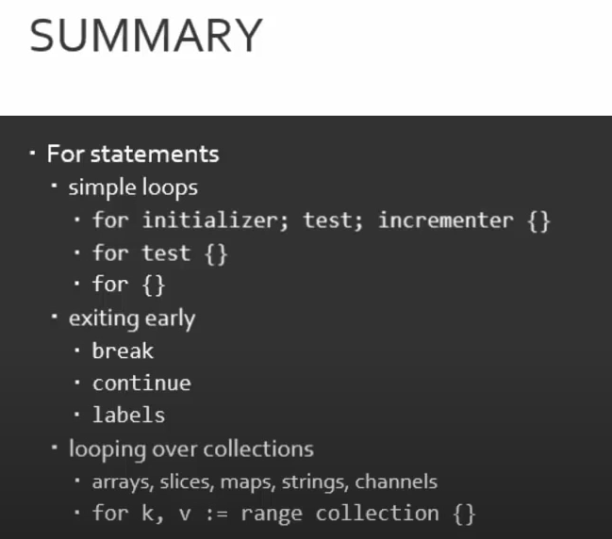

## Defer, Panic and Recover

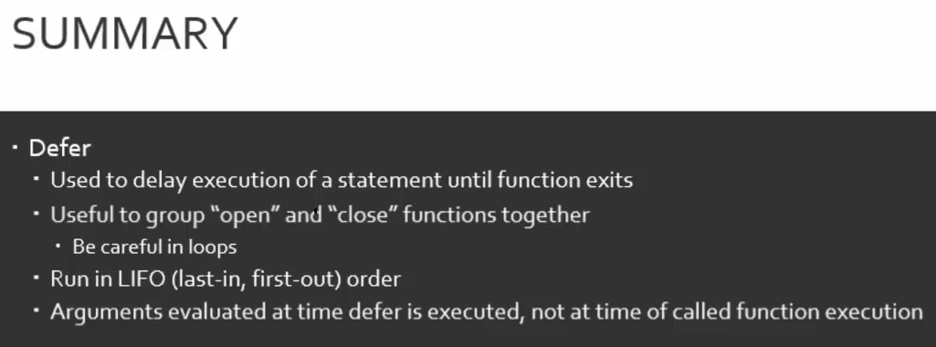

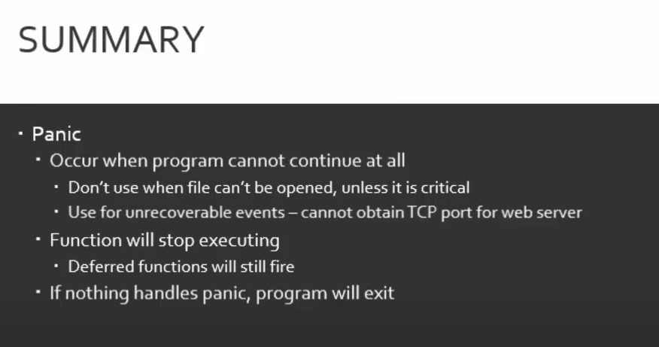

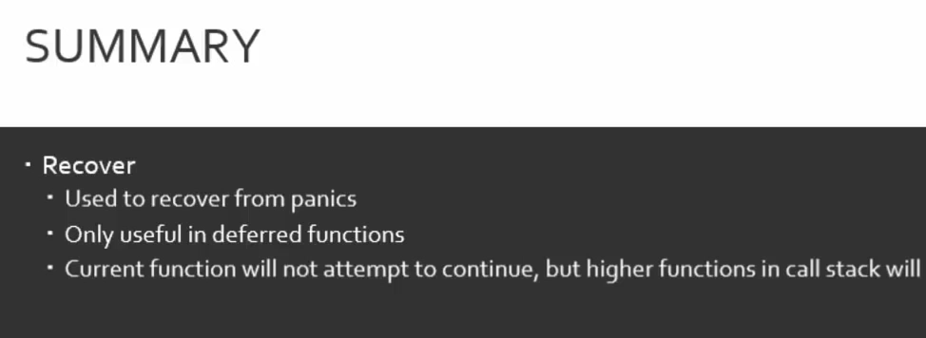

## Pointers

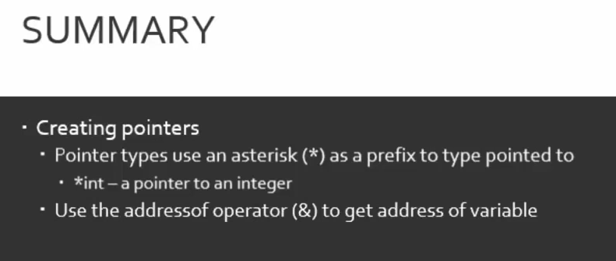

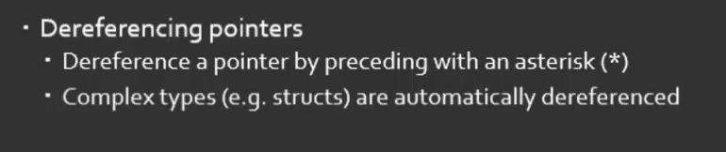

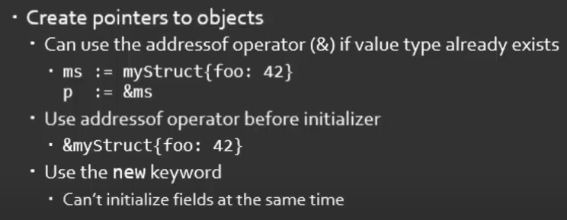

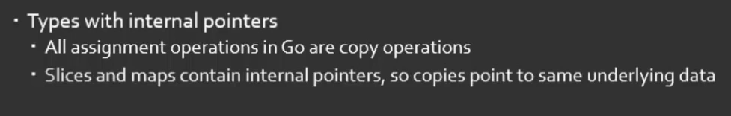

## Functions

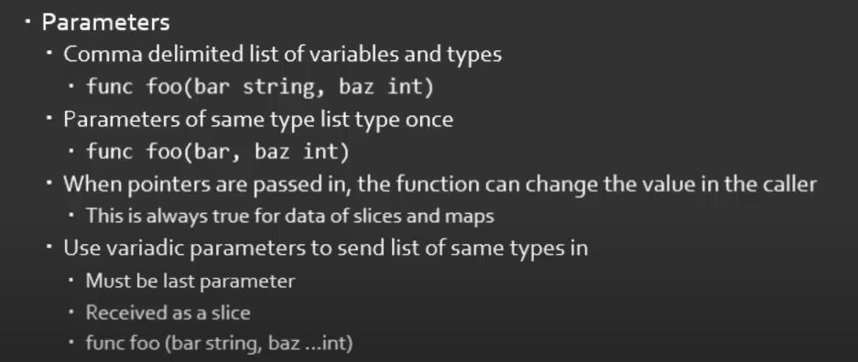

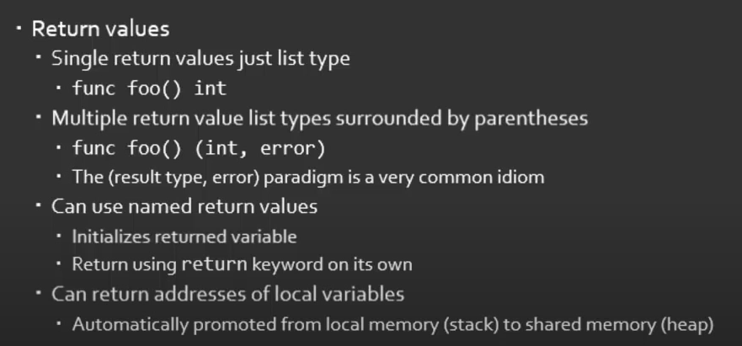

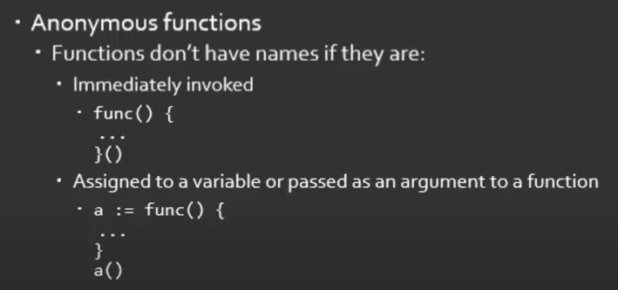

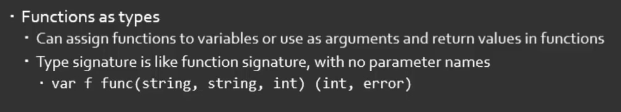

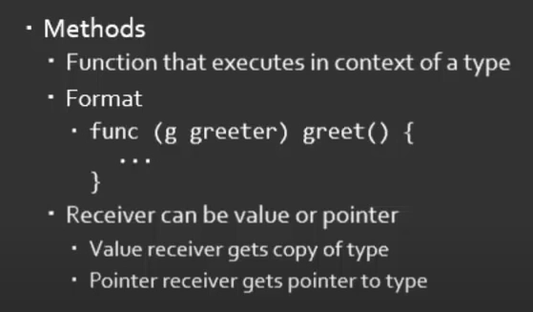

## Interfaces

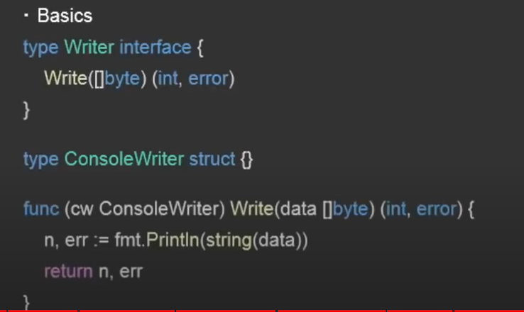

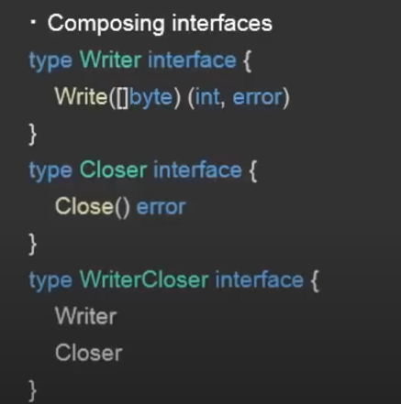

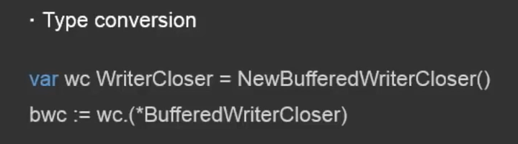

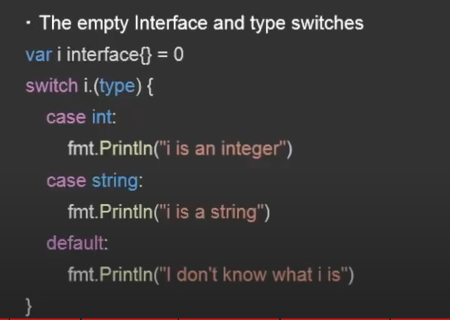

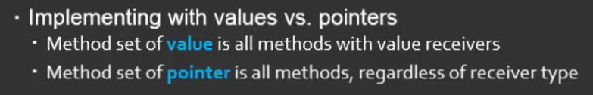

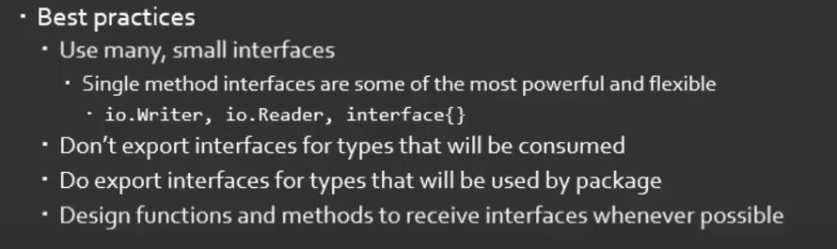

## Go Routines

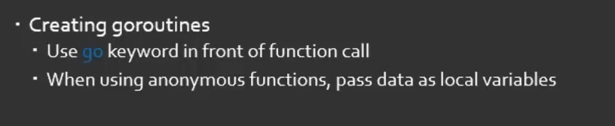

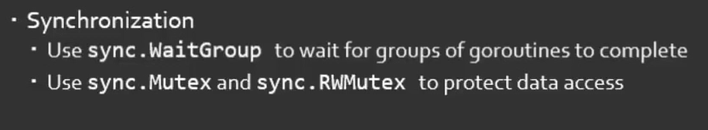

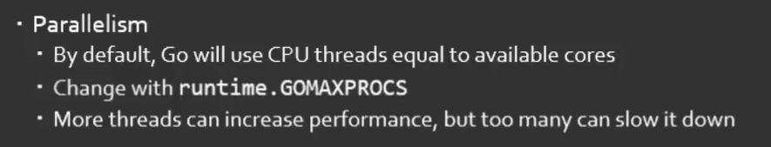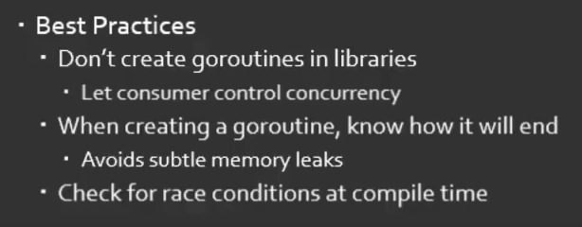

## Channels

## Memory Allocation

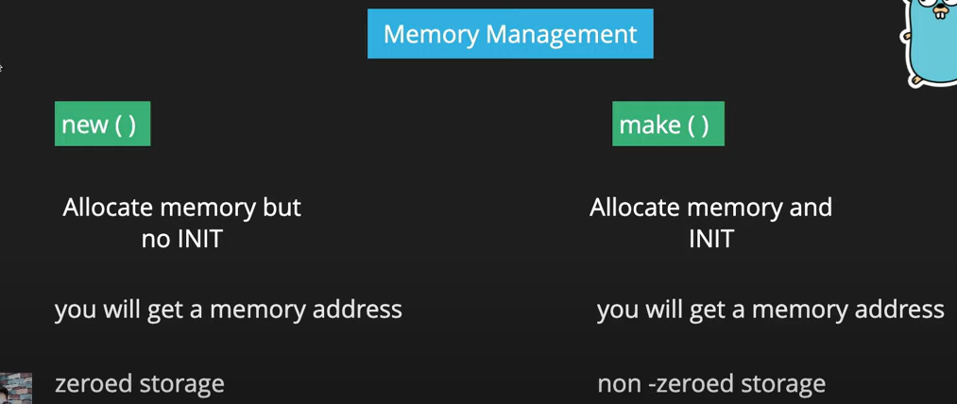

https://go.dev/doc/effective_go#allocation_new

## Go Routine

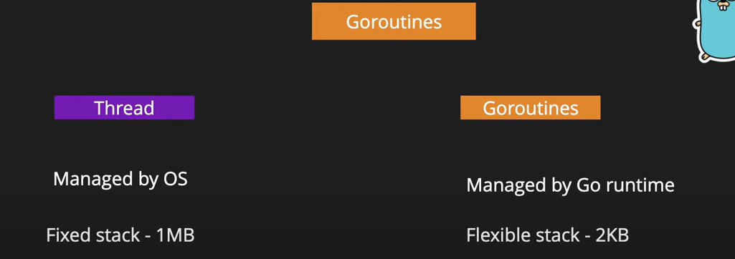

## Go Testing

https://www.digitalocean.com/community/tutorials/how-to-write-unit-tests-in-go-using-go-test-and-the-testing-package

https://pkg.go.dev/testing#section-documentation

https://stackoverflow.com/questions/16353016/how-to-go-test-all-tests-in-my-project