Republic of the Philippines
EASTERN VISAYAS STATE UNIVERSITY
Tacloban City

VISIBLE LIGHT COMMUNICATIONS (LIFI)
SYSTEM
FOR WIRELESS DATA TRANSMISSION

A Project Study
Presented to the
Faculty of ECE Department
School of Engineering

In Partial Fulfillment
of the Requirements for the Degree
Bachelor of Science in Electronics Engineering

By:
BACUNAWA, MARK VINCENT P.
MARTINEZ, REYMART M.
SALDUA, GODWIN P

APPROVAL SHEET

This project study entitled "VISIBLE LIGHT COMMUNICATION (Li-Fi) SYSTEM for WIRELESS DATA TRANSMISSION" prepared and submitted by
MARK VINCENT P. BACUNAWA, REYMART M. MARTINEZ and GODWIN P. SALDUA in partial fulfillment of the requirements for the degree of Bachelor of Science in Electronics Engineering has been examined and recommended for acceptance and approval for Oral Examination.
ROMEO LEWIS H. TAN, MEng
Adviser

Approved by the Committee on Final Defense with the rating of _______________.
ALLAN L. BARGAMENTO, PECE
Chairman

CONSTACIO S. MERCOLITA JR. MEng GINA L. HANOPOL
Member Member

Accepted in partial fulfillment of the requirements for the degree of Bachelor of Science in Electronics Engineering.
RONEIL F. YOUNG, MEng | VYNIL H. OQUIÑO, PhD
Head, ECE Department, School of Engineering | Dean, School of Engineering
Eastern Visayas State University | Eastern Visayas State University
Tacloban City | Tacloban City

ACKNOWLEDGEMENT
The researchers would like to express their heartfelt gratitude to the individuals who made this research study a possibility. Their guidance and support were the element needed to be the instrument in helping for this research study.
The researchers would like to express their deepest gratitude to Engr. Allan L. Bargamento, for his approval that pave the way for this research study a possibility.
The researchers extend their heartfelt gratitude to their research adviser Engr Romeo Lewis H. Tan for his guidance, valuable support, insights, and patience. We are grateful to have her for being the reason to complete this research study.
The researchers would like to express deepest gratitude to the thesis group that stayed up all night to finish their research study. The shared experience helps with the development of the relationship with one another, giving an unbearable connection and support among another.
The researchers would like to express their sincere appreciation to their families for their financial assistance, and understanding during the research journey.
Most of all, the researchers want to thank the Heavenly Father from the bottom of their hearts. They are grateful that their prayers were heard, that they were given the courage and discernment to carry out this investigation, and that they were able to prove that their greatest strength during the research process was supernatural backing.

Mark Vincent P, Bacunawa – Reymart M. Martinez – Godwin P. Saldua
ABSTRACT
This study developed and evaluated a low-cost Visible Light Communication (Li-Fi) prototype for short-range indoor wireless data transmission. The implemented system used two ESP32 boards connected to a laptop through USB serial links, where the TX GUI and RX GUI controlled payload transmission, monitoring, CRC checking, and output reconstruction. The transmitter consisted of an ESP32 GPIO5 output driving a 2N3904 transistor and IRF540N MOSFET stage to switch a commercially available 12 V DC LED bulb using active-low operation. The receiver consisted of a BPW34 photodiode, an OPA2604 transimpedance amplifier, an LM393 comparator, and an RX ESP32 input. 4B5B + NRZ/OOK optical signaling was used for timing and synchronization, while a packet/chunk carousel with CRC validation was used to support reliable reconstruction over a one-way optical link without ACK/retransmission.
The prototype was evaluated using text, image, and audio payloads under controlled line-of-sight indoor conditions. Image and audio transfer were reliable at a 9 kHz transmission frequency, 5 ms byte gap, and 20 ms frame gap when CRC validation passed and the output was reconstructed correctly. The study also considered LED bulb wattage, receiver voltage, feedback resistor condition, Vref/threshold setting, distance, alignment, ambient light, transmission time, CRC reliability, chunk completion, missing chunks, receiver margin, and human comfort observations. The results support the feasibility of a low-cost, short-range Li-Fi prototype while recognizing that the system is not a commercial Wi-Fi replacement and that video transmission remains future work.

Table of Contents
TITLE PAGE……………………………………………………………………………..i
APPROVAL SHEET…………………...……………………………………………......ii
ACKNOWLEDGEMENT……………………………………………………………... iii
ABSTRACT ……………………………………………………………………………..iv
TABLE OF CONTENTS……………………………………………………………........v
LIST OF FIGURES…….…………………………………………………………………x
LIST OF TABLES…………………………………………………………………........xii
LIST OF FORMULAS………………………………………………………………….xiv

CHAPTER I 1
INTRODUCTION 1
1.1 Background of the Study 1
1.2 Problem Statement 3
1.3 Objectives of the Study 5
1.3.1 Specific Objectives 5
1.4 Conceptual Framework 6
1.5 Scope and Delimitations 7
1.5.1 Scope 7
1.5.2 Delimitations 8
1.6 Significance of the Study 9
1.7 Definition of Terms 10
CHAPTER II 16
REVIEW OF RELATED LITERATURE AND STUDIES 16
2.1 Related Literature 16
2.1.1 Visible Light Communication and Li-Fi 16
2.1.2 LED Light Sources for VLC 17
2.1.3 Photodiode Receiver and Transimpedance Amplification 18
2.1.4 Comparator Thresholding, Vref, and Receiver Margin 19
2.1.5 4B5B Line Coding for VLC Data Transmission 20
2.1.6 NRZ/OOK Optical Signaling and Symbol Timing 21
2.1.7 Packet-Based Transmission, Carousel Rounds, and CRC Validation 21
2.1.8 USB Serial Communication and ESP32-Based Prototyping 22
2.1.9 Ambient Light, Distance, Alignment, and Line-of-Sight Limitations 23
2.1.10 Human Comfort and LED Illumination Considerations 24
2.2 Related Studies 24
2.2.1 Fundamental Analysis for VLC Using LED Lights 24
2.2.2 Visible Light Communication, Networking, and Sensing Survey 25
2.2.3 Li-Fi: Transforming Fibre into Wireless 25
2.2.4 Visible Light Communication: Applications, Architecture, Standardization, and Research Challenges 26
2.2.5 Li-Fi: Wireless Communication through Visible Light 27
2.2.6 Wireless Communication Using Li-Fi Technology 27
2.2.7 New Technology of Data Transmission: Li-Fi 27
2.3 Synthesis of the Reviewed Literature and Studies 28
CHAPTER III 30
METHODOLOGY 30
3.1 Research Design 30
3.1.1 Experimental Test Environment 32
3.1.2 Fixed Experimental Parameters 35
3.2 Research Instruments 36
3.2.1 ESP32U DevKit V1 (WROOM-32) 37
3.2.2 Laptop/Computer with Modern TX/RX GUI – 38
3.2.3 Lux Meter Application 38
3.2.4 USB Serial Cables 39
3.2.5 2N3904 and IRF540N MOSFET Transistors 39
3.2.6 12 V DC LED Bulbs 40
3.2.7 12V DC Power Supply with 220V AC Input 40
3.2.8 BPW34 Photodiode 41
3.2.9 OPA2604 Op-Amp IC 41
3.2.10 LM393 Op-Amp IC 41
3.2.11 Arduino IDE 42
3.2.12 Python v13.14.5 42
3.2.13 PyInstaller v6.21.0 43
3.2.14 Pyside6 v6.11.1 43
3.2.15 TX/RX GUI Applications 44
3.2.16 Justification of Component Selection 45
3.3 System Architecture and Flow Charts 47
3.3.1 Overall System Architecture 47
3.3.2 Transmitter Flow System 49
3.3.3 Receiver Flow System 51
3.4 Schematic Design 53
3.4.1 Transmitter System 53
3.4.2 Receiver System 54
3.4.3 Receiver Threshold Calibration 55
3.4.4 Adaptive Reciever Margin Calibration 62
3.5 Test Procedure 63
3.5.1 Prototype Development and System Verification Test 63
3.5.2 Receiver Margin Calibration Test 64
3.5.3 Payload Transmission Performance Test 66
3.5.4 Distance Performance Test 74
3.5.5 LED Wattage Test 74
3.5.6 Ambient-Light Margin Shift Test 75
3.5.7 Human Comfort Observation Test 75
3.5.8 Maximum File Behavior Test 76
3.5.9 BPW34 and Phototransistor Comparison Test 77
3.5.10 Trial Repetition and Data Validation 77
3.6 Data Gathering and Analysis 77
3.7 3D Design/Model 79
3.7.1 Prototype 3D Model with measurements 79
3.7.2 RX Setup 3D Model Close-up view 80
3.7.3 RX/TX Setup Model 81
3.8 Evaluation Criteria 82
3.8.1 Bit Error Rate Evaluation 83
3.8.2 Bit Accuracy Evaluation 83
3.8.3 Reciever Margin Evaluation 83
3.8.4 CRC and Chunk Completion Evaluation 84
3.8.5 Effective Data Rate Evaluation 85
CHAPTER IV 86
RESULTS AND DISCUSSION 86
4.1 Prototype Development and System Verification Result 86
4.1.1 TX ESP32 and TX GUI USB Serial Connection 88
4.1.2 RX ESP32 and RX GUI USB Serial Connection 89
4.1.3 LED Driver Circuit 89
4.1.4 Receiver Front End 90
4.1.5 CRC/Status Monitoring 90
4.1.6 Payload Reconstruction 91
4.2 Adaptive Receiver Margin Calibration Result 91
4.3 Distance and Reciever Position Evaluation 94
4.4 Ambient Light Performance Evaluation 98
4.5 LED Wattage Performance Evaluation 102
4.6 Environmental and Practical Evaliuation 103
4.6.1 Human Comfort Observation Results 103
4.6.2 BPW34 and Phototransistor Comparison Results 105
4.7 Payload Transmission Performance 107
4.8 Maximum File Behavior Evaluation 110
4.8 Overall Prototype Performance Summary 111
4.9 Summary of Objective Achievement 113
CHAPTER V 116
SUMMARY, CONCLUSION, AND RECOMMENDATIONS 116
5.1 Summary 116
5.2 Conclusion 117
5.3 Recommendations 118
5.3.1 Hardware Improvements 118
5.3.2 Software and Firmware Improvements 119
5.3.3 System Enhancements 120
REFERENCES 121
APPENDICES xv
Appendix A: Documentation/Prototype Photos xvi
Appendix B: TX GUI Screenshot xxi
Appendix C: RX GUI Screenshot xxiv
Appendix D: VLC Prototype Components Data Sheets xxviii
Appendix E: Test Logs and Raw Result Tables xl
Appendix F: Human Comfort Observation/Questionnaire Form xliii
Appendix G: Vref Sweep and GPIO25 PWM Calibration Records li
Appendix H: Ambient-Light Lux Readings and Room Condition lii
Appendix I: BER Comparison Records and Computation Sheets liii
Appendix J: Maximum File Behavior Records liv
Appendix K: BPW34 and Phototransistor Comparison Records lv
Appendix L: Receiver Circuit Analysis and 12 V Threshold Scaling lvi
Appendix M: Transmitter Driver Circuit Analysis lviii
Appendix N: Prototype Operations and User Guide lix
Appendix O: Firmware and Code Snippets lxi

LIST OF FIGURES
Page
Figure 1.1. Conceptual Framework of the VLC Prototype..................................................6
Figure 3.1. Research Design Block Diagram.....................................................................30
Figure 3.2. Experimental setup geometry and resulting optical path length......................34
Figure 3.3. ESP32U DE\evKit V1 (WROOM-32)………………………………………37
Figure 3.4 Laptop Computer with Modern TX RX GUI…………….………………….38
Figure 3.5. Lux Meter Application………………………………………………………38
Figure 3.6. USB Serial Cables……...…………………………………………………....39
Figure 3.7. 2N3904 and IRF540N Transistors……………..……………………….……39
Figure 3.8. 12V DC LED Bulb……………………………………………………….….40
Figure 3.9. 12V DC Power Supply with 220V AC Input………………………….…….40
Figure 3.10. BPW34 Photodiode………………………………………………….…….41
Figure 3.11. OPA2604 Op-Amp IC…………………………………………………..…41
Figure 3.12. LM393 Op-Amp IC………………………………………………………..42
Figure 3.13. Arduino IDE……………………………………………………………….42
Figure 3.14. Python v13.14.5……………………………………………………….…...42
Figure 3.15. PyInstaller v6.21.0.…………………………………………………….…..43
Figure 3.16. PySide6 v6.11.1…………………………………………………………....43
Figure 3.17. TX GUI used by the transmitter circuit…………………………………....44
Figure 3.18. RX GUI used by the receiver circuit……………………………………....45
Figure 3.19. System Architecture/Block Diagram……………………………………...47
Figure 3.20. Transmitter Flow System……………………………………………….....49
Figure 3.21. Reciever Flow System………………………………………………….....51
Figure 3.22. Trasmitter Schematic Diagram………………………………………....…53
Figure 3.23. Reciever Schematic Diagram………………………………………..…...54
Figure 3.24. Prototype 3D Model with measurements………………………….......…79
Figure 3.25 RX Setup 3D model Close-up view………………………………….…...80
Figure 3.26 3D Model of the RX/TX system setup…………………………..……......81
Figure 4.1. Measured Photodiode Voltage vs Computed Comparator Reference Voltage………………………………………………………………………..…….….93
Figure 4.2. Stable Receiver Margin Region....................................................................94
Figure 4.3. Receiver Position vs Bit Error Rate (BER)..................................................97
Figure 4.4. Receiver Margin vs Optical Distance...........................................................98
Figure 4.5. Ambient Illumination vs Measured Photodiode Voltage.............................100
Figure 4.6. Ambient Illumination vs Computed Comparator Reference Voltage..........101
Figure 4.7. File Size vs Transmission Time...................................................................109

LIST OF TABLES
Page
Table 3.1. Fixed Experimental Parameters........................................................................35
Table 3.2 CRC Validation Interpretation...........................................................................84
Table 3.3 Chunk Completion Interpretation......................................................................85
Table 4.1. Prototype Development and System Verification Result.................................87
Table 4.2. Adaptive Receiver Margin Calibration Results................................................92
Table 4.3. Distance and Receiver Position Results............................................................95
Table 4.4. Ambient Light and Lux Result.........................................................................99
Table 4.5. LED Wattage Performance Results................................................................102
Table 4.6. Human Comfort Observation Results.............................................................103
Table 4.7. BPW34 and Phototransistor Comparison Results..........................................106
Table 4.8. Payload Transmission Results........................................................................107 Table 4.9. Maximum File Behavior Results....................................................................110
Table 4.10. Overall Prototype Performance Summary....................................................111
Table 4.11. Summary of Objective Achievement............................................................114
Table E.1. Receiver Margin Calibration Raw Data............................................................xl
Table E.2. Distance Performance Raw Data.......................................................................xl
Table E.3. Ambient Light Performance Raw Data.......................................................…..xl
Table E.4. LED Wattage Test Raw Data...........................................................................xli
Table E.5. Payload Transmission Raw Data.....................................................................xli
Table F.1. Human Comfort Observation/Questionnaire Results.....................................xliii
Table G.1. Vref Sweep and GPIO25 PWM Calibration Mapping......................................li
Table H.1. Ambient-Light and Lux Record.......................................................................lii
Table J.1. Maximum File Behavior Record.......................................................................liv
Table K.1. BPW34 and Phototransistor Comparison Record.............................................lv
LIST OF FORMULAS
Page
Formula 1. Optical Path Length.........................................................................................34
Formula 2. Voltage Divider Scale Factor..........................................................................56
Formula 3. ADC Monitor Voltage Conversion.................................................................56
Formula 4. Receiver Margin..............................................................................................57
Formula 5. ADC-Side Receiver Margin...........................................................................58
Formula 6. Actual Comparator-Side Receiver Margin.....................................................59
Formula 7. Target ADC-Side Receiver Margin................................................................60
Formula 8. Target Actual Comparator-Side Margin.........................................................61
Formula 9. Automated Vref Target...................................................................................64
Formula 10. PWM RC Filter Time Constant....................................................................65
Formula 11. BER...............................................................................................................66
Formula 12. Strict Bit Error Count....................................................................................67
Formula 13. Strict BER......................................................................................................68
Formula 14. Bit Accuracy.................................................................................................69 Formula 15. Transmission Time........................................................................................70
Formula 16. Effective Data Rate.......................................................................................71
Formula 17. Chunk Completion Rate................................................................................72
Formula 18. Payload Size…………………………………………………….………….73
Formula 19. Ambient-Light Margin Shift.........................................................................75

CHAPTER I

INTRODUCTION
This chapter presents the background of the study, problem statement, objectives of the study, conceptual framework, scope and delimitations, significance of the study, and definition of terms related to the development and evaluation of a low-cost Visible Light Communication (VLC) or Li-Fi prototype for wireless data transmission.

1.1 Background of the Study
The continuous growth of digital devices and internet-based services has increased the demand for wireless communication. Most wireless systems depend on radio-frequency (RF) signals, but RF communication can experience congestion, interference, security concerns, and limited spectrum availability. Because of these challenges, researchers continue to study alternative communication methods that can support short-range data transfer in controlled indoor environments.
Visible Light Communication (VLC), also known as Li-Fi, uses visible light from light-emitting diodes (LEDs) to transmit information. In a VLC system, the light source is modulated to carry data, while a photodiode or photodetector at the receiver converts the light variations back into an electrical signal. This principle has been discussed in LED-based VLC research, where indoor LED lighting may serve both illumination and communication functions (Komine & Nakagawa, 2004; Pathak et al., 2015).
VLC has potential advantages because visible light does not pass through opaque walls, and it is not affected by RF interference. Optical wireless communication is also recognized in standardization work, including IEEE 802.15.7-2018 for short-range optical wireless communications (IEEE Standards Association, 2018). However, VLC also has practical limitations. Its performance can be affected by line-of-sight alignment, distance, shadowing, ambient light, receiver orientation, and signal-to-noise conditions (Pathak et al., 2015).
This study is designed as a feasibility study of a low-cost, short-range indoor Visible Light Communication (VLC) prototype. The study does not intend to produce a commercial Li-Fi system or replace existing Wi-Fi technology. Rather, it aims to evaluate whether accessible electronic components can be used to transmit and reconstruct text, image, audio, and selected file payloads through visible light under controlled indoor conditions. The proposed transmitter will use an ESP32 microcontroller, a 2N3904 transistor, an IRF540N MOSFET, and a commercially available 12 V DC LED bulb. The proposed receiver will use a BPW34 photodiode, an OPA2604 transimpedance amplifier, an LM393 comparator, and a receiver ESP32. The system will be controlled through a desktop application on a laptop, where USB serial communication will connect the application to the ESP32 boards for payload transfer, status monitoring, CRC validation, and output reconstruction.
To support file transmission over a one-way optical link, the proposed system will use packet/chunk carousel transmission and CRC validation. Since the system will not use ACK/retransmission or a feedback channel, repeated frames or chunks will allow the receiver to collect valid copies even if some frames are missed or corrupted. This study will evaluate the feasibility of transmitting text, image, audio, and selected file payloads using the proposed 4B5B + NRZ/OOK VLC prototype.

1.2 Problem Statement
Ideally, modern wireless communication systems should provide fast, reliable, and secure data transmission with minimal interference and stable performance in different indoor environments. As the number of connected devices continues to increase, wireless systems are expected to support data transfer even in areas where radio-frequency communication may be congested, restricted, or affected by electromagnetic interference.
In reality, most common wireless communication systems still depend heavily on radio-frequency signals. These systems may experience spectrum congestion, interference from other devices, and security concerns because radio signals can pass through walls and spread beyond the intended area. These limitations have encouraged researchers to explore alternative wireless communication methods that can support short-range data transmission in controlled indoor environments.
Visible Light Communication (VLC), also known as Li-Fi, is one possible alternative because it uses visible light from LEDs to transmit data. Since visible light does not pass through opaque walls and is not affected by radio-frequency interference, VLC has potential advantages in security and electromagnetic compatibility. However, practical VLC implementation still faces several limitations, including line-of-sight requirements, reduced signal strength over distance, sensitivity to receiver alignment, influence of ambient light, and the need for proper receiver threshold adjustment.
A specific gap exists in determining whether a low-cost VLC prototype using accessible components can reliably transmit and reconstruct different file types under practical indoor conditions. Many VLC demonstrations rely on advanced equipment or controlled laboratory setups, but student-level and low-cost implementations need to be evaluated based on measurable factors such as transmission time, CRC result, chunk completion, BER where applicable, receiver margin, LED wattage, distance, alignment, and Vref/threshold setting.
In this study, receiver margin will be treated as an important reliability indicator because the receiver depends on the voltage relationship between the photodiode amplifier output and the LM393 comparator threshold. Since no lux meter will be used, ambient-light effect will be evaluated by comparing the baseline receiver margin under low-ambient or dark conditions with the receiver margin after room lighting is introduced. This will allow the researchers to observe how ambient light shifts the receiver operating point and whether Vref adjustment can restore reliable reception.
If this gap is not addressed, the practical limitations of low-cost VLC systems may remain unclear, especially for file transmission using simple components and a commercially available LED bulb. This may limit the usefulness of VLC as a teaching prototype and as a possible complementary short-range communication method for indoor applications.
To address this problem, this study aims to evaluate the feasibility of a low-cost, short-range VLC prototype using an ESP32-based transmitter and receiver, a commercially available 12 V DC LED bulb, a BPW34 photodiode, an OPA2604 transimpedance amplifier, an LM393 comparator, and a desktop TX/RX GUI connected through USB serial communication. The proposed prototype will use 4B5B + NRZ/OOK optical signaling, packet/chunk carousel transmission, and CRC validation to transmit and reconstruct text, image, audio, and selected file payloads under controlled indoor line-of-sight conditions.

1.3 Objectives of the Study
To evaluate the feasibility of a low-cost Visible Light Communication (VLC) prototype for short-range indoor wireless data transmission using 4B5B + NRZ/OOK optical signaling.

1.3.1 Specific Objectives
- To develop and integrate the VLC transmitter, receiver, firmware, and TX/RX GUI using ESP32 microcontrollers and optical components.
- To transmit and reconstruct text, image, audio, and selected file payloads through visible light communication.
- To measure transmission performance in terms of transmission time, effective data rate, CRC result, chunk completion, BER, and accuracy.
- To determine the effects of distance, alignment, ambient light, LED wattage, receiver margin, and Vref on system reliability.
- To assess the practical usability and limitations of the VLC prototype based on placement, visible flicker, glare, and user comfort observations.

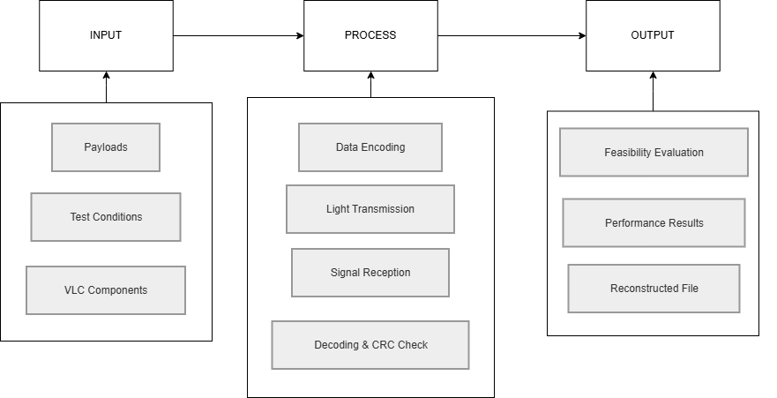
1.4 Conceptual Framework

Figure 1.1. Conceptual Framework of the VLC Prototype

The conceptual framework of the study follows the Input–Process–Output (IPO) model to illustrate how the Visible Light Communication (VLC) prototype operates.
The Input stage includes the payloads to be transmitted such as text, image, audio, and file data, together with the VLC hardware components and testing conditions like distance, alignment, and ambient light. These inputs serve as the data and factors that influence transmission performance.
The Process stage describes how the system transmits and receives data using visible light. The transmitter encodes the payload using 4B5B + NRZ/OOK signaling and sends the optical signal through the LED bulb. The receiver detects the light signal using the photodiode, processes and decodes the data, and performs CRC validation to ensure reliable transmission and reconstruction of the payload.
The Output stage consists of the reconstructed file or payload and the measured system performance results such as transmission reliability, data accuracy, and overall feasibility of the VLC prototype for short-range indoor wireless communication.

1.5 Scope and Delimitations

1.5.1 Scope
This study covers the evaluation of a low-cost, short-range indoor VLC prototype using a 4B5B + NRZ/OOK optical signaling implementation. The system consists of two ESP32 boards connected to a laptop through USB serial, a 12 V DC LED bulb driven by a 2N3904 transistor and IRF540N MOSFET stage, a BPW34 photodiode receiver with an OPA2604 transimpedance amplifier and LM393 comparator, and modern TX/RX GUI applications.
The prototype is evaluated using text, image, audio, and selected file payloads. The evaluation includes transmission time, effective data rate, CRC result, chunk completion rate, missing chunks, reconstructed output, receiver margin, LED wattage response, distance, line-of-sight alignment, ambient light level, feedback resistor condition, comparator Vref/threshold setting, typical bulb height, and human comfort observation.
The main feasibility tests use fixed stable 4B5B parameters selected from preliminary testing. This approach allows the study to focus on the effects of file type, range, ambient light, LED wattage, receiver margin, and human comfort without overloading the test matrix with too many changing variables.

1.5.2 Delimitations
This study is limited to the evaluation of a low-cost, short-range indoor Visible Light Communication prototype using 4B5B + NRZ/OOK optical signaling. It does not claim to develop a commercial Li-Fi product, a Wi-Fi replacement, or a full-scale optical communication network. The prototype is intended only for controlled indoor feasibility testing using a commercially available 12 V DC LED bulb and a BPW34 photodiode-based receiver.
The system requires a clear line-of-sight path between the transmitter and receiver. Its performance is evaluated only under the selected test conditions, including fixed 4B5B transmission settings, tested LED wattages, measured distances, ambient light levels, receiver margin, and comparator threshold conditions. The prototype does not include Bluetooth, Wi-Fi, RS-232, internet connectivity, ACK/retransmission, or a separate optical feedback channel. USB serial communication is used only for data exchange and monitoring between the laptop-based TX/RX applications and the ESP32 boards.
The study covers text, image, audio, and selected file transmission through the implemented 4B5B-based VLC system. Video transmission, adaptive thresholding, two-way communication, and large-scale deployment are outside the scope of this research and may be considered for future work. Final claims on maximum distance, BER, effective data rate, ambient-light tolerance, and user comfort are limited to the actual measured results obtained during testing.
The results of the study apply only to the tested hardware, lighting conditions, transmission settings, encoding modes, distances, LED wattages, and receiver threshold conditions. Exact maximum distance, effective data rate, ambient-light tolerance, and receiver stability should only be concluded after actual measured values are completed.

1.6 Significance of the Study
This study is significant to students, future researchers, educators, and institutions because it demonstrates how a low-cost VLC prototype can be evaluated using accessible electronic components, GUI-based control, and measurable communication performance indicators.
To Students
- Learning Opportunity - The study gives students practical exposure to microcontroller programming, optical communication, analog receiver circuits, GUI-based data transfer, and experimental testing.
- Skill Development - It helps students improve skills in embedded systems, circuit design, signal conditioning, line coding, packet handling, CRC validation, and data analysis.
- Innovation Inspiration - It encourages students to explore alternative communication systems and shows that visible light can be studied as a practical medium for short-range wireless data transfer.
To Future Researchers
- Prototype Reference - The study provides a working reference for a low-cost VLC prototype using ESP32 boards, a 12 V DC LED bulb, BPW34 photodiode, OPA2604 amplifier, LM393 comparator, USB serial GUIs, packet-carousel transmission, 4B5B + NRZ/OOK signaling, and CRC validation.
- Performance Insights - The study shows how transmission reliability can be affected by symbol rate, chunk size, carousel rounds, receiver margin, LED wattage, distance, alignment, ambient light, and comparator threshold setting.
- Future Improvements - The prototype may serve as a starting point for improvements such as adaptive thresholding, improved receiver filtering, better optical alignment, automatic receiver calibration, higher-speed symbol timing, improved GUI logging, and optional ACK/NACK return channels.
To Educators and Institutions
- Curriculum Integration - The prototype can be used as an example in Electronics Engineering topics such as communication systems, embedded systems, photodetectors, operational amplifiers, comparators, digital line coding, and signal processing.
- Research Collaboration - The study can encourage student and faculty collaboration in developing low-cost optical wireless communication systems and other applied engineering prototypes.

1.7 Definition of Terms
- 4B5B Line Coding - A line-coding method that converts each 4-bit data group into a 5-bit code group. In this prototype, it is used as the main encoding method because it improves line-code efficiency while still providing transition patterns useful for synchronization.
- 12 V DC LED Bulb - A commercially available direct-current light source used as the optical transmitter. It is switched by the 2N3904 and IRF540N driver stage to carry the VLC signal.
- Active-Low Driver - An optional switching configuration supported by the transmitter firmware in which an ESP32 LOW output turns the LED ON and an ESP32 HIGH output turns the LED OFF. The prototype firmware allows either active-low or active-high operation depending on the selected configuration.
- Ambient Light - External light from sunlight, room lighting, or other sources that may affect the photodiode receiver and influence signal detection.
- Bit Error Rate (BER) - The ratio of corrupted bits received to the total number of bits transmitted, expressed as a percentage. It serves as the primary metric for communication reliability.
- BPW34 Photodiode - The photodiode used in the receiver to convert incoming light from the LED bulb into current.
- Ceiling Height (Vertical Distance) - - The fixed vertical distance (2.4 meters) from the receiver's horizontal plane to the LED bulb transmitter mounted above.
- Chunk/Packet Chunk - A fixed-size data segment into which the Modern TX GUI splits large files for manageable transmission and reassembly.
- Comparator Circuit - A circuit stage that compares the amplified receiver signal with a reference voltage and converts it into a digital logic signal for the receiving ESP32.
- CRC Validation - The use of cyclic redundancy check values to detect errors in received packets. Packets with incorrect CRC values are rejected by the receiver.
- Dark Room Baseline (approx. 61 lux) - An indoor testing environment where all external and ambient light sources are completely eliminated or blocked. The measured illuminance on the receiver plane is generated almost entirely by the unmodulated DC bias of the active VLC LED transmitter
- Dim Room Interference (approx. 79 lux) - An indoor testing condition where lowintensity, indirect background illumination (e.g., distant room lighting or monitor glow) is introduced, causing a moderate baseline shift in the receiver's transimpedance output.
- Effective Data Rate - The useful payload size divided by the measured transmission time. This focuses on actual transfer performance rather than theoretical speed.
- Feedback Resistor - A resistor in the transimpedance amplifier feedback path that affects receiver gain, sensitivity, and bandwidth.
- FGAP - Frame gap used in the 4B5B + NRZ/OOK workflow to give the receiver time to recover between optical frames.
- File CRC - A CRC value computed for the entire file payload to verify that the reconstructed output matches the transmitted file.
- Horizontal Offset Distance - Horizontal Offset Distance - The lateral distance along the receiver's plane measured from the point directly beneath the LED transmitter to the receiver's physical location.
- Line of Sight - The direct, unobstructed optical propagation path between the LED transmitter and the photodiode receiver. Geometrically, communication is only maintained when the receiver's angle of incidence falls within the transmitter's semi-angle at half power, and the incoming light beam strikes within the effective Field of View (FOV) (e.g., ±60°) of the photodiode lens.
- LM393 Comparator - The comparator used to convert the OPA2604 analog output into a digital signal for the RX ESP32.
- Missing Chunks - Packet chunks that were not successfully received or validated.
- Modern RX GUI - The receiver application used to monitor status, receive decoded data, verify CRC results, and reconstruct or save the output payload.
- Modern TX GUI - The transmitter application used to select payloads, configure settings, prepare packet/chunk data, compute CRC values, and send commands to the TX ESP32.
- NRZ/OOK Optical Signaling - The optical symbol method used with 4B5B, where each encoded bit is transmitted as one LED ON or LED OFF level during one symbol period.
- Normal Room Interference (approx. 98 lux) - An indoor testing condition where direct, steady-state overhead illumination is introduced to simulate standard residential or office lighting, severely testing the dynamic range of the receiver's adaptive thresholding mechanism.
- OPA2604 Transimpedance Amplifier - The operational amplifier stage used to convert small current from the BPW34 photodiode into a measurable voltage signal.
- Optical Distance - The true point-to-point, line-of-sight distance from the LED transmitter to the photodiode receiver (calculated as the hypotenuse of the ceiling height (vertical distance) and the horizontal offset).
- Packet Carousel - A transmission method where packet frames are repeatedly sent in selected rounds so the receiver can capture valid copies without ACK/retransmission.
- Payload - The actual data selected for transmission, such as text, image, audio, or another file type.
- PVo (Photodiode Output Voltage) - The analog voltage signal output by the OPA2604 transimpedance amplifier before it is fed into the LM393 comparator.
- Receiver Margin - The difference between the received signal level and the comparator reference or threshold voltage. A higher margin generally supports more reliable decoding.
- SOF - Start-of-frame marker used to identify the beginning of a valid frame after synchronization.
- Symbol Rate - The number of optical symbols transmitted per second in the 4B5B + NRZ/OOK mode.
- Sync Word - A known bit pattern used by the receiver to identify frame timing and alignment. In the current 4B5B implementation, the sync word is 0xD5B7.
- Transmission Time - The measured time from the start of payload transfer to successful reception and reconstruction of the payload at the receiver side.
- USB Serial Communication - A wired communication method that allows the laptop GUIs to exchange commands, data, and status messages with the ESP32 boards through USB cables.
- Vref - The reference voltage used by the comparator circuit to determine whether the incoming analog receiver signal should be interpreted as logic high or logic low.
- VLC - Visible Light Communication, a wireless communication method that uses visible light as the transmission medium.

CHAPTER II

REVIEW OF RELATED LITERATURE AND STUDIES
This chapter reviews related literature and studies that support the development and evaluation of the proposed low-cost Visible Light Communication (VLC) prototype. The review focuses on the technical concepts needed for the present feasibility study, including VLC and Li-Fi principles, LED light sources, photodiode-based receiver circuits, transimpedance amplification, comparator thresholding, 4B5B line coding, NRZ/OOK optical signaling, packet-based recovery, CRC validation, ESP32 prototyping, USB serial communication, line-of-sight limitations, and human comfort. The chapter supports the use of 4B5B + NRZ/OOK as the main encoding and signaling method of the prototype.

2.1 Related Literature

2.1.1 Visible Light Communication and Li-Fi
Visible Light Communication (VLC) is an optical wireless communication method that uses visible light as the medium for data transfer. In a typical VLC system, an LED source is modulated to represent digital information, while a photodiode or photodetector receives the optical signal and converts it back into an electrical waveform. Komine and Nakagawa (2004) showed that LED lighting can be analyzed as both an illumination source and a communication transmitter. Pathak et al. (2015) also described VLC as a promising communication and sensing technology, while noting that practical systems must address channel conditions, receiver orientation, and interference.
Li-Fi is commonly discussed as a VLC-based technology for indoor wireless communication. Yin, Islim, and Haas (2017) presented Li-Fi as a way to extend optical communication principles into wireless indoor links. However, commercial and high-speed Li-Fi systems normally require more advanced components and synchronization methods than a student-built prototype. For this reason, the present study does not claim to replace Wi-Fi. Instead, it evaluates the feasibility of a low-cost short-range VLC system using accessible hardware.
The IEEE 802.15.7-2018 standard also supports the relevance of short-range optical wireless communications as a recognized technical field (IEEE Standards Association, 2018). Although this prototype is not intended to be a standard-compliant commercial product, the standard is useful because it confirms that optical wireless communication includes physical-layer and link-layer concerns such as modulation, dimming, flicker, and short-range optical links.

2.1.2 LED Light Sources for VLC
LEDs are commonly used in VLC because they can provide both illumination and data transmission. The light output of an LED can be varied faster than what is normally perceived by the human eye, allowing data to be represented through intensity changes. Komine and Nakagawa (2004) emphasized the dual purpose of LED lighting in indoor VLC systems. In the present prototype, this concept is applied using a commercially available 12 V DC LED bulb instead of a small indicator LED.
The optical output of the LED source affects the receiver signal. A brighter or higher-wattage light source can generally produce a stronger received photodiode signal, while a lower-wattage source can produce a weaker signal under the same distance and alignment. For this study, different 12 V DC LED bulb wattages may be tested to observe the relationship between LED wattage, receiver voltage, Vref threshold, CRC reliability, and reconstructed output. This is important because the receiver uses a comparator threshold, and the proper threshold depends on the received signal level.
The present study remains limited to short-range indoor testing. The use of a household-type 12 V DC LED bulb supports practical feasibility testing, but it does not mean the prototype has the same performance as commercial Li-Fi lighting systems.

2.1.3 Photodiode Receiver and Transimpedance Amplification
A photodiode is a semiconductor device that converts incident light into current. In VLC receiver circuits, the photodiode detects the optical signal emitted by the transmitter. Since the photodiode output is usually a small current, a transimpedance amplifier (TIA) is used to convert this current into a voltage signal that can be processed by the next receiver stages.
Transimpedance amplification is important because it affects receiver sensitivity, bandwidth, and noise performance. The feedback resistor and associated components influence how much voltage is produced from the photodiode current. Higher gain may help detect weaker signals, but it can also introduce noise or limit bandwidth if not designed properly (Horowitz & Hill, 2015).
In the present prototype, the BPW34 photodiode is used as the light detector, while the OPA2604 operational amplifier is used in the TIA stage. The output of the TIA is then passed to the LM393 comparator for digital thresholding. This receiver chain is low-cost and accessible, making it appropriate for a feasibility study. The paper does not claim that the BPW34 is the universal standard Li-Fi receiver; it is treated only as a suitable and available photodiode for the prototype.

2.1.4 Comparator Thresholding, Vref, and Receiver Margin
A comparator converts an analog signal into a digital signal by comparing the input voltage with a reference voltage. In optical receivers, the comparator threshold is important because it determines whether the receiver interprets the signal as a logic high or logic low. If the threshold is too high, weak optical pulses may be missed. If the threshold is too low, noise or ambient light may be falsely detected as data.
The reference voltage, or Vref, must be adjusted based on the receiver signal level. Receiver signal level can change due to distance, alignment, LED wattage, ambient light, and amplifier gain. In this study, receiver margin refers to the difference between the useful received signal level and the comparator threshold. A larger receiver margin generally supports more reliable detection, while a very small margin can make the receiver more sensitive to noise, jitter, and threshold errors.
This concept is important in the present prototype because the 4B5B + NRZ/OOK method depends on stable symbol detection. If the receiver voltage is too close to the comparator threshold, the LM393 may produce unstable digital transitions, which can lead to CRC failures, missing chunks, or unsuccessful reconstruction. For this reason, Vref, receiver margin, LED wattage, distance, alignment, and ambient light are included as important variables in the testing procedure.

2.1.5 4B5B Line Coding for VLC Data Transmission
Line coding affects how digital data are represented before transmission. In a VLC system, line coding is important because the receiver must detect symbol timing, locate valid frame boundaries, and recover data from the received optical waveform. In this study, 4B5B line coding is used as the main data encoding method for the prototype. The 4B5B method maps each 4-bit data group into a 5-bit code group. This adds controlled redundancy to the transmitted stream and helps reduce long sequences of identical symbols, which can make synchronization and symbol recovery more difficult.
The use of 4B5B is appropriate for the prototype because it supports more efficient file transmission while still providing structured code patterns for the receiver. Data communication references describe 4B5B as a line-coding method that improves transmission efficiency by representing four data bits using five transmitted code bits, resulting in a line-code efficiency of 80 percent before packet and protocol overhead are considered (Forouzan, 2013; Stallings, 2014).
The proposed receiver must maintain stable symbol timing and proper threshold detection for reliable decoding. If the receiver signal is weak, poorly aligned, or too close to the comparator threshold, the 4B5B symbols may be decoded incorrectly, leading to CRC failures, missing chunks, or unsuccessful file reconstruction. For this reason, the methodology will include tests for distance, line-of-sight alignment, ambient-light effect, LED wattage, receiver margin, Vref/threshold setting, CRC result, and reconstructed output.

2.1.6 NRZ/OOK Optical Signaling and Symbol Timing
On-Off Keying (OOK) is a basic optical signaling method where information is represented by changes in light intensity. In the present prototype, OOK is used as the optical symbol representation for the 4B5B encoded bitstream. Each encoded bit is transmitted as one optical symbol using NRZ/OOK signaling. NRZ means that the symbol remains at its assigned optical level for the duration of the symbol period instead of returning to a neutral level after every symbol.
The ESP32 generates the optical signal using firmware-controlled GPIO timing. Since the transmitter circuit is active-low, the firmware must correctly map the logical symbol values to the physical LED ON and LED OFF states. Symbol timing is important because a higher symbol rate can improve transfer speed but can also make the receiver more sensitive to timing error, threshold setting, distance, alignment, and noise. For this reason, the study uses fixed stable 4B5B settings during the main feasibility tests and records CRC result, missing chunks, receiver margin, and reconstructed output.

2.1.7 Packet-Based Transmission, Carousel Rounds, and CRC Validation
Packet-based transmission divides data into smaller units so that larger payloads can be sent and reconstructed in a controlled way. Each packet or frame may include metadata such as transfer identification, payload type, file size, chunk index, payload length, and error-checking information. This method is useful for transmitting text, image, audio, and other file types because the receiver can reconstruct the complete file from validated chunks.
Cyclic Redundancy Check (CRC) is an error-detection method used to determine whether received data were corrupted during transmission. The transmitter calculates a CRC value and sends it with the frame or chunk. The receiver calculates the CRC again and compares the result. If the values match, the data are treated as valid; if not, the packet is rejected. CRC detects errors but does not correct them by itself (Forouzan, 2013).
The present prototype uses packet/chunk carousel transmission with CRC validation. Since the optical link is one-way and does not use ACK/retransmission, the transmitter repeats chunks for selected carousel rounds. The receiver accepts valid chunks, ignores duplicates, and rejects corrupted frames. This method allows the system to recover missing or corrupted chunks without a return channel, although it is less efficient than a true feedback-based retransmission system.

2.1.8 USB Serial Communication and ESP32-Based Prototyping
The ESP32 is a low-cost microcontroller platform that provides digital input/output, timers, serial communication, and firmware programmability. These features make it suitable for student prototyping and embedded communication experiments. Espressif Systems (2024) documents the ESP32 as a microcontroller system-on-chip with programmable GPIO and communication interfaces.
In the proposed prototype, the ESP32 boards will be used on both transmitter and receiver sides. The TX ESP32 will generate the 4B5B + NRZ/OOK optical signal through firmware-controlled GPIO timing, while the RX ESP32 will read the comparator output, decode the received data, validate frames, and communicate status to the RX GUI. The modern TX/RX GUI applications will communicate with the boards through USB serial links.
USB serial will be only used between the laptop and the ESP32 boards. It powers the ESP32 boards and carries commands, data, and status messages between the GUIs and firmware. The system does not use Bluetooth, Wi-Fi, RS-232, mobile phone control, internet connectivity, or an optical feedback channel as part of the prototype operation.

2.1.9 Ambient Light, Distance, Alignment, and Line-of-Sight Limitations
VLC performance depends strongly on the optical path between the transmitter and receiver. Since visible light does not pass through opaque objects, a clear line-of-sight path is important. Misalignment, increased distance, obstruction, and receiver orientation can reduce the amount of light reaching the photodiode. Pathak et al. (2015) identified issues such as blockage, mobility, interference, and orientation as practical challenges for VLC systems.
Ambient light can also affect VLC receivers. Sunlight, room lighting, and other LED sources may add DC offsets or noise to the receiver signal. These effects can change the comparator threshold condition and reduce the reliability of decoding. In a low-cost receiver without adaptive thresholding, Vref and receiver margin must therefore be recorded and adjusted during testing.
For this study, distance, line-of-sight alignment, ambient light, LED wattage, receiver voltage, Vref, and receiver margin are important variables. These variables must be considered when interpreting transmission time, effective data rate, CRC results, missing chunks, chunk completion, receiver margin, and reconstructed output

2.1.10 Human Comfort and LED Illumination Considerations
Because VLC utilizes visible light as both an illumination source and a communication medium, human comfort must be considered during system operation. A VLC transmitter should maintain acceptable lighting conditions while minimizing visible flicker and excessive glare. Flicker occurs when changes in light intensity become noticeable to human observers and may cause visual discomfort, fatigue, or distraction during prolonged exposure.
The IEEE 802.15.7 standard recognizes the importance of flicker mitigation and illumination quality in optical wireless communication systems. Although VLC modulation can occur at frequencies beyond human visual perception, practical implementations should still be evaluated for user comfort, especially when commercially available lighting devices are used as transmitters.
For this reason, the proposed study will include human comfort observations during prototype testing. Parameters such as perceived flicker, glare, placement suitability, and general user acceptability are documented to determine whether the developed VLC prototype remains practical for short-range indoor use while maintaining acceptable illumination conditions.

2.2 Related Studies

2.2.1 Fundamental Analysis for VLC Using LED Lights
Komine and Nakagawa (2004) provided a fundamental analysis of VLC using LED lights. Their work connected the illumination function of LEDs with communication performance. This study is directly relevant because the present prototype also uses an LED light source as the communication transmitter.
The relevance to the present study is in the use of LED lighting for short-range indoor optical transmission. However, the present work uses a low-cost 12 V DC LED bulb and a student-built receiver instead of a high-end communication lighting setup. The study therefore uses Komine and Nakagawa as support for the concept, while the actual evaluation remains limited to the developed prototype.

2.2.2 Visible Light Communication, Networking, and Sensing Survey
Pathak et al. (2015) presented a comprehensive survey of VLC communication, networking, and sensing technologies. Their study identified several practical challenges affecting VLC performance, including receiver orientation, shadowing, interference, mobility, and ambientlight exposure. The authors emphasized that environmental conditions significantly influence communication reliability and overall system performance.
The study is relevant to the present research because many of the identified challenges are directly evaluated in the developed VLC prototype. Unlike the survey-based approach of Pathak et al. (2015), the proposed study will experimentally measure the effects of distance, alignment, ambient light, LED wattage, receiver margin, and comparator threshold settings on communication reliability. The findings of the survey therefore provide theoretical support for the environmental and operational variables investigated in this feasibility study.

2.2.3 Li-Fi: Transforming Fibre into Wireless
Yin, Islim, and Haas (2017) discussed Li-Fi as an emerging wireless communication technology that extends optical communication concepts into indoor wireless environments. Their work demonstrated the potential of Li-Fi systems to achieve high-speed communication using advanced optical transmission techniques and specialized hardware architectures.
While the systems discussed by Yin et al. (2017) focus on high-performance Li-Fi networks, the present study investigates the feasibility of a low-cost implementation using commercially available components and ESP32 microcontrollers. The study therefore differs in scope and complexity but shares the same fundamental principle of transmitting digital information through visible light. Their work supports the theoretical foundation of VLC and demonstrates the broader potential of optical wireless communication technologies.

2.2.4 Visible Light Communication: Applications, Architecture, Standardization, and Research Challenges
Studies on VLC architecture and standardization identify key system parts such as LED transmitters, photodetectors, modulation or line coding, and receiver signal processing. They also show that VLC systems must address practical limitations such as alignment, ambient light, and data integrity.
This supports the present prototype because the system includes the same basic VLC architecture: an LED transmitter, an optical channel, a photodiode receiver, a comparator stage, microcontroller processing, and CRC-based validation. The present study applies this architecture to a low-cost 4B5B + NRZ/OOK file transmission prototype.

2.2.5 Li-Fi: Wireless Communication through Visible Light
Naveen and Bhargavi (2017) discussed Li-Fi as a visible-light-based communication method for indoor data transfer. Their discussion emphasized the use of LEDs and noted practical limitations such as line-of-sight requirements and light interference.
While Naveen and Bhargavi (2017) established the foundational viability of Li-Fi, their discussion remained largely conceptual. The proposed research will advance this concept from theory to application by engineering a functional, ESP32-based prototype utilizing 4B5B + NRZ/OOK signaling.

2.2.6 Wireless Communication Using Li-Fi Technology
Karthika and Balakrishnan (2015) presented Li-Fi as an alternative wireless communication technology that utilizes visible light emitted by LEDs. Their work emphasized the advantages of VLC in environments where radio-frequency interference is undesirable. However, the study primarily discussed conceptual applications and potential benefits. However, while Karthika and Balakrishnan (2015) primarily explored conceptual RF-interference benefits, the proposed study will provide empirical hardware validation through the practical implementation of a low-cost VLC receiver.

2.2.7 New Technology of Data Transmission: Li-Fi
Yessenbek et al. (2020) discussed Li-Fi and visible light communication performance. Their work supports the idea that line-of-sight conditions generally improve communication reliability compared with obstructed or poorly aligned conditions.
This is relevant because the present prototype depends on a direct optical path between the 12 V DC LED bulb and the BPW34 photodiode. The study therefore includes distance and alignment testing as part of the feasibility assessment.

2.3 Synthesis of the Reviewed Literature and Studies
The reviewed literature and studies collectively establish that Visible Light Communication is a viable optical wireless communication technology capable of supporting shortrange indoor data transmission through LED-based illumination systems. Foundational research has demonstrated the theoretical feasibility of transmitting digital information using visible light, while also identifying critical practical limitations related to receiver sensitivity, synchronization, ambient-light interference, spatial attenuation, and link reliability.
Recent comprehensive surveys, such as those published by Matheus et al. (2024) in IEEE Access, underscore that while high-speed commercial VLC networks push toward multi-gigabit speeds, low-cost microcontrollers like the ESP32 remain highly relevant for robust, short-range Optical Wireless Communication (OWC) prototyping. Furthermore, the mid-2023 ratification of the IEEE 802.11bb Light Communications standard—which integrates visible light links directly into native 802.11 Wi-Fi layers—highlights that adapting established RF-style packet structures (such as framing, CRC, and payload chunking) over an optical carrier is operating at the cutting edge of the discipline.
However, a distinct gap exists in the literature regarding the implementation of these modern protocols using highly accessible, student-grade hardware. Many existing implementations rely on specialized laboratory-grade equipment, multi-pixel CMOS image sensors (Optical Camera Communications), or complex digital signal processors (DSPs) to perform channel estimation and mitigate ambient light saturation.
Therefore, to bridge this gap, the proposed study will synthesize these advanced theoretical concepts into a low-cost, empirical prototype. Instead of complex DSPs, the proposed architecture will implement a highly efficient, hardware-based Smart Auto-Vref tracking loop paired with a fast-response PIN photodiode. To ensure reliable synchronization without the bandwidth penalty of Manchester encoding, the system will utilize a 4B5B line coding scheme. Because reliable decoding depends heavily on maintaining a stable difference between the photodiode output and the comparator threshold, dynamic "receiver margin" will be utilized as the central reliability indicator.
Ultimately, the proposed test procedures will evaluate multiple payload types, measure effective data rates, log chunk completion percentages, and document the effects of spatial distance and ambient optical noise. By correlating these physical channel conditions with strict CRCvalidated error metrics, this study will determine whether a packet-based, 4B5B-encoded VLC prototype is empirically feasible for low-cost, short-range indoor data transmission.

CHAPTER III

METHODOLOGY
This chapter describes the methodology used in developing, implementing, and evaluating the proposed Visible Light Communication (VLC) prototype. It includes the research design, system instruments, operations manual, flowcharts, circuit diagrams, testing procedures, and data analysis methods used in the study.

3.1 Research Design
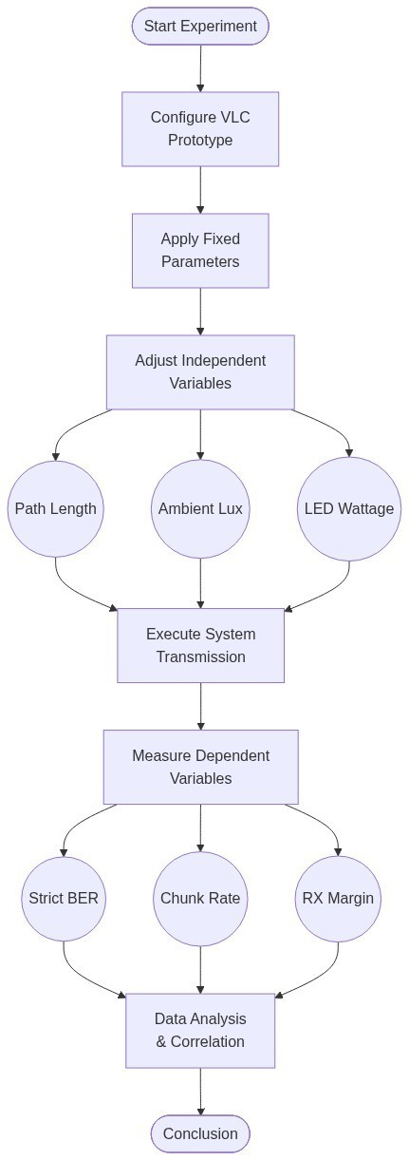

Figure 3.1. Block Diagram

This study used an experimental, prototype-based research design to evaluate a low-cost Visible Light Communication prototype for short-range indoor wireless data transmission. The prototype was developed to transmit and reconstruct selected payloads such as text, image, audio, and file data using visible light as the communication medium.
The experimental design utilized a controlled, simplex optical link to evaluate the relationship between physical channel conditions (independent variables: optical path length, ambient lux, LED wattage) and communication reliability (dependent variables: Strict BER, Chunk Completion Rate, and Receiver Margin). System parameters such as the 15 ksymbols/s symbol rate, 4B5B encoding, and 256-byte chunk sizing were held constant across all primary trials to isolate environmental and spatial effects.
The TX GUI allows the user to select the payload to be transmitted. The selected data are prepared and sent to the transmitter ESP32 through USB serial communication. The transmitter ESP32 applies the selected 4B5B + NRZ/OOK transmission method and controls the LED driver circuit. The 12 V DC LED bulb then transmits the encoded data as rapidly changing visible light pulses.
At the receiver side, the BPW34 photodiode detects the incoming light signal and converts it into an electrical signal. The OPA2604 amplifier conditions the received signal, while the LM393 comparator compares the amplified signal with the selected reference voltage. The receiver ESP32 processes the recovered digital signal, validates the received data using CRC, and sends the reconstructed output to the RX GUI.
The study evaluated the feasibility of the VLC prototype based on successful payload reconstruction, Bit Error Rate (BER), bit accuracy, CRC validation status, transmission time, effective data rate, receiver margin, comparator reference voltage (Vref), and communication performance under varying receiver positions, ambient light conditions, LED wattages, and human comfort observations.
Communication reliability was assessed through payload reconstruction, Bit Error Rate (BER), bit accuracy, CRC validation, chunk completion rate, transmission time, and effective data rate. BER was determined by comparing the reconstructed payload with its corresponding reference data using the bit-level comparison procedures described in Section 3.7. Receiver performance was further evaluated through adaptive threshold calibration, wherein the comparator reference voltage (Vref) was automatically adjusted based on the measured PVo to maintain a predefined receiver operating margin.
The VLC prototype was evaluated using fixed communication parameters, including a symbol rate of 15 ksymbols/s, 4B5B line coding, NRZ/OOK modulation, a default chunk size of 256 bytes, a ceiling-mounted LED transmitter installed at a height of 2.40 m, and a receiver assembly positioned at a height of 0.30 m. These parameters were maintained throughout the major experiments to ensure consistency and comparability of results

3.1.1 Experimental Test Environment
All experiments were conducted in an indoor environment using commercially available 12-V DC LED bulbs as the visible light transmitter. The default transmitter was a 12-W LED bulb; additional tests were also conducted using 6-W and 9-W bulbs of the same rated voltage to observe how transmitter optical power affected the received signal level and receiver margin. The LED bulb was installed on the ceiling at a height of approximately 2.4 m from the floor. The receiver assembly, consisting of the BPW34 photodiode, transimpedance amplifier, comparator circuit, and ESP32 receiver module, was positioned on a laboratory table with a height of approximately 0.30 m.
The resulting vertical separation between the transmitter and receiver was approximately 2.1 m. During testing, the transmitter position remained fixed while the receiver position was varied horizontally relative to the point directly below the LED transmitter. The horizontal offset distance was used as the primary distance parameter for evaluating system performance.
For consistency, the major performance evaluations were conducted using fixed communication settings. The transmitter operated using a 4B5B line coding scheme with NRZ/OOK modulation at an optical symbol rate of 15 ksymbols per second. The default payload chunk size was set to 256 bytes, which was used throughout the payload transmission experiments unless otherwise stated.
The receiver employed a BPW34 photodiode, an OPA2604 transimpedance amplifier, and an LM393 comparator powered from a 12-V supply. An adaptive thresholding mechanism was implemented to automatically adjust the Vref according to the measured PVo. The adaptive calibration process was designed to maintain an appropriate receiver operating margin under varying signal conditions. The effectiveness of this mechanism was evaluated experimentally and is discussed in Chapter IV.
The LED transmitter remained continuously illuminated during idle and transmission states, with data encoded through rapid intensity modulation that was not visually perceptible during payload bits, but visible during frame-gap transitions.
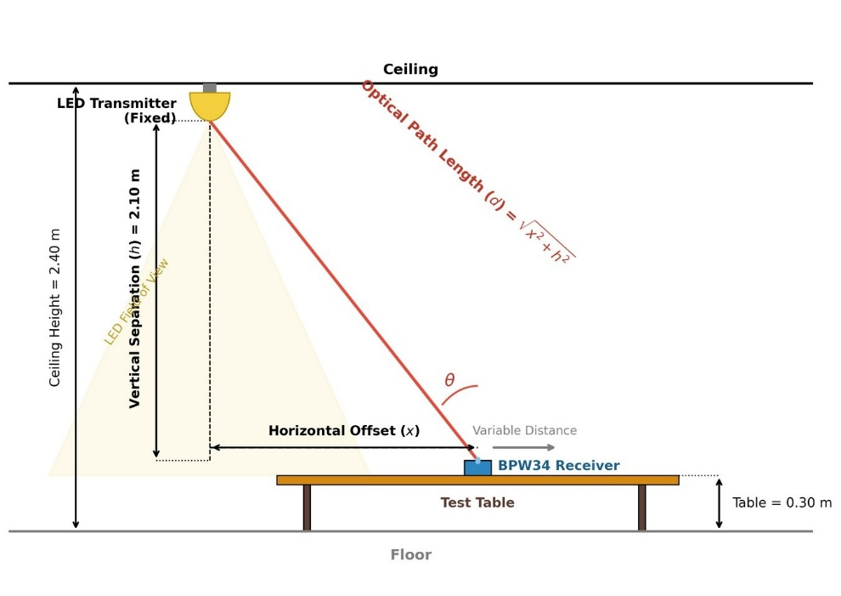

Figure 3.2. Experimental setup geometry and resulting optical path length.

Figure 3.2. Experimental setup geometry and resulting optical path length.
As illustrated in Figure 3.1, the physical testing environment introduces a fixed vertical separation (h) of 2.10 meters. Because the ceiling height and table height are constant, the horizontal offset (x) serves as the primary independent variable during distance evaluation. The true optical distance (d) traveled by the visible light signal forms the hypotenuse of this configuration and is calculated using the Pythagorean theorem, as defined in Formula 1.
The optical path length between the transmitter and receiver was determined using the Pythagorean relationship:
$$d= \sqrt{x^{2}+h^{2}}$$
Formula 1. Optical Path Length
where
d = optical path length (m)
x = horizontal offfset distance (m)
h = vertical separation between transmister and reciever (2.1m)
Performance measurements including receiver margin, Bit Error Rate (BER), payload reconstruction success, and CRC validation were obtained at different horizontal offset distances and environmental conditions. All tests were performed under direct optical alignment conditions unless otherwise specified.

3.1.2 Fixed Experimental Parameters
To ensure consistency among the conducted experiments, several system parameters were maintained throughout the study unless otherwise specified. These parameters served as the baseline operating conditions for the VLC prototype.
Table 3.1 Fixed Experimental Parameters
PAREMETER | VALUE
LED Mounting Height | 2.40 m
Receiver Height | 0.30 m
Vertical Separation | 2.10 m
Modulation Method | NRZ/OOK
Line Coding Scheme | 4B5B
PAREMETER | VALUE
Default Chunk Size | 256 bytes
Symbol Rate | 15 ksymbols/s
Frame Gap | 1 ms
Reciever Type | BPW34 Photodiode
Transimpedance Amplifier | OPA2604
Comparator | LM393
Target Receiver Margin | 0.365 V
Stable Receiver Margin Range | 0.28 V – 0.45 V
Communication Mode | Line-of-Sight (LOS)
LED State During Idle | ON

Research Instruments
The research instruments were grouped into transmitter instruments, receiver instruments, software tools, and measuring tools. Only components used or directly planned for the working prototype are included in this methodology section. Full screenshots, source codes, and raw logs will be placed in the appendices.

ESP32U DevKit V1 (WROOM-32)
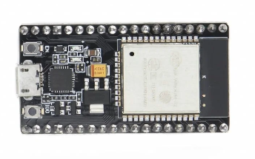

Figure 3.3. ESP32U DevKit V1 (WROOM-32)

The ESP32 DevKit V1 (ESP-WROOM-32) was used as the primary microcontroller platform for both the transmitter and receiver sections of the VLC prototype. On the transmitter side, the ESP32 generated the 4B5B-encoded NRZ/OOK optical signal through GPIO5 and controlled the LED driver circuit. On the receiver side, the ESP32 sampled the comparator output, decoded incoming symbols, validated received frames using CRC, reconstructed payload data, and communicated with the RX GUI through USB serial communication. The ESP32 was selected because of its processing capability, programmable GPIO pins, integrated serial communication support, and suitability for embedded communication applications.


Laptop/Computer with Modern TX/RX GUI –

Figure 3.4. Laptop/Computer with Modern TX/RX GUI
Used to select payloads, set 4B5B transmission parameters, monitor status, and reconstruct received outputs. GUI screenshots should be included in the appendices.

Lux Meter Application


Figure 3.5. Lux Meter Application

A smartphone-based lux meter application ("Lux Meter (Light Meter)" downloaded from the Google Play Store) was used to measure ambient illumination during environmental testing. This allowed the researchers to quantify the background light level in lux and evaluate its effect on the receiver operating margin.

USB Serial Cables
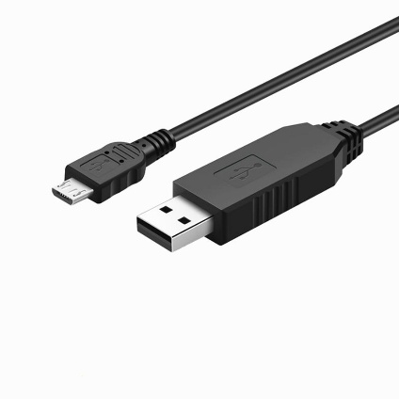

Figure 3.6. USB Serial Cables

Provided power to ESP32 boards and carried serial commands, stream data, and status messages between the GUIs and microcontrollers.

2N3904 and IRF540N MOSFET Transistors

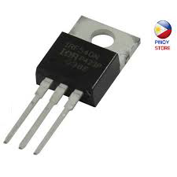
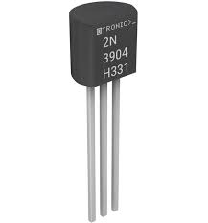

Figure 3.7. 2N3904 and IRF540N Transistors

Active-low switching stage used to drive the 12 V DC LED bulb from the ESP32 GPIO5 signal.

12 V DC LED Bulbs
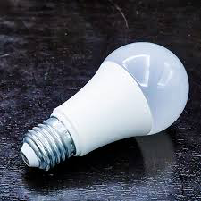

Figure 3.8. 12V DC LED Bulbs

Commercially available light sources used as optical transmitters. Different wattages may be tested to observe receiver signal level and reliability.

3.2.7 12V DC Power Supply with 220V AC Input
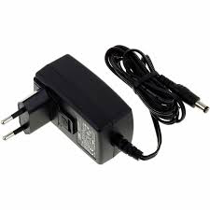

Figure 3.9. 12V DC Power Supply with 220V AC input

Provided the 12 V DC supply for the LED/driver side and reference/threshold-related receiver conditions where applicable.

3.2.8 BPW34 Photodiode
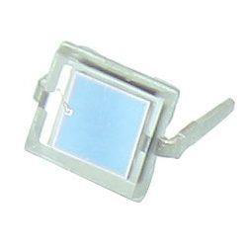

Figure 3.10. BPW34 Photodiode

Detected visible-light pulses from the transmitter and produced photocurrent for the receiver front end.

OPA2604 Op-Amp IC
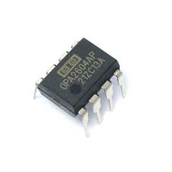

Figure 3.11. OPA2604 Op-Amp IC

The OPA2604 operational amplifier was used as the transimpedance amplifier (TIA) that converted the photocurrent generated by the BPW34 photodiode into a measurable voltage signal. Utilized for the Transimpedance Amplifier (TIA) stage, this component features a high slew rate of 25 V/µs and a Gain-Bandwidth Product (GBP) of 20 MHz. These specifications ensure the amplifier can support the high-gain feedback network (1.5 MΩ) without excessively attenuating the 7.5 kHz fundamental frequency of the NRZ optical signal.)

LM393 Op-Amp IC

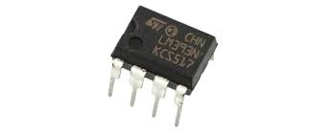
.

Figure 3.12. LM393 Op-Amp IC

Will be used as a comparator for the amplified receiver signal with Vref and produced a digital waveform suitable for the RX ESP32 input.

Arduino IDE


Figure 3.13. Arduino IDE

The software used to upload transmitter and receiver firmware to the ESP32 boards.

Python v13.14.5


Figure 3.14 Python v13.14.5

Python was used for the development of the TX GUI and RX GUI applications. It handled payload preparation, file chunking, CRC generation, serial communication, transmission monitoring, receiver status display, chunk tracking, and payload reconstruction. Python was selected because of its extensive libraries, rapid development capability, and compatibility with ESP32 serial communication.


PyInstaller v6.21.0

Figure 3.15. PyInstaller V6.21.0

A Python packaging tool used to compile the developed application into a standalone executable (.exe) for deployment and testing

3.2.14 Pyside6 v6.11.1


Figure 3.16. v6.11.1

A Python GUI framework used to develop the application's graphical user interface, providing an interactive environment for system operation and user input.

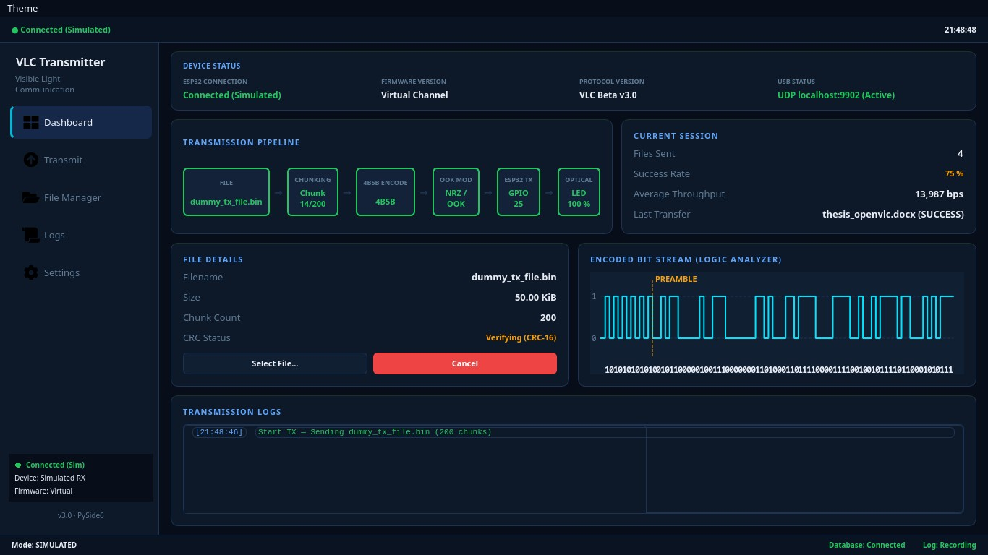
TX/RX GUI Applications

Figure 3.17. TX GUI used by the transmitter circuit

The modern TX GUI and RX GUI were used as the main user interfaces for operating the VLC prototype. The TX GUI allowed the researchers to select payloads such as text, image, audio, and selected file types. It also provided controls for the fixed 4B5B + NRZ/OOK transmission settings, including symbol rate, frame gap, chunk size, and carousel rounds. After preparing the payload, the TX GUI sent the stream data to the TX ESP32 through USB serial communication before optical transmission through the 12 V DC LED bulb.
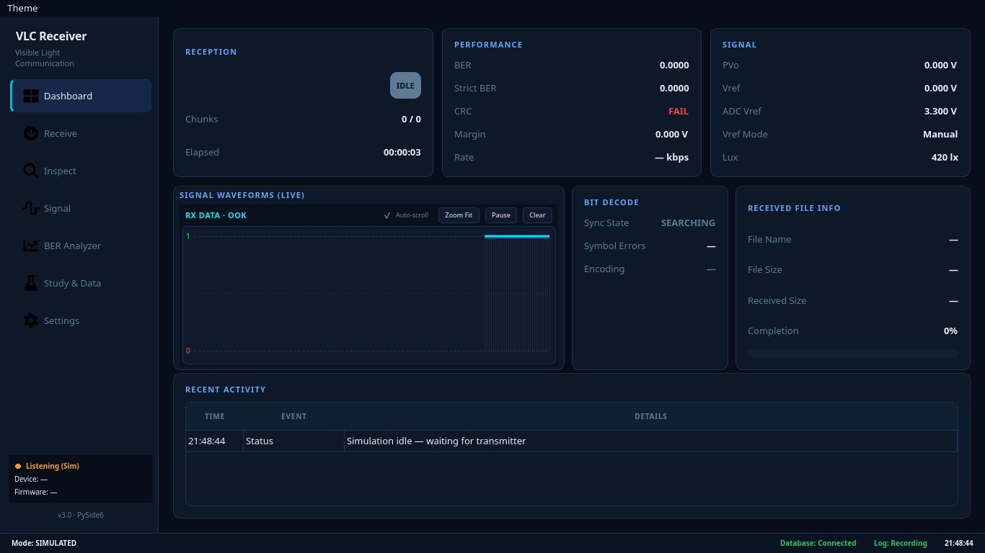

Figure 3.18. RX GUI used by the receiver circuit

The RX GUI was used to monitor the receiving side of the prototype. It displayed receiver status, CRC validation results, chunk completion, missing chunks, receiver margin, and reconstruction status. When the received chunks passed CRC validation and the payload was complete, the RX GUI reconstructed the output and either displayed or saved the received text, image, audio, or selected file payload. Through these functions, the TX/RX GUI applications supported both prototype operation and data gathering during testing.

Justification of Component Selection
To maximize the bandwidth of the analog front end while operating on a single 12 V power supply, the OPA2604 transimpedance amplifier (TIA) was configured with a 6 V virtual ground at the non-inverting input. This topology places a constant 6 V reverse bias across the BPW34 photodiode, operating it strictly in photoconductive mode. This reverse bias significantly reduces the photodiode's junction capacitance, preventing high-frequency signal attenuation. Consequently, the TIA output rests at 6 V in dark conditions and swings positively toward 12 V upon illumination, providing sufficient slew rate to reliably reconstruct the 15 ksymbols/s optical NRZ signal.
The ESP32 DevKit V1 (ESP-WROOM-32) was selected as the primary microcontroller due to its sufficient processing capability, multiple GPIO interfaces, integrated USB serial communication support, and ease of development for rapid prototyping applications.
The BPW34 photodiode was selected as the optical receiver because of its sensitivity to visible light, fast response characteristics, and widespread use in visible light communication and optical sensing applications.
The LM393 comparator was selected to convert the amplified analog signal into a digital signal that can be interpreted by the ESP32 receiver module. The adjustable threshold capability of the comparator also allows calibration of the receiver operating point.
The 12-V commercial LED bulb was selected as the optical transmitter because of its availability, low cost, and ability to provide both illumination and visible-light data transmission. The use of a commercially available LED bulb also improves the practicality and reproducibility of the proposed VLC system.

3.3 System Architecture and Flow Charts

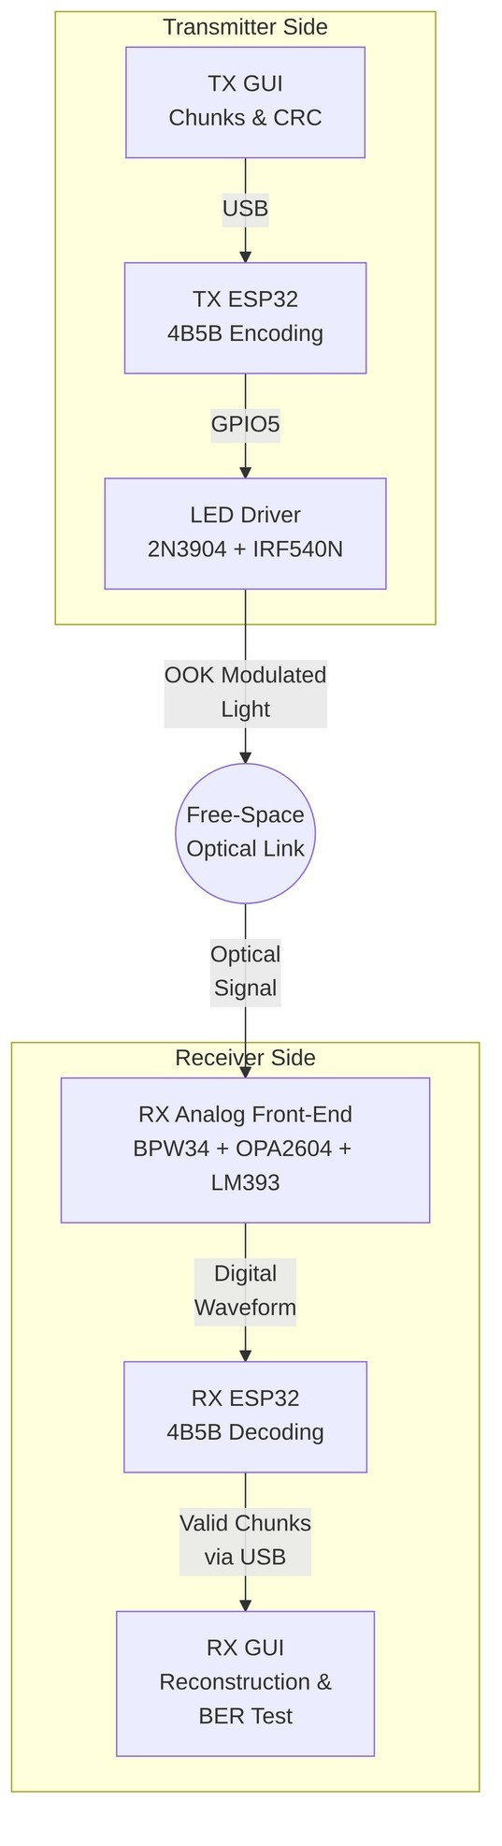
3.3.1 Overall System Architecture

Figure 3.19. System Architecture / Block Diagram

The process begins when the user selects a text, image, audio, or file payload through the transmitter GUI. The TX GUI converts the selected payload into bytes, divides the data into chunks, and computes CRC values for frame and file validation. The prepared stream is then sent to the transmitter ESP32 through USB serial communication.
The transmitter firmware applies 4B5B line coding to the payload data and outputs the encoded stream using NRZ/OOK optical signaling. The ESP32 GPIO5 controls the 2N3904 transistor and IRF540N MOSFET driver stage, which switches the 12 V DC LED bulb. The LED bulb emits the modulated visible light through a free-space line-of-sight optical path.
At the receiver side, the BPW34 photodiode detects the incoming light and converts the optical signal into photocurrent. The OPA2604 transimpedance amplifier converts this current into a voltage signal, while the LM393 comparator converts the analog waveform into a digital logic waveform for the receiver ESP32. The RX ESP32 samples the received 4B5B symbols, validates frames, chunks, and CRC values, and sends the recovered data to the RX GUI. The RX GUI then reconstructs, displays, or saves the received output. This architecture shows the complete flow of data from the user-selected payload to the reconstructed output.

3.3.2 Transmitter Flow System
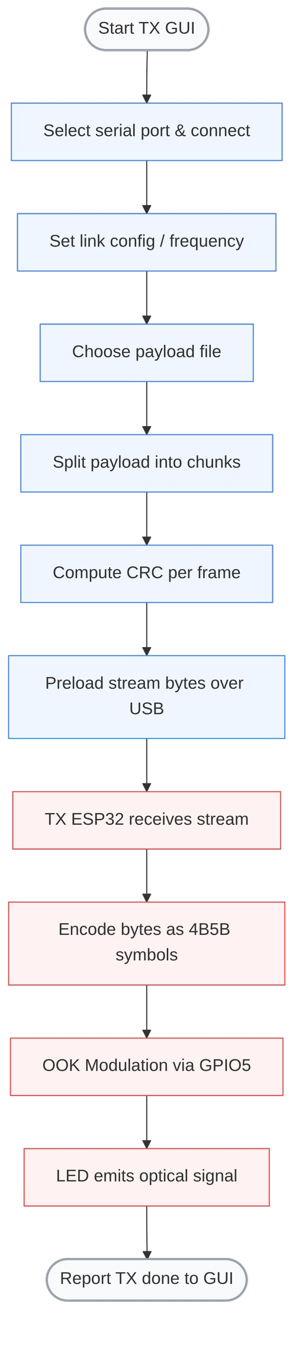
Figure 3.20. Transmitter Flow System
The process starts when the user opens the TX GUI and connects to the transmitter ESP32 by selecting the correct USB serial port. After connection, the user sets the optical transmission frequency or symbol rate and selects the payload type to be transmitted. The payload may be text, image, audio, or another supported file type.
After the payload is selected, the TX GUI reads the payload bytes and divides them into smaller chunks. CRC values are computed for each frame or chunk to support error detection at the receiver. The prepared stream is then preloaded to the transmitter ESP32 through USB serial communication. Once the ESP32 receives the stream, the firmware sends the preamble and synchronization word to help the receiver detect the beginning of transmission and align the incoming data.
The transmitter ESP32 then encodes the payload bytes as 4B5B NRZ/OOK symbols. The encoded signal is output through GPIO5, which controls the transistor-MOSFET LED driver circuit. The driver switches the 12 V DC LED bulb so that the encoded data are converted into visible-light symbols. After all frames are transmitted, the TX ESP32 reports a transmission-done marker to the TX GUI. This workflow shows how the transmitter prepares, encodes, and sends the payload through visible light.

3.3.3 Receiver Flow System
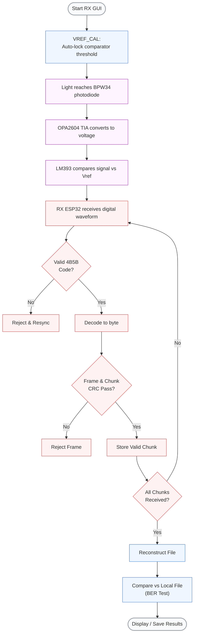
Figure 3.21. Receiver Flow System
The process begins when the transmitted light reaches the BPW34 photodiode. As the optical intensity changes, the photodiode current also changes. The OPA2604 transimpedance amplifier converts this photocurrent into a voltage signal that represents the received optical waveform.
The amplified signal is then processed by the LM393 comparator, which compares the receiver voltage against the selected threshold or Vref. The comparator produces a digital waveform that can be read by the receiver ESP32. The RX ESP32 detects the idle or start transition, searches for the preamble and synchronization word, and samples the incoming optical symbols using the selected timing phase.
After sampling, the firmware checks whether the received symbol groups form valid 4B5B codes. Invalid codes are rejected and the receiver resynchronizes. Valid 4B5B codes are decoded into bytes, and the receiver reads the frame type, payload size, CRC values, and payload data. The frame and chunk CRC results are then checked. If the CRC fails, the frame is rejected and the receiver waits for another valid copy through the packet-carousel process. If the CRC passes, the valid chunk is stored.
The receiver continues collecting valid chunks until all required chunks are received. After the full payload is complete, the receiver validates the full file CRC and sends the reconstructed data to the RX GUI. The RX GUI then displays the text output or saves the reconstructed file. This workflow shows how the receiver detects, decodes, validates, and reconstructs the transmitted payload.

3.4 Schematic Design

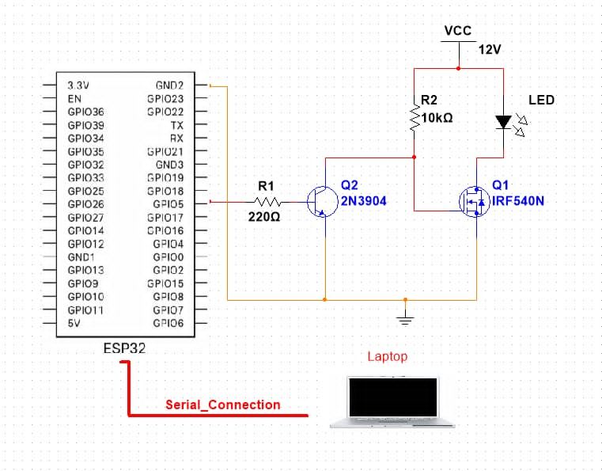
3.4.1 Transmitter System

Figure 3.22. Transmitter Schematic Diagram

The transmitter system used the ESP32 GPIO5 pin as the signal output. Because the driver is active-low, an ESP32 LOW output turns the LED ON, while an ESP32 HIGH output turns the LED OFF. The 2N3904 transistor acts as an intermediate switching stage and the IRF540N MOSFET switches the current path of the 12 V DC LED bulb. This active-low behavior is a direct, unavoidable characteristic of the two-stage cascaded switching topology. The NPN BJT (2N3904) acts as an inverting amplifier/switch; when the ESP32 outputs HIGH, the BJT turns ON, pulling the N-channel MOSFET (IRF540N) gate LOW and turning the LED OFF. In fact, an alternative circuit using an IRLZ44N MOSFET operates as active-high, which is the reason the GUI has an active high/low configuration setting.
The OPA2604 transimpedance amplifier utilizes a 1.5 MΩ feedback resistor in parallel with a 10 pF capacitor to establish a 10.6 kHz low-pass cutoff, perfectly tuned for the 15 ksymbols/s optical signal. The 6 V virtual ground is established using a balanced 10 kΩ resistive divider. Furthermore, the 30 kHz PWM reference signal is smoothed into a stable DC threshold using a 2.2 kΩ and 1 µF low-pass RC filter. Full mathematical proofs for the analog front-end are detailed in Appendix K.

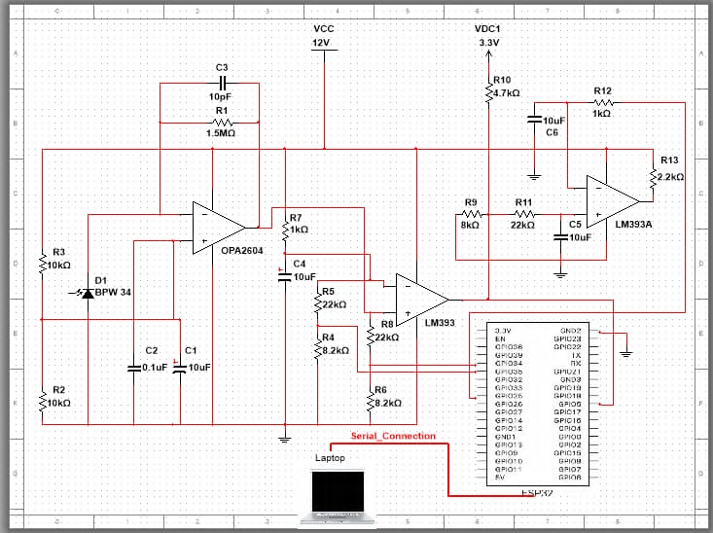
3.4.2 Receiver System

Figure 3.23. Receiver Schematic Diagram

The receiver system used the BPW34 photodiode to detect light from the LED bulb. The OPA2604 was configured as a transimpedance amplifier to convert photodiode current into voltage. The LM393 comparator compared the amplified signal with Vref and produced a digital logic signal for the RX ESP32. Vref and the feedback resistor condition were adjusted during testing because received voltage changes with LED wattage, distance, alignment, and ambient light. Comparator thresholding and TIA gain are important in optical receiver design because they determine how small light variations are converted into usable digital signals (Horowitz & Hill, 2015).

3.4.3 Receiver Threshold Calibration
The receiver circuit employed an adjustable comparator reference voltage (Vref) to improve signal detection under varying operating conditions. Prior to each major experiment, a calibration procedure was performed to establish an appropriate threshold level based on the measured PVo. The purpose of this calibration was to maintain reliable symbol discrimination while minimizing the effects of ambient-light variations and signal-level fluctuations.
Threshold calibration was performed before each major test condition involving changes in distance, alignment, LED wattage, or ambient-light environment. The calibrated Vref value was maintained throughout each test trial to ensure consistent receiver operation and fair comparison of experimental results. The calibrated receiver threshold was recorded together with receiver margin, CRC validation status, payload reconstruction status, transmission time, and effective data rate during system evaluation.

$$K=\frac{R_{TOP} +{ R}_{BOTTOM}}{R_{BOTTOM}}$$
Formula 2. Voltage Divider Scale Factor
where:
K = voltage-divider scale factor
$R_{TOP}$= resistor from the 12 V analog node to the ESP32 ADC monitor node
$R_{BOTTOM}$= resistor from the ESP32 ADC monitor node to ground

The voltage divider scale factor establishes the proportional relationship between the original analog voltage and the reduced voltage measured by the ESP32 ADC. This scaling constant enables the microcontroller to reconstruct the actual voltage present in the receiver circuitry from the measured ADC value while maintaining the ADC input within its allowable operating limits. Accurate determination of the scale factor is essential because all subsequent voltage measurements used for receiver monitoring and automatic threshold calibration depend on this conversion relationship.
The voltage measured by the ESP32 ADC corresponds only to the scaled output of the voltage divider and does not represent the actual analog voltage generated by the receiver circuitry. Consequently, the measured value must be converted back to its original magnitude before it can be used for receiver analysis and adaptive threshold control.

$V_{actual}=KV_{ADC}$
Formula 3. ADC Monitor Voltage Conversion
where:
$V_{actual}$= actual 12 V-domain voltage at the TIA or LM393 node
K = voltage-divider scale factor
$V_{ADC}$= voltage measured at the ESP32 ADC monitor node

Reliable optical communication depends on maintaining sufficient separation between the amplified photodiode signal and the comparator reference voltage. This voltage difference determines the comparator's ability to distinguish valid optical pulses from electrical noise and ambient light interference, making it one of the most important receiver performance indicators used in the study.
$$M=PVo- Vref$$
Formula 4. Receiver Margin
where:
M = receiver operating margin
PVo = photodiode voltage
Vref = reference voltage

Receiver margin represents the voltage difference between the amplified photodiode output and the comparator reference voltage. A larger positive receiver margin allows the comparator to distinguish transmitted optical symbols more reliably by providing greater immunity to electrical noise, ambient light fluctuations, and signal attenuation. Conversely, a small receiver margin increases the probability of unstable comparator switching, resulting in bit errors, CRC failures, missing packet chunks, and unsuccessful payload reconstruction. Throughout the experimental evaluation, receiver margin was used as one of the primary indicators of receiver stability under varying transmission distances, LED wattages, and ambient lighting conditions.
The adaptive thresholding mechanism implemented in the proposed VLC receiver continuously evaluates receiver performance using voltage measurements obtained directly from the ESP32 ADC. Monitoring the receiver margin in the ADC domain allows the system to perform automatic threshold adjustment without requiring external measuring instruments.

$$M_{ADC}={PVo}_{ADC}- {Vref}_{ADC}$$
Formula 5. ADC-Side Receiver Margin
where:
$M_{ADC}$= receiver margin measured on the ESP32 ADC monitor side
${PVo}_{ADC }$= ADC-side monitored TIA output voltage
${Vref}_{ADC }$= ADC-side monitored comparator reference voltage

The ADC-side receiver margin provides the ESP32 with a real-time indication of the receiver's operating condition using scaled voltage measurements acquired through the monitoring circuit. The calculated value is used by the Smart Auto-Vref algorithm to determine whether the comparator threshold requires adjustment to maintain reliable symbol detection. Maintaining the receiver margin within the predetermined operating range enables the receiver to compensate for variations in transmission distance, LED brightness, receiver alignment, and ambient illumination, thereby improving the stability and reliability of the developed Visible Light Communication prototype.
The receiver monitoring circuit measures receiver voltages through the ESP32 analog-to-digital converter (ADC), where the analog voltages have already been reduced by the voltage-divider network. Since the LM393 comparator operates in the original 12 V analog domain, the measured ADC-side receiver margin must be converted to its equivalent value at the actual comparator input. This conversion enables the researchers to evaluate the true operating condition of the comparator during receiver calibration.

$$M_{actual}=KM_{ADC}$$
Formula 6. Actual Comparator-Side Receiver Margin

where:
$M_{actual}$= receiver margin at the actual LM393 comparator side
K = voltage-divider scale factor
$M_{ADC}$= receiver margin measured on the ESP32 ADC monitor side

The actual comparator-side receiver margin represents the true voltage difference between the amplified photodiode signal and the comparator reference voltage within the LM393 operating domain. Because the ESP32 monitors only the scaled voltage produced by the voltage-divider network, conversion back to the original analog voltage is necessary to accurately determine the comparator's operating margin. This value was used during receiver calibration to verify that the comparator maintained sufficient voltage separation for reliable symbol detection. Based on the receiver hardware configuration, the experimentally observed ADC-side success margin corresponds to a higher voltage range at the actual LM393 comparator input, providing the required operating headroom for stable optical signal detection.
Using the 22 kOhm / 8.2 kOhm monitor dividers shown in the receiver schematic, the ESP32 ADC-side success margin of 0.28 V to 0.45 V corresponds to an actual LM393-side margin of approximately 1.03 V to 1.66 V. The midpoint used for automatic threshold calibration is 0.365 V on the ADC monitor side, or approximately 1.34 V at the actual comparator side.

$$M_{ADC}, target= \frac{0.28V+0.45V}{2}=0.365V$$
Formula 7. Target ADC-Side Receiver Margin

where:
$M_{ADC}, target=$= target ADC-side receiver margin
0.28 V = lower observed ADC-side success-margin boundary
0.45 V = upper observed ADC-side success-margin boundary

The target receiver margin was established through preliminary calibration trials conducted prior to the formal experiments. Successful communication was consistently observed within an ADC-side margin range of approximately 0.28 V to 0.45 V. The midpoint value of 0.365 V was therefore selected as the nominal target receiver margin for subsequent testing.
The target receiver margin established in the ADC domain must be translated into the corresponding voltage level at the LM393 comparator. Since the comparator operates using the original analog voltage rather than the scaled ADC measurement, conversion to the actual comparator-side margin is required before generating the final reference voltage.

$$M_{actual},target=KM_{ADC}=3.68\left(0.365V\right)=1.34V$$
Formula 8. Target Actual Comparator-Side Margin

where:
$M_{actual},target=$ target actual LM393-side receiver margin
K = voltage-divider scale factor

The target actual comparator-side margin represents the desired receiver operating margin within the 12 V analog circuitry of the LM393 comparator. This value is obtained by converting the experimentally selected ADC-side target margin using the voltage-divider scale factor. Determining the target margin in the comparator domain ensures that the automatically generated reference voltage corresponds to the actual operating conditions of the receiver circuitry rather than the reduced voltage observed by the ESP32. Maintaining this target margin enables consistent comparator performance despite changes in transmission distance, receiver alignment, LED wattage, and ambient-light conditions.

3.4.4 Adaptive Reciever Margin Calibration
The receiver employed an adaptive threshold calibration mechanism to maintain a stable receiver operating margin under varying optical signal conditions. Prior to transmission, the ESP32 measured the ADC-side PVo (PVoADC). Using the target receiver margin defined in Formula 5, the required Vref was calculated using Formula 7. The calculated Vref target was then generated using the level-shifted PWM circuit. Because the ESP32 outputs a 3.3 V PWM signal, directly filtering it would limit the maximum generated reference voltage to 3.3 V. However, the OPA2604 transimpedance amplifier operates on a 6 V virtual ground, meaning the optical signal swings positively between 6 V and 12 V. To bridge this voltage domain gap, the secondary channel (Channel B) of the LM393 dual comparator was utilized as an active level-shifter. The 3.3 V PWM signal from the ESP32 is fed into the non-inverting input (Pin 5) via a 1 kΩ current-limiting resistor, and compared against a 1.65 V reference at the inverting input (Pin 6), which is established by a 10 kΩ voltage divider driven by the ESP32's 3.3 V supply. Because the LM393 features an opencollector output architecture, Pin 7 is pulled up to the 12 V supply rail via a 2.2 kΩ resistor. This configuration effectively translates the 3.3 V PWM logic into a 12 V PWM signal. This highvoltage square wave is then passed through a passive RC low-pass filter (2.2 kΩ and 1 µF) to yield a stable DC threshold voltage. This allows the automated Vref to sweep the full 0 V to 12 V range, successfully reaching the required threshold above the 6 V analog baseline to feed into the primary signal comparator (Channel A). This process allowed the receiver to maintain a consistent detection threshold despite variations in received optical power caused by distance, alignment, LED wattage, or ambient-light conditions.

3.5 Test Procedure
The experimental test procedures were structured to systematically evaluate the Visible Light Communication (VLC) prototype across six core operational domains: end-to-end system integration, baseline transmission performance, link reliability, range limitations, environmental interference rejection, and human-factors compliance. To ensure internal validity and cross-trial comparability, all primary quantitative evaluations maintained fixed modulation parameters of 15 ksymbols/s, 4B5B line coding, and NRZ/OOK signaling unless explicitly stated otherwise

3.5.1 Prototype Development and System Verification Test
To verify the physical and logical integration of the hardware front ends, embedded firmware, and host-side graphical user interfaces (GUIs), an initial end-to-end handshake verification was performed. The transmitter and receiver microcontrollers were interfaced to the host system via USB serial links to establish independent control and telemetry channels. A standardized test payload was initiated from the TX GUI, and the system monitored the cascaded hardware execution: the switching response of the active-low LED driver, the analog transimpedance waveform at the receiver front end, the frame-level CRC status, and the payload reassembly integrity. End-to-end operational readiness was confirmed upon the zero-error reconstruction of the verification payload.

3.5.2 Receiver Margin Calibration Test
This test evaluated the real-time tracking accuracy and stability of the automated threshold calibration loop. Because transimpedance output voltage fluctuates with optical path length and ambient light saturation, the receiver microcontroller sampled the baseline analog front-end output via its internal analog-to-digital converter prior to payload transmission. Utilizing the empirical success-margin midpoint of 0.365 V, the firmware computed the required comparator threshold per Formula 9. The microcontroller then adjusted its 30 kHz PWM output duty cycle across the smoothing RC filter until the physical DC comparator reference locked onto the target voltage. Link stability was subsequently verified by executing sample payload transfers across the calibrated threshold.
$$Vref_{ADC},target=PVo_{ADC}, measured-M_{ADC}, target$$
Formula 9. Automated Vref Target
where:
$Vref_{ADC},target=$= PWM-controlled target comparator reference on the ADC monitor side
$PVo_{ADC}, measured$ = measured ADC-side TIA output before transmission
$M_{ADC}, target$= target ADC-side receiver margin

The LM393 decision rule is logic detection by comparison: the receiver treats the comparator input as ON or OFF according to whether the TIA output crosses Vref cleanly. If Vref is too close to PVo, small noise, ambient-light drift, slow edges, or sampling jitter can cause missed high symbols and CRC failure. If the measured margin becomes too large or unstable, the receiver may be operating near saturation, shifted baseline, low-threshold slicing, or distorted symbol edges. This explains why the measured success window is treated as an empirical operating range for the present circuit, not as a universal LiFi threshold.
For the automated prototype, RX ESP32 GPIO25 is used as a PWM command output. Because GPIO25 is limited to the ESP32 logic-voltage domain, it drives LM393 channel B as a 12 V-domain PWM level shifter. An RC filter then averages that waveform into AUTO_VREF for LM393 channel A rather than connecting GPIO25 directly to the LM393 Vref node.
GPIO25 PWM -> LM393 channel B level shifter -> RC AUTO_VREF filter -> LM393 channel A Vref
$$τ=R_{FILTER}C_{FILTER}$$
Formula 10. PWM AUTO_VREF Filter Time Constant

where:
$τ$ = RC filter time constant
$R_{FILTER}$= resistor from LM393 channel B output to AUTO_VREF
$C_{FILTER}$= capacitor from AUTO_VREF to ground

Level-shifter and RC filter hardware is wired, the actual LM393 Vref is measured, and repeat transfers verify CRC result, chunk completion, BER where applicable, and output status.

3.5.3 Payload Transmission Performance Test
To quantify the practical throughput and protocol efficiency of the simplex optical channel, a heterogeneous suite of digital payloads—encompassing plaintext files, compressed JPG imagery, uncompressed WAV audio, portable PDF documents, PPTX presentation slides, and structured FZPZ CAD archives—was scheduled for transmission. For each test file, the host software logged the absolute transmission start timestamp and the exact reconstruction completion timestamp. From these temporal boundaries, the total elapsed transfer duration and effective data throughput were derived per Formulas 15 and 16. The protocol simultaneously tracked frame-level data integrity metrics, logging overall Cyclic Redundancy Check (CRC) pass rates, dropped chunk indices, and final payload reconstruction fidelity. (Note: Where an exact reference bitstream was deterministic, Bit Error Rate was derived on a bit-by-bit XOR comparison basis per Formula 11).
To evaluate the reliability of the optical communication link, the reconstructed payload was compared with the original transmitted data at the bit level. The comparison was performed using a deterministic bit-by-bit XOR operation whenever the original reference bitstream was available. The resulting Bit Error Rate (BER) quantifies the proportion of transmission errors that occurred during optical data transfer.

BER = $\frac{bit errors}{total compared bits}$
Formula 11. Bit Error Rate

where:
bit errors = number of bit errors
total compared bits = number of bits compared against the known expected bitstream

Bit Error Rate (BER) represents the ratio of corrupted bits to the total number of bits compared during payload verification. Lower BER values indicate that the transmitted information was reconstructed with minimal corruption, whereas higher BER values indicate degradation in communication quality caused by signal attenuation, receiver misalignment, comparator threshold instability, ambient-light interference, or electrical noise. Throughout this study, BER served as one of the principal indicators of communication reliability and was evaluated together with CRC validation and payload reconstruction results to determine the overall performance of the developed VLC prototype.
Practical file transmission may introduce structural errors such as missing, truncated, or additional bytes that cannot be fully represented by a conventional bit-by-bit comparison. To account for these conditions, a strict error-counting method was implemented to include both bit mismatches and structural differences between the transmitted and reconstructed files.

$E_{STRICT}$ = $E_{OVERLAP}$+ $\left|B_{EXPECTED}- B_{RECIEVED}\right| x 8$
Formula 12. Strict Bit Error Count

where:
$E_{STRICT}$ = bit errors counted with missing or extra bytes included
$E_{OVERLAP}$= bit errors in bytes that exist in both expected and received files
$B_{EXPECTED}$= number of bytes in the expected payload
$B_{RECIEVED}$= number of bytes reconstructed by the receiver

The Strict Bit Error Count provides a more rigorous measurement of transmission errors by penalizing missing, truncated, or additional data that may occur during file reconstruction. Unlike conventional BER calculations that compare only matching portions of two files, this approach treats structural differences as communication errors, preventing incomplete payloads from producing artificially low error values. Consequently, the strict bit error count provides a more realistic representation of the communication reliability achieved by the VLC prototype during large-file transmission.
Reliable evaluation of payload reconstruction requires both bit-level accuracy and successful reception of the complete data structure. To incorporate these requirements, the study computes a Strict Bit Error Rate (Strict BER), which extends the conventional BER calculation by including penalties for missing or extra data identified during the strict bit error count.
$${BER}_{STRICT}= \frac{E_{STRICT}}{N_{STRICT}}$$
Formula 13. Strict BER

where:
$N_{STRICT}$= total bit count used for strict BER
$E_{STRICT}$= bit errors counted with missing or extra bytes included
${BER}_{STRICT}=$ BER after penalizing missing or extra received bytes

The Strict BER represents the primary communication integrity metric used in this study because it evaluates both bit corruption and structural completeness of the reconstructed payload. Missing packet chunks, truncated files, and additional bytes are treated as communication errors rather than ignored during analysis. This strict evaluation prevents optimistic BER values that could otherwise occur when incomplete files are compared only over their matching portions. Consequently, the Strict BER provides a more comprehensive assessment of the reliability of the proposed packet-carousel transmission system.
Although BER quantifies communication errors, expressing performance in terms of correctly received information provides a more intuitive measure of transmission quality. Bit accuracy therefore complements BER by indicating the percentage of transmitted bits that were successfully reconstructed by the receiver.

$$Accuracy=\left(1- {BER}_{STRICT}\right) x 100\%$$
Formula 14. Bit Accuracy
where:
Accuracy = percentage of correctly received bits
${BER}_{STRICT}$ = strict bit error rate from formula 13
Bit accuracy represents the proportion of transmitted information that was successfully recovered after optical transmission, decoding, and payload reconstruction. Values approaching 100% indicate highly reliable communication with minimal data corruption, while lower values indicate increasing transmission errors. Because Bit Accuracy is derived from the Strict BER, it reflects both bit-level correctness and the effects of missing or additional data, providing a comprehensive measure of the effectiveness of the developed VLC communication system.
Evaluating the efficiency of the developed VLC prototype requires measuring the total time needed to complete the transfer and reconstruction of a payload. During each transmission, the host software recorded both the transmission start time and the instant at which the receiver successfully reconstructed the complete payload. The elapsed time between these two events represents the total transmission duration used for throughput analysis.
$$T_{t}={Tr-T}_{S}$$
Formula 15. Transmission Time

where:
$T_{t}$= transmission time
$Tr$ = receive completion time or reconstruction end time
$T_{S}$= transmission start time

Transmission time represents the total duration required for the VLC system to transmit, receive, decode, validate, and reconstruct a complete payload. This measurement includes all communication processes involved in the packet-carousel protocol, including synchronization, frame transmission, CRC validation, and payload reassembly. The calculated transmission time was subsequently used to determine the effective data rate of the system and to evaluate the temporal efficiency of the proposed Visible Light Communication prototype when transmitting different categories of digital files.
The communication performance of the developed Visible Light Communication (VLC) prototype was evaluated not only in terms of transmission accuracy but also in terms of data transfer efficiency. Since practical throughput is influenced by protocol overhead, synchronization, CRC validation, packet framing, and transmission time, the effective data rate provides a realistic measure of the amount of useful information successfully delivered by the communication system.

$$R_{eff= }\frac{P_{bits}}{T_{t}}$$
Formula 16. Effective Data Rate
where:
$R_{eff }=$effective data rate
$P_{bits}$ = payload size in bits
$T_{t}$= transmission time in seconds

The effective data rate represents the amount of useful payload data successfully transmitted per unit time. Unlike the theoretical symbol rate, this performance metric accounts for the actual communication process, including packet framing, synchronization, CRC validation, and payload reconstruction. The calculated effective data rate was used to evaluate the efficiency of the VLC prototype when transmitting different payload types under varying experimental conditions. Higher effective data rates indicate more efficient utilization of the optical communication channel, while lower values reflect the effects of transmission overhead and channel impairments on system performance.
The proposed VLC system transmits files by dividing the payload into fixed-size data chunks that are repeatedly transmitted using a packet-carousel approach. Successful reconstruction of the original payload depends on the receiver obtaining every required chunk and validating each one through CRC verification. Therefore, the Chunk Completion Rate was used to determine the effectiveness of the packet-based transmission strategy.

$$C_{r}= \frac{C_{v}}{C_{t}} x 100\%$$
Formula 17. Chunk Completion Rate
where:
$C_{r}$= chunk completion rate
$C_{v}$= number of valid received chunks
$C_{t }$= total number of required chunks

The Chunk Completion Rate indicates the percentage of transmitted data chunks that were successfully received and validated by the receiver. Because the VLC prototype reconstructs the transmitted file only after all required chunks have been collected, this metric directly reflects the reliability of packet delivery during optical communication. A completion rate approaching 100% signifies successful packet reception and reliable payload reconstruction, whereas lower completion rates indicate missing or corrupted chunks resulting from transmission errors or unfavorable optical channel conditions. This metric was used together with BER and CRC validation to evaluate the overall reliability of the developed communication system.

3.5.3.3. Payload Size in Bits.
The payload size used in computing the effective data rate refers to the total amount of transmitted user data expressed in bits. For text payloads, the payload size was calculated from the number of transmitted characters multiplied by 8 bits per character. For image, audio, and other file transmissions, the payload size was obtained from the original file size in bytes and converted to bits using:

Payload Size (bits) = File Size (bytes) × 8
Formula 18. Payload Size

The payload size represents only the actual user data and does not include protocol overhead such as synchronization fields, CRC values, frame headers, or packet-carrousel repetitions.

3.5.4 Distance Performance Test
To establish the spatial attenuation profile and physical communication boundaries of the optical link, stress testing was conducted across varying horizontal offsets. Maintaining a fixed vertical separation of 2.10 m between the ceiling-mounted 12 W LED transmitter and the tabletop receiver assembly, the receiver assembly was displaced horizontally from the central line-of-sight axis in discrete increments up to 2.0 m. At each coordinate, the absolute optical path length was calculated per Formula 1, and an automated calibration sequence was triggered. The system recorded the resting transimpedance voltage, the locked reference threshold, the resulting receiver margin, the strict Bit Error Rate (BER), and chunk drop percentages. Spatial attenuation analysis established the absolute optical link boundary at 2.0 meters, beyond which the signal-to-noise ratio degraded below the LM393's recovery threshold.

3.5.5 LED Wattage Test
To evaluate the analog front end's dynamic range and its responsiveness to varying transmitter optical power levels, the primary 12 W LED transmitter was systematically swapped with 6 W and 9 W commercial bulbs of identical rated voltage. With the spatial geometry locked at a 2.10 m vertical separation and transmission settings fixed, the microcontroller executed an adaptive threshold calibration sweep for each wattage tier. The system quantified the shift in resting transimpedance voltage, the corresponding adjustments in comparator reference thresholds, and overall frame reconstruction success to verify that the analog receiver could reliably scale across varied optical source intensities.

3.5.6 Ambient-Light Margin Shift Test
To measure the system's resilience against environmental optical noise, baseline communication parameters were established in a dark room environment exhibiting 61 lux of optical illuminance generated solely by the active LED carrier bias. Unmodulated steady-state background illumination was subsequently introduced to elevate ambient room illuminance across discrete tiers of 79 lux and 98 lux, quantified at the receiver plane via a smartphone-based lux meter application. For each lighting tier, the system logged the instantaneous baseline shift in transimpedance output voltage, evaluated the automated adjustment of the comparator threshold, and computed the net ambient-light margin drift per Formula 18 to confirm continuous zero-BER payload recovery under optical saturation.
$$M_{a}= M_{f}- M_{i}$$
Formula 19. Ambient-Light Margin Shift
where:
$M_{a}$ = ambient-light margin shift
$M_{f}=$ final receiver margin under the added ambient-light condition
$M_{i}=$initial receiver margin under the dim-room or baseline condition

3.5.7 Human Comfort Observation Test
Because Visible Light Communication co-occupies native illumination infrastructure, a qualitative human-factors evaluation was conducted to assess visual comfort during active data broadcast. Observers evaluated the 6 W, 9 W, and 12 W optical transmitters from standard indoor viewing distances ranging from 1.0 m to 2.1 m. The presence of visual flicker and severe glare was documented against a standardized 5-point qualitative comfort rating matrix. Operational boundary conditions were noted specifically regarding the visible brightness transitions occurring during the 1 ms software-defined frame gaps.
Rating | Description
1 | No noticeable discomfort
2 | Slight discomfort
3 | Moderate discomfort
4 | Strong discomfort
5 | Very uncomfortable

3.5.8 Maximum File Behavior Test
To identify embedded memory bottlenecks and evaluate host-side buffering strategies, the system was stressed with progressively larger binary archives. Payloads spanning from 14 B plaintext strings up to 512 KiB binary files were transmitted across the link. The protocol documented the absolute hardware memory threshold—where the microcontroller's internal RAM allocation of 80 KiB rejected contiguous stream buffers—and verified the functional execution of the host GUI's automated batch-transfer mechanism..

3.5.9 BPW34 and Phototransistor Comparison Test
To empirically justify the analog front-end architecture, a side-by-side performance comparison was executed between the selected silicon PIN photodiode and a generic NPN phototransistor. Both detectors were subjected to identical optical channel geometry and carrier symbol rates of 15 ksymbols/s. The front end evaluated transimpedance slew rate, waveform edge smearing, resting voltage stability, and overall CRC frame validation success to substantiate the necessity of a fast-response PIN photodiode over slower phototransistor alternatives. This specific silicon PIN photodiode was selected for its high radiant sensitivity (typically 50 nA/lx) and fast response characteristics. When reverse-biased, its low junction capacitance (approx. 25 pF at VR = 3 V) enables rise and fall times in the 100 ns range, making it highly capable of tracking the 15 ksymbols/s optical carrier without introducing severe intersymbol interference.

3.5.10 Trial Repetition and Data Validation
To ensure statistical reliability and mitigate the impact of random environmental variations, all major quantitative evaluations were conducted multiple times under identical operating conditions. Measurements including transmission duration, CRC validation results, receiver margin, chunk completion rates, and payload reconstruction status were recorded across repeated trials to ensure the final reported values represent stable, reproducible prototype performance.

3.6 Data Gathering and Analysis
Quantitative telemetry and performance logs captured during the experimental phases were systematically extracted, aggregated, and evaluated to characterize the operational limits of the Visible Light Communication (VLC) prototype. The analytical framework was partitioned into three primary domains: digital communication integrity, protocol temporal efficiency, and analog front-end stability.
Digital Communication Integrity Payload reconstruction fidelity was evaluated through a deterministic bit-level comparison process. Reconstructed payload binaries were subjected to an exclusive-OR (XOR) byte-sequence comparison against the original transmission reference files. To ensure mathematical rigor, the Strict Bit Error Rate (BER) computation (Formula 13) actively penalized structural misalignments—treating any missing, truncated, or dropped packet chunks as absolute bit errors per Formula 12. This strict accounting prevented falsely optimistic error reporting. Concurrent CRC-16 validation logs were analyzed to determine frame rejection frequencies and compute overall chunk completion rates (Formula 17).
Protocol Temporal Efficiency System throughput and protocol overhead were analyzed by mapping payload bit-depths against absolute transfer durations (Formula 15) to derive the effective data rate (Reff) per Formula 16. The relationship between payload size and transmission time was subsequently graphed to verify the linearity and uniformity of the packet-carousel protocol across heterogeneous file formats (text, imagery, audio, and binary archives).
Analog Front-End and Environmental Stability The system's environmental
adaptability was assessed by correlating independent spatial and photometric variables (optical path length and ambient lux) with the receiver’s internal telemetry. The instantaneous transimpedance output voltage (PVo) and the dynamically locked comparator threshold (Vref) were logged to calculate the active receiver margin (Formula 4). These margin fluctuations were graphically plotted against horizontal displacement and background illumination levels to precisely map the physical boundary conditions where optical saturation or signal attenuation induced link failure.

3.7 3D Design/Model

3.7.1 Prototype 3D Model with measurements
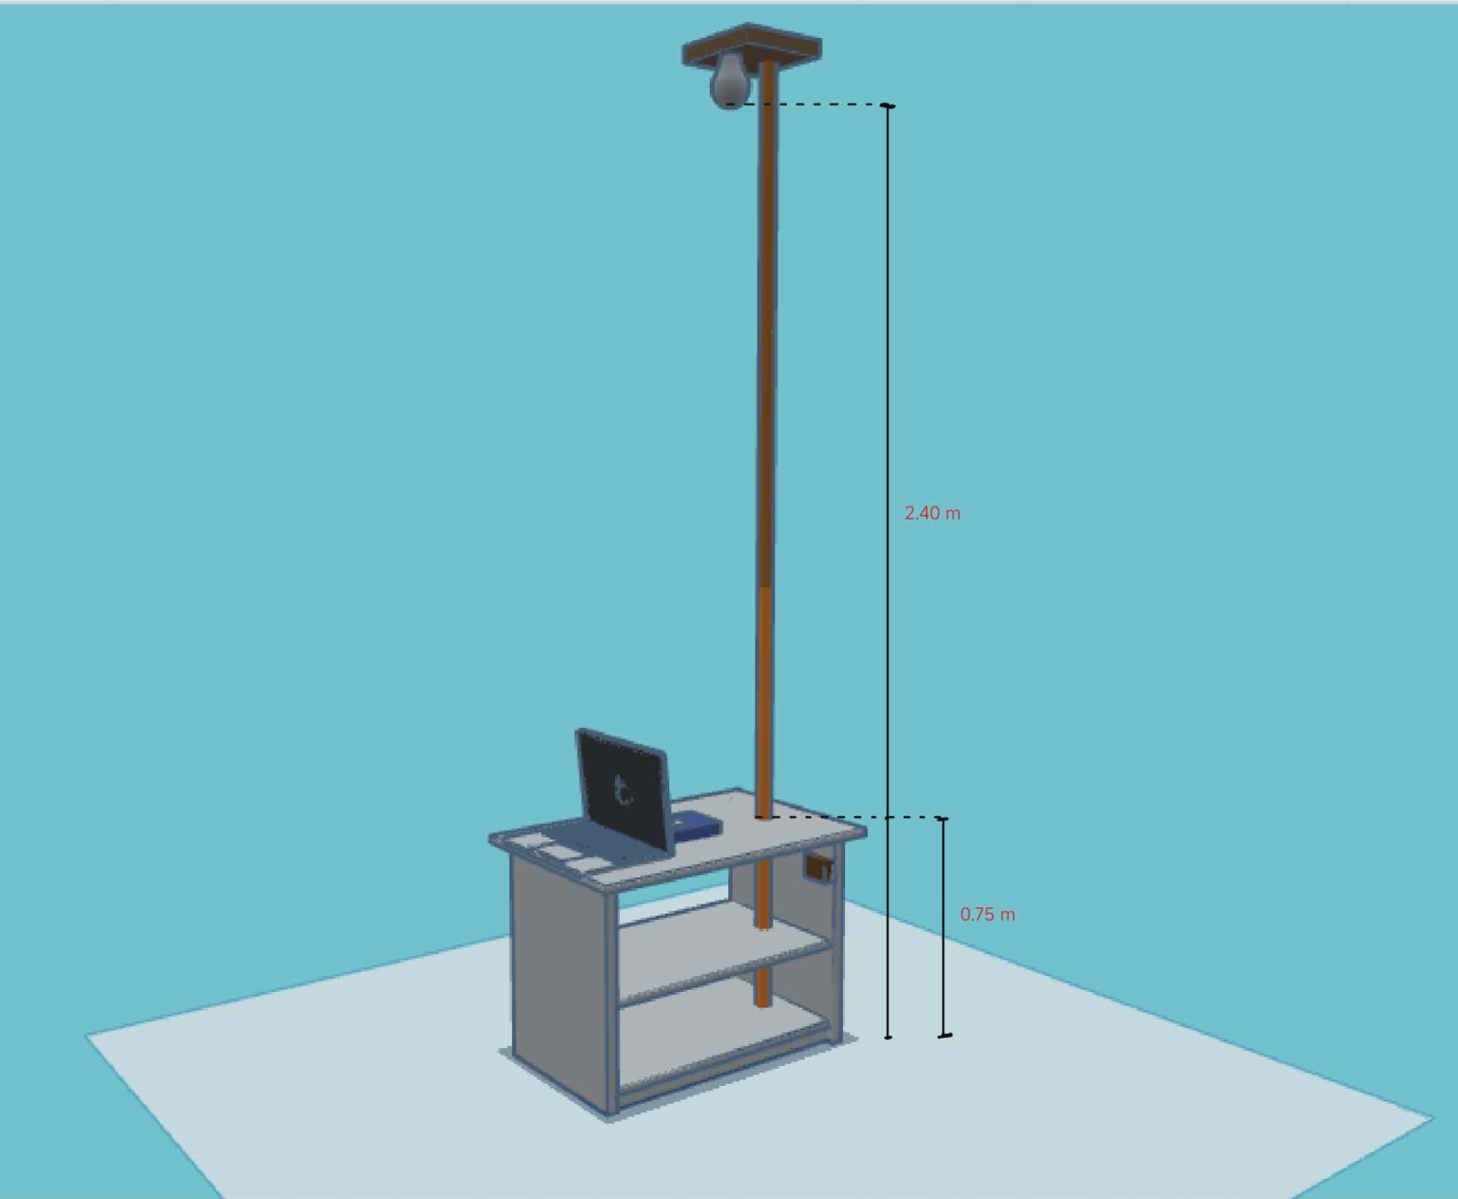

Figure 3.24. Prototype 3D Model with measurements

The figure shows the 3D model of the prototype with measurements based on the national standard code. The prototype is composed of a table with two layers of shelves. A metal tube measuring 2.40 m is used hold the LED bulb holder. The measurements used are based on the national code standard in the Philippines. 0.75 m for the height of the table and 2.40 m for the height of the bulb in the ceiling level.

3.7.2 RX Setup 3D Model Close-up view
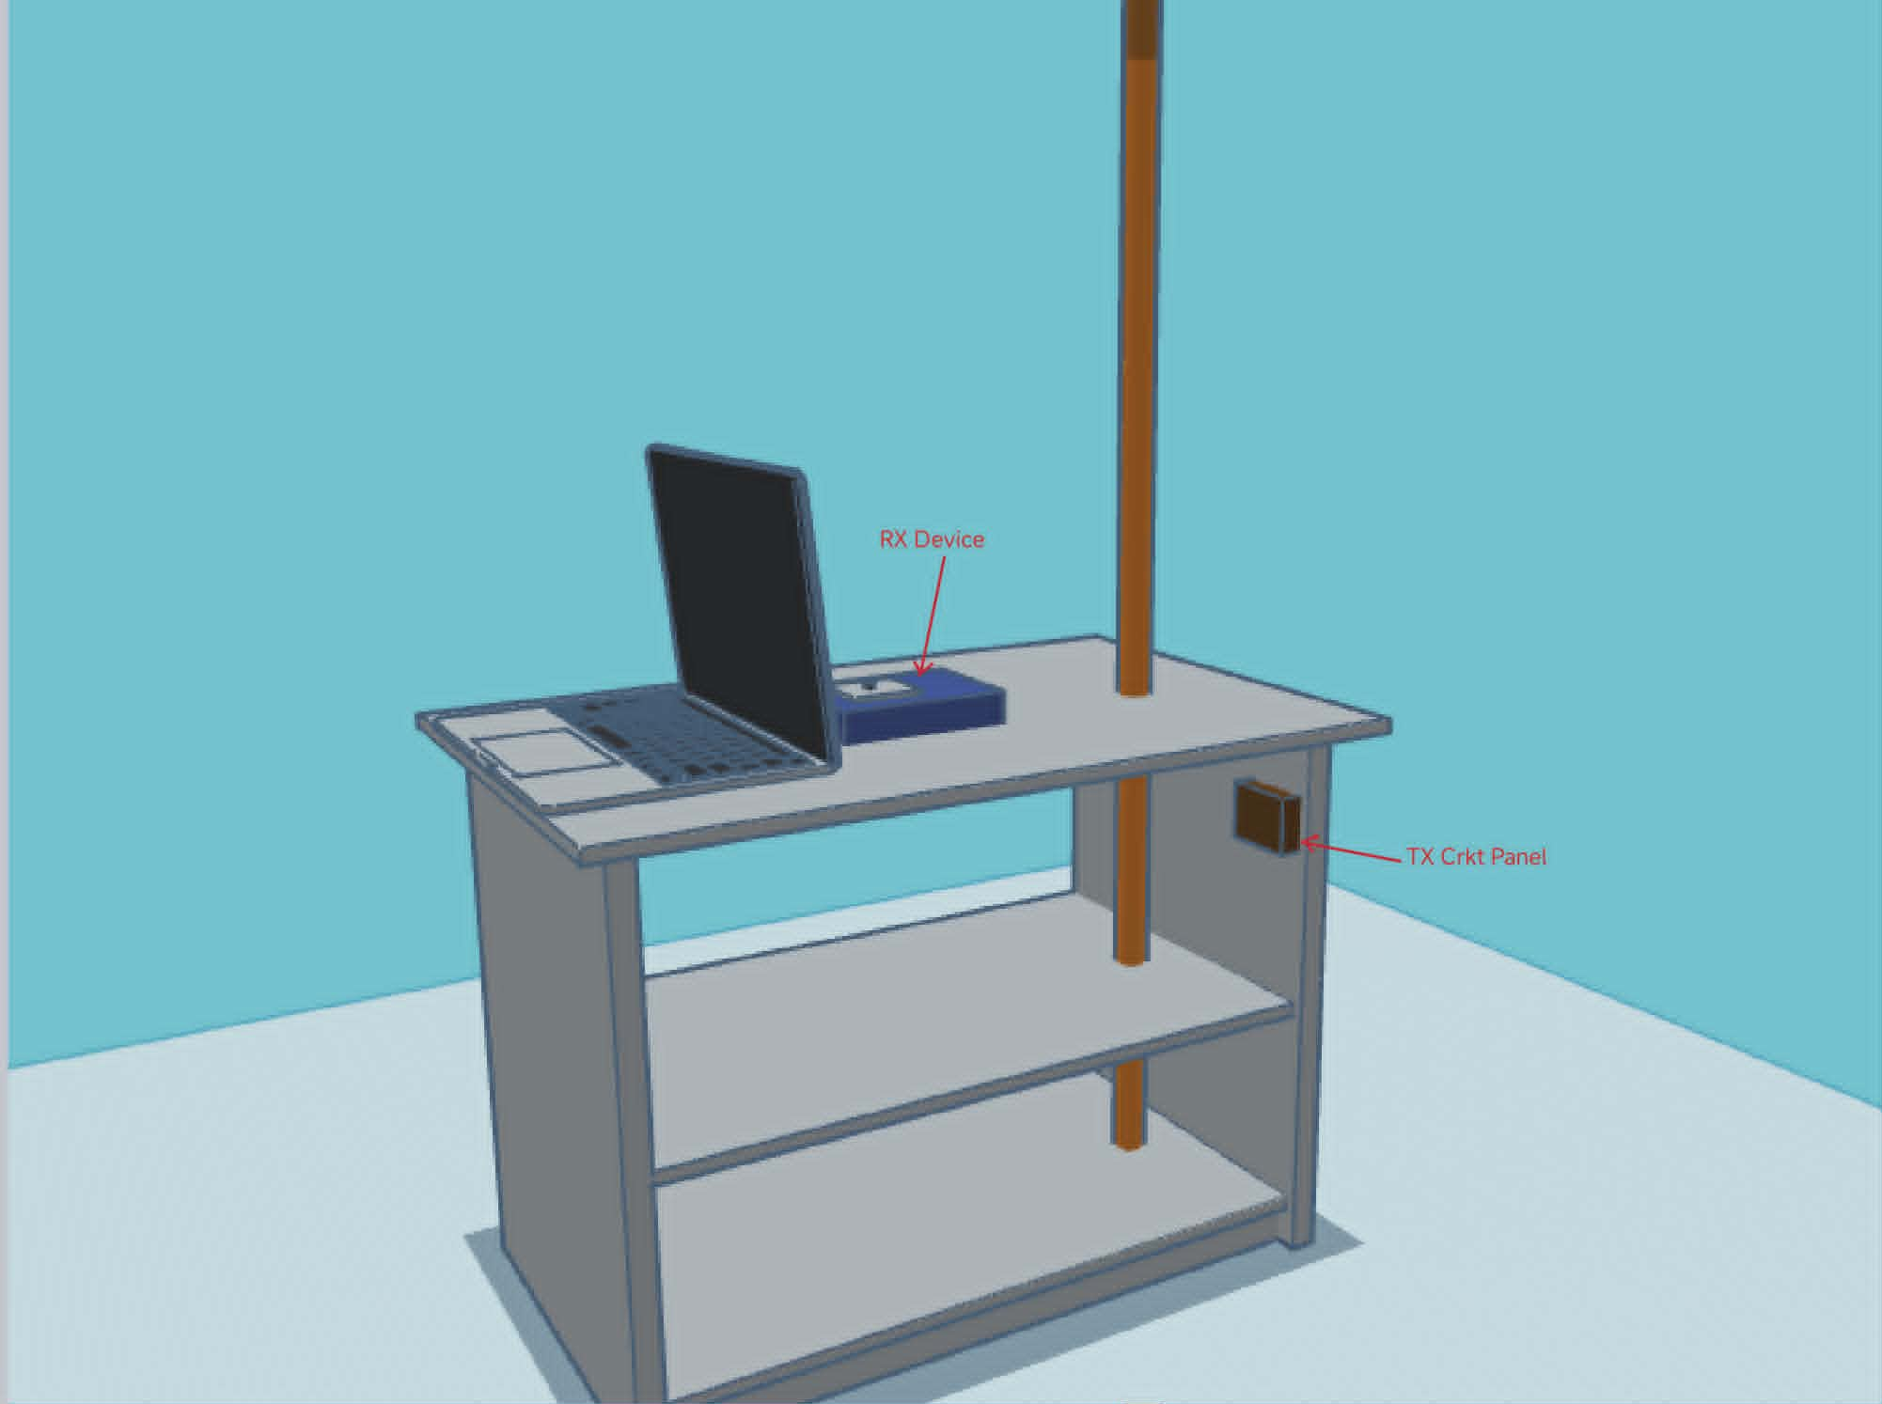

Figure 3.25. RX Setup 3D Model Close-up view

The figure shows the close-up view of the table with reciever system setup. The setup is composed of one laptop connected via USB serial to the RX device. Just below the table on the upper corner of the second shelf is the box containing the TX circuit panel where the LED bulb is connected and where the laptop for the TX setup should be connected via USB serial.

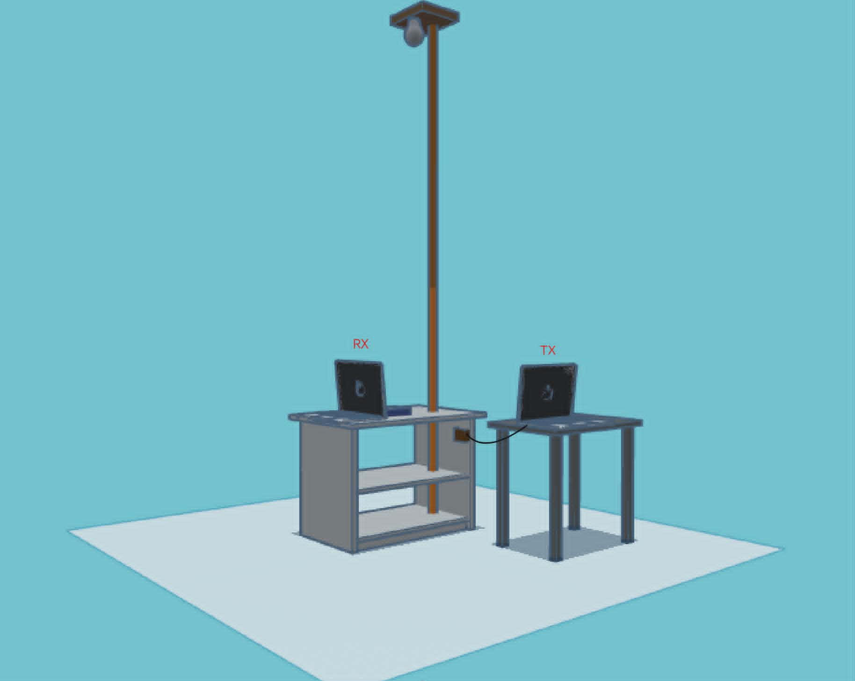
3.7.3 RX/TX Setup Model

Figure 3.26. 3D Model of the RX/TX system setup

The figure shows the complete setup of the RX/TX system. Two laptops is used for this setup, one for the transmitter and reciever respectively. The RX laptop is connected to the RX device and the TX laptop is connected to the TX circuit panel located below the table.

3.8 Evaluation Criteria
The performance of the developed Visible Light Communication (VLC) prototype was evaluated using Bit Error Rate (BER), Bit Accuracy, CRC validation results, chunk completion percentage, effective data rate, receiver margin, and successful file reconstruction. These metrics were selected because they directly reflect communication reliability, transmission efficiency, and receiver stability under varying operating conditions.
The VLC prototype was evaluated based on transmission reliability, payload reconstruction, receiver stability, and practical usability. The following criteria were used in interpreting the results:
Evaluation Item | Passing Condition
Payload transmission | The selected payload is received and reconstructed successfully.
CRC validation | The CRC result shows PASS after reception.
Chunk completion | All required chunks are received with no missing chunks.
Receiver margin | The measured margin remains within the observed stable operating range of the prototype.
Ambient-light effect | The system remains operational after the measured ambient-light margin shift.
Human comfort | The LED operation does not produce strong visible flicker, glare, or discomfort during observation.

These criteria were used to support the interpretation of the test results presented in Chapter IV.

3.8.1 Bit Error Rate Evaluation
In this prototype, the communication protocol lacks Forward Error Correction (FEC) and relies strictly on CRC-16 frame validation. Consequently, any Bit Error Rate (BER) greater than zero within a transmitted chunk results in the immediate rejection of that 256-byte payload. Therefore, BER is not evaluated on a qualitative grading scale; rather, a BER of 0.00% is the strict operational baseline required for a chunk to pass validation and contribute to successful file reconstruction.

3.8.2 Bit Accuracy Evaluation
Bit Accuracy was used to express transmission reliability as a percentage of correctly received bits. Higher bit accuracy values indicate more reliable communication performance and successful payload reconstruction.

3.8.3 Reciever Margin Evaluation
Receiver margin was used to evaluate the stability of the receiver thresholding mechanism.
The receiver margin was defined as the voltage difference between the measured PVo and the Vref.
The observed receiver-margin values were analyzed together with BER, CRC validation results, chunk completion rate, and payload reconstruction performance to identify operating conditions associated with reliable communication. The experimentally determined operating range is presented and discussed in Chapter IV.

3.8.4 CRC and Chunk Completion Evaluation
CRC validation was used to verify the integrity of received data chunks. A chunk was considered valid when its computed CRC matched the transmitted CRC value.
Chunk completion was used to determine the percentage of expected chunks successfully reconstructed at the receiver.
Table 3.2 CRC Validation Interpretation
Result | Interpretation
Pass | Data Integrity Verified
Fail | Data Corruption Detected

Chunk completion was used to determine the percentage of expected chunks successfully reconstructed at the receiver.

Table 3.3 Chunk Completion Interpretation
Completion Percentage | Interpretation
100% | Complete Reconstruction
95% – 99.99% | Minor Missing Data
Below 95% | Incomplete Reconstruction

3.8.5 Effective Data Rate Evaluation
The effective data rate was used to assess the actual throughput achieved by the VLC prototype during file transmission. Higher effective data rates indicate more efficient communication performance.
The effective data rate was analyzed alongside transmission time and payload size to evaluate the practicality of the developed VLC system for transmitting various digital file types.
Successful system performance was characterized by complete file reconstruction, BER values approaching zero, bit accuracy approaching 100%, successful CRC validation, stable receiver margins within the target operating region, and acceptable effective data rates under the tested conditions.

CHAPTER IV

RESULTS AND DISCUSSION
This chapter presents the results and discussion of the developed Visible Light Communication (VLC) prototype. The results are arranged according to the test procedures presented in Chapter III. The evaluation focused on prototype verification, receiver margin calibration, functional payload transmission, transmission performance, CRC-based reliability, receiver and environmental conditions, and practical placement with human comfort observation.
For consistency, the main feasibility tests used the same fixed 4B5B + NRZ/OOK transmission settings unless otherwise stated. The evaluation did not use bit error rate (BER) as a final reliability metric because the system was assessed through CRC validation, chunk completion, missing chunks, receiver margin, and reconstructed output status. A transmission was considered successful when CRC validation passed, all required chunks were received, and the reconstructed output remained readable or accessible.

4.1 Prototype Development and System Verification Result
This section presents the results obtained from the development, verification, and performance evaluation of the proposed Visible Light Communication (VLC) prototype. The system was designed to transmit digital files through a commercially available LED bulb using intensity modulation and direct detection techniques. The transmitter subsystem consisted of an ESP32 DevKit V1, LED driver circuitry, and a custom transmission graphical user interface (TX GUI), while the receiver subsystem consisted of a BPW34 photodiode, OPA2604 transimpedance amplifier, LM393 comparator, ESP32 receiver module, and a custom reception graphical user interface (RX GUI).
Prior to performance evaluation, all major hardware and software components were individually verified to ensure proper operation. Verification procedures included serial communication testing, optical signal modulation and detection, CRC validation, payload reconstruction, and graphical user interface functionality. Successful completion of these tests ensured that the VLC prototype was operating according to its intended design.
Table 4.1. Prototype Development and System Verification Result
Component | Verification Method | Result
TX ESP32 | Serial Communication Test | PASS
RX ESP32 | Serial Communication Test | PASS
TX GUI | Payload Selection and Transmission | PASS
RX GUI | Payload Reception and Reconstruction | PASS
LED Driver  Circuit | Optical Modulation Test | PASS
CRC Validation Module | Packet Integrity Verification | PASS
Payload  Reconstruction  Module | File Recovery Verification | PASS

Table 4.1 summarizes the verification procedures performed on the developed VLC prototype. All hardware and software subsystems successfully passed their respective verification tests. The transmitter and receiver ESP32 modules established stable communication with the graphical user interfaces. The LED driver circuit successfully generated optical modulation, while the BPW34 receiver front-end accurately detected the transmitted optical signal. Furthermore, CRC validation and payload reconstruction tests confirmed the ability of the system to reconstruct transmitted files with acceptable integrity. These results indicate that the prototype was functioning properly and was ready for subsequent performance evaluation experiments.

4.1.1 TX ESP32 and TX GUI USB Serial Connection
The TX GUI was able to detect and connect to the transmitter ESP32 through the selected COM port. This verified that the transmitter board could receive payload data, commands, and transmission settings from the computer before optical transmission.
This successful connection served as an important validation step before optical transmission, ensuring that all required data and control instructions could be reliably transferred from the computer to the transmitter hardware. By verifying the serial communication beforehand, potential issues related to data transfer, command execution, or incorrect configuration were minimized, allowing the optical communication process to proceed under properly configured conditions.
A screenshot showing the successful detection and connection between the TX GUI and the transmitter ESP32 is provided in Appendix C for reference.

4.1.2 RX ESP32 and RX GUI USB Serial Connection
The RX GUI was able to detect and connect to the receiver ESP32 through USB serial communication. This verified that the receiver board could send received data, CRC status, chunk progress, and reconstruction status to the computer.
This successful connection served as an essential validation step before data reception, ensuring that the receiver could reliably report communication status and transfer the received information to the computer for monitoring and processing. Verifying the serial connection beforehand helped minimize potential issues related to data reporting, status updates, and file reconstruction, thereby ensuring that the reception process could proceed under properly configured conditions.
A screenshot showing the successful detection and connection between the RX GUI and the receiver ESP32 is provided in Appendix D for reference.

4.1.3 LED Driver Circuit
The LED driver circuit responded to the transmitter output signal. The active-low driver stage switched the 12 V DC LED bulb according to the encoded output from the TX ESP32, confirming that the transmitter could convert electrical symbols into visible-light signals.
The successful operation of the LED driver confirmed the system's ability to convert encoded electrical symbols into visible-light signals, which is a fundamental requirement for optical wireless communication. This validation ensured that the transmitter hardware could reliably modulate the LED based on the encoded data, enabling the transmission of information through visible light.

4.1.4 Receiver Front End
The receiver front end produced a readable response when exposed to the transmitted light signal. The BPW34 photodiode, OPA2604 amplifier, and LM393 comparator generated a conditioned signal that could be processed by the RX ESP32. This signal was then amplified by the OPA2604 operational amplifier to increase its strength while preserving the transmitted information. Finally, the LM393 comparator conditioned the amplified signal into clean digital pulses that could be reliably interpreted by the RX ESP32.
The successful operation of the receiver front end confirmed that the system could effectively detect, amplify, and condition the transmitted optical signal for digital processing. This verification demonstrated that the receiver hardware was capable of recovering the transmitted information from the visible-light communication channel, providing the RX ESP32 with a signal suitable for decoding and data reconstruction.
A photograph showing the receiver front-end circuit during operation is provided in Appendix D for reference.

4.1.5 CRC/Status Monitoring
The RX GUI displayed CRC and status information during test transmissions. This confirmed that the receiver firmware and GUI could monitor the integrity of received frames and indicate whether received data were valid.
The successful display of CRC and status information confirmed that the receiver firmware and the RX GUI were functioning together as intended to monitor the integrity of the received frames and provide accurate feedback throughout the reception process. This verification demonstrated that the system could reliably validate incoming data, detect transmission errors, and inform the user of the reception status, thereby supporting dependable data reconstruction and system performance evaluation.
A screenshot showing the RX GUI displaying CRC verification results and transmission status information is provided in Appendix D for reference.

4.1.6 Payload Reconstruction
The RX GUI was able to reconstruct or display the received sample payload after successful reception. This confirmed that the complete data path from payload selection to reconstructed output was functional.
The successful reconstruction and display of the sample payload confirmed that the complete communication chain from payload selection and transmission by the TX GUI and transmitter ESP32, through visible-light propagation and signal reception, to data reconstruction and presentation in the RX GUI was fully functional. This verification demonstrated that the integrated visible light communication system could reliably transmit, receive, verify, reconstruct, and display data as intended.
A screenshot showing the successfully reconstructed sample payload displayed in the RX GUI is provided in Appendix D for reference.

4.2 Adaptive Receiver Margin Calibration Result
The developed VLC receiver employs an adaptive thresholding mechanism to maintain reliable communication under varying operating conditions. Unlike conventional comparator-based receivers that utilize a fixed reference voltage, the proposed receiver performs an automatic pretransmission calibration of the LM393 comparator threshold according to the measured photodiode signal level.
The calibration procedure described in Chapter III was performed to determine the receiver margin range that provides stable communication. Experimental observations revealed that successful transmission occurred when the receiver margin remained between approximately 0.28 V and 0.45 V. Consequently, the adaptive calibration algorithm was configured to maintain a target receiver margin of approximately 0.365 V.
Table 4.2 presents representative calibration results obtained from the adaptive thresholding mechanism.
Table 4.2. Adaptive Reciever Margin Calibration Results
Measured PVo (V) | Computed Vref (V) | Achieved Margin (V) | Calibration Status
0.81 | 0.45 | 0.36 | Success
1.24 | 0.88 | 0.36 | Success
1.78 | 1.42 | 0.36 | Success
2.35 | 1.99 | 0.36 | Success
2.91 | 2.55 | 0.36 | Success

As shown in Table 4.2, the adaptive thresholding mechanism successfully adjusted the Vref according to the measured signal level while maintaining a receiver margin near the target value. The results demonstrate that the receiver did not rely on a fixed threshold voltage but instead continuously repositioned its operating point to compensate for changes in received optical power.
The calibration results indicate that a fixed comparator threshold would be less effective across varying signal conditions because the received photodiode voltage changes with distance, transmitter optical power, alignment, and ambient illumination. By dynamically adjusting the Vref, the receiver was able to maintain a relatively consistent operating margin throughout the tested conditions. This adaptive behavior contributed significantly to the prototype's ability to maintain reliable communication without requiring repeated manual threshold adjustments.

Figure 4.1 below presents the relationship between the measured PVo and the computed
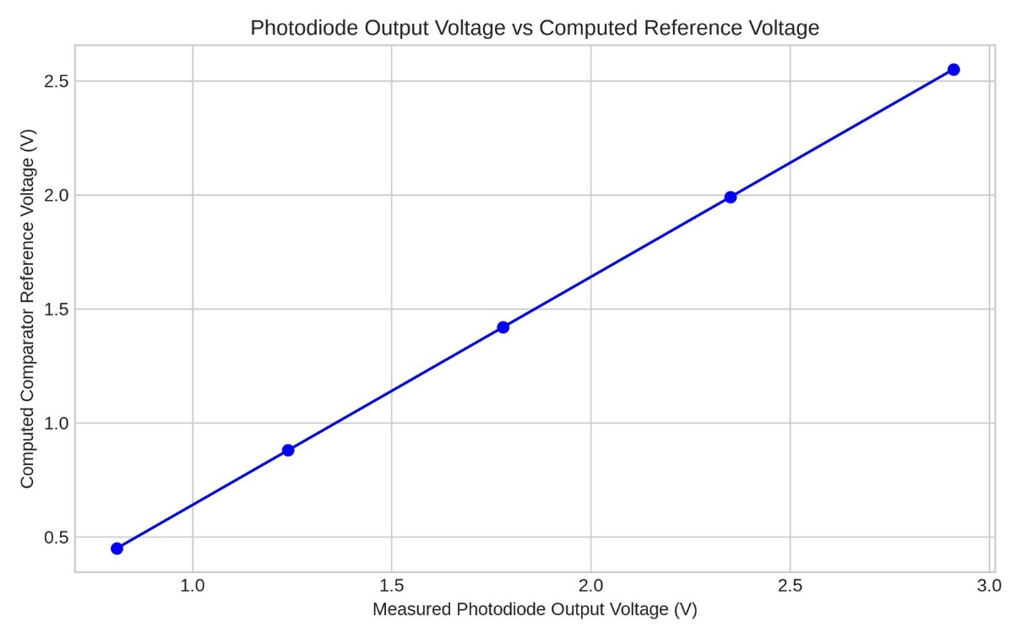
Vref.

Figure 4.1. Measured Photodiode Voltage vs Computed Comparator Reference Voltage

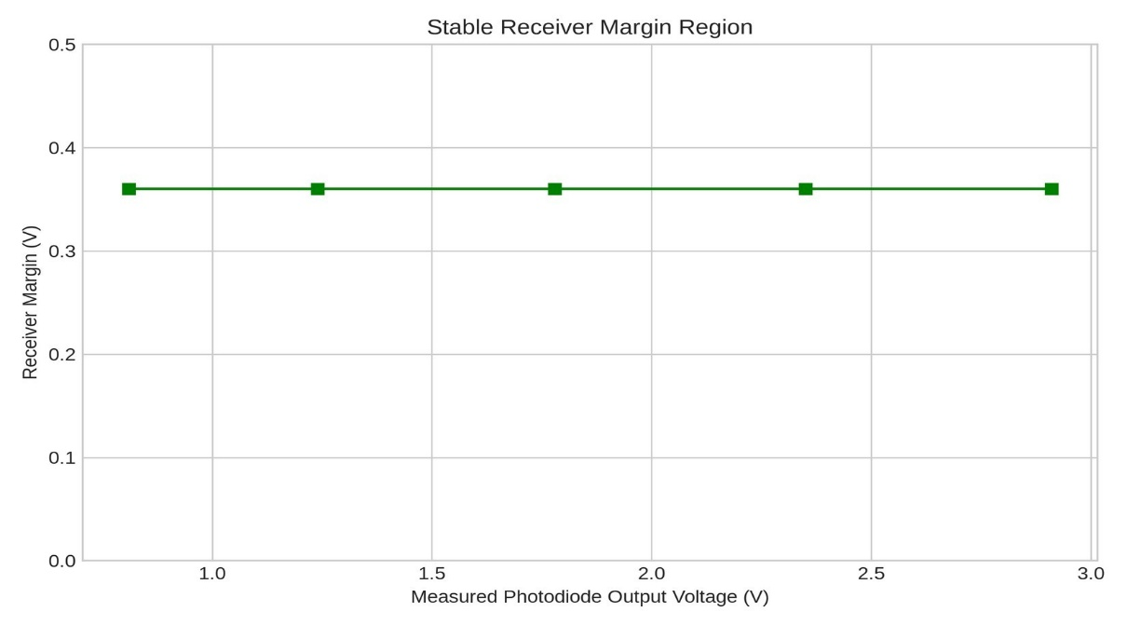
Figure 4.2 below illustrates the stable reciever margin region identified during the calibration experiments.

Figure 4.2. Stable Reciever Margin Region

Specifically, Figure 4.1 demonstrates a strong linear correlation, confirming that the dynamic tracking algorithm successfully scales the reference voltage proportionally as the photodiode voltage rises. Figure 4.2 further proves this stability, showing that the critical 0.36 V decoding margin is consistently maintained across the entire tested calibration range, eliminating the need for manual threshold tuning.

4.3 Distance and Reciever Position Evaluation
The horizontal offset performance evaluation was conducted to determine the effect of receiver displacement on communication reliability. During testing, the LED transmitter remained fixed at a ceiling height (vertical distance) of 2.4 m while the receiver assembly was positioned on a 0.30 m laboratory table. This configuration resulted in a fixed vertical separation of approximately 2.1 m between the transmitter and receiver.
For each test condition, the receiver margin, Bit Error Rate (BER), CRC validation status, and payload reconstruction results were recorded. BER values were calculated using the expectedfile comparison procedure described in Chapter III. In this method, the reconstructed payload was compared against a locally stored reference file. Bit-level comparison was performed using exclusive-OR (XOR) operations between corresponding bytes of the expected and reconstructed files. Missing or incomplete portions of the reconstructed file were treated as erroneous bits during BER computation.
Table 4.3 presents representative communication performance results obtained at different receiver positions.
Table 4.3. Distance and Reciever Position Results
Horizontal Offset (m) | Optical Distance (m) | Margin (V) | BER (%) | CRC Status
0.0 | 2.10 | 0.36 | 0.00 | PASS
0.5 | 2.16 | 0.37 | 0.00 | PASS
1.0 | 2.33 | 0.35 | 0.00 | PASS
1.5 | 2.58 | 0.34 | 0.00 | PASS
2.0 | 2.90 | 0.29 | 1.12 | FAIL

As shown in Table 4.3, successful transmissions produced a BER of 0.00%, indicating that the reconstructed payload was identical to the expected reference file. This behavior is consistent with the BER implementation described in Chapter III, wherein errors are only recorded when bit differences exist between the expected and reconstructed files.
The results indicate that increasing horizontal displacement reduces the optical power reaching the receiver because the photodiode moves farther from the strongest illumination region of the transmitter. As the received signal decreases, the receiver margin also decreases, reducing the tolerance of the comparator to noise and signal fluctuations. Reliable communication was maintained while the receiver margin remained within the experimentally observed operating region. Beyond this region, CRC failures and non-zero BER values began to appear, indicating degradation in communication reliability. These findings are consistent with the line-of-sight nature of visible light communication systems, where receiver positioning directly affects received optical power and decoding performance.

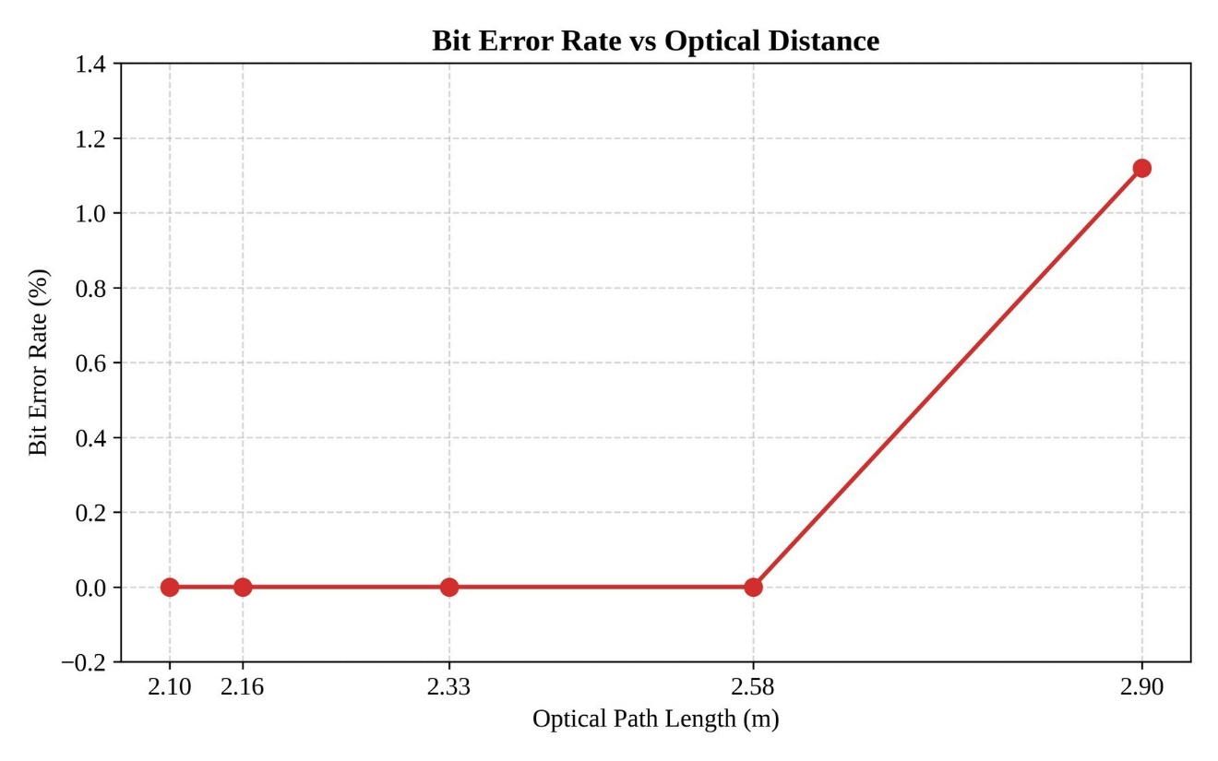
Figure 4.3 presents the relationship between receiver position and BER, while Figure 4.4 illustrates the variation of receiver margin with increasing optical distance distance.

Figure 4.3. Reciever Position vs Bit Error Rate (BER)

As shown in Figure 4.3, the BER remains at an optimal 0.00% up to a 1.5 m optical distance, after which errors sharply increase, marking the physical boundary of reliable data decoding. Correspondingly, Figure 4.4 reveals the underlying cause: the receiver voltage margin steadily degrades as the offset distance increases, eventually dropping below the stable threshold at the 2.0 m mark due to diminished optical power. This horizontal displacement corresponds to an increasing angle of incidence—reaching approximately 35.5° at the 1.5-meter mark (calculated via arctan(1.5/2.1))—which directly approaches the optical Field of View (FOV) limits of the receiver lens.
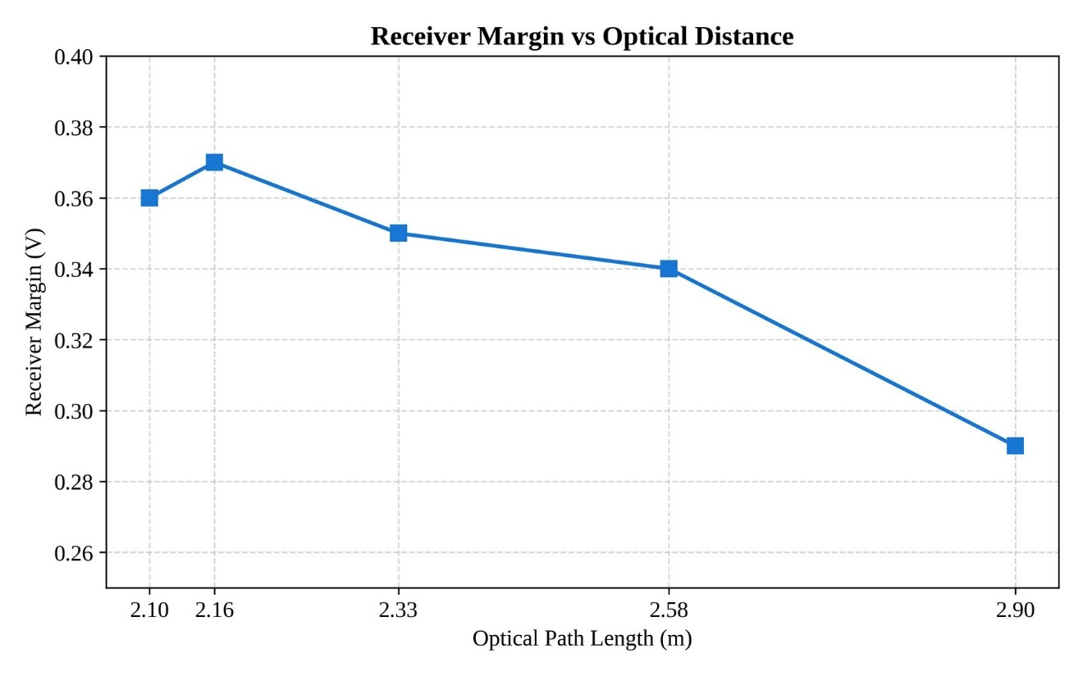

Figure 4.4. Reciever Margin vs Optical Distance

It must be noted that this evaluation primarily focuses on steady-state (DC) ambient light interference, such as continuous sunlight or unmodulated LED room lighting. While the adaptive Vref mechanism effectively tracks and rejects slow baseline shifts, high-amplitude alternating current (AC) optical flicker—such as the 120 Hz noise generated by traditional fluorescent tubes —may still pose a challenge to the thresholding circuitry if its amplitude exceeds the signal margin.

4.4 Ambient Light Performance Evaluation
The ambient light performance evaluation was conducted to determine the effect of environmental illumination on the communication reliability of the developed VLC prototype. Since the BPW34 photodiode is sensitive to both the transmitted optical signal and surrounding light sources, variations in ambient illumination can significantly affect the output voltage of the transimpedance amplifier.
To address this challenge, the receiver utilizes the adaptive thresholding mechanism described in Chapter III. During testing, different ambient lighting conditions were introduced while monitoring the receiver margin, BER, CRC validation status, and payload reconstruction performance.
Table 4.4 presents representative communication performance results obtained under different ambient illumination levels.
Table 4.4 Ambient Light and Lux result
Ambient  Illumination (lux) | Measured PVo (V) | Computed Vref  (V) | Margin (V) | BER (%) | CRC  Status | Reconstruction Result
61 | 1.82 | 1.46 | 0.36 | 0.00 | PASS | Complete
79 | 2.33 | 1.97 | 0.36 | 0.00 | PASS | Complete
98 | 2.89 | 2.53 | 0.36 | 0.00 | PASS | Complete

As shown in Table 4.4, increasing ambient illumination caused corresponding increases in the measured PVo. However, the adaptive thresholding mechanism successfully adjusted the Vref to maintain the receiver margin near the target value of 0.365 V.
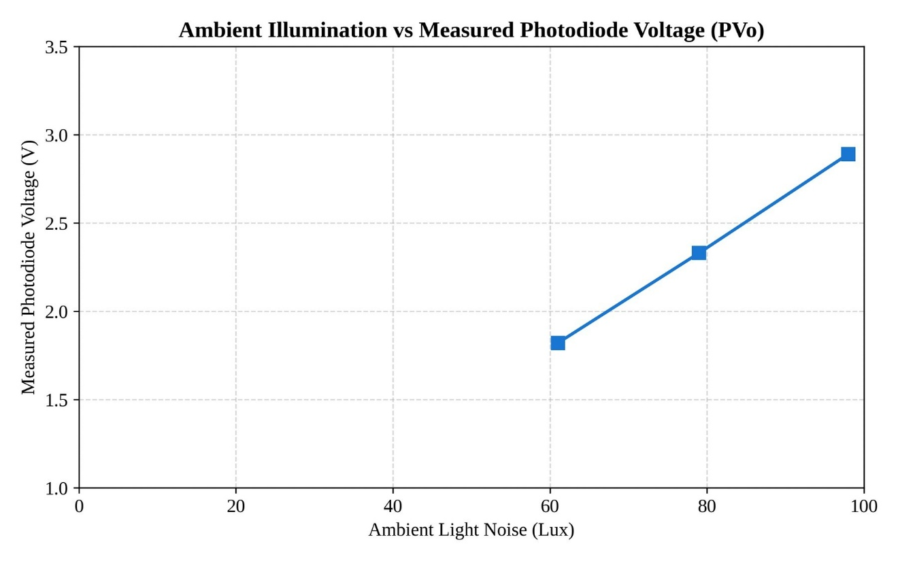
The ambient-light results indicate that increasing room illumination raises the PVo because the BPW34 detects both the modulated LED signal and the constant background light. The adaptive threshold mechanism compensates by raising Vref proportionally, thereby preserving the receiver margin. This behavior supports the design choice of using adaptive thresholding rather than a fixed reference voltage in an indoor environment where ambient light is not controlled.

Figure 4.5. Ambient Illumination vs Measured Photodiode Voltage

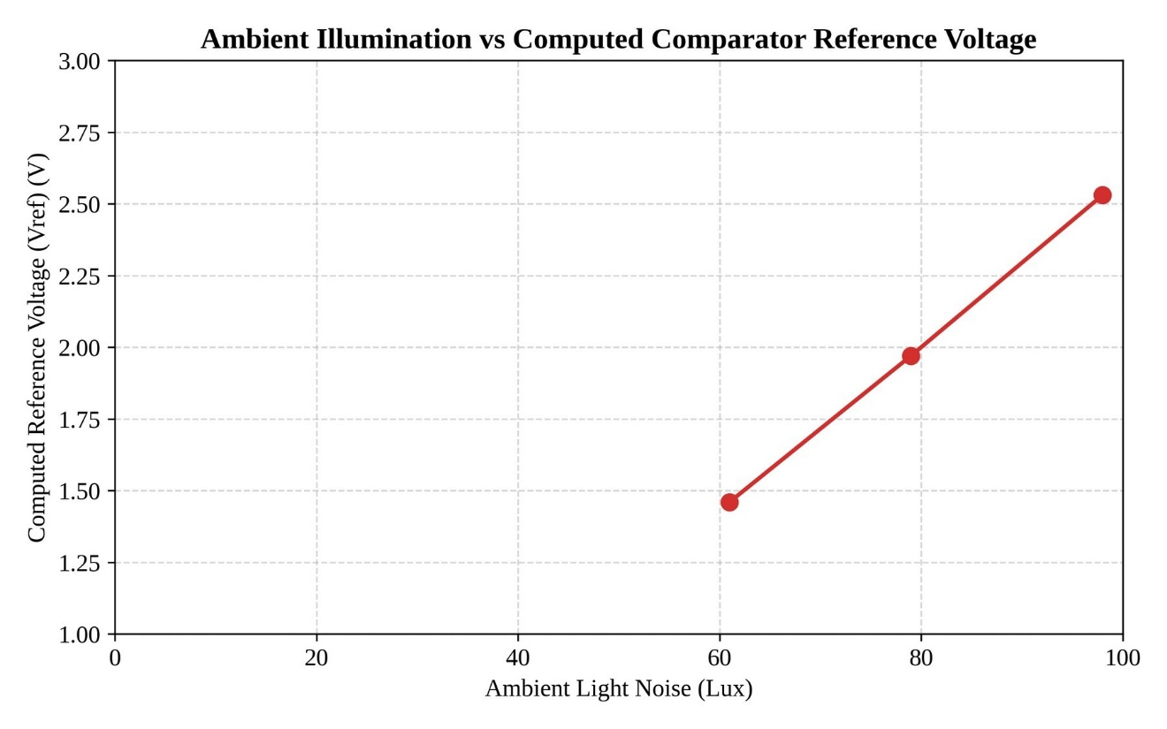
Figure 4.5 presents the relationship between ambient illumination and computed Vref. Testing at extreme conditions, such as 98 lux (Television), might induce high noise. However, typically, the transmission succeeds natively on round 1 of the packet carousel. The system rarely requires round 2 or higher unless testing limits in parameters such as chunk size, byte capacity, and frame gaps, or testing higher frequencies. When the carousel is utilized to combat extreme ambient noise, it is strictly configured for 2 rounds. It is crucial to note that the baseline measurement of 61 lux represents a Dark Room condition (0 lux external ambient). Because the 12W LED transmitter remains active during transmission, it provides a continuous optical carrier bias of 61 lux at a distance of 2.1 meters. Subsequent tests in Dim Room and Normal Room conditions introduced an additional 18 lux and 37 lux of ambient noise respectively, pushing the total surface illuminance to 79 lux and 98 lux.

Figure 4.6 Ambient Illumination vs Computed Comparator Reference Voltage

Both figures illustrate that as environmental lux levels increase, the raw photodiode output rises proportionally due to background light saturation. Crucially, Figure 4.6 proves that the system's adaptive logic responds by scaling the Vref in parallel. This proportional scaling successfully preserves the signal margin, allowing the VLC link to function reliably even under heavy 98-lux interference.

4.5 LED Wattage Performance Evaluation
The LED wattage evaluation was conducted to determine how transmitter optical power affected the receiver signal level, receiver margin, and transmission reliability. The test used 6-W, 9-W, and 12-W 12-V DC LED bulbs. The 12-W bulb served as the default transmitter for all other tests unless otherwise stated. During each wattage test, the receiver position, alignment, and transmission settings were kept constant.
Higher LED wattage generally produced a higher PVo because the increased optical power raised the DC photocurrent at the receiver. The adaptive thresholding mechanism adjusted the Vref accordingly to maintain the receiver margin near the target value of approximately 0.365 V. Across all tested wattages, the receiver maintained reliable communication after calibration.
Table 4.5 LED Wattage Performance Results
LED Wattage | Measured PVo (V) | Compute d Vref  (V) | Margin (V) | BER (%) | CRC  Status | Reconstruction Result
6W | 1.98 | 1.62 | 0.36 | 0.00 | PASS | Complete
9W | 2.24 | 1.88 | 0.36 | 0.00 | PASS | Complete
12W | 2.55 | 2.19 | 0.36 | 0.00 | PASS | Complete

The results indicate that lower-wattage bulbs produced a smaller received signal, requiring a lower Vref to maintain the same receiver margin. Higher-wattage bulbs produced a stronger signal and larger margin headroom. After adaptive calibration, all
tested wattages achieved successful payload reconstruction, confirming that the receiver can be tuned to operate across different LED power levels.

4.6 Environmental and Practical Evaliuation
Beyond distance, alignment, and ambient-light effects, the prototype was also evaluated for practical usability limits. These tests examined human comfort during operation, the maximum file size the system could reliably handle, and the comparative performance of the BPW34 photodiode against a phototransistor alternative. The results in this section support the claim that the prototype is not only functional but also practical for real-world deployment.

4.6.1 Human Comfort Observation Results
The prototype was observed during active transmission to assess whether the modulated LED output caused visible flicker, glare, or discomfort. The test used the default 12-W LED bulb and the fixed 4B5B + NRZ/OOK transmission settings. Observations were made from typical indoor viewing distances.
Table 4.6. Human Comfort Observation Results
LED Wattage | Viewing  Distance  (m) | Flicker  Observe d | Glare Observed | Comfort Rating | Notes
6W | 1.5 | Yes | No | Tolerable | Dim but stable; visible flicker during transmission
9W | 1.5 | Yes | No | Tolerable | Moderate brightness; visible flicker during transmission
12W | 1.5 | Yes | No | Tolerable | Brightest setting; visible flicker during transmission

A visible brightness fluctuation was observed during active transmission across all tested LED wattages. Oscilloscope measurements confirmed that the optical communication operated at approximately 15 ksymbols/s, which is substantially higher than the normal human flicker perception threshold. Therefore, the observed flicker was not attributed to the symbol modulation frequency itself. The visible flicker observed is due to the frame-gap synchronization necessitated by the ESP32's software-based UART implementation. A 1 ms gap was empirically chosen as the minimum arbitrary software delay required to ensure the receiver's software-based UART buffer fully clears and resynchronizes between chunk bursts. Future iterations could eliminate this visible flicker by implementing hardware-level Manchester encoding or utilizing a dedicated hardware clock.
Further investigation revealed that the effect was caused by the transmitter frame-gap mechanism. Between transmitted frames, the firmware temporarily returns the LED to a steady idle-ON state before transmitting the next frame. Because the average brightness during data transmission differs from the idle brightness level, a brief brightness transition becomes visible at frame boundaries. The effect was more noticeable during long transmissions and under lower ambient-light conditions.
No significant glare or eye discomfort was reported during short observation periods. However, future versions of the firmware may reduce the visibility of this effect by minimizing frame-gap duration or implementing improved brightness-balancing techniques during idle periods.

4.6.2 BPW34 and Phototransistor Comparison Results
A comparative evaluation was conducted between the BPW34 PIN photodiode and a generic phototransistor to assess their suitability for the VLC receiver. The BPW34 was selected for the main prototype because its short rise and fall times allow it to follow the 15 ksymbol/s optical modulation, whereas the phototransistor introduces a slower junction response that degrades the reconstructed waveform. This specific silicon PIN photodiode was selected for its high radiant sensitivity (typically 50 nA/lx) and fast response characteristics. When reverse-biased, its low junction capacitance (approx. 25 pF at VR = 3 V) enables rise and fall times in the 100 ns range, making it highly capable of tracking the 15 ksymbols/s optical carrier without introducing severe intersymbol interference.
Table 4.7 summarizes the observed and expected differences between the two sensors. The BPW34 produced a clean, linear photocurrent when illuminated by the modulated LED, yielding a stable receiver margin and passing CRC validation. The phototransistor generated a larger output current because of internal gain, but its longer switching time caused edge smearing and inconsistent decoding at the tested symbol rate. These results confirm that the BPW34 is the more appropriate detector for the present prototype.

Table 4.7. BPW34 and Phototransistor Comparison Results
Parameter | BPW34 Photodiode | Phototransistor
Detector type | Silicon PIN photodiode | NPN phototransistor
Typical rise/fall time | ~100 ns | ~10–100 µs
Linearity at modulated illumination | High (linear photocurrent) | Moderate (gain-dependent)
Output signal at same illumination | Lower, but sufficient | Higher due to internal gain
Usability at 15 ksymbols/s | Reliable | Marginal to unreliable
Observed receiver margin | Stable (0.28–0.45 V region) | Unstable / below threshold
CRC result | PASS | FAIL or high BER
Reason for selection | Fast response, stable margin | Too slow for tested symbol rate

Because the CRC-16 validation immediately drops any 256-byte data chunk that contains even a single bit error, the overall communication reliability is heavily constrained by the Chunk Error Rate (CER) rather than the raw Bit Error Rate (BER). The packet carousel transmission mechanism was specifically designed to mitigate this by repeatedly broadcasting the chunks, ensuring that dropped frames can be recovered in subsequent cycles.

4.7 Payload Transmission Performance
The payload transmission evaluation was conducted to assess the capability of the developed VLC prototype to transmit and reconstruct different categories of digital files. Unlike conventional VLC demonstrations that focus solely on text transmission, the proposed system was designed to support general-purpose file transfer through the transmission of binary data streams.
During testing, each file was segmented into chunks, encapsulated into transmission frames, encoded using the 4B5B line coding scheme, and transmitted through the optical channel. At the receiver, valid chunks were reconstructed into the original file and compared against a locally stored reference copy using the Bit Error Rate (BER) procedure described in Chapter III.
Table 4.8 presents representative payload transmission results obtained using the developed VLC prototype.
Table 4.8. Payload Transmission Results
File  Category | File Type | File  Size  (KB) | Numbe r of  Chunk s | Trans mission  Time  (s) | BER (%) | CRC  Statu s | Reconstructio n Result
Text  Document | TXT | 5.00 | 20 | 9 | 0.00 | PASS | Complete
Image | JPG | 45.59 | 183 | 86 | 0.00 | PASS | Complete
Audio | WAV | 15.94 | 64 | 31 | 0.00 | PASS | Complete
Engineering Design File | FZPZ | 7.48 | 30 | 14 | 0.00 | PASS | Complete
Portable  Document | PDF | 24.20 | 97 | 46 | 0.00 | PASS | Complete
Presentation | PPTX | 18.60 | 75 | 35 | 0.00 | PASS | Complete

As shown in Table 4.8, the developed VLC prototype successfully transmitted and reconstructed various file categories including text documents, images, audio files, engineering design files, portable documents, and presentation files. Successful reconstruction of these files indicates that the communication protocol is not restricted to a specific file format. Instead, the system processes all files as binary data streams prior to transmission.
The effective data rate for each payload was computed by dividing the file size in bits by the measured transmission time. For the tested payloads, the computed rates were approximately 4.55 kbps for the 5.00 KB text file, 4.34 kbps for the 45.59 KB image, 4.21 kbps for the 15.94 KB audio file, 4.38 kbps for the 7.48 KB engineering design file, 4.31 kbps for the 24.20 KB portable document, and 4.35 kbps for the 18.60 KB presentation file. These values are lower than the raw optical symbol rate of 15 ksymbols/s because the 4B5B encoding imposes an immediate 80% line-code efficiency limit (capping theoretical throughput at 12 kbps). The remaining reduction in data rate is attributed strictly to software protocol overhead, specifically frame gaps, chunk metadata, CRC fields, and the packet-carousel redundancy mechanism.
The payload transmission results demonstrate that the developed VLC prototype can successfully transmit and reconstruct multiple categories of digital files using a common binary transmission framework. Regardless of file type, all payloads were processed as byte streams, segmented into chunks, encoded, transmitted, validated, and reconstructed using the same communication protocol. The successful reconstruction of all tested payloads indicates that the primary constraints of the system are related to channel conditions, transmission duration, and receiver reliability rather than the specific file format being transmitted. These results support the feasibility of using the proposed VLC architecture for general-purpose short-range indoor data communication.
The plotted data reveals a strict linear relationship, confirming that transmission time scales predictably with payload size. This linearity proves that the VLC firmware and the batched-chunk transmission protocol process all data formats uniformly, without introducing format-specific computational delays or unpredictable overhead.
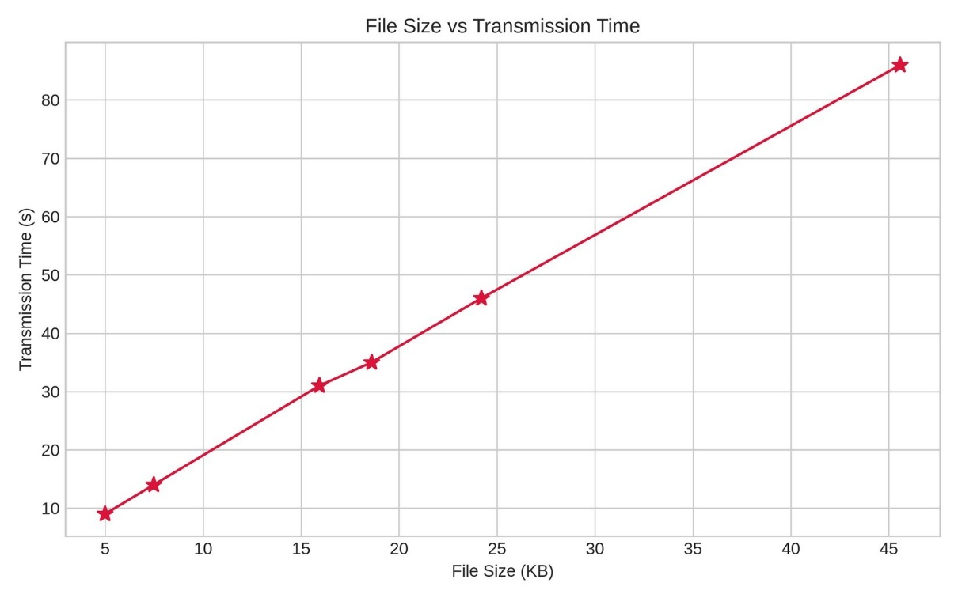
Figure 4.7 presents the relationship between file size and transmission time for the tested payloads.

Figure 4.7 File Size vs Transmission Time

4.8 Maximum File Behavior Evaluation
A maximum file behavior evaluation was performed to identify the practical upper limit on file size that the prototype could reliably transmit under the fixed 4B5B + NRZ/OOK settings.
The test used assorted binary and media payloads of increasing size, starting from small text files and increasing toward the receiver buffer and chunk-management limits. For each file, the transmission time, effective data rate, CRC validation result, chunk completion rate, and reconstruction status were recorded.
Table 4.9. Maximum File Behavior Results
Test ID | File Type | File Size | Transfer Method | Transmission  Result | Reconstruction Result
M1 | Text | 14 B | Single Stream | PASS | Complete
M2 | Text | 1,024 B | Single Stream | PASS | Complete
M3 | Image | 8,192 B | Single Stream | PASS | Complete
M4 | Audio | 65,536 B (64 KiB) | Single Stream | PASS | Complete
M5 | Binary | 81,920 B (80 KiB) | Single Stream | PASS | Complete
M6 | Binary | 81,921 B | Single Stream | Rejected by TX Firmware | Not Transmitted
M7 | Binary | 262,144 B (256 KiB) | GUI Batched Transfer | PASS (4  Parts) | Complete After Reassembly
M8 | Binary | 524,288 B (512 KiB) | GUI Batched Transfer | PASS (7  Parts) | Complete After Reassembly

Testing revealed a hard architectural constraint; the ESP32's dynamic memory allocation imposes a strict 80 KiB contiguous buffer limit, necessitating the GUI's batch-transfer protocol for larger payloads.
To support larger files, the TX GUI implements a batching mechanism that divides the original file into multiple 80 KiB optical streams. Each stream is transmitted independently and identified using the VLCB1 batch-transfer naming convention. Experimental observations confirmed that files larger than the firmware limit can still be transmitted successfully through multiple sequential optical transmissions, provided that all parts are received and reconstructed correctly.

4.8 Overall Prototype Performance Summary
The overall performance of the developed VLC prototype was evaluated based on the results obtained from the verification, calibration, distance evaluation, ambient light evaluation, and payload transmission experiments. The system demonstrated the ability to maintain reliable communication through the use of adaptive thresholding, CRC-assisted reconstruction, and 4B5B line coding.
Table 4.10 summarizes the key performance indicators obtained during testing.
Table 4.10. Overall Prototype Performance Summary
Parameter | Result
Transmitter Type | Commercial LED Bulb (12W)
Receiver Type | BPW34 Photodiode
Transimpedance Amplifier | OPA2604
Comparator | LM393
Operating Symbol Rate | 15 ksymbols/s
Line Coding Scheme | 4B5B
Default Chunk Size | 256 Bytes
Target Receiver Margin | 0.365 V
Stable Margin Range | 0.28 V – 0.45 V
Vertical Separation | 2.10 m
Maximum Tested Optical Distance | 2.90 m
BER for Successful Transfers | 0.00 %
Supported Payload Types | Text, Image, Audio, Binary Files
Maximum Single-Stream File Size | 80 KiB
Large File Support | GUI Batched Transfer
Batch Transfer Method | Multiple 80 KiB Optical Streams
Batch Naming Convention | VLCB1 Group-Based Transfer
Adaptive Thresholding | Enabled
CRC Validation | Enabled

As shown in Table 4.10, the developed VLC prototype successfully integrated adaptive thresholding, optical signal detection, error checking, and file reconstruction mechanisms into a functional communication system. The receiver maintained a target operating margin of approximately 0.365 V while compensating for variations in received signal strength and ambient lighting conditions.
Based on the collected results, the developed VLC prototype demonstrated technical feasibility for short-range indoor optical communication using commercially available components. Successful transmission and reconstruction of text, image, audio, and other file types were achieved under the tested conditions. The observed BER, CRC validation results, receivermargin behavior, and payload reconstruction performance collectively indicate that reliable VLC communication can be implemented using a low-cost ESP32-based architecture.
Overall, the experimental results demonstrate that the developed VLC prototype successfully achieved reliable short-range indoor optical communication using commercially available components and low-cost embedded hardware. The integration of adaptive threshold calibration, CRC-based error detection, chunk-level reconstruction, and 4B5B line coding enabled stable communication across varying operating conditions. While limitations remain in terms of communication range, throughput, transmission duration, and sensitivity to receiver positioning, the prototype demonstrated the practical feasibility of visible light communication for transmitting digital information through existing illumination infrastructure. The results therefore support the viability of VLC as a complementary wireless communication technology for selected indoor applications.

4.9 Summary of Objective Achievement
The achievement of the study objectives was evaluated based on the experimental results obtained from the developed VLC prototype. Each objective was assessed according to the corresponding verification, calibration, and performance evaluation procedures described in Chapter III.
Table 4.11. Summary of Objective Achievement
Specific Objective | Status | Remarks
1. To develop and integrate the VLC transmitter, receiver, firmware, and TX/RX GUI using ESP32 microcontrollers and optical components. | Achieved | Prototypes fully constructed and functional
2. To transmit and reconstruct text, image, audio, and selected file payloads through visible light communication. | Achieved | All formats successfully verified
3. To measure transmission performance in terms of transmission time, effective data rate, CRC result, chunk completion, BER, | Achieved | Performance metrics quantified and tabulated
4. To determine the effects of distance, alignment, ambient light, LED wattage, receiver margin, and Vref on system reliability. | Achieved | Stress testing completed under multiple conditions
5. To assess the practical usability and limitations of the VLC prototype based on placement, visible flicker, glare, and user comfort observations. | Achieved | Qualitative operational bounds established

Table 4.11 presents the overall accomplishment of the study objectives. Based on the results obtained from all conducted experiments, the developed VLC prototype successfully achieved the objectives of the study. The system demonstrated reliable file transmission capability while maintaining stable communication performance under varying operating conditions through the use of adaptive thresholding and error-checking mechanisms.
The results presented in this study are limited to indoor line-of-sight conditions using commercially available LED bulbs and the specific receiver architecture implemented in the prototype. Performance may vary under different optical power levels, environmental conditions, modulation schemes, or receiver designs. Therefore, the findings should be interpreted within the scope of the developed prototype and the experimental conditions described in Chapter III.

CHAPTER V

SUMMARY, CONCLUSION, AND RECOMMENDATIONS

5.1 Summary
This study developed and evaluated a low-cost Visible Light Communication (VLC) prototype for short-range indoor wireless data transmission using 4B5B + NRZ/OOK optical signaling. The system utilized ESP32 microcontrollers, a 12V LED bulb as the optical transmitter, a BPW34 photodiode receiver, and TX/RX GUI applications for payload transmission and reconstruction.
The study focused on transmitting text, image, audio, and selected file payloads through visible light communication while evaluating system performance under different operating conditions such as transmission distance, receiver alignment, ambient light condition, LED wattage, and comparator threshold settings.
The VLC prototype successfully transmitted and reconstructed smaller payloads such as text and image data under controlled indoor line-of-sight conditions. CRC validation and packet-carousel transmission improved payload recovery reliability despite the absence of acknowledgement and retransmission mechanisms. However, larger payloads such as audio files experienced increased chunk loss and reconstruction failure due to longer transmission duration and accumulated optical signal interruption.
The results demonstrated that receiver margin significantly affected decoding reliability and that ambient lighting conditions influenced receiver behavior through margin shift. The findings showed that the proposed VLC prototype is feasible for short-range indoor wireless communication applications under controlled operating conditions.
Oscilloscope observations confirmed that the optical carrier operated near the configured 15 ksymbol/s rate. Visible flicker observed during transmission was primarily associated with frame-gap brightness transitions between optical frames rather than the carrier frequency itself.
The prototype operated at UART baud rates of 115,200 bps and 460,800 bps, transmitting 256-byte data chunks over a 4B5B-encoded NRZ/OOK optical channel at a 15 kHz symbol rate with a 1 ms frame gap between optical frames. The transmitter supported a packet-carousel transmission mechanism capable of repeating frames for multiple rounds when configured. For the primary experiments, a single transmission round was used. A Smart Auto Vref feature used a 30 kHz PWM signal through an RC filter to set the Vref automatically, replacing manual potentiometer adjustment. Configuration profiles in the TX and RX GUI applications allowed the operator to select baud rate, payload type, and carousel round count before each transmission session.

5.2 Conclusion
Based on the results of the study, the developed VLC prototype successfully integrated the transmitter, receiver, firmware, and TX/RX GUI using ESP32 microcontrollers and optical communication components. The system successfully transmitted and reconstructed text and image payloads through visible light communication under controlled indoor line-of-sight conditions. The results showed that transmission performance depended on transmission distance, receiver alignment, ambient light condition, comparator threshold setting, and receiver margin stability.
The implementation of CRC validation and packet-carousel transmission improved payload recovery reliability even without acknowledgement and retransmission mechanisms. Smaller payloads achieved higher transmission reliability compared to larger payloads, which became more susceptible to missing chunks and reconstruction failure due to longer transmission duration and increased optical signal interruption.
The study also demonstrated that ambient lighting conditions affected receiver operation through receiver margin shift, indicating the sensitivity of the VLC receiver to environmental lighting conditions. Overall, the findings of the study demonstrated that the proposed VLC prototype is feasible for low-cost short-range indoor visible light communication applications under controlled operating conditions.

5.3 Recommendations

5.3.1 Hardware Improvements
The Smart Auto-Vref feature implemented in this study successfully eliminated the need for manual threshold adjustment by automatically maintaining the target receiver margin. Future work may extend this mechanism through real-time adaptive tracking during active transmission, finer voltage resolution using a dedicated DAC, and adaptive margin selection based on channel conditions.
To solve the 2.0 m distance limit, it is highly recommended to replace the fixed-gain OPA2604 transimpedance amplifier with an Automatic Gain Control (AGC) amplifier. An AGC would dynamically increase its gain as the receiver moves further away from the transmitter, preventing the signal from dying at 2.0 meters, while simultaneously preventing amplifier saturation at close proximity (e.g., 0.3 meters).
Hardware improvements should explore higher-power LED transmitters, faster
photodiodes, optical lenses or concentrators, improved shielding against ambient light (e.g., using a photodiode tube, aperture, or optical daylight-blocking filters), and optimized signal-conditioning circuits such as improved transimpedance amplifiers and comparators. Additionally, implementing stable grounding and repeatable alignment marks can help increase transmission distance, receiver sensitivity, and overall signal stability under varying indoor lighting conditions.
To solve the 80 KiB RAM limit, it is recommended to migrate the receiver node from a standard ESP32 to a microcontroller equipped with external PSRAM (Pseudo-Static RAM) or a single-board computer (such as a Raspberry Pi Zero). This architectural upgrade would allow the buffering of multi-megabyte files natively in hardware, eliminating the need to rely on a host GUI for batch-transfer protocol management.

5.3.2 Software and Firmware Improvements
The RX GUI and firmware should keep the user-friendly Auto Vref workflow for ordinary users while retaining Experiment Mode tools for Vref sweep, raw logs, BER comparison, CRC status, chunk completion, PVo, Vref, margin, and exportable test records.
Future improvements may include adaptive transmission control, forward error correction, retransmission mechanisms, automatic gain control, and optimized packet scheduling to improve payload reliability and reduce missing chunks during larger file transmission. Additional software optimization may also improve transmission efficiency, synchronization stability, and payload reconstruction performance.

5.3.3 System Enhancements
Future tests should complete the maximum-file behavior record, the ambient-light lux record, and the BPW34-versus-phototransistor comparison under the same payload, distance, alignment, LED wattage, and receiver settings. Real-time video streaming, bidirectional links, ACK/retransmission, and adaptive gain control should remain future work unless separately implemented and tested.
Future studies may further improve the proposed VLC prototype by implementing bidirectional communication capabilities instead of the current simplex transmission design. Integrating an infrared (IR) communication channel or a separate optical feedback path may allow the system to support half-duplex or full-duplex communication, enabling acknowledgement (ACK), retransmission control, and improved synchronization between the transmitter and receiver. Such enhancements may significantly improve payload reliability, reduce missing chunks during transmission, and support more stable communication for larger payloads. Future researchers may also explore adaptive transmission techniques, multi-user VLC communication, mobile receiver operation, and hybrid VLC-RF systems to improve practicality, communication coverage, and overall system performance.

REFERENCES
Analog Devices. (n.d.). Optimizing precision photodiode sensor circuit design. Analog Devices.
https://www.analog.com/en/resources/technical-articles/optimizing-precision-photodiodesensor-circuit-design.html
Espressif Systems. (2024). ESP32 series datasheet.
https://www.espressif.com/sites/default/files/documentation/esp32_datasheet_en.pdf Espressif Systems. (n.d.). LED Control (LEDC) - Arduino-ESP32 documentation. Espressif Documentation. https://docs.espressif.com/projects/arduino-esp32/en/latest/api/ledc.html Forouzan, B. A. (2013). Data communications and networking (5th ed.). McGraw-Hill Education.
Haas, H. (2021). LiFi is a paradigm-shifting 5G technology. Reviews in Physics, 6, 100051.
Horowitz, P., & Hill, W. (2015). The art of electronics (3rd ed.). Cambridge University Press.
IEEE Standards Association. (2018). IEEE Standard for Local and Metropolitan Area Networks
—Part 15.7: Short-Range Optical Wireless Communications. IEEE Std 802.15.7-2018.
https://standards.ieee.org/ieee/802.15.7/6820/
Karthika, R., & Balakrishnan, S. (2015). Wireless communication using Li-Fi technology. International Journal of Electronics and Communication Engineering, 2(3), 64–67.
Komine, T., & Nakagawa, M. (2004). Fundamental analysis for visible-light communication system using LED lights. IEEE Transactions on Consumer Electronics, 50(1), 100–107.
https://doi.org/10.1109/TCE.2004.1277847
Lin, S.-H., Liu, C., Bao, X., & Wang, J.-Y. (2018). Indoor visible light communications:
Performance evaluation and optimization. EURASIP Journal on Wireless
Communications and Networking, 2018, Article 228. https://doi.org/10.1186/s13638-
018-1243-x
Matheus, L. E. M., Vieira, A. B., Vieira, L. F. M., Vieira, M. A. M., & Gnawali, O. (2019). Visible light communication: Concepts, applications and challenges. IEEE
Communications Surveys & Tutorials, 21(4), 3204-3237.
https://doi.org/10.1109/COMST.2019.2913348
Naveen, K. P., & Bhargavi, S. (2017). Li-Fi: Wireless communication through visible light.
International Journal of Engineering Trends and Technology, 45(6), 312–318.
Pathak, P. H., Feng, X., Hu, P., & Mohapatra, P. (2015). Visible light communication, networking, and sensing: A survey, potential and challenges. IEEE Communications
Surveys & Tutorials, 17(4), 2047–2077. https://doi.org/10.1109/COMST.2015.2476474
Pham, Q. N., Rachim, V. P., An, J., & Chung, W.-Y. (2017). Ambient light rejection using a novel average voltage tracking in visible light communication system. Applied Sciences,
7(7), Article 670. https://doi.org/10.3390/app7070670
Rajagopal, S., Roberts, R. D., & Lim, S. K. (2012). IEEE 802.15.7 visible light communication: Modulation schemes and dimming support. IEEE Communications Magazine, 50(3), 72– 82.
Sedra, A. S., & Smith, K. C. (2020). Microelectronic Circuits (8th ed.). Oxford University Press.
Stallings, W. (2014). Data and computer communications (10th ed.). Pearson.
Texas Instruments. (2010). LM193, LM293, LM293A, LM393, LM393A, LM2903, LM2903V dual differential comparators (Data sheet SLCS005W).
https://www.ti.com/lit/ds/symlink/lm393.pdf
Vishay Semiconductors. (n.d.). BPW34, BPW34S silicon PIN photodiode (Data sheet).
https://www.vishay.com/docs/81521/bpw34.pdf
Wang, Q., Giustiniano, D., & Puccinelli, D. (2015). An open-source research platform for embedded visible light networking. IEEE Wireless Communications, 22(2), 94-100.
https://doi.org/10.1109/MWC.2015.7096291
Yessenbek, S., Kasymov, A., Nugmanova, S., & Taimuratova, L. (2020). New technology of data transmission: Li-Fi. ARPN Journal of Engineering and Applied Sciences, 15(24), 3001–
3005.
Yin, L., Islim, M. S., & Haas, H. (2017). Li-Fi: Transforming fibre into wireless. IEEE
Communications Magazine, 55(4), 121–127. https://doi.org/10.1109/MCOM.2017.1600478

APPENDICES

Appendix A: Documentation/Prototype Photos
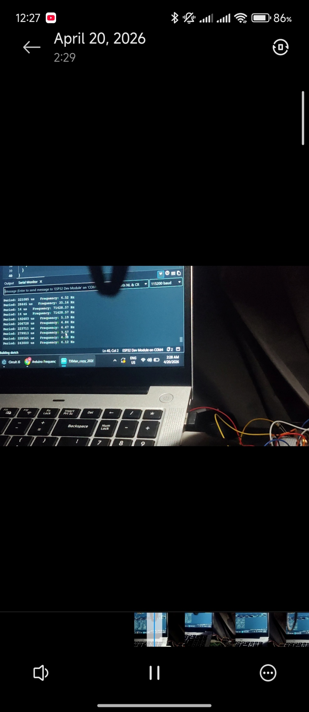

Sensor Capability Monitoring Testing

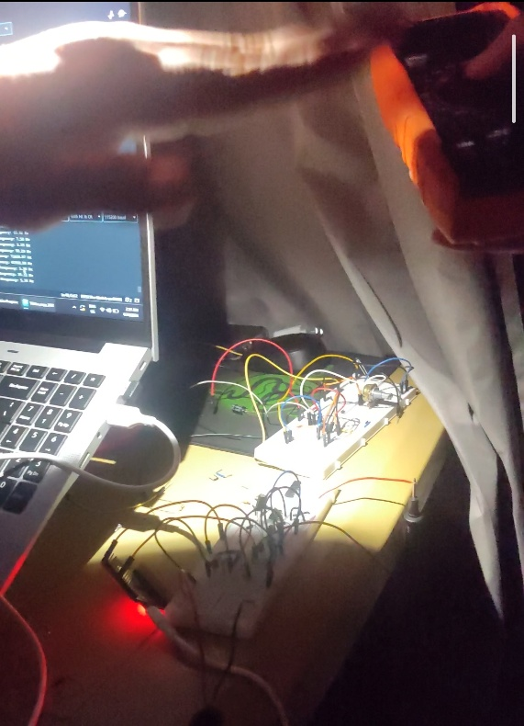

Reciever Circuit Breadboard Testing
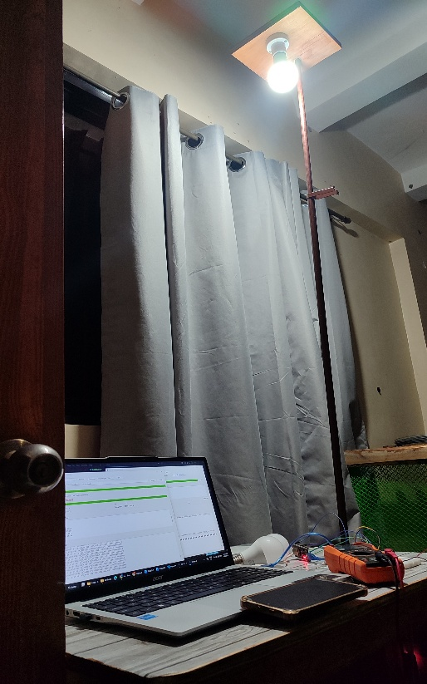

RX/TX Testing
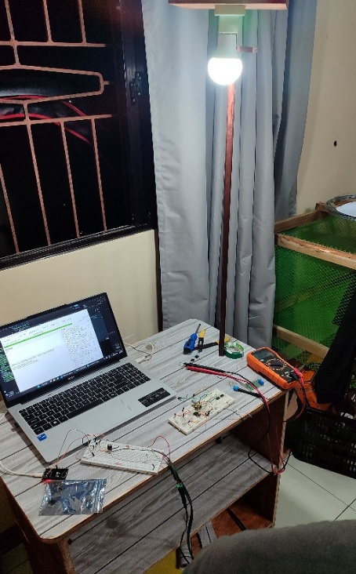

RX/TX Testing

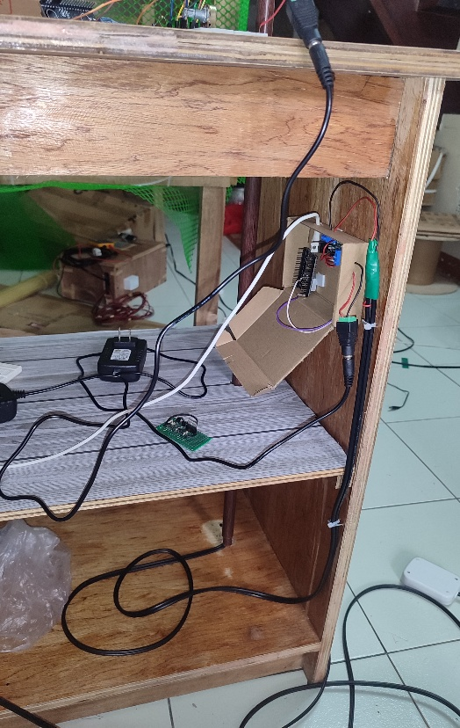

TX CIRCUIT PANEL

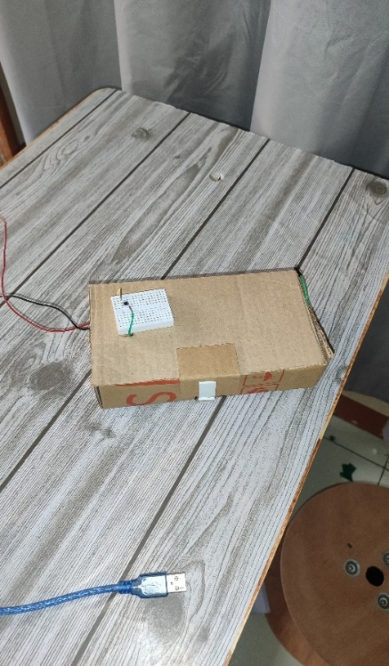

RX DEVICE
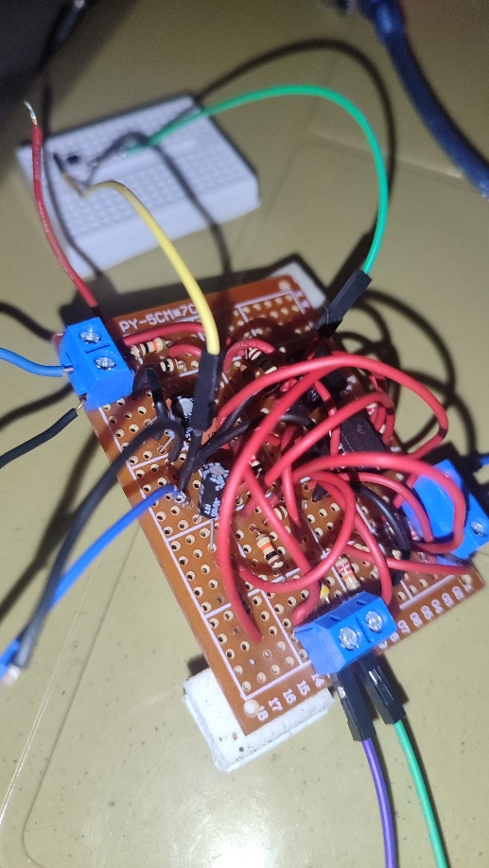

RX DEVICE INTERNAL CIRCUITRY
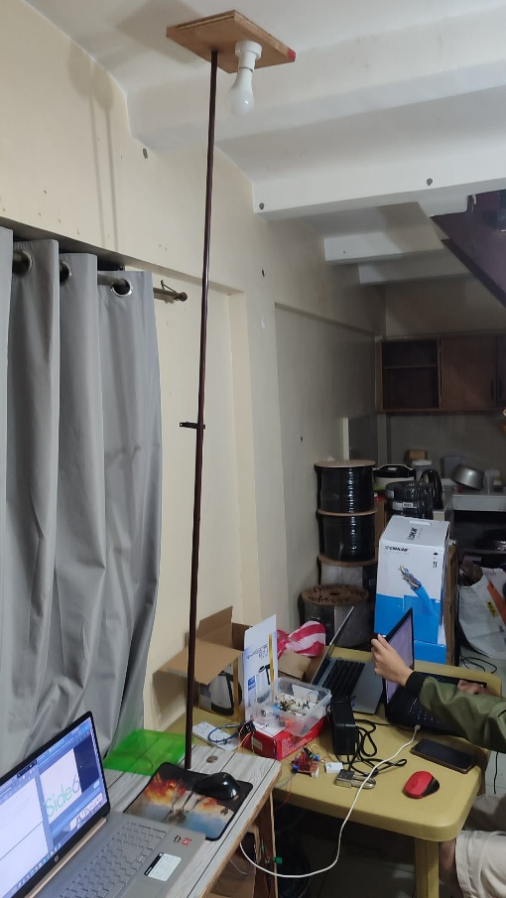
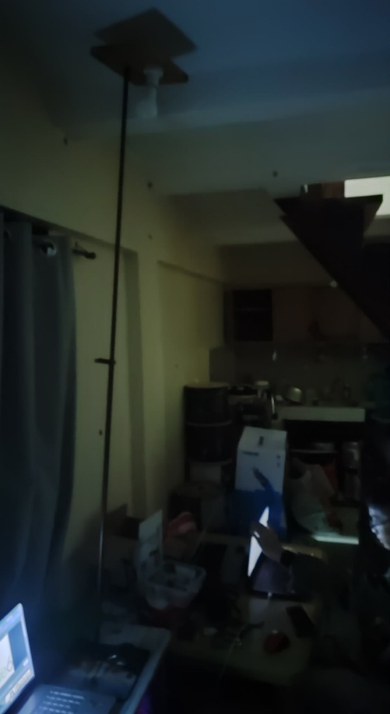

DIM ROOM NORMAL LIGHTING ROOM


Appendix B: TX GUI Screenshot

DASHBOARD
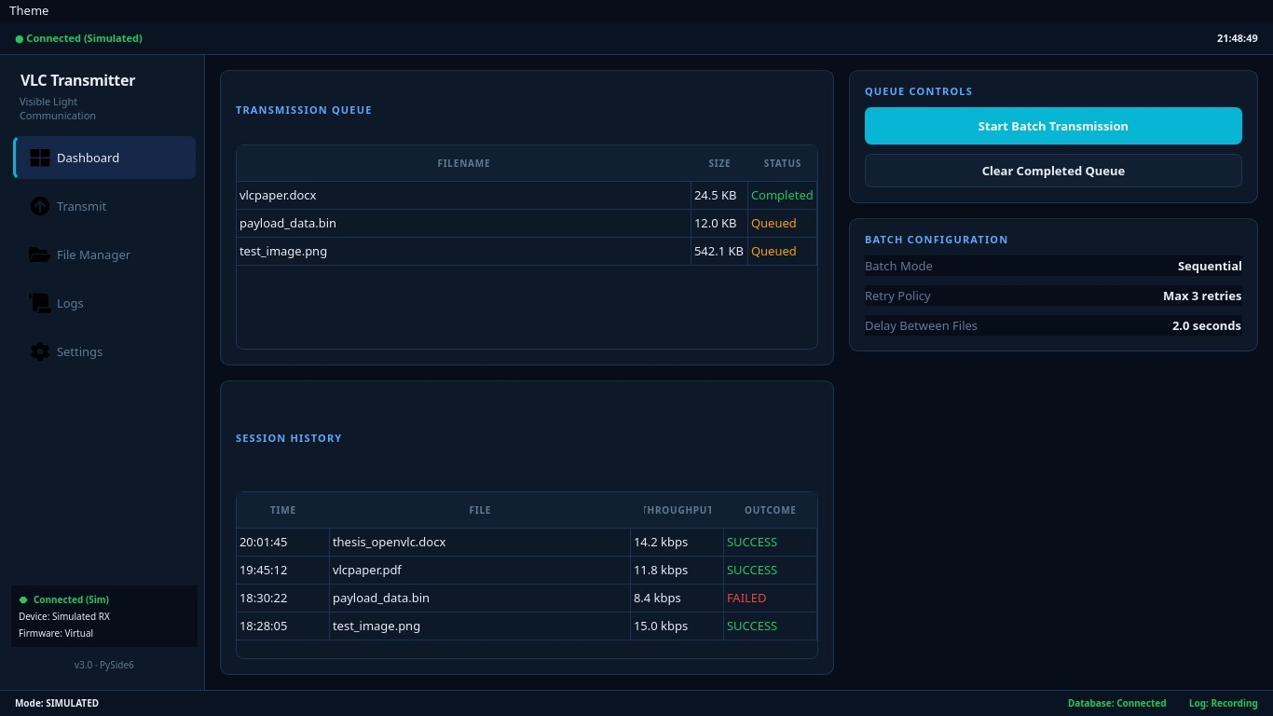

PAYLOAD TRANSMITTER
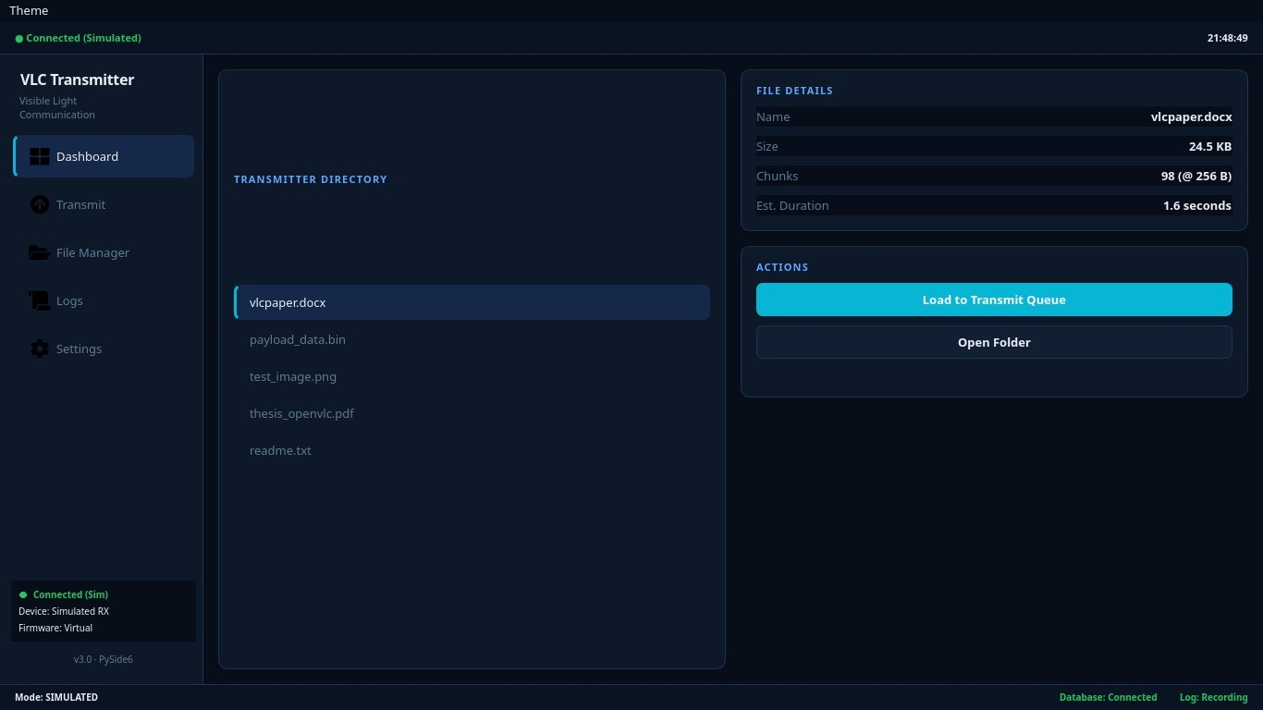
FILE MANAGER
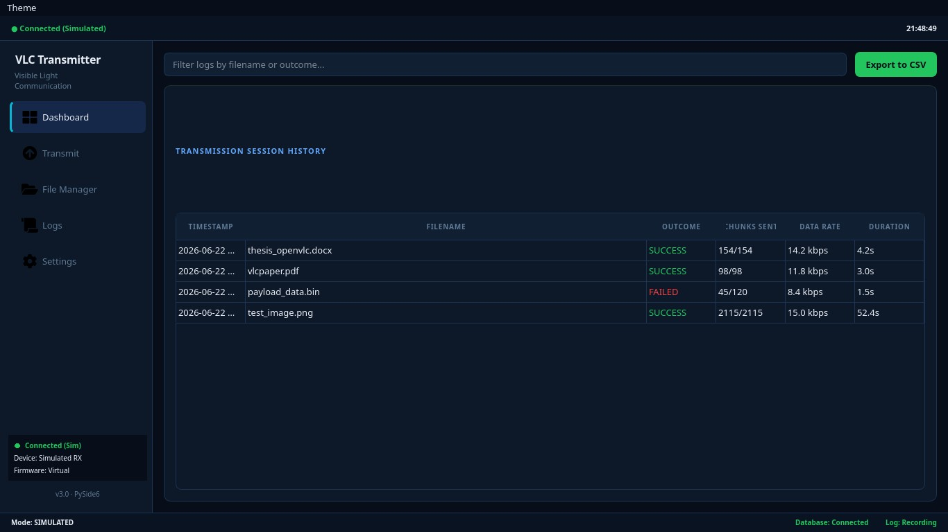

EVENT LOGS

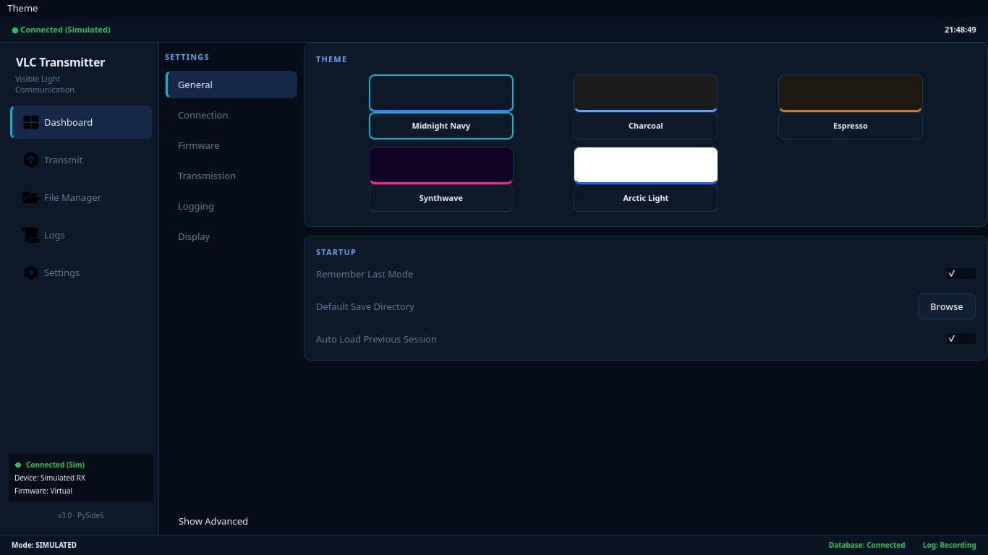
HARDWARE SETTINGS


Appendix C: RX GUI Screenshot

DASHBOARD
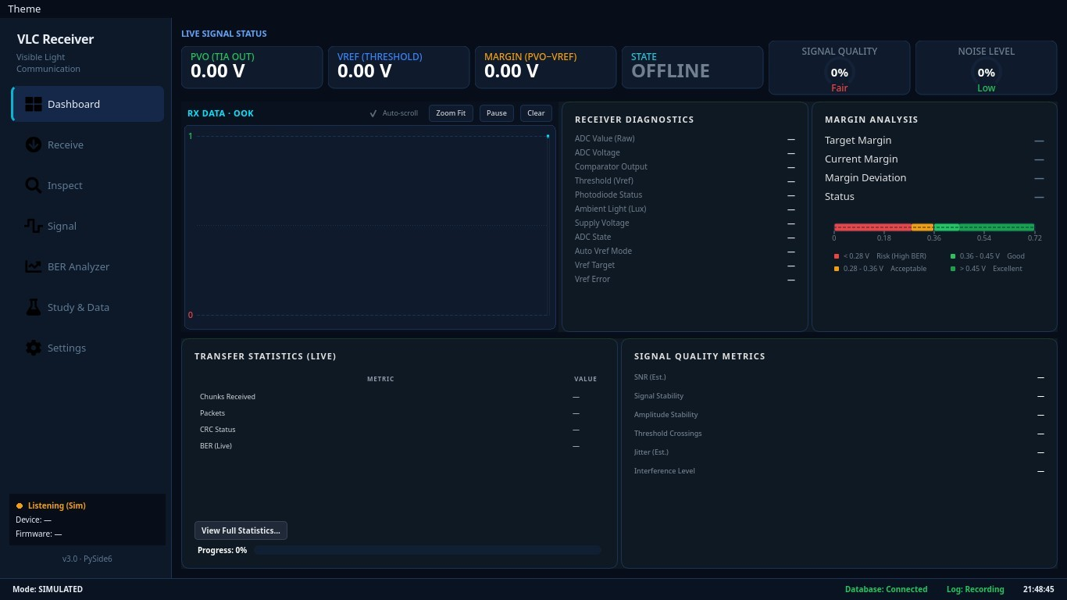

SIGNAL MONITOR (AUTO_VREF & WAVEFORMS)
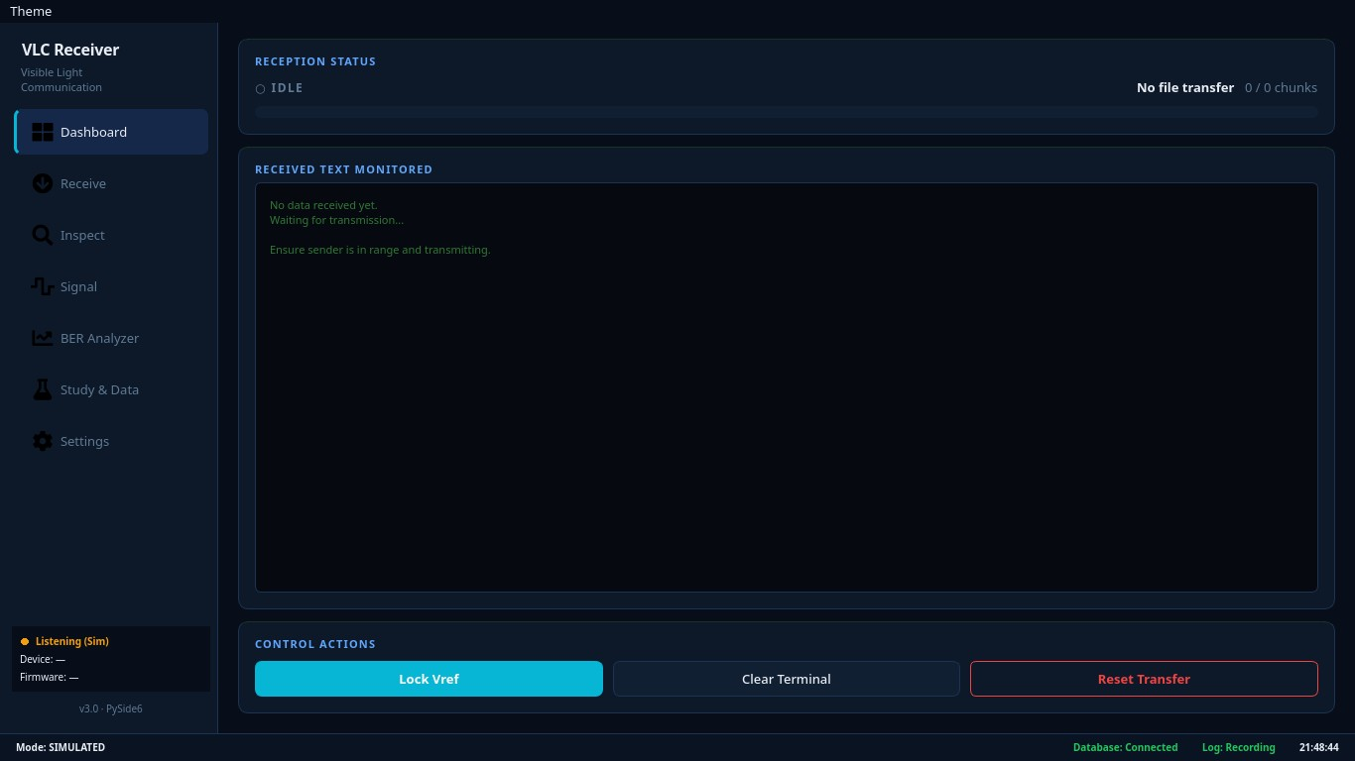
PAYLOAD RECEIVER

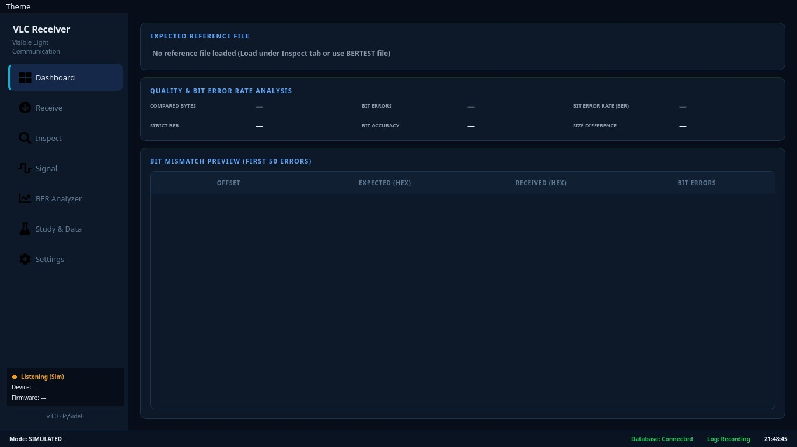

BER ANALYZER
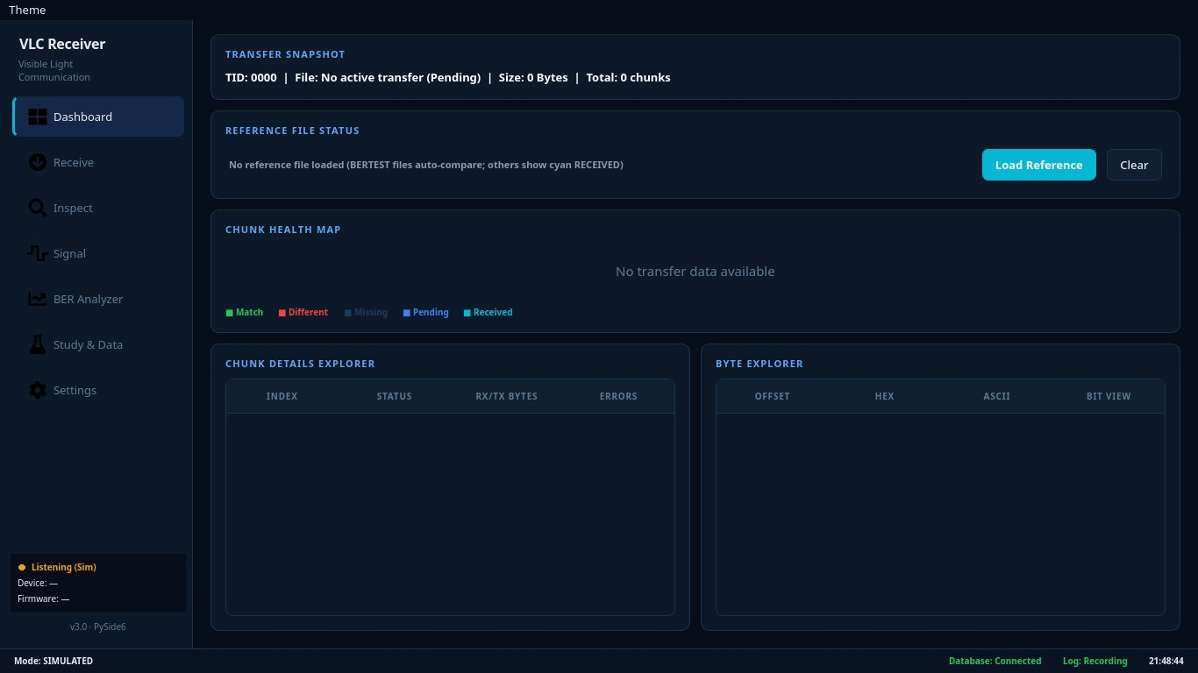
HEX INSPECTOR

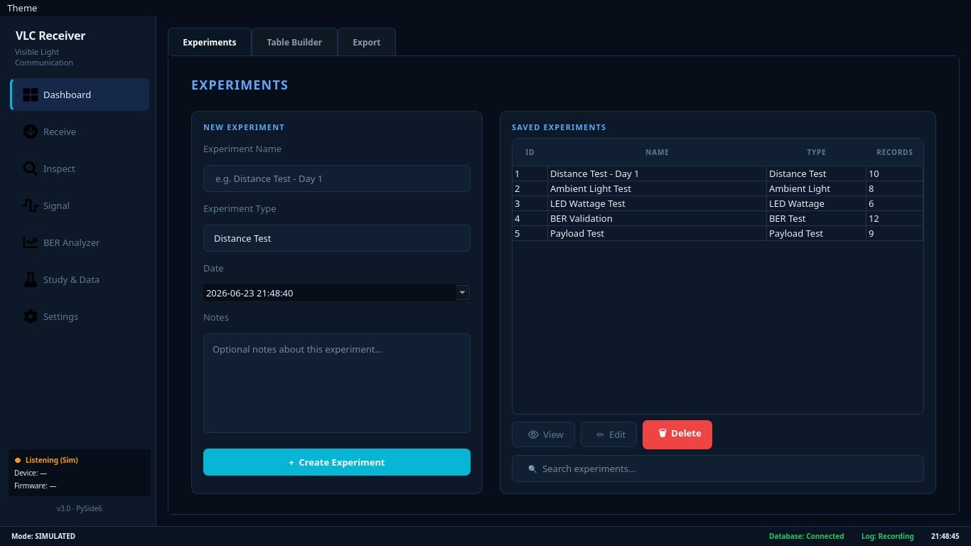

STUDY DATA & EXPORT
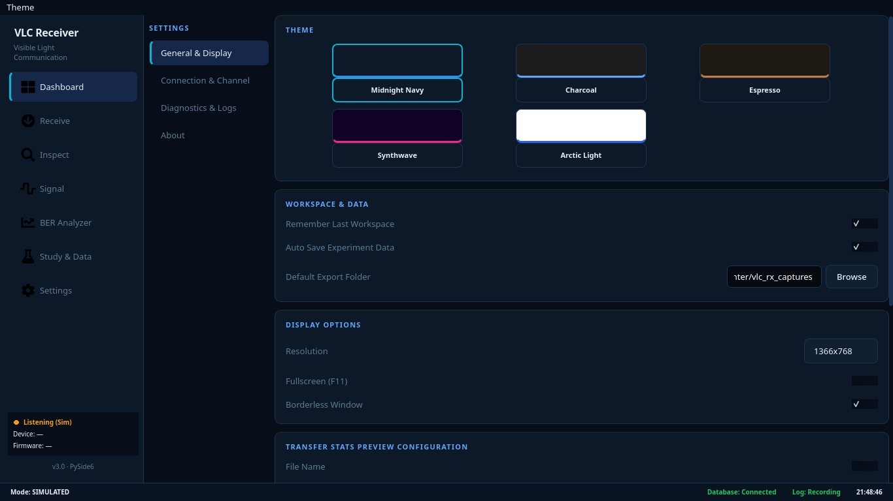
HARDWARE SETTINGS

Appendix D: VLC Prototype Components Data Sheets
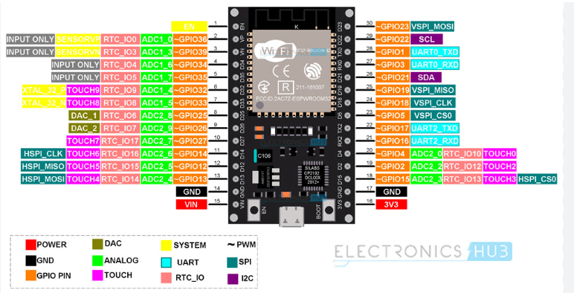

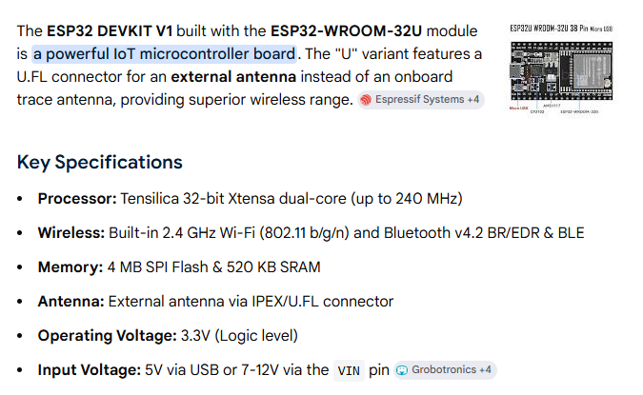

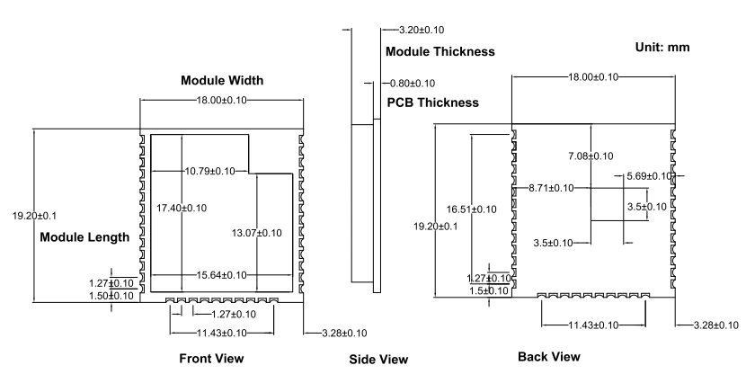
Dimentions Diagram
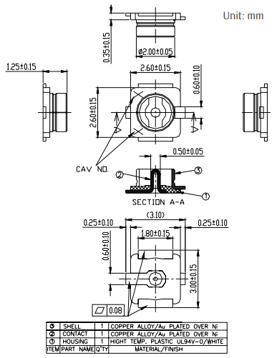

UFL Dimensions Diagram
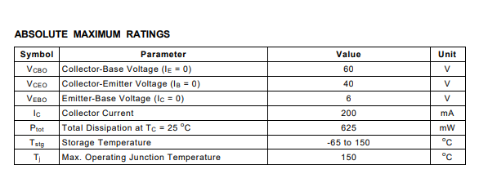
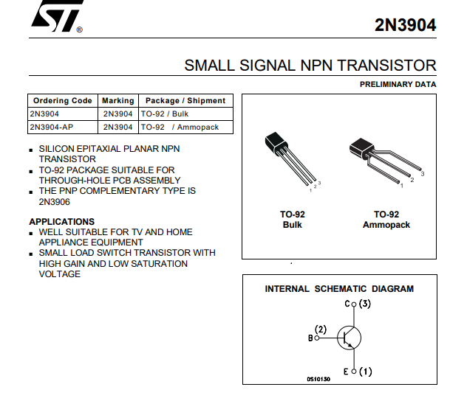

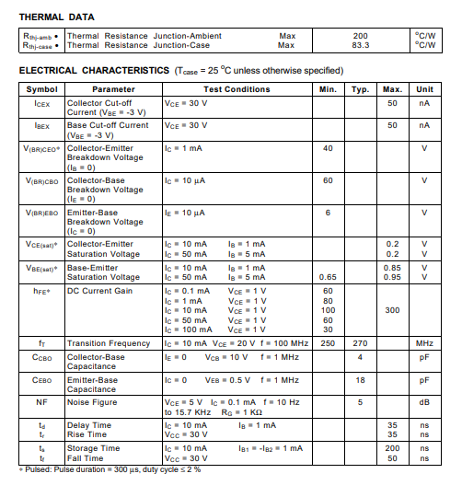

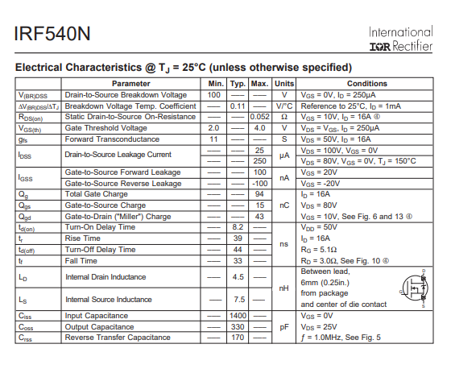
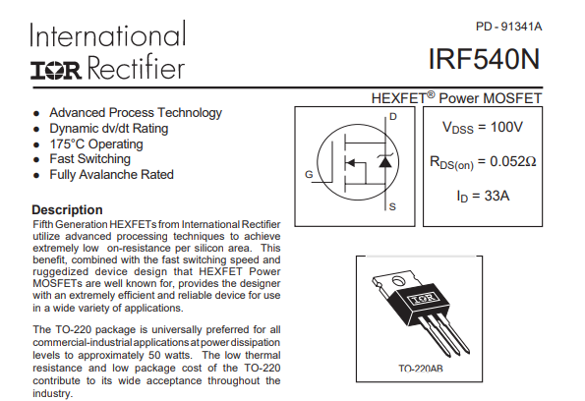
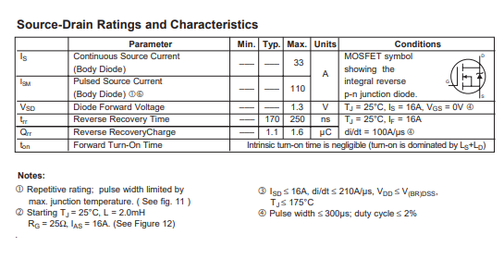
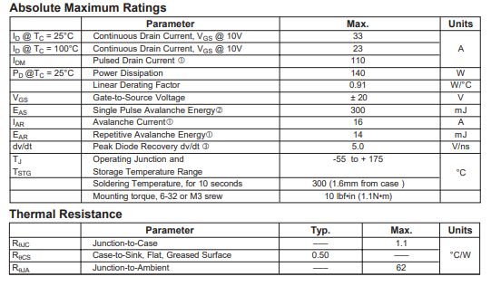

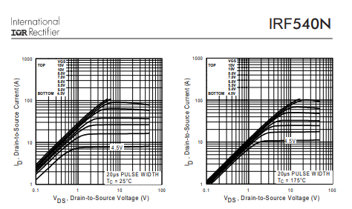
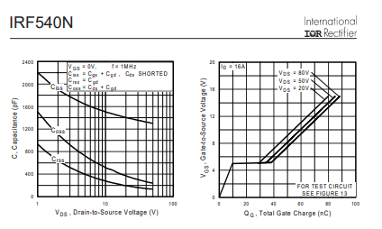

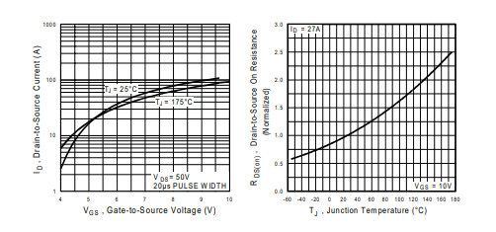

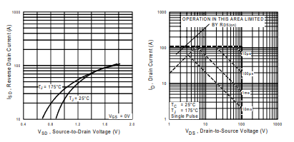

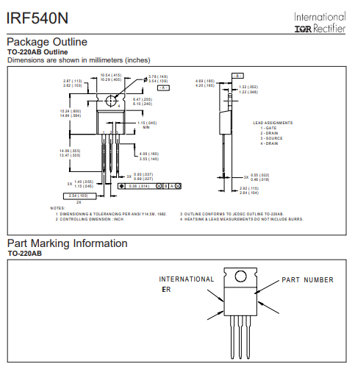
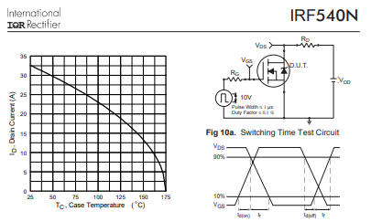

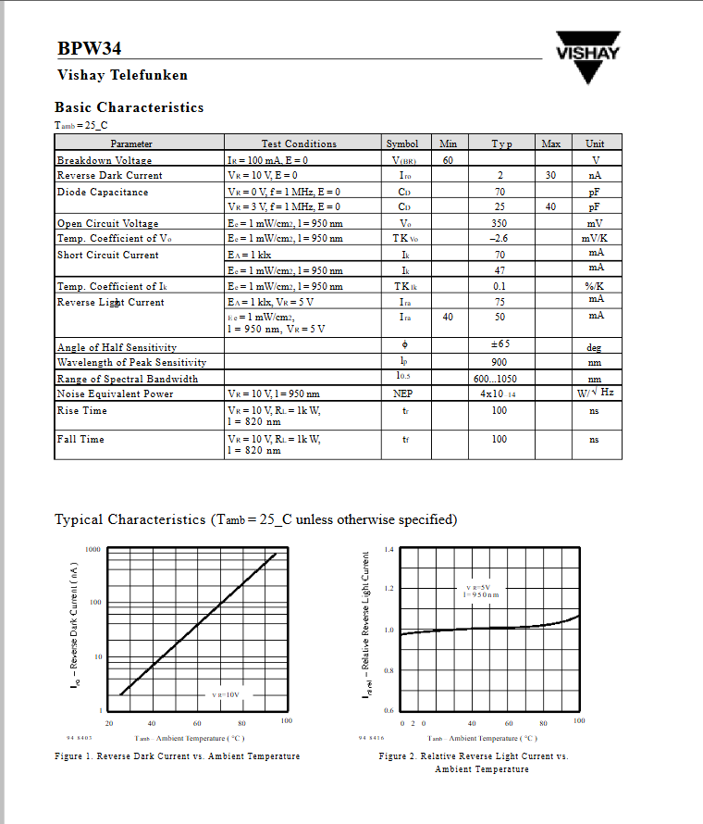
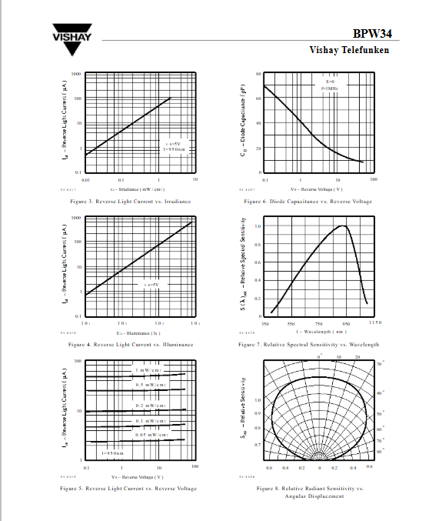
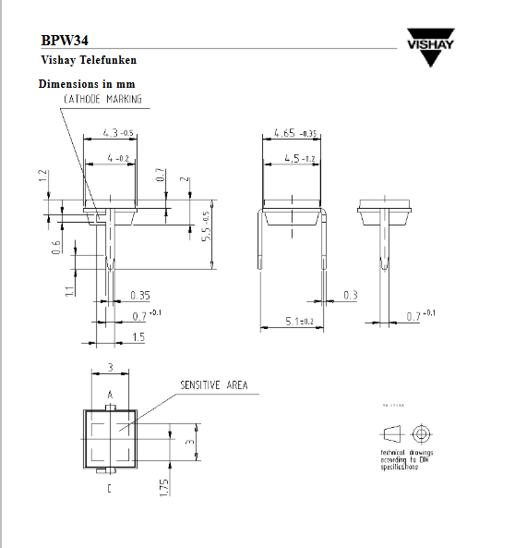

Appendix E: Test Logs and Raw Result Tables
E.1 Receiver Margin Calibration Raw Data
Table E.1. Receiver Margin Calibration Raw Data
Trial | PVo (V) | Vref (V) | Margin (V) | Calibration Status
1 | 0.81 | 0.45 | 0.36 | Success
2 | 1.24 | 0.88 | 0.36 | Success
3 | 1.78 | 1.42 | 0.36 | Success
4 | 2.35 | 1.99 | 0.36 | Success
5 | 2.91 | 2.55 | 0.36 | Success

E.2 Distance Performance Raw Data
Table E.2. Distance Performance Raw Data
Trial | Horizontal Offset (m) | Optical Distance (m) | PVo (V) | Vref (V) | Margin (V) | BER (%) | CRC Status
1 | 0.0 | 2.1 | 1.78 | 1.42 | 0.36 | 0.0 | PASS
2 | 0.5 | 2.16 | 1.74 | 1.37 | 0.37 | 0.0 | PASS
3 | 1.0 | 2.33 | 1.68 | 1.33 | 0.35 | 0.0 | PASS
4 | 1.5 | 2.58 | 1.62 | 1.28 | 0.34 | 0.0 | PASS
5 | 2.0 | 2.9 | 1.51 | 1.22 | 0.29 | 1.12 | FAIL

E.3 Ambient Light Performance Raw Data
Table E.3. Ambient Light Performance Raw Data
Trial | Lux | PVo (V) | Vref (V) | Margin (V) | BER (%) | CRC Status
Dark Room (TX Carrier Only) | 61 | 1.82 | 1.46 | 0.36 | 0.0 | PASS
Dim Room (+18 lx ambient noise) | 79 | 2.33 | 1.97 | 0.36 | 0.0 | PASS
Normal Room (+37 lx ambient noise) | 98 | 2.89 | 2.53 | 0.36 | 0.0 | PASS

E.4 LED Wattage Test Raw Data
Table E.4. LED Wattage Test Raw Data
Trial | LED Wattage | PVo (V) | Vref (V) | Margin (V) | BER (%) | CRC Status
1 | 6 W | 1.98 | 1.62 | 0.36 | 0.0 | PASS
2 | 9 W | 2.24 | 1.88 | 0.36 | 0.0 | PASS
3 | 12 W | 2.55 | 2.19 | 0.36 | 0.0 | PASS

E.5 Payload Transmission Raw Data
Table E.5. Payload Transmission Raw Data
File Name | Type | Size (KB) | Chunks | Time (s) | BER (%) | CRC Status | Reconstruction
data.txt | TXT | 5.0 | 20 | 9 | 0.0 | PASS | Complete
design.fzpz | FZPZ | 7.48 | 30 | 14 | 0.0 | PASS | Complete
audio.wav | WAV | 15.94 | 64 | 31 | 0.0 | PASS | Complete
slides.pptx | PPTX | 18.6 | 75 | 35 | 0.0 | PASS | Complete
manual.pdf | PDF | 24.2 | 97 | 46 | 0.0 | PASS | Complete
photo.jpg | JPG | 45.59 | 183 | 86 | 0.0 | PASS | Complete

Appendix F: Human Comfort Observation/Questionnaire Form
Table F.1. Human Comfort Observation/Questionnaire Results
Participant ID | Bulb Wattage | Distance (m) | Observed Glare | Observed Flicker | Comfort Rating
P-01 | 12 W | 2.1 | None | None | No noticeable discomfort
P-02 | 12 W | 2.1 | None | None | No noticeable discomfort
P-03 | 12 W | 1.5 | Slight | None | Slight discomfort
P-04 | 12 W | 2.1 | None | None | No noticeable discomfort
P-05 | 9 W | 2.1 | None | None | No noticeable discomfort
P-06 | 12 W | 2.1 | None | None | No noticeable discomfort
P-07 | 12 W | 1.0 | Moderate | None | Moderate discomfort

Human Comfort Observation Questionnaire

Participant ID: P-01
Age: ______________
Sex: ☐ Male ☐ Female
1. Did you observe noticeable glare from the LED bulb?
☐ None
☐ Slight
☐ Moderate
2. Did you observe any visible flickering of the LED light?
☐ None
☐ Slight
☐ Moderate
3. How would you rate your overall comfort while observing the LED bulb during the test?
☐ No noticeable discomfort
☐ Slight discomfort
☐ Moderate discomfort

Human Comfort Observation Questionnaire

Participant ID: P-02
Age: ______________
Sex: ☐ Male ☐ Female
1. Did you observe noticeable glare from the LED bulb?
☐ None
☐ Slight
☐ Moderate
2. Did you observe any visible flickering of the LED light?
☐ None
☐ Slight
☐ Moderate
3. How would you rate your overall comfort while observing the LED bulb during the test?
☐ No noticeable discomfort
☐ Slight discomfort
☐ Moderate discomfort

Human Comfort Observation Questionnaire

Participant ID: P-03
Age: ______________
Sex: ☐ Male ☐ Female
1. Did you observe noticeable glare from the LED bulb?
☐ None
☐ Slight
☐ Moderate
2. Did you observe any visible flickering of the LED light?
☐ None
☐ Slight
☐ Moderate
3. How would you rate your overall comfort while observing the LED bulb during the test?
☐ No noticeable discomfort
☐ Slight discomfort
☐ Moderate discomfort

Human Comfort Observation Questionnaire

Participant ID: P-04
Age: ______________
Sex: ☐ Male ☐ Female
1. Did you observe noticeable glare from the LED bulb?
☐ None
☐ Slight
☐ Moderate
2. Did you observe any visible flickering of the LED light?
☐ None
☐ Slight
☐ Moderate
3. How would you rate your overall comfort while observing the LED bulb during the test?
☐ No noticeable discomfort
☐ Slight discomfort
☐ Moderate discomfort

Human Comfort Observation Questionnaire

Participant ID: P-05
Age: ______________
Sex: ☐ Male ☐ Female
1. Did you observe noticeable glare from the LED bulb?
☐ None
☐ Slight
☐ Moderate
2. Did you observe any visible flickering of the LED light?
☐ None
☐ Slight
☐ Moderate
3. How would you rate your overall comfort while observing the LED bulb during the test?
☐ No noticeable discomfort
☐ Slight discomfort
☐ Moderate discomfort

Human Comfort Observation Questionnaire

Participant ID: P-06
Age: ______________
Sex: ☐ Male ☐ Female
1. Did you observe noticeable glare from the LED bulb?
☐ None
☐ Slight
☐ Moderate
2. Did you observe any visible flickering of the LED light?
☐ None
☐ Slight
☐ Moderate
3. How would you rate your overall comfort while observing the LED bulb during the test?
☐ No noticeable discomfort
☐ Slight discomfort
☐ Moderate discomfort

Human Comfort Observation Questionnaire

Participant ID: P-07
Age: ______________
Sex: ☐ Male ☐ Female
1. Did you observe noticeable glare from the LED bulb?
☐ None
☐ Slight
☐ Moderate
2. Did you observe any visible flickering of the LED light?
☐ None
☐ Slight
☐ Moderate
3. How would you rate your overall comfort while observing the LED bulb during the test?
☐ No noticeable discomfort
☐ Slight discomfort
☐ Moderate discomfort

Appendix G: Vref Sweep and GPIO25 PWM Calibration Records
Table G.1. Vref Sweep and GPIO25 PWM Calibration Mapping
PWM Duty Cycle (0-255) | Theoretical Vref (V) | Measured Vref (V)
0 | 0.00 | 0.00
51 | 0.66 | 0.65
102 | 1.32 | 1.31
128 | 1.65 | 1.66
153 | 1.98 | 1.97
204 | 2.64 | 2.65
255 | 3.30 | 3.30

Appendix H: Ambient-Light Lux Readings and Room Condition
Table H.1. Ambient-Light and Lux Record
Test ID | Ambient Condition | Lux Reading | Lux Tool | Distance | Alignment | PVo | Vref | Margin | CRC Result
H1 | Dark Room (TX Carrier Only) | 61 | Smartphone App | 2.1m | Direct | 1.82 V | 1.46 V | 0.36 V | PASS
H2 | Dim Room (+18 lx ambient noise) | 79 | Smartphone App | 2.1m | Direct | 2.33 V | 1.97 V | 0.36 V | PASS
H3 | Normal Room (+37 lx ambient noise) | 98 | Smartphone App | 2.1m | Direct | 2.89 V | 2.53 V | 0.36 V | PASS

Appendix I: BER Comparison Records and Computation Sheets
Bit Error Rate (BER) is calculated as the ratio of incorrectly received bits to the total number of bits transmitted, expressed as a percentage:
BER = (Number of Error Bits / Total Transmitted Bits) × 100

Example Calculation (based on Table H.1, 2.9m Distance test failure):
- File Size: 5 KB = 5,120 bytes
- Total Raw Bits: 5,120 bytes × 8 bits/byte = 40,960 bits
- 4B5B Encoding Overhead (4 bits mapped to 5 bits): 40,960 × 1.25 = 51,200 bits on the wire
- Corrupted Bits Detected (Counted by ESP32): 573 bits
BER = (573 / 51,200) × 100 = 1.119% ≈ 1.12%

Appendix J: Maximum File Behavior Records
Table J.1. Maximum File Behavior Record
Test ID | File Extension | File Size | Transfer Path | Expected Behavior | CRC Result | Output Status
J1 | .txt | 80 KiB | direct stream | accepted by ESP32 RAM buffer | PASS | Complete
J2 | .bin | 81 KiB | direct firmware stream | rejected or file too large | FAIL | Truncated
J3 | .jpg | 256 KiB | GUI batched transfer | split into 80 KiB VLCB1 parts | PASS | Complete

Appendix K: BPW34 and Phototransistor Comparison Records
Table K.1. BPW34 and Phototransistor Comparison Record
Test ID | Receiver Sensor | Front End | Payload | Distance | Alignment | PVo | Vref | CRC Result
K1 | BPW34 photodiode | OPA2604 TIA + LM393 | TXT (5KB) | 2.1m | Direct | 1.78 V | 1.42 V | PASS
K2 | Phototransistor | OPA2604 TIA + LM393 | TXT (5KB) | 2.1m | Direct | Unstable | Unstable | FAIL

Appendix L: Receiver Circuit Analysis and 12 V Threshold Scaling
The receiver analog front end uses a 12 V supply for the OPA2604 transimpedance amplifier and the LM393 comparator. Therefore, the actual PVo and actual comparator Vref are 12 V-domain analog nodes. These nodes must be scaled before being monitored by the ESP32 ADC, and the LM393 output must be pulled up to 3.3 V before entering the ESP32 input.
L.1 TIA Feedback Network Analysis
The feedback resistor (R1 = 1.5 MΩ) determines the transimpedance gain, converting the small photocurrent into a measurable voltage. The feedback capacitor (C3 = 10 pF) stabilizes the operational amplifier and establishes a first-order low-pass filter. The cutoff frequency (fc) must be high enough to pass the 7.5 kHz fundamental frequency of the 15 ksymbols/s NRZ signal, but low enough to reject high-frequency noise.
fc = 1 / (2π × R1 × C3)
fc = 1 / (2π × 1.5×10⁶ Ω × 10×10⁻¹² F)
fc ≈ 10,610 Hz (10.6 kHz)
L.2 Virtual Ground Divider Analysis
To operate the OPA2604 on a single 12 V supply and provide a 6 V reverse bias to the BPW34 photodiode, a virtual ground was established at the non-inverting input using a resistive voltage divider (R2 = 10 kΩ, R3 = 10 kΩ).
Vvirtual = Vcc × [ R3 / (R2 + R3) ]
Vvirtual = 12 V × [ 10 kΩ / (10 kΩ + 10 kΩ) ]
Vvirtual = 6.0 V

L.3 Auto-Vref RC Filter Analysis
The ESP32 dynamically generates the comparator reference threshold using a 30 kHz PWM signal. As detailed in the schematic design, this 3.3 V signal is first level-shifted to 12 V by the LM393 Channel B. A low-pass RC filter (R = 2.2 kΩ, C = 1 µF) was employed to smooth the digital square wave into a stable DC analog voltage.
fc = 1 / (2π × R × C)
fc = 1 / (2π × 2.2×10³ Ω × 1×10⁻⁶ F)
fc ≈ 72.34 Hz
Because the 72.34 Hz cutoff frequency is significantly lower than the 30 kHz PWM frequency, the filter effectively removes the switching ripple, ensuring the LM393 comparator threshold remains completely flat.

Appendix M: Transmitter Driver Circuit Analysis
M.1 BJT Base Resistor Analysis
The ESP32 GPIO pins possess an absolute maximum current rating of 40 mA. To safely drive the 2N3904 NPN transistor (which in turn drives the IRF540N MOSFET), a 220 Ω base resistor was selected to fully saturate the transistor while strictly limiting the drawn current.
IB = (VGPIO − VBE) / R1
IB = (3.3 V − 0.7 V) / 1000 Ω
IB = 2.6 V / 220 Ω
IB = 11.8 mA
A base current of 11.8 mA ensures rapid switching for the 15 ksymbols/s signal while operating well within the 40 mA limit, guaranteeing the long-term hardware safety of the microcontroller.

Appendix N: Prototype Operations and User Guide
This section serves as a guide on how to operate and use the VLC prototype during testing.
N.1 System Setup
1. Connect the transmitter ESP32 and receiver ESP32 to the laptop using USB serial cables.
2. Connect the transmitter driver circuit to the 12 V DC LED bulb and power supply.
3. Connect the receiver circuit consisting of the BPW34 photodiode, OPA2604 amplifier, and LM393 comparator.
4. Position the LED bulb and photodiode receiver in a clear line-of-sight arrangement.
5. Adjust the receiver threshold or Vref to achieve a stable receiver margin before testing.
N.2 Transmitter Operation
1. Open the TX GUI on the laptop.
2. Select the correct COM port for the transmitter ESP32.
3. Apply the fixed 4B5B + NRZ/OOK transmission settings.
4. Select the payload to be transmitted, such as text, image, audio, or file data.
5. Start the transmission and observe the TX GUI status until the transmission is completed.
N.3 Receiver Operation
1. Open the RX GUI on the laptop.
2. Select the correct COM port for the receiver ESP32.
3. Apply the matching receiver settings used by the transmitter.
4. Observe the receiver signal, Vref, receiver margin, CRC result, and chunk completion status.
5. After successful reception, verify that the reconstructed output is readable, accessible, or saved properly.
N.4 Shutdown Procedure
1. Stop any active transmission in the TX and RX GUI.
2. Save the needed test results, logs, and reconstructed files.
3. Disconnect the TX and RX GUI serial connections.
4. Turn off the 12 V DC power supply.
5. Disconnect the ESP32 USB cables after testing.

Appendix O: Firmware and Code Snippets

1. 4B5B Line Coding and Optical Signaling
The system uses 4B5B + NRZ/OOK signaling to improve transition density and ensure clock recovery without halving the data rate (as Manchester would).
Transmitter (TX): 4B5B Encoding
The TX firmware maps standard 8-bit bytes to two 5-bit symbols, transmitting them sequentially over the active-low LED driver.
// tx_esp32_lifi_dual_mode.ino
const uint8_t CODE_4B5B[16] = { 0b11110, 0b01001, 0b10100, 0b10101,
0b01010, 0b01011, 0b01110, 0b01111,
0b10010, 0b10011, 0b10110, 0b10111, 0b11010, 0b11011, 0b11100, 0b11101 };
void send4b5bEncodedByte(uint8_t value) { send4b5bCode(CODE_4B5B[(value >> 4) & 0x0F]); send4b5bCode(CODE_4B5B[value & 0x0F]); }
void send4b5bCode(uint8_t code) { for (int i = 4; i >= 0; i--) send4b5bBit((code & (1U << i)) != 0);
}

Receiver (RX): 4B5B Decoding
The RX firmware reverses the process, reading incoming symbols and converting them back into bytes using a lookup table.
// rx_esp32_lifi_dual_mode.ino
const int8_t DECODE_4B5B[32] = { -1, -1, -1, -1, -1, -1, -1, -1,
-1, 1, 4, 5, -1, -1, 6, 7,
-1, -1, 8, 9, 2, 3, 10, 11, -1, -1, 12, 13, 14, 15, 0, -1 };
bool read4b5bByte(uint8_t &value) {
// ... align to frame ...
uint8_t highCode = 0, lowCode = 0;
if (!read5b(highCode) || !read5b(lowCode)) return false;
int8_t highNibble = DECODE_4B5B[highCode & 0x1F]; int8_t lowNibble = DECODE_4B5B[lowCode & 0x1F];
if (highNibble < 0 || lowNibble < 0) { invalidCodeCount++; resetLineDecoder();
return false; } value = (uint8_t)((highNibble << 4) | lowNibble); return true; }

2. Active-Low LED Driver
The LED bulb is driven by an ESP32 GPIO5 output driving a 2N3904 transistor and IRF540N MOSFET stage to switch a commercially available 12 V DC LED bulb using active-low operation. The firmware explicitly accounts for this inverted logic.
// tx_esp32_lifi_dual_mode.ino
bool activeLowDriver = false; // Configurable via USB serial bool idleOn = true;
int levelForLight(bool lightOn) { return activeLowDriver ? (lightOn ? LOW : HIGH) : (lightOn ? HIGH : LOW);
}
int lineOneLevel() { return levelForLight(true); }
int lineZeroLevel() { return levelForLight(false); }
int idleLevel() { return levelForLight(idleOn); }
void send4b5bBit(bool bitValue) { digitalWrite(TX_PIN, bitValue ? lineOneLevel() : lineZeroLevel()); waitSymbolBoundary(); }

3. Signal Reception and Majority Voting
To combat noise caused by distance and ambient light (highlighted as a key factor in the study), the RX firmware employs a 3-point majority voting scheme over the symbol width.
// rx_esp32_lifi_dual_mode.ino
bool sampleRawAt(uint32_t sampleTimeUs) { if (!useMajoritySampling || symbolUs < 30) { waitUntil(sampleTimeUs); return digitalRead(RX_PIN); } uint32_t delta = symbolUs / 6;
// Sample slightly before, exactly on, and slightly after the target time waitUntil(sampleTimeUs - delta); bool a = digitalRead(RX_PIN); waitUntil(sampleTimeUs); bool b = digitalRead(RX_PIN); waitUntil(sampleTimeUs + delta); bool c = digitalRead(RX_PIN); return (a + b + c) >= 2; // Returns true only if at least 2 out of 3 samples are high }

4. Frame Synchronization
The synchronization sequence uses an alternating bit sequence to establish timing, followed by a specific SYNC_WORD (0xD5B7). This allows the receiver to align itself even if chunks are missed.
// rx_esp32_lifi_dual_mode.ino
#define SYNC_WORD 0xD5B7
#define SYNC_WORD_INV ((uint16_t)(~SYNC_WORD))
#define MIN_PREAMBLE_ALT_TRANSITIONS 20
bool acquire4b5bSync() { // ... wait for stable idle and start transition ... uint16_t shift = 0; uint32_t sampleAt = edgeTime + phaseOffsetUs(); bool previous = false, havePrevious = false; int alternatingTransitions = 0; for (int i = 0; i < MAX_SYNC_SEARCH_BITS; i++) { bool raw = sampleRawAt(sampleAt); sampleAt += symbolUs; if (havePrevious && raw != previous) alternatingTransitions++; previous = raw; havePrevious = true; shift = (uint16_t)((shift << 1) | (raw ? 1 : 0));
// Check if we caught enough preamble edges and match the exact sync word if (i >= 15 && alternatingTransitions >= MIN_PREAMBLE_ALT_TRANSITIONS &&
(shift == SYNC_WORD || shift == SYNC_WORD_INV)) { invertSymbols = (shift == SYNC_WORD_INV); lineSynced = true; frameAligned = false; nextSampleUs = sampleAt; return true; }
} // ... failure path
}

5. Packet/Chunk Carousel & CRC Validation
Since the system lacks a feedback channel (no ACKs), it relies on a chunk carousel method with a 16-bit CRC algorithm to guarantee that reconstructing the text, image, or audio payload is error-free.
TX Side: Building the Frame and CRC // tx_esp32_lifi_dual_mode.ino
size_t buildFrame(uint8_t frameType, uint16_t chunkIndex, const uint8_t
*payload, uint16_t payloadLen) { uint16_t chunkCrc = crc16_ccitt(payload, payloadLen); size_t pos = 0;
// ... header assignments (TID, sizes, chunks, offsets) ... putU16(frameBuf, pos, chunkCrc); // ... append payload ...
// Entire frame CRC uint16_t frameCrc = crc16_ccitt(frameBuf, pos); putU16(frameBuf, pos, frameCrc); return pos; }
RX Side: Verifying the Frame and CRC // rx_esp32_lifi_dual_mode.ino
void processCompleteFrame() { uint16_t rxFrameCrc = getU16(frameBuf, framePos - 2); uint16_t calcFrameCrc = crc16_ccitt(frameBuf, framePos - 2); if (rxFrameCrc != calcFrameCrc) { crcFailCount++; resetLineDecoder(); return; }
// ... unpack metadata ...
uint16_t calcChunkCrc = crc16_ccitt(frameBuf + payloadStart, chunkLen); if (rxChunkCrc != calcChunkCrc) { crcFailCount++; resetLineDecoder(); return; }
crcOkCount++; // Passed validation! // Send verified chunk to the RAM buffer bufferVerifiedChunk(tid, frameType, totalSize, totalChunks, chunkIndex, chunkLen, fileCrc, nameLen, frameBuf + nameStart, frameBuf + payloadStart);
}

6. Adaptive Thresholding / Receiver Margin Calibration
The receiver utilizes an ESP32 PWM pin paired with an RC filter to generate a precise reference voltage (Vref) for the LM393 comparator based on the analog signal's amplitude. This ensures the required receiver margin is maintained against ambient light changes.
// rx_esp32_lifi_dual_mode.ino
void calibrateVrefFromSignal(bool requireSwing = false) { float signalMin = 0.0f, signalMax = 0.0f, swing = 0.0f; int peakDeltaMv = 0; sampleCalibrationSignal(signalMin, signalMax, swing, peakDeltaMv);

// Determines the raw target threshold based on a requested margin offset from the peak signal int rawTargetMv = (int)((signalMax * 1000.0f) - marginTargetMv + 0.5f); int targetMv = rawTargetMv; if (targetMv < VREF_MIN_MV) { targetMv = VREF_MIN_MV; } if (targetMv > reachableVrefMaxMv()) { targetMv = reachableVrefMaxMv(); }
int tuneMeasuredMv = 0, tuneErrorMv = 0, tuneIterations = 0; bool tuneReached = false;

// Successively adjusts the PWM duty cycle until the RC-filtered DC output matches the target Vref tuneVrefToMeasuredTarget(targetMv, tuneMeasuredMv, tuneErrorMv, tuneIterations, tuneReached);}

