No | Out Diameter | Thicuess | Bolt Thicuess | Bolt
1 | 65 mm | 40 mm | ±30 mm | 10 mm
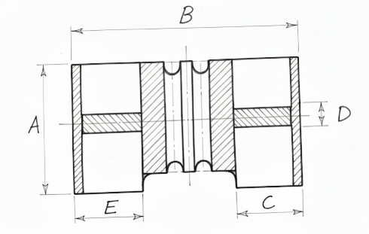
Keterangan:
A : Out Diameter
B : Thicuess
C : Bolt Thicuess
D : Bolt

