Actor & Relationship Intelligence — MVP Proposal
Scoped-down version for initial build & validation

1. Why this, and why now
The earlier version of this document tried to cover the full picture — training, extraction, graph construction, governance — all at once. That was useful for me to think through the domain end to end, but it isn't something we can build or validate in one go. This version narrows it down to a single, testable slice: can we reliably pull out actors and their relationships from the kind of data we already work with, and represent that as a graph someone can actually query?
Everything below is scoped to what I believe can be built, tested, and shown working within a short MVP cycle. Anything broader is noted separately as a later-phase idea, not part of this build.

2. MVP Objective
Given a batch of existing records/documents, extract the actors mentioned, tag the relationships between them, and load the result into a small graph that can be queried and visually inspected. Success for the MVP is: a working end-to-end pipeline on a limited dataset, with a human review step, not a production-scale system.

3. System Block Diagram
This is the shape of the MVP — five components, nothing more. No training pipeline, no multi-model orchestration, no automated governance layer yet.
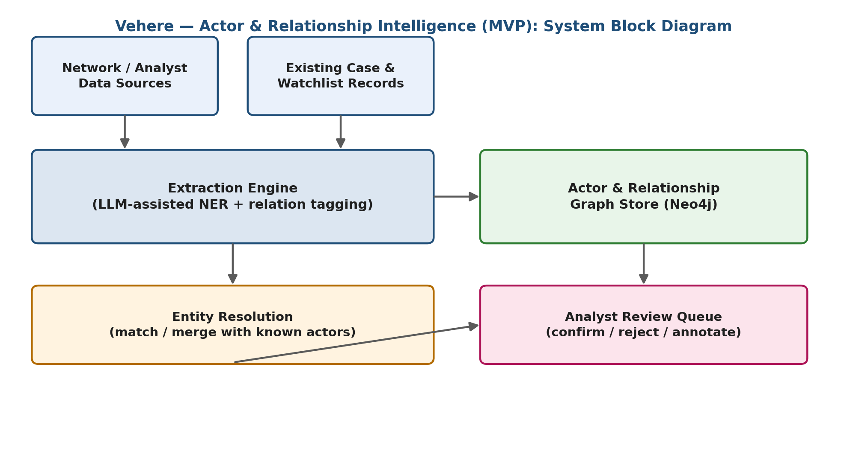

4. Process Flow
This is how a single record moves through the system, start to finish. The dashed line matters most to me: every analyst decision (confirm/reject) is logged, so the next iteration of the extraction step gets a little better — that's the feedback loop I want to validate first, even at small scale.
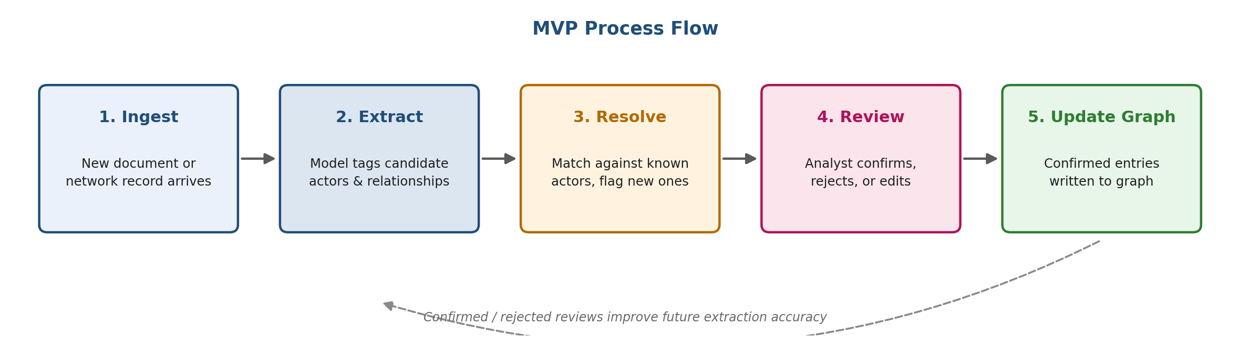

5. What's in scope for the MVP
Component | MVP scope
Data | A small, fixed sample set I already have access to — not a live feed.
Extraction | Prompted extraction using an existing LLM (no fine-tuning yet) — just actors and a short list of relationship types.
Resolution | Simple name-matching against a small known-actor list. No embedding search yet.
Graph | Neo4j, local instance, manually inspected via the browser UI.
Review | A basic accept/reject list — spreadsheet or simple script is enough for now.

6. What's explicitly out of scope (for now)
These were part of the original write-up. I still think they matter, but not for this cycle — I'm listing them here so it's clear this is a deliberate cut, not something I forgot:
- Fine-tuning a dedicated extraction model — worth doing once we know prompted extraction is accurate enough to be useful.
- Automated community/group detection on the graph — meaningful only once there's enough data in the graph to detect anything.
- Formal governance, audit logging, and access-control layers — necessary before production, not before a proof of concept.
- Scheduled/event-driven ingestion — the MVP runs on demand, not as a pipeline.

7. My take on this
Honestly, the biggest risk I see isn't the graph or the database — it's extraction quality. If the model mislabels relationships or invents connections that aren't really there, everything downstream (the graph, the review queue) inherits that noise. So I want the first real test to be narrow and honest: run it on a small known dataset where I can manually check every output, and see how close it actually gets before I trust it with anything bigger.
I'd rather bring a working, small, and slightly boring MVP to the next review than a bigger diagram that hasn't been tested against real data.

8. Next Steps
- Pick a small sample dataset (10–20 records) I can manually verify against.
- Build the extraction + resolution steps and run them on that sample.
- Load results into a local Neo4j instance and check the graph by hand.
- Log accept/reject decisions and measure how often extraction was right vs. wrong.
- Bring results back for review before deciding what (if anything) from Section 6 gets added next.

