Multimodal Threat Intelligence Platform Architecture
A unified pipeline from physical and digital sensing through to agentic reasoning, built for entity resolution and threat-actor identification at scale.

1. System Engineering Blueprint
A modern threat intelligence architecture cannot rely on any single data source. It requires a unified pipeline that takes raw physical and digital signals and carries them through to an analyst-facing reasoning layer.
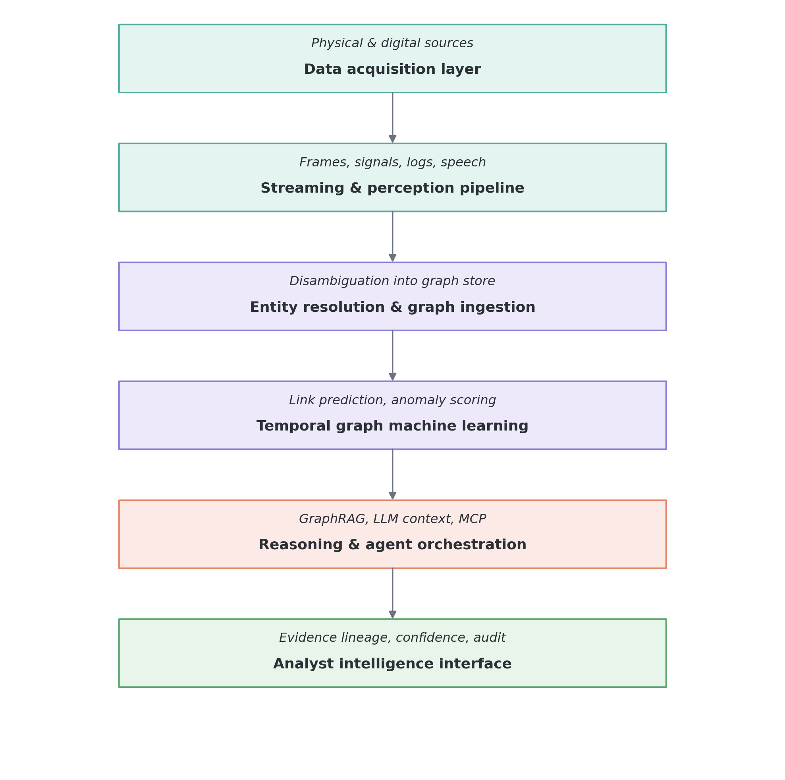
Figure 1. End-to-end platform pipeline.

2. 11-Layer Functional Specification for Threat Actor Identification & Entity Linkage
Each layer below contributes a distinct signal type. Layers are designed to be composable — a given investigation may draw on as few or as many as the available data supports.

Layer 1: Visible Computer Vision (Reconnaissance & Physical Linkage)
Sensor & extraction: Bounding box detection, human pose tracking, vehicle tracking, and trajectory mapping via YOLO and ByteTrack/BoT-SORT.
Actor identification: Identifies specific individuals engaged in pre-operational surveillance, unauthorized perimeter probing around critical infrastructure, or weapon handling.
Linkage mechanism: Resolves physical movements into persistent track IDs, binding individuals to specific vehicles (license plates) and observed equipment.

Layer 2: Identity & Biometric Verification (Watchlist Disambiguation)
Sensor & extraction: High-dimensional facial vector embeddings generated via RetinaFace and ArcFace.
Actor identification: Direct matching against sanctioned watchlists and biometric border-control databases under variable lighting or partial concealment (hats, masks).
Linkage mechanism: Binds an unconfirmed physical track (Track_892) to a real-world identity or alias (Person_Entity_X), merging previously separated aliases across disparate incident reports.

Layer 3: Thermal Radiometric Sensing (Concealed Operations & Night Logistics)
Sensor & extraction: Long-wave infrared (LWIR) radiometric thermal sensors extracting differential heat signatures.
Actor identification: Uncovers activity under blackout conditions, concealed staging locations, safehouses with abnormal cooling/power signatures, or perimeter breaches through tree lines.
Linkage mechanism: Tags vehicles based on engine-block thermal signatures (indicating recent operation) and maps human heat trails to hidden or disguised structures.

Layer 4: RF & Wi-Fi CSI Sensing (Non-Line-of-Sight Presence Detection)
Sensor & extraction: IEEE 802.11bf Channel State Information (CSI) subcarrier perturbation analysis.
Actor identification: Identifies human presence, respiration, and movement within reinforced spaces or closed rooms without requiring line-of-sight cameras.
Linkage mechanism: Flags locations with unregistered occupants, counting hidden occupants and associating their presence with simultaneous wireless beacon transmissions.

Layer 5: Micro-Doppler Radar (Gait Analysis & Covert Transport)
Sensor & extraction: FMCW millimeter-wave (mmWave) radar measuring frequency shifts, range, and velocity.
Actor identification: Extracts unique gait profiles to track suspected individuals even when faces are obscured, and distinguishes concealed payloads within standard vehicle compartments.
Linkage mechanism: Connects movement across adverse weather conditions (fog, dust storms) to specific physical transit corridors.

Layer 6: Audio & Speech Forensics (Voiceprint & Operational Signals)
Sensor & extraction: Speaker diarization, acoustic vector embeddings (wav2vec 2.0 / Whisper), and transcription.
Actor identification: Matches intercepted voice communications against known threat-actor audio archives to confirm high-value targets (HVTs) using shared or unverified satellite/cellular connections.
Linkage mechanism: Maps operational jargon, code phrases, and commands to caller-receiver communication edges (Person_A -[:COMMUNICATED_WITH]-> Person_B).

Layer 7: Behavioral Sequence Analysis (Anomalous OPSEC Deviations)
Sensor & extraction: Sequential deviation modeling against baseline normative patterns.
Actor identification: Detects deliberate operational security (OPSEC) tradecraft — abrupt "go-dark" behavior, sequential SIM-swapping, erratic counter-surveillance driving paths, or off-hour visits to secondary locations.
Linkage mechanism: Binds sudden behavioral deviations to planned activation schedules or cyber attack windows.

Layer 8: Dynamic Social & Network Graphs (Cell Structure & Cell Isolation)
Sensor & extraction: Graph topological clustering, Louvain/Leiden community detection, and centrality metrics.
Actor identification: Isolates the operational coordinator, courier, or logistical facilitator who acts as a high-betweenness bridge between compartmentalized sub-cells.
Linkage mechanism: Traces indirect trust networks (Person A never calls Person B directly, but both interface with Contact C), resolving the entire cell boundary rather than a single actor.

Layer 9: Cyber Telemetry & CTI Attribution (Technical TTP Footprint)
Sensor & extraction: Ingestion of NetFlow, SIEM alerts, EDR process executions, and MITRE ATT&CK TTP mapping.
Actor identification: Correlates offensive network scanning, living-off-the-land malware binaries, and command-and-control (C2) beaconing to known Advanced Persistent Threat (APT) groups or hostile cyber units.
Linkage mechanism: Connects outbound external reconnaissance scans from target infrastructure back to internal digital endpoints and staging servers.

Layer 10: OSINT & Surface Web Intelligence (Recruitment & Ideological Footprint)
Sensor & extraction: Natural language entity extraction (NER) over forums, public channels, registries, and paste sites.
Actor identification: Surfaces claims of responsibility, recruitment outreach, propaganda dissemination, and public-facing operational statements tied to specific handles or phone numbers.
Linkage mechanism: Resolves disparate online pseudonyms, forum IDs, and PGP key fingerprints to the same physical actor cluster via text embedding similarity.

Layer 11: Logistics, Physical Infrastructure & C2 (Staging & Interdiction Planning)
Sensor & extraction: Geospatial movement records, GPS telemetry, real-estate lease tracking, and supply chain manifests.
Actor identification: Identifies staging locations, vehicle rental clusters, and critical infrastructure target locations.
Linkage mechanism: Provides the spatial-temporal anchor linking the cyber probe (Layer 9) and physical presence (Layer 1/2), establishing the evidentiary convergence needed for a defensible response.

3. Technology Stack & Protocol Orchestration
Infrastructure tier | Recommended production tooling | Operational role
Edge Vision & RF | Ultralytics YOLO, PyTorch, Linux Wi-Fi CSI drivers | Real-time object tracking, pose estimation, and RF disturbance ingestion.
Streaming Pipeline | Apache Kafka, Vector / Fluentbit | Low-latency stream ingestion of high-volume telemetry and physical sensor events.
Graph Database | Neo4j Enterprise (Graph Data Science Library) | Multilayer entity storage, temporal relationship indexing, and Cypher queries.
Graph ML Engine | PyTorch Geometric (PyG), DGL | Dynamic temporal GNNs for link prediction, anomaly flagging, and cell detection.
Agent Interface | Model Context Protocol (MCP) servers | Secure protocol bridges connecting reasoning models directly to Cypher and SQL.
Reasoning Engine | GraphRAG + fine-tuned LLM orchestration | Synthesizing graph subgraphs into contextual analyst intelligence briefings.

4. Operational Risk, Ethics, and Governance Standard
To adhere to the NIST AI Risk Management Framework (AI RMF 1.0) and prevent high-consequence system failures:
- Elimination of pseudoscience predictors: the platform must not predict threat levels based on facial micro-expressions, speech sentiment, emotional state, or socio-cultural categorizations.
- Auditable evidence provenance: threat scores cannot exist as opaque numbers. Every alert must display an explicit chain of evidence linking raw sensor events, specific database IDs, and timestamps.
- Dual-key human authorization: automated pipelines identify correlation anomalies; human intelligence analysts retain sole authority over operational escalation and real-world interventions.

