Software-Only Threat Intelligence Platform
Dropping physical/edge hardware — keeping the LLM + graph intelligence core

The pivot, in one line
All physical/edge hardware — cameras, thermal sensors, RF/Wi-Fi sensing, mic arrays, drone/PTZ control — is dropped. What stays is the part that actually matches Vehere's business: pulling structured intelligence out of text and building it into a queryable knowledge graph.

What's removed vs. kept
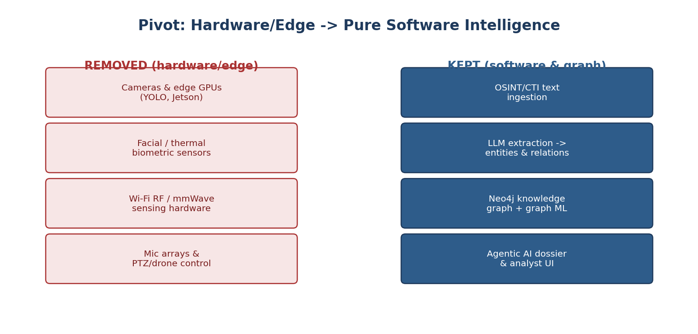

Removed — detail
Layer | Why it's gone
Edge object/pose detection | No camera deployments, no on-prem GPU boxes to maintain.
Facial & biometric vision | No camera hardware, no calibration, no video feeds to manage.
Thermal biometrics | No specialized thermal sensors or infrared conversion pipeline.
RF / Wi-Fi sensing | No microcontrollers, RF calibration, or through-wall tracking complexity.
Audio hardware | No mic arrays or physical sound capture to install and maintain.
Hardware actuation | No PTZ/drone control — the system doesn't operate physical devices.

Kept — detail
Layer | Why it stays
Digital data ingestion | Pulls in OSINT, CTI reports, and public text/chat data — no sensors needed.
LLM information extraction | Turns unstructured reports into structured actor/relationship data.
Knowledge graph (Neo4j) | Maps how actors, organizations, and wallets connect to each other.
Graph machine learning | Surfaces hidden clusters and the key actors bridging them.
Agentic AI & analyst UI | Lets an analyst ask questions and get a generated threat dossier back.

Flow
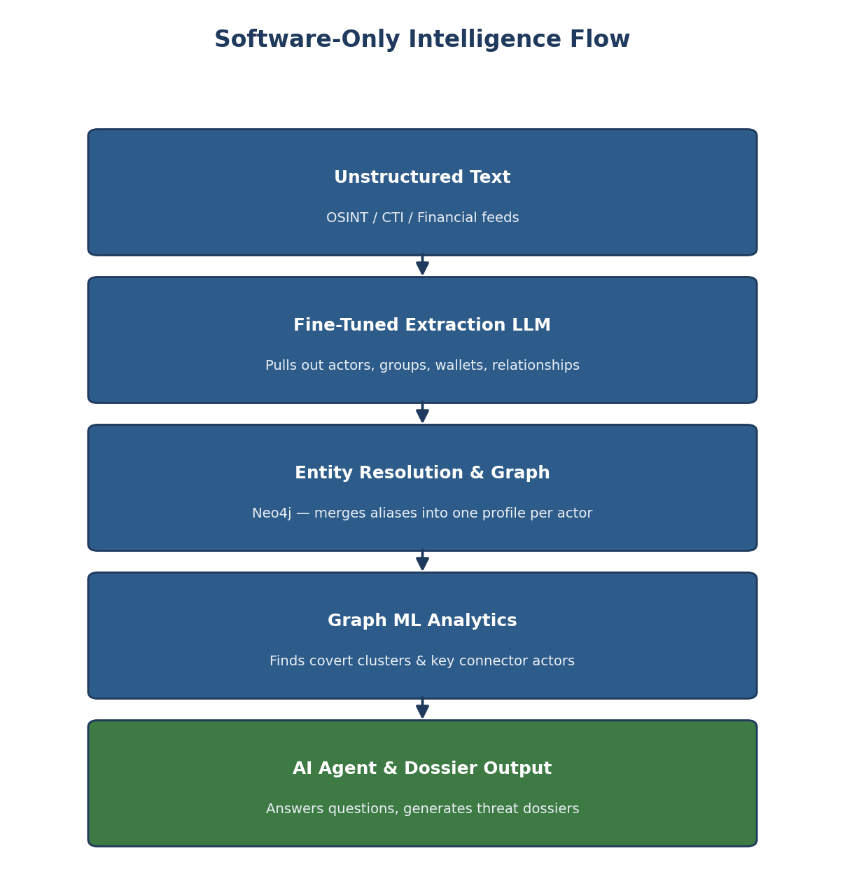

Why this is a better MVP
Everything runs on standard cloud infrastructure — no hardware to buy, install, or maintain. That means a faster build, a much smaller upfront cost, and nothing physical that can break or need field support. It's also a closer fit to Vehere's actual product line: cyber and network intelligence, not physical surveillance hardware.

