Threat Network Support Systems & Graph Architecture

Threat Assessment Flow
The diagram below traces the full analytical path: establishing who the actor is, what supports their activity, what they may be targeting, and the resulting risk-based response.
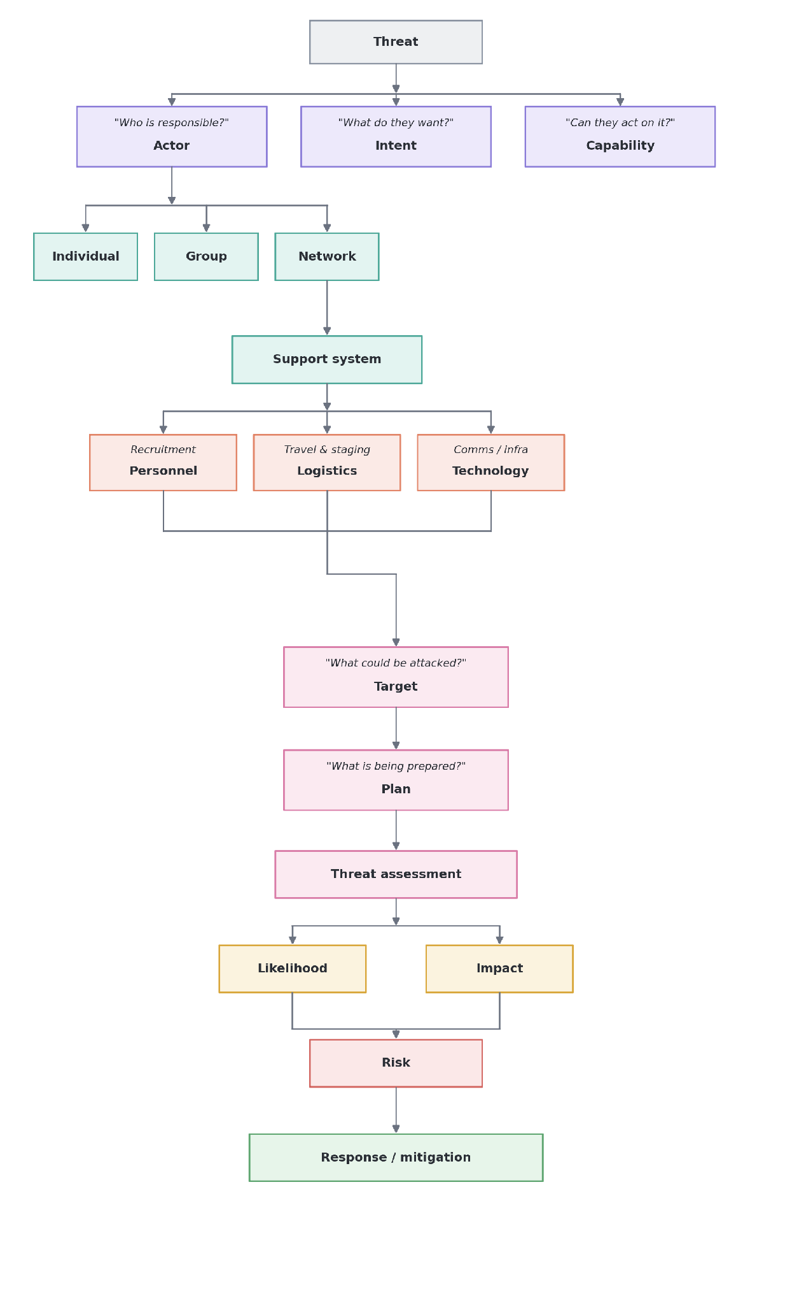
Figure 1. Actor assessment and response flow.

1. Executive Summary & Taxonomy
Threat actors rarely operate in isolation. Sustained activity depends on a surrounding network of support functions — people, resources, and infrastructure that enable operations to continue. This model organizes that ecosystem into 16 operational support components:
- Human Support: Core leadership, specialists, facilitators, couriers, and advisers.
- Recruitment Support: Outreach channels, online communities, influencers, and training pipelines.
- Logistical Support: Safe housing, transport corridors, staging storage, and procurement intermediaries.
- Communication Support: Encrypted messaging, radio networks, telecom metadata, and dead drops.
- Technology Support: Command-and-control infrastructure, server hosting, encryption, and custom tooling.
- Material Support: Equipment, electronics, vehicles, and supply caches.
- Training & Knowledge Support: Tactical instruction, operational security education, and tradecraft sharing.
- Political & Institutional Support: Political shielding, institutional influence, and advocacy fronts.
- Social Support: Kinship ties, community trust enclaves, and diaspora networks.
- Ideological Support: Propaganda networks, radicalization platforms, and public narratives.
- Information Support: Target reconnaissance, open-source intelligence (OSINT), and human sources.
- Legal & Administrative Support: Document handling, shell-entity registration, and legal coordination.
- Infrastructure Support: Warehouses, cloud accounts, and private facilities.
- External Support: Cross-border sponsors, diaspora networks, and foreign broker relationships.
- Concealment & Protection Support: Obfuscated ownership structures, aliases, and compartmentalized cells.
- Operational Execution Support: The point where upstream support converges into an active operation.

2. Six-Class Graph Taxonomy
To keep the intelligence graph schema manageable, the 16 operational areas roll up into six parent meta-classes, which in turn converge into two structural categories used for entity linkage.
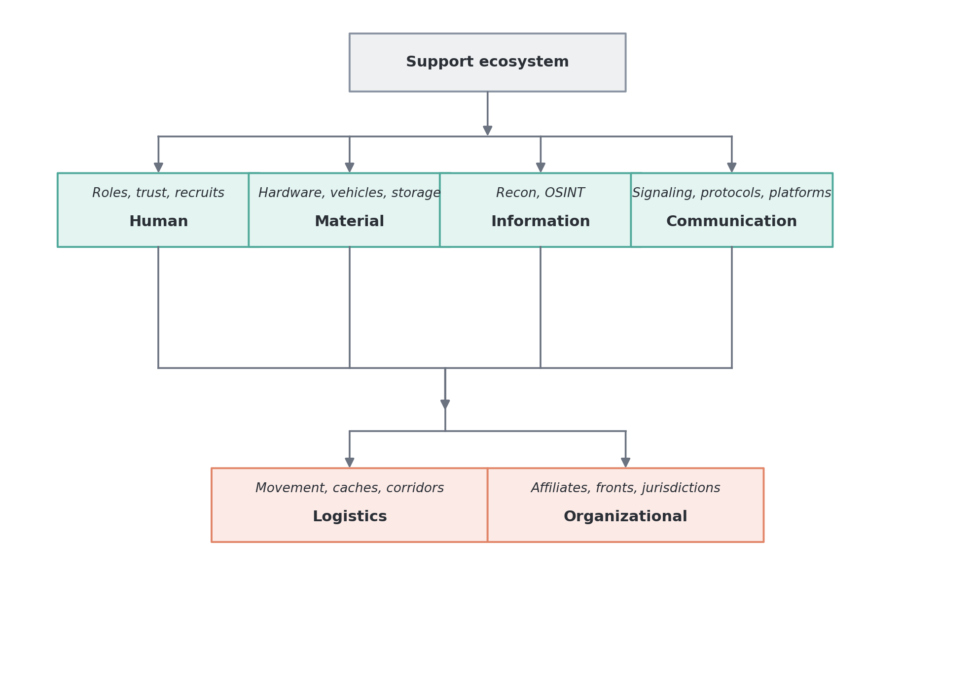
Figure 2. Support ecosystem meta-class taxonomy.

3. Threat Traceability Ranking & Intelligence Blindspots
Investigative friction is driven by visibility limits, data compartmentalization, and regulatory coverage. The table below ranks support domains by how difficult they are to trace.
Difficulty tier | Support domain | Core operational blindspot
Very High | Human & Social Trust Enclaves | Familial and offline personal trust leave zero institutional traces.
Very High | Concealed Ultimate Beneficial Ownership | Layered offshore structures and nominee directors legally mask actual network principals.
High | Ephemeral & Encrypted Communications | End-to-end encryption eliminates content analysis; requires complex traffic analysis.
High | Cross-Border Operational Routing | Jurisdictional borders create delays in data acquisition across sovereign entities.
High | Pseudonymous Online Operations | Single operators mask actions behind synthetic or rotated digital profiles.
Medium-High | Distributed Logistics & Supply Routing | Individual transport legs mimic standard commercial retail and logistics traffic.
Medium | Regulated Corporate Networks | Discoverable through commercial registers, though often slowed by multi-state filings.
Low | Registered Titled Assets | Real estate and registered transport assets maintain public registry records.

