Pipeline Architecture — Layer-by-Layer Explanation
This document walks through the full intelligence pipeline in order — what happens at each stage, which data feeds it, why that data and technique were chosen, and what comes out the other end. Each layer's output is the next layer's input, so by the end everything traces back to a specific piece of raw evidence.
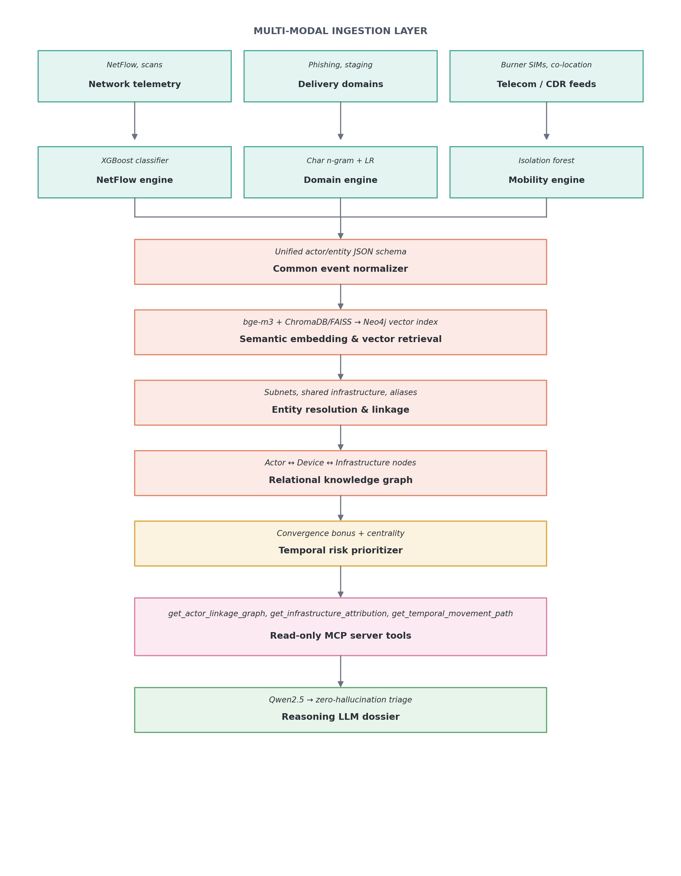
Figure 1. End-to-end pipeline, from raw signals to the final analyst dossier.

Layer 1: Multi-Modal Ingestion Layer
This is where raw data first enters the system. Three unrelated data sources come in side by side — network traffic, suspicious web domains, and phone/cell activity — because a real actor rarely leaves a trace in only one of these. Each source has its own dedicated "engine" that turns raw records into a first risk signal.

1.1 Network Telemetry → NetFlow Engine
- Dataset used: UNSW-NB15 Network Telemetry Benchmark.
- Why this dataset: It's built from real modern attack traffic rather than an old, staged lab capture, so it includes the slow, quiet reconnaissance and command-and-control patterns that real intrusions actually look like.
- What's inside it (in plain terms): Each row is one network "conversation" — which IP talked to which IP, on which port, for how long, how many packets, and whether it used TCP/UDP/ICMP. Think of it as an itemised phone bill, but for computers talking to each other.
- Model / technique: XGBoost classifier (a gradient-boosted decision tree).
- Why this model: Network data is tabular, has features on very different scales (durations vs. packet counts vs. flags), and has lots of "mostly zero" columns. Tree-based models handle that naturally, whereas a neural network would need much more data and tuning to avoid overfitting.
- Output passed to the next layer: A 0–1 probability score per network event, e.g. "this looks 89% like a reconnaissance scan."

1.2 Delivery Domains → Domain Engine
- Dataset used: Pirocheto Phishing & Malicious URL Corpus.
- Why this dataset: Actors don't build brand-new infrastructure every time — they reuse patterns (typo-squatted domains, shortened links). A labelled corpus of known-bad vs. known-good URLs teaches the model what those patterns look like.
- What's inside it (in plain terms): A big list of web addresses, each tagged malicious or benign, plus surface details like the domain suffix (.com, .org) and the full link text.
- Model / technique: Character n-gram (3–5 letter chunks) + TF-IDF, fed into a balanced Logistic Regression.
- Why this model: Malicious domains are built from odd letter combinations rather than real words, so looking at small chunks of characters catches this without needing a heavy language model.
- Output passed to the next layer: A 0–1 confidence score that a given domain is malicious infrastructure.

1.3 Telecom / CDR Feeds → Mobility Engine
- Dataset used: Synthetic Call Detail Record (CDR) & cell tower log dataset.
- Why this dataset: Phone and SIM behaviour exposes tradecraft — like swapping SIM cards or turning a phone on only at night — that never shows up in network or web data, so it fills a blind spot the other two sources can't see.
- What's inside it (in plain terms): Phone numbers, handset hardware IDs (IMEI), which cell tower a call connected through and its coordinates, how long calls lasted, and exactly when each event happened.
- Model / technique: Isolation Forest combined with a sequential IMEI-churn estimator.
- Why this model: There's no labelled "this is a burner phone" dataset to learn from, so the model instead learns what normal behaviour looks like and flags anything that stands out — bursts of night-time calls, or one handset cycling through many SIM cards.
- Output passed to the next layer: A 0–1 anomaly score per device, e.g. "this handset's behaviour is 72% consistent with burner-phone use."

Layer 2: Common Event Normalizer
The three engines above each produce their own shape of output. Before anything can be linked together, every event — network, domain, or telecom — is rewritten into one shared format. This is the "translator" step: without it, the graph in Layer 5 would have no consistent way to compare an IP address risk score to a phone anomaly score.
- What it contains (in plain terms): Every event becomes a JSON record with the same six fields: a unique event ID, an event type (network/url/telecom/CTI), the entity it belongs to, its calibrated risk score, which engine produced it, and a human-readable one-line summary.
- Output passed to the next layer: A stream of standardised JSON events, all directly comparable regardless of which of the three engines produced them.

Layer 3: Semantic Embedding & Vector Retrieval
Not everything is a clean number — a lot of useful context lives in free text: threat-intel writeups, an actor's known aliases, or the wording of a MITRE ATT&CK technique. This layer turns that text into something searchable by meaning rather than exact keyword.
- Embedding technology: BAAI/bge-m3, which turns any piece of text into a 1024-number vector.
- Why this embedding technology: Investigations cross languages and naming conventions (an actor might be called "Fancy Bear", "APT28", or "Strontium" depending on the source). bge-m3 is multi-lingual and captures meaning rather than exact wording, so all three names end up close together in vector space even though the text is completely different.
- Vector store technology: ChromaDB or in-memory FAISS during prototyping, moving to Neo4j's built-in Vector Index in production.
- Why this vector store: It lets the system ask "what's semantically closest to this new indicator?" (a nearest-neighbour / cosine-similarity search) in milliseconds, instead of manually writing a rule for every possible alias or technique name. Moving to Neo4j in production means the vectors live right next to the graph data they support, avoiding a second database to keep in sync.
- Output passed to the next layer: A similarity score linking a raw indicator to the closest known threat actor or attack technique.

Layer 4: Entity Resolution & Linkage
At this point the system has lots of separate events pointing at lots of separate identifiers — IPs, phone numbers, domains, aliases. This layer's job is to work out which of those actually belong to the same real-world actor, so the system isn't tracking ten fragments of one person as if they were ten different people.
- How it's done: Infrastructure joining merges two identifiers if they share an IP inside the same /24 network block or the same internet provider (ASN). Co-location logic merges two devices if they keep switching to the same cell towers within 15 minutes of each other, even if they never call one another directly.
- Output passed to the next layer: A set of merged entities — e.g. "Track_892", "Device IMEI_3520...", and "secure-auth-login[.]org" are now understood to be the same operational cluster.

Layer 5: Relational Knowledge Graph
The merged entities and their relationships are now stored as an actual graph — nodes connected by labelled arrows — rather than flat rows in a table. This is what lets an analyst (or the LLM later on) ask "show me everything connected to this actor" and get a real answer instead of a manual search.
- Technology (prototype): NetworkX — a Python graph library good for building and testing graphs with thousands of connections in memory.
- Technology (production): Neo4j AuraDB / Neo4j Enterprise — a dedicated graph database built to store millions of nodes and answer graph questions ("who is 2 hops away from this actor?") in under a second.
- Why these technologies: Prototyping in NetworkX is fast and needs no setup; moving to Neo4j at scale is necessary once the graph is too big to fit comfortably in memory or needs to serve live queries from multiple analysts at once.
- What the graph looks like: Actor nodes connect to Device nodes (uses), Devices connect to Cell Towers (attached to), Actors connect to Infrastructure/IP nodes (operates), Infrastructure connects to Domains (hosts), and Events connect to Attack Pattern nodes (indicates).
- Output passed to the next layer: A connected graph of actors, devices, infrastructure, and events that can be queried and scored.

Layer 6: Temporal Risk Prioritizer
Not every flagged actor deserves the same attention. This layer combines everything the graph knows about an actor into one priority score, and — critically — gives a bonus to actors who show up across multiple different data sources at once, since that kind of convergence is a much stronger signal than one loud alert from a single source.
- How the score is built: Each domain contributes a weighted score: network telemetry (35%), malicious URLs/staging infrastructure (25%), MITRE technique attribution (20%), and telecom/burner-phone anomalies (20%). If three or more of these domains flag the same actor independently, an extra convergence bonus is added on top.
- Why this matters: An actor with four moderate alerts across different sources is treated as higher priority than someone with one very loud alert from a single source — this is what prevents a single noisy sensor from drowning out a quieter but more coordinated threat.
- Temporal tracking: The system also watches how central an actor becomes in the graph over time (betweenness centrality) — someone drifting from a minor, peripheral node to a well-connected hub is a sign of growing operational coordination, and their timeline is reconstructed to show the order of events (recon → staging → activation).
- Output passed to the next layer: A ranked queue of actors, each with a single composite risk number and a reconstructed activity timeline.

Layer 7: Read-Only MCP Server Tools
Before any of this reaches a language model, it passes through a strict, read-only interface. This exists because handing an LLM raw, unformatted logs invites it to guess or "hallucinate" details that aren't actually there — instead, the LLM is only ever allowed to call a small set of fixed, predictable functions.
- get_actor_linkage_graph(actor_id): returns everything directly and indirectly connected to an actor (IPs, domains, devices, towers).
- get_infrastructure_attribution(actor_id): returns which known threat group or technique this actor's infrastructure matches.
- get_temporal_movement_path(actor_id): returns the actor's reconstructed timeline of activity.
- Output passed to the next layer: Bounded, factual JSON — never raw logs — ready to be handed to the reasoning model.

Layer 8: Reasoning LLM Dossier
The final step turns everything above into something a human analyst can actually read and act on.
- Model: Qwen2.5 (a small instruction-tuned model for local/offline use, or a larger 7B version in production).
- Why this model: It runs entirely on local infrastructure, so sensitive data never has to leave the building through a third-party cloud API — an important constraint for this kind of intelligence work.
- How it's constrained: The model is only allowed to reason over the exact JSON returned by the Layer 7 tools, with an explicit instruction not to invent indicators that weren't provided.
- Final output: A four-part written dossier: an executive threat assessment, a breakdown of the evidence by source, a graph/role analysis (is this actor a coordinator, a courier, an infrastructure admin?), and concrete recommended next steps.

Appendix: The Analytical Framework Behind the Pipeline
Everything above is the technical machinery. Conceptually, it exists to answer a small set of standing intelligence questions about any actor the pipeline flags — who they are, what they want, whether they're capable of acting, and what should be done about it.
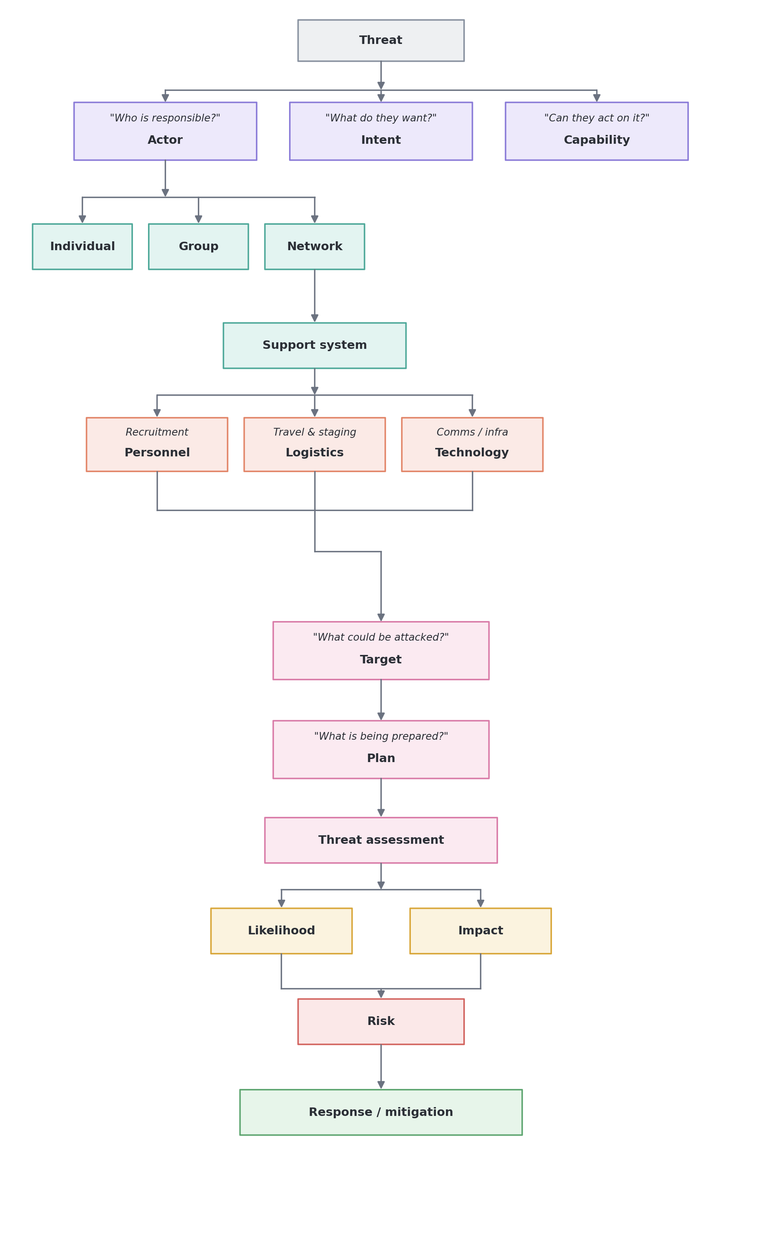
Figure 2. The actor-assessment framework the pipeline's outputs feed into.
In practice, the pipeline layers above map onto this framework as follows:
- Actor: resolved by Layer 4 (Entity Resolution) — is this an individual, a small group, or part of a wider network?
- Intent & Capability: informed by the domain risk scores from Layer 1 and the technique attribution from Layer 3 — what are they doing, and do they have the infrastructure to follow through?
- Support system: visible in the knowledge graph (Layer 5) as the personnel, logistics, and technology nodes connected to the actor.
- Risk & response: produced directly by Layer 6 (Temporal Risk Prioritizer) and written up by Layer 8 (Reasoning LLM Dossier).

