System Mission & Pipeline Overview
The redesigned Multi-Modal Counter-Terrorism Intelligence (MMCTI) platform is completely decoupled from banking and retail fraud classification. Its operational mandate is defined strictly by four core objectives:
- Target Identification: Flagging emerging hostile actors across weak, distributed operational signals.
- Entity Linkage: Connecting resolved actors to devices, IP infrastructure, domains, cell towers, and coordinating peers.
- Risk Scoring: Fusing heterogeneous signals into a prioritized ranking to eliminate analyst alert fatigue.
- Actor Tracking: Tracing the chronological evolution of infrastructure and relationships over time.
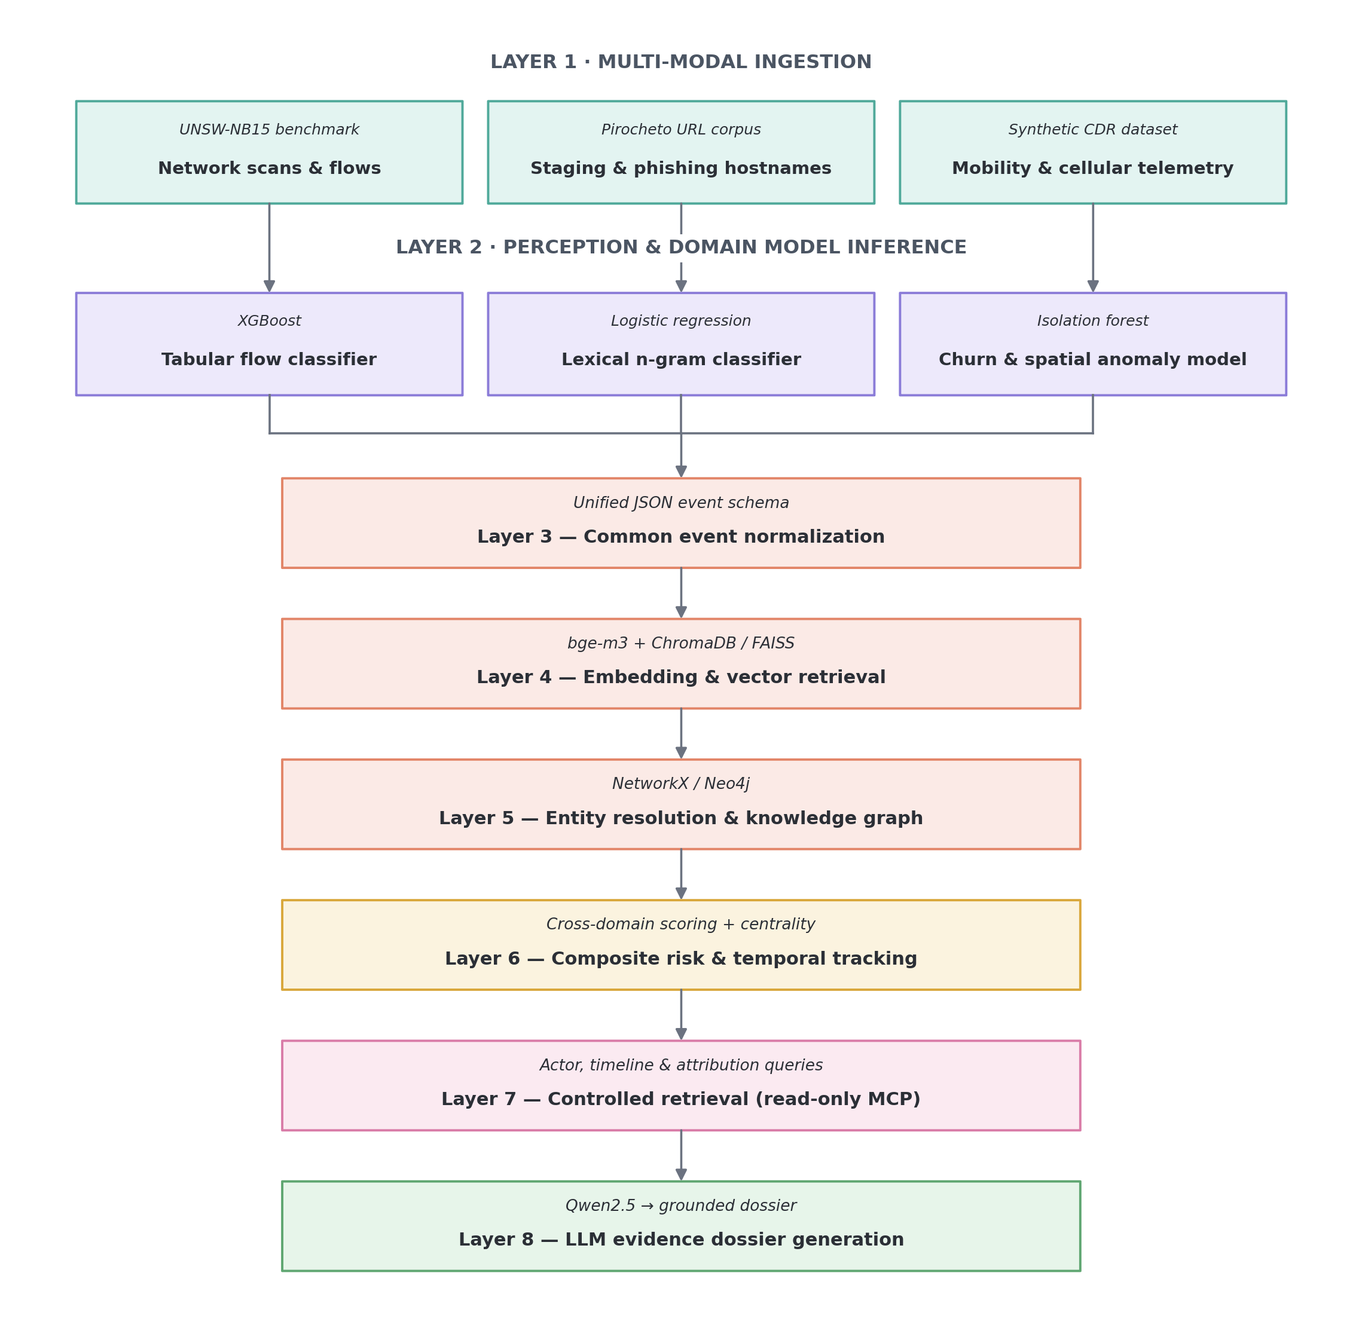
Figure 1. Eight-layer MMCTI processing pipeline.

Layer 1: Multi-Modal Data Ingestion Layer

1. Cyber Telemetry & Network Flows
- Dataset Used: UNSW-NB15 Network Telemetry Benchmark.
- Why This Dataset: Unlike synthetic lab captures, UNSW-NB15 mirrors modern low-and-slow reconnaissance, port scans, and command-and-control (C2) channel handshakes.
- What Information It Contains: 49 structured network flow features, including source/destination IP addresses, port numbers, duration, packet counts, TTL (Time-to-Live) values, protocol flags (TCP, UDP, ICMP), and transaction round-trip states.
- Operational Value: Discovers reconnaissance probes against critical infrastructure and unauthorized lateral scans.

2. Delivery & Weaponized Infrastructure
- Dataset Used: Pirocheto Phishing & Malicious URL Corpus.
- Why This Dataset: Hostile staging cells rely heavily on disguised hostnames, shortened delivery URLs, and typo-squatted domains to harvest credentials or stage malware payloads.
- What Information It Contains: Raw URLs, full HTTP strings, top-level domain (TLD) classifications, and labels indicating malicious versus benign infrastructure.
- Operational Value: Identifies domains being set up or accessed by actors during preliminary staging.

3. Cellular Mobility & Telecom CDR Feeds
- Dataset Used: Synthetic Telecommunications Call Detail Record (CDR) & Cell Tower Logs.
- Why This Dataset: Telecom logs expose physical operational security (OPSEC) tradecraft — specifically burner phone usage and co-location — that cyber sensors miss entirely.
- What Information It Contains: Mobile Station International Subscriber Directory Numbers (MSISDNs / phone numbers), International Mobile Equipment Identity (IMEI / handset hardware IDs), Cell Tower IDs with associated latitude/longitude coordinates, call durations, and precise event timestamps.
- Operational Value: Pinpoints physical burner phone activation rings, IMEI churn (multiple SIM cards swapped into a single physical phone), and geographic transit patterns.

Layer 2: Perception & Domain-Specific Model Inference

1. Network Behavior Model
- Model Architecture: XGBoost Classifier (max_depth=3, eval_metric="logloss", learning_rate=0.1).
- Why This Model: Tabular network flows feature non-linear boundaries, heterogeneous scales, and sparse features that cause deep neural networks to overfit unless heavily regularized. Gradient-boosted decision trees naturally partition these metrics efficiently.
- Input: Numerical flow vector (duration, packet count, rate, error flags).
- Output: Calibrated cyber anomaly probability score P(attack) ∈ [0, 1].

2. Domain & Delivery Classifier
- Model Architecture: Character N-Gram (3–5) TF-IDF + Balanced Logistic Regression.
- Why This Model: Hostile domains rarely rely on standard vocabulary; they utilize character-level variations (e.g., secure-login-v4.com, auth-portal-gov[.]org). Character n-grams directly capture lexical entropy and sub-word indicators without requiring heavy language models.
- Input: Raw URL string.
- Output: Malicious infrastructure confidence score P(malicious) ∈ [0, 1].

3. Cellular Mobility & Burner Detector
- Model Architecture: Isolation Forest + Sequential IMEI Churn Estimator.
- Why This Model: Unsupervised tree isolation efficiently identifies anomalous outliers in mobility records (e.g., sudden bursts of late-night calls or rapid geographic relocations exceeding normal human velocity).
- Input: IMEI churn counts, nighttime communication ratios, and cell tower transit velocity.
- Output: Telecom anomaly risk score P(burner) ∈ [0, 1].

Layer 3: Common Event Normalization Engine
Disparate model outputs cannot be directly mapped into a knowledge graph without standardizing their formats. The normalizer converts raw predictions into an immutable, unified JSON schema:
{
"event_id": "NET_88412",
"event_type": "network_event",
"entity_id": "ACTOR_48",
"risk_score": 0.892,
"source": "network_behavior_model",
"details": "Anomalous SCADA port reconnaissance scan",
"timestamp": "2026-09-06T14:32:10Z",
"metadata": {
"target_port": 502,
"duration": 0.14,
"ip_address": "198.51.100.45"
}
}
- Standardized Fields:
  - event_id: Unique identifier for the transaction, scan, or cellular ping.
  - event_type: Categorical label (network_event, url_event, telecom_anomaly, cti_ttp_event).
  - entity_id: The logical entity or suspect cluster the event binds to.
  - risk_score: Calibrated probability output from the Layer 2 domain model.
  - source: Provenance engine tag for auditability and compliance.
  - details: Human-readable investigative summary for forensic dossiers.

Layer 4: Semantic Embedding & Vector Retrieval Engine

1. Embedding Model
- Technology: BAAI/bge-m3 (1024-dimensional dense semantic vectors).
- Why This Technology: Multi-modal threat investigations require cross-lingual mapping across unstructured intelligence reports, hacker aliases, and text descriptions of MITRE ATT&CK techniques. bge-m3 provides dense vector retrieval, multi-lingual support, and high semantic precision for technical threat intelligence taxonomies.
- What It Embeds: Unstructured threat reports, actor alias variants (e.g., "Fancy Bear", "APT28", "Strontium"), and formal MITRE ATT&CK scope descriptions.

2. Vector Store Storage
- Technology: ChromaDB / In-Memory FAISS (Colab workbench) → Neo4j Vector Index (Production).
- Why This Technology: Allows nearest-neighbor search (k-NN via cosine similarity) to instantly link an observed event indicator to a documented Advanced Persistent Threat (APT) tactic without manual rule creation.
- Layer Output: Semantic similarity scores matching active telemetry to known threat actors and techniques.

Layer 5: Entity Resolution & Knowledge Graph Assembly

1. Technology Selection
- Google Colab Prototype: NetworkX (multi-directed graph handling thousands of in-memory connections).
- Enterprise Production: Neo4j AuraDB / Neo4j Enterprise (native property graph storing millions of nodes with sub-second Cypher queries).

2. Graph Schema & Structural Ontologies
The graph models relationships between actors, physical devices, digital infrastructure, and observed events:
(:Actor) ──[:USES_DEVICE]──> (:Device:IMEI) ──[:ATTACHED_TO]──> (:CellTower)
│
├──[:OPERATES]────────> (:Infrastructure:IP) ──[:HOSTS]──> (:Domain:URL)
│
└──[:GENERATED_EVENT]───> (:Event) ──[:INDICATES]──────────> (:AttackPattern)
- Node Labels:
  - :Actor: Unique suspect or operative node (ACTOR_48).
  - :Device: Physical cellular hardware (IMEI_352094...).
  - :Infrastructure: Cyber assets (IP_198.51.100.45).
  - :Domain: Staging URLs and web destinations (secure-auth-login[.]org).
  - :CellTower: Geolocation towers with coordinates and azimuth tags.
  - :AttackPattern: MITRE ATT&CK techniques (T1190: Exploit Public-Facing App).
- Edge Relationships: Typed, directed edges (USES_DEVICE, OPERATES, HOSTS, GENERATED_EVENT, INDICATES, CO_LOCATED_WITH).

3. Automated Entity Resolution (Resolving Disparate Indicators)
Instead of relying on synthetic ID assignments, the graph resolves identities using:
- Infrastructure Joining: Merging distinct actors if they share an IP within the same /24 CIDR block or identical BGP Autonomous System Numbers (ASNs).
- Co-Location Algorithms: Calculating spatial-temporal overlap between two devices consistently switching cell towers within 15 minutes without placing direct calls to each other.

Layer 6: Composite Risk Scoring & Temporal Actor Tracking

1. Fused Cross-Domain Risk Formula
To elevate multi-domain operations over isolated alerts, the engine applies weighted multi-source scoring with a cross-domain convergence booster:
Composite Risk(A) = Σₘ wₘ · Rₘ(A) + γ · ℙ(|M_A| ≥ 3)
- Calibrated Weights:
  - Cyber NetFlow Telemetry (w = 0.35)
  - Malicious URLs / Staging Infrastructure (w = 0.25)
  - MITRE CTI Technique Attribution (w = 0.20)
  - Telecom Mobility / Burner Phone Anomalies (w = 0.20)
- Multi-Source Booster (γ = 0.35): Applied as an operational penalty when three or more distinct domains independently flag the target.
- Why This Matters: An actor with four moderate alerts (0.65 × 4) receives a higher investigation priority than an entity with a single high-volume network alert (0.95), directly addressing weak-signal invisibility.

2. Temporal Actor Tracking
- Centrality Drift: Measures Betweenness Centrality over discrete time windows (T₁, T₂, T₃). An actor transitioning from a low-degree peripheral node to a high-betweenness connector signals operational coordination.
- Timeline Extraction: Sequences indicators chronologically to identify attack lifecycles (Reconnaissance → Infrastructure Staging → Operational Activation).

Layer 7: Controlled Retrieval Layer (Read-Only MCP Server)
Generative LLMs hallucinate when fed raw, unformatted logs. The platform uses a Read-Only Model Context Protocol (MCP) Tool Server that provides the language model with deterministic, structured endpoints:
- get_actor_linkage_graph(actor_id: str) -> dict: Retrieves the 1-hop and 2-hop graph topology, returning all linked IPs, domains, devices, and cell towers.
- get_infrastructure_timeline(actor_id: str) -> dict: Returns a time-indexed sequence of all cyber reconnaissance and domain activities tied to the actor.
- get_telecom_co_location(actor_id: str) -> dict: Queries cellular metadata for IMEI churn frequency, cell tower transitions, and co-traveling devices.
- get_threat_actor_attribution(actor_id: str) -> dict: Queries the STIX knowledge graph to return confirmed APT group signatures and MITRE techniques.

Layer 8: Evidence-Grounded Dossier Synthesis (Local LLM)

1. Reasoning Engine
- Model: Qwen2.5-0.5B-Instruct (Local Colab Inference) / Qwen2.5-7B (Production).
- Why This Model: Operates entirely on sovereign, local compute infrastructure without leaking sensitive national security data to external third-party cloud APIs. It supports ChatML prompt formats and follows strict tool-grounded instructions.

2. Prompt Architecture
The model is constrained to analyze only the verified JSON context provided by the MCP tools:
<|im_start|>system
You are a senior counter-terrorism cyber intelligence officer. Synthesize the provided
multi-modal MCP intelligence telemetry into a structured, evidence-grounded threat dossier.

Structure your response into 4 distinct sections:
1. EXECUTIVE THREAT ASSESSMENT: Overall severity, attribution likelihood, and cross-domain convergence.
2. MULTI-DOMAIN SIGNAL SYNTHESIS: Concise breakdown across NetFlow, Phishing URLs, Telecom CDRs, and MITRE TTPs.
3. GRAPH TOPOLOGY & CONNECTIONS: Centrality analysis and multi-modal clustering.
4. ACTIONABLE CONTAINMENT DIRECTIVES: 3 targeted, concrete law-enforcement/cyber defense containment steps.

Do not invent indicators. Rely only on the provided MCP context.<|im_end|>

3. Output Generated (Forensic Threat Dossier)
The analyst receives a synthesized, evidence-backed dossier:
- Executive Threat Assessment: Evaluates attack severity, attribution confidence, and cross-domain coordination.
- Multi-Domain Signal Breakdown: Formulates specific evidence linking cyber reconnaissance, staging infrastructure, and cellular mobility.
- Graph Topology & Role Assessment: Classifies the target's operational role (e.g., coordinator, courier, infrastructure administrator) based on network centrality.
- Targeted Containment Directives: Recommends concrete actions (e.g., domain sinkholing, PCAP captures, cellular tower surveillance).

Pipeline Component & Operational Mapping Reference
Pipeline Stage | Primary Technology / Standard | Input Payload | Processing Function | Final Layer Output
Ingestion | UNSW-NB15, Phishing URLs, Telecom CDRs | Raw network PCAP flows, raw URLs, cellular switch logs | Stratified sampling, feature tensor parsing | Normalized feature matrices
Domain Models | XGBoost, Char N-Gram LR, Isolation Forest | Tabular flow vectors, text character strings, spatial logs | Specialized probabilistic inference | Calibrated domain risk scores (P ∈ [0, 1])
Normalization | Unified JSON Schema | Domain risk probabilities + raw telemetry metadata | JSON standardization and entity key assignment | Common Event Schema JSON payloads
Vector Engine | BAAI/bge-m3 + FAISS / ChromaDB | Unstructured threat reports, TTP technique texts | 1024-d dense embedding generation & k-NN indexing | Semantic cosine distance scores to APT profiles
Graph Assembly | NetworkX (Local) / Neo4j AuraDB (Prod) | Normalized JSON events | Multi-hop directed edge generation & entity resolution | Connected knowledge graph topology
Risk Scoring | Corroboration-Boosted Mathematical Engine | Graph degrees, domain scores, distinct source counts | Multi-source weighted convergence calculation | Prioritized Target Triage Queue
Tool Interface | Model Context Protocol (MCP) | Parameterized tool queries (actor_id) | Graph neighborhood querying & JSON packaging | Bounded factual JSON payloads
LLM Synthesis | Qwen2.5-0.5B-Instruct (Local Engine) | Factual MCP JSON payloads + System Prompt | Constrained reasoning & evidentiary synthesis | Grounded, Actionable Intelligence Dossier

