AI-Assisted Intelligence Platform
A Scoped, MVP-First Proposal — Built on Vehere's Existing Strengths
Draft for discussion — v2 (reduced scope)

1. Why This Document Changed
The first version tried to cover too much at once — physical sensors, biometrics, financial tracking, cyber telemetry, OSINT, and autonomous response, all in one architecture. It read like a generic AI systems catalog rather than a plan for what we can realistically build here.
This version narrows the scope to what fits Vehere's actual product line — cyber network intelligence, threat detection, and forensics — and lays out 10 clear parts so we can decide together which ones belong in a first MVP and which ones wait.

2. The 10-Part Scope (for discussion)
Each part below is something Vehere's platform already touches in some form. The AI/LLM layer we're proposing sits on top of these — it doesn't replace them, it makes them faster and smarter to use.

1. Data Ingestion & Telemetry
- Network traffic capture (packets, NetFlow)
- Log & host telemetry collection
- Basic data cleanup / normalization
Why it matters: Foundation layer — nothing downstream works without clean, reliable data coming in.

2. Network Detection & Response (NDR) Core
- Anomaly detection on network behavior
- Signature / rule-based detection
- This is Vehere's existing flagship strength
Why it matters: Already Vehere's core product — this is where AI adds the most direct, provable value.

3. Cyber Threat Intelligence (CTI)
- Ingest known threat indicators (IOCs)
- Map activity to known attacker techniques (MITRE ATT&CK)
- Track known threat campaigns
Why it matters: Turns raw alerts into 'this matches a known attacker pattern' — a big time-saver for analysts.

4. Network Forensics
- Investigate an incident after the fact
- Reconstruct what happened, in what order
- Root-cause analysis
Why it matters: Customers need to answer 'what actually happened' after an alert — this closes that loop.

5. OSINT & External Intelligence
- Public/open-source data relevant to a threat
- Cross-reference external indicators with internal alerts
Why it matters: Adds outside context to internal alerts — often what separates noise from a real threat.

6. Entity Resolution & Graph Analytics
- Link related entities (IPs, accounts, users, devices)
- Visualize how an incident connects across the network
- Detect clusters of related activity
Why it matters: This is where scattered alerts turn into one connected story an analyst can act on.

7. Financial / Transaction Intelligence
- Flag unusual transaction patterns (if relevant to a customer)
- Optional — only for customers who need it
Why it matters: Relevant mainly for BFSI customers — a good candidate to trim from the very first MVP.

8. AI / LLM Text & Intent Analysis
- Summarize alerts in plain language for analysts
- Extract key entities from unstructured reports/logs
Why it matters: The direct 'LLM value-add' layer — makes existing data faster and easier to use.

9. Automated Response & Alerting
- Prioritize alerts by severity
- Trigger a notification or playbook step automatically
Why it matters: Reduces manual triage time — a concrete, measurable efficiency win for customers.

10. Deployment & Customer Fit
- Fit into how a specific customer (defense / telecom / BFSI) already works
- Basic data governance and access control
Why it matters: Even a great engine fails if it doesn't fit how the customer's team actually works day to day.

What's deliberately left out for now
- Physical/biometric sensing (face recognition, thermal imaging, Wi-Fi-based motion tracking, voice ID) — interesting, but a different product line, different hardware, and a much heavier compliance conversation. Not needed to prove the core idea.
- Full autonomous/agentic response (the system acting on its own without a human approving) — worth exploring later, but the MVP should recommend actions, not take them.

3. Scope Map (Block Diagram)
A simple visual of the 10 parts — blue is proposed MVP scope, grey is future/optional.
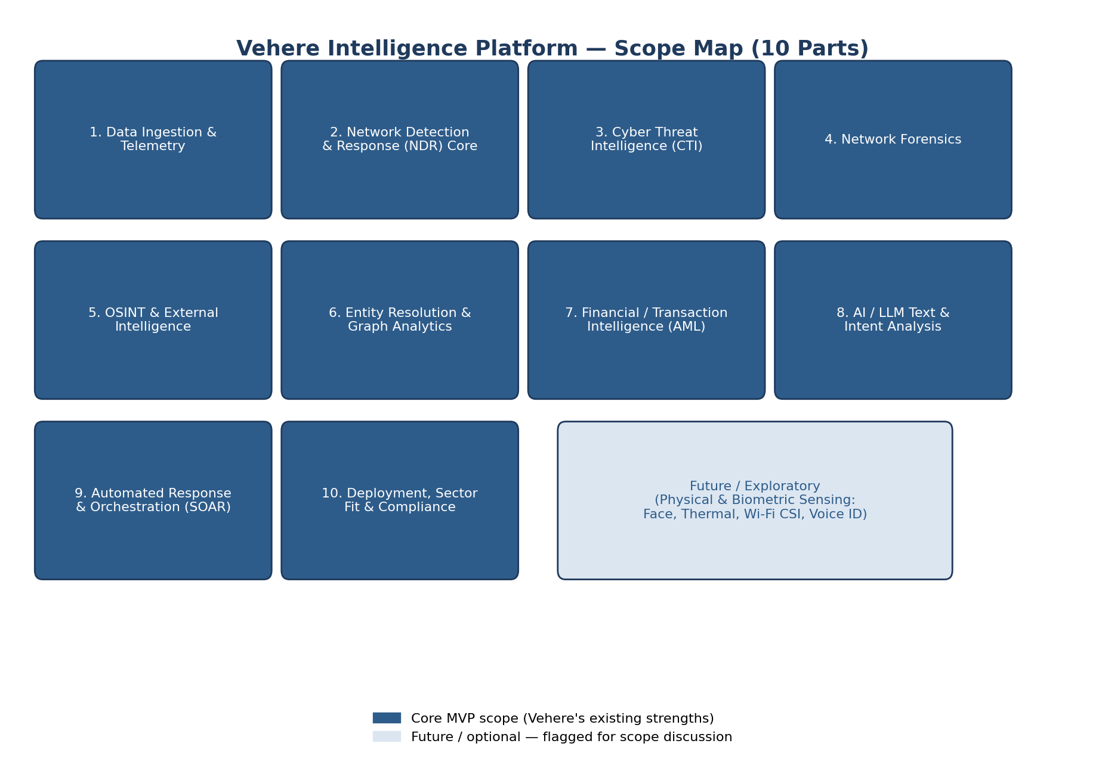

4. How Data Actually Flows (Flow Diagram)
Kept intentionally simple — five steps from raw data to something an analyst can act on.
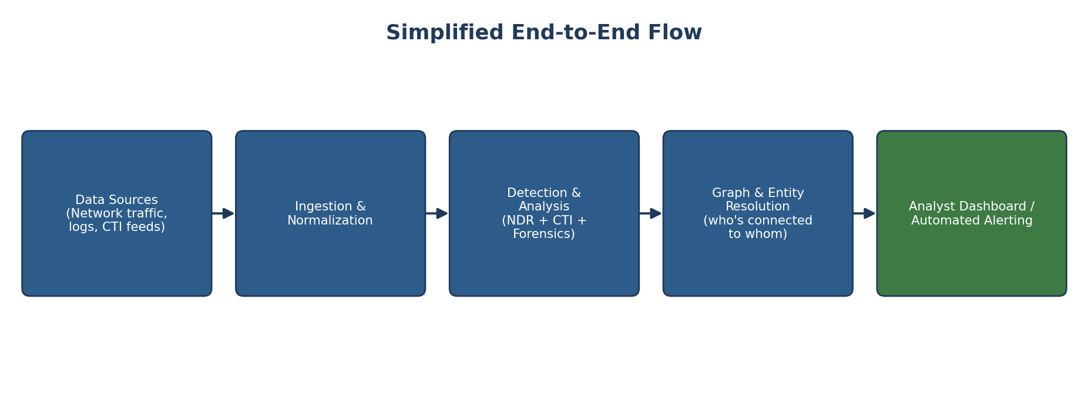

5. Where the Profit Actually Comes From
This isn't just a technically interesting project — it maps to how Vehere makes money today:
Business angle | How this scope helps
Analyst time saved | Plain-language alert summaries and auto-prioritization (Parts 8–9) cut the time an analyst spends triaging — a direct, measurable cost saving we can put in front of customers.
Fewer missed threats | Graph-based entity linking (Part 6) connects alerts that look unrelated on their own — catching things a rules-only system misses.
Upsell to existing customers | This is an enhancement layer on Vehere's current NDR/CTI product, not a new product line — easier to sell to customers we already have than to find new ones.
Competitive differentiation | Competitors (Corelight, Cybersixgill, ExtraHop) are also adding AI layers — staying scoped and shipping something working is more valuable than a broader idea that never ships.
Lower delivery risk | A 10-part scope we can trim (vs. one giant system) means we can show working value in weeks, not a year — less risk for the team and for the customer commitment.

6. Questions for You (Manager)
To lock the MVP scope, I'd like your call on:
- Which of the 10 parts are must-have for a first working demo, vs. which can wait?
- Is Part 7 (Financial/AML) relevant to our near-term customers, or should it be cut entirely for now?
- Should the MVP target one customer segment first (e.g., telecom or defense), or stay generic?
- Are we comfortable proposing 'recommend, don't auto-act' for the first version (Part 9), with full automation as a later phase?

7. My Next Step
Once scope is agreed, I'll break the confirmed parts into a small MVP, build each piece myself, test it against real data, and validate whether it holds up in practice before we plan anything larger.

