Threat Intelligence Graph — Scope Proposal
A simple walkthrough of the idea, in 10 parts
Prepared for scope discussion — draft v2

Why This Document
This is a simplified version of the earlier draft, cut down to the essentials and organized around how Vehere actually works today. The goal here isn't to build everything at once — it's to lay out the pieces clearly so we can agree on what's worth building first, and what can wait.
The core idea: take the data we already collect (network logs, analyst reports, threat feeds), automatically identify the actors and entities in it, work out how they're connected, and show that as a connected graph instead of scattered records. Below is the flow, the building blocks, and a 10-part breakdown so we can decide together what stays in scope.

How Data Flows Through the System
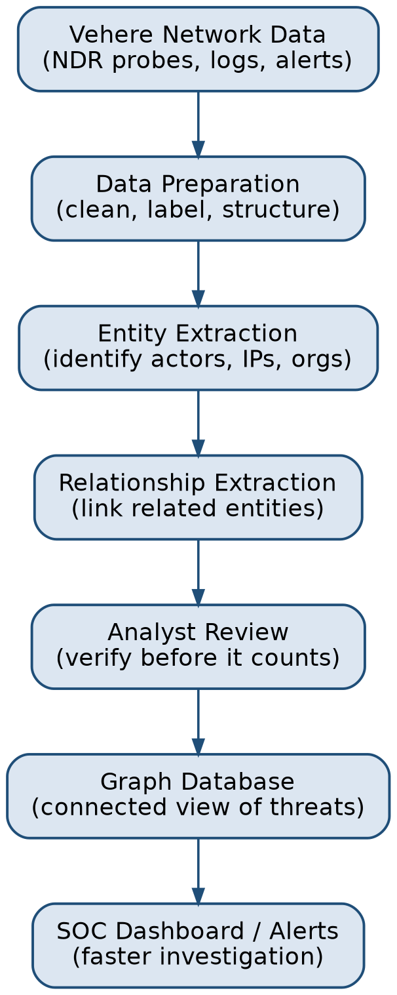

System Block Diagram
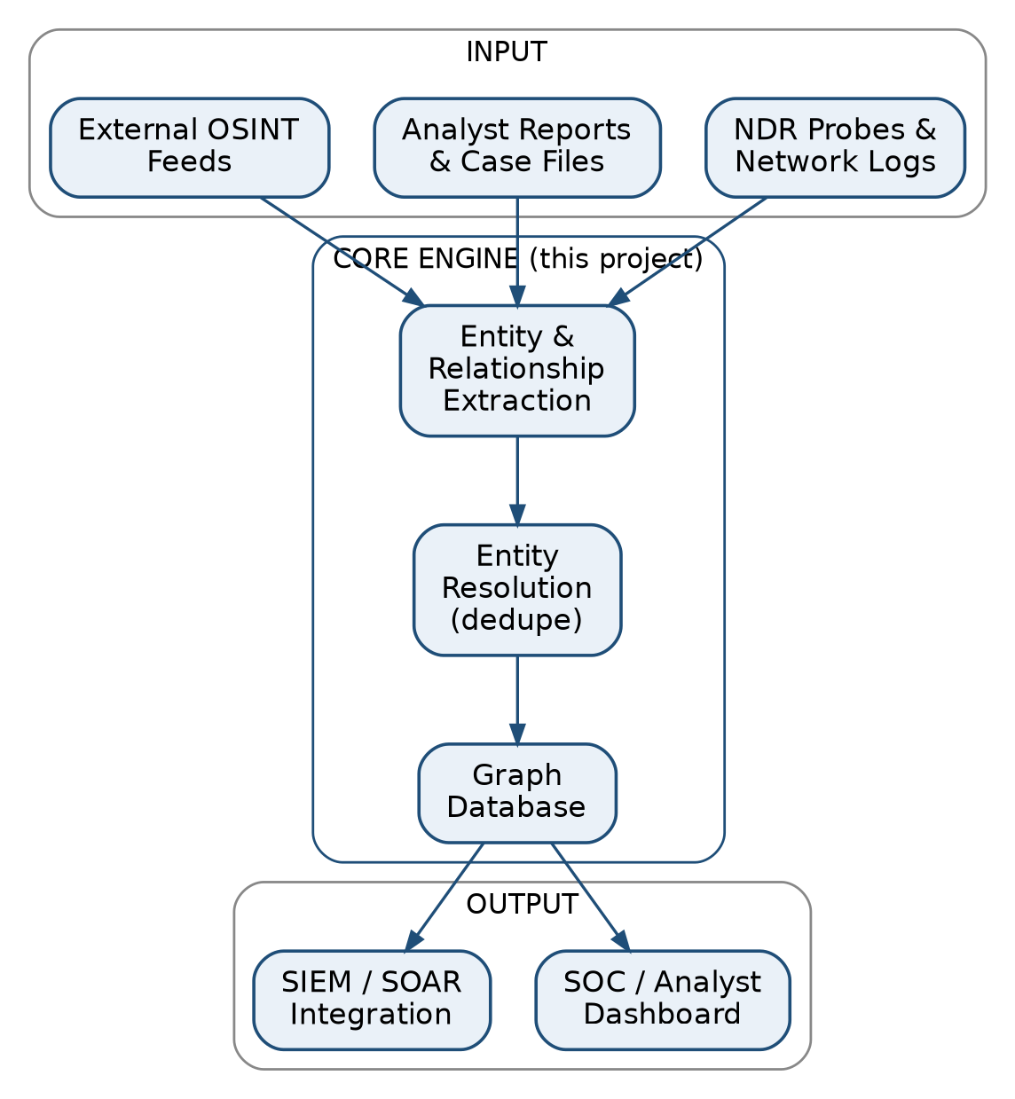

Scope — 10 Parts
Each part below is fairly independent. If some of these should be cut, deferred, or combined, this is exactly the list to mark up.

1. Data Sources
Where the information comes from — our own NDR probes/logs, analyst case files, and outside threat feeds.
- NDR probes & network logs (already collected today)
- Analyst reports & case notes
- External OSINT / threat feeds
Business value: Reuses data we already have — no new collection cost.

2. Data Preparation
Cleaning and organizing raw data so a model can actually learn from it.
- Cleaning & de-duplication
- Defining entity/relationship types for our domain
- Small labeled sample for testing
Business value: One-time setup cost; makes every later stage more accurate.

3. Entity Extraction
Automatically pulling out 'who/what' — people, organizations, IPs, domains, devices — from raw text and telemetry.
- Extraction from text reports
- Extraction from network telemetry (IP/domain/device)
- Confidence scoring per entity
Business value: Cuts manual tagging time for analysts — faster case turnaround.

4. Relationship Extraction
Working out how those entities are connected — communicates with, shares infrastructure with, funded by, etc.
- Communication links
- Shared-infrastructure links
- Financial / logistics links (for CT & fraud use cases)
Business value: Surfaces connections analysts would otherwise miss manually.

5. Entity Resolution (De-duplication)
Making sure the same real person/asset isn't shown as five different entities.
- Alias & name matching
- Cross-source merge (report data + telemetry data)
Business value: Keeps the graph trustworthy — bad merges erode analyst confidence fast.

6. Graph Database
Storing entities and relationships in a connected structure instead of flat tables.
- Neo4j (or similar) backend
- Basic query/search access
Business value: Turns scattered records into one explorable picture of a threat network.

7. Model Training
Teaching the extraction model on our own data instead of relying only on a generic off-the-shelf model.
- Start with prompt-based extraction (fast, no training needed)
- Fine-tune a smaller model later if accuracy/cost demands it
Business value: On-prem/offline-capable — important for defense & government deals.

8. Analyst Review Loop
A human always checks what the model proposes before it's treated as fact.
- Simple review queue for new entities/links
- Analyst feedback improves future accuracy
Business value: Avoids false leads — protects trust in the product.

9. Integration with Existing Vehere Stack
Connecting this into what we already sell, instead of building a separate island product.
- SIEM / SOAR alert enrichment
- Feed into existing NDR dashboard
Business value: Adds value to our current product instead of competing with it — easier upsell.

10. MVP & Business Case
Proving it works on one small, real use case before going further.
- Pick one customer/use case for pilot
- Measure time saved per investigation
- Build the ROI case for wider rollout
Business value: Concrete proof point to take to customers and leadership.

Where This Helps the Business
- Faster investigations: analysts spend less time manually connecting the dots, which shortens time-to-detection/response — a metric customers already care about.
- Product differentiation: competitors offer detection and forensics; a connected-entity view adds a layer most of them don't.
- Upsell path: this sits on top of our existing NDR/SIEM integration rather than replacing anything, so it's an add-on story to current customers, not a hard sell.
- Defense/government fit: our biggest accounts need on-prem, explainable systems — this is designed to be built that way from day one, not bolted on later.

Suggested Next Step
Rather than committing to all 10 parts, I'd suggest we pick 2–3 to build as a small MVP (parts 1, 2, 3, 6, and 10 are the minimum needed to show something real), test it against one use case, and use that to decide what to add next. I'll implement and validate this myself before we talk about scaling it further.

