Above is my architecture diagram.

Backend service will provide APIs to

1. Create new paste entry based on current sign in user email and paste content.
2. Query past paste entries based on current sign in user.

**API Design**

**API #1 – Post New Paste**

This API will be used to create new paste after use signed in.

**URL**: POST /user/{user_id}/pastes

**Header**: AWS Cognito user OAuth token.

**Request:**

{

“content_type”: (string),

“keyword”: (string),

“content_details”: (string)

}

**Response**

* HTTP/200/204: OK
* HTTP/400: Bad input
* HTTP/403: Access denied when user is not signed in.

**Sample Request:**

POST /user/user_0123456789/pasts

{

“content_type”: “link”,

“keyword”: “week2 assignment link”

“content_details:” “https://maryville.instructure.com/courses/60451/assignments/1418827”

}

**API #2 – Get Existing Pastes**

This API will be used to query last N posts for current signed in user.

**URL**: GET /user/{user_id}/pastes?last={last_x_posts}

**Header**: AWS Cognito user OAuth token.

**Request**: None

**Response**:

* HTTP/200: OK
* HTTP/400: Bad input
* HTTP/403: Access denied when user is not signed in.

{

“pastes”: [

{

“paste_id”: (string),

“content_type”: (string),

“keyword”: (string),

“content_details”: (string),

“paste_datetime”: (timestamp)

},

{

“paste_id”: (string),

“content_type”: (string),

“keyword”: (string),

“content_details”: (string),

“paste_datetime”: (timestamp)

},

…

]

}

**Sample Request:**

GET /user/user_0123456789/pastes?last=5

**Sample Response:**

{

“pastes”: [

{

“paste_id”: “paste_2”

“content_type”: “link”,

“keyword”: “week2 assignment link”,

“content_details”: “https://maryville.instructure.com/courses/60451/assignments/1418827”,

“paste_datetime”: 1635713152

},

{

“paste_id”: “paste_1”,

“content_type”: “text”,

“keyword”: “”,

“content_details”: “First paste on my paste board!!!”,

“paste_datetime”: 1635710152

},

…

]

}

**API #3 – Delete Existing Pastes**

This API can be used to delete existing pastes for current signed in user.

**URL**: DELETE /user/{user_id}/pastes/{paste_id}

**Header**: AWS Cognito user OAuth token.

**Request**: None

**Response**:

* HTTP/200/204: OK
* HTTP/400: Bad input
* HTTP/403: Access denied when paste id doesn’t belongs to current signed in user.

**Sample Request:**

DELETE /user/user_0123456789/pates/paste_1

**Sequence Design**

When user requests to sign into the account, the sequence diagram will look like the below:

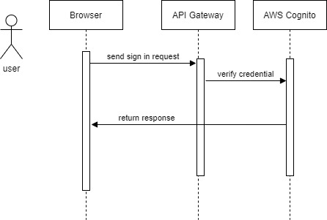

When user requests to post / delete / get pastes, the sequence diagram will look like the below:

